# Exercise 1 - modules, functions, generators

“Yam mesika” is a Hebrew python tutorial that contains exercises and explanations.

<https://github.com/PythonFreeCourse/Notebooks>

You need to hand in 6 exercises. These are the recommended ones.

5.1 - זו הדרך, אין לי וִנִגְרֶט

5.2 - cup of join , חתכת עוגה

5.3 - לחששנית

5.4 - כלים שלובים

If you know the material already, feel free to skip ahead and do any 6 exercises you want, from weeks 5 -8.

If your python is rusty, I recommend on reading week 3 and week 4 as well.

**How to hand in –**

* Hand in the assignments in the git repository you have created from the supplied link (Available in moodle). If you know how to open a pull request, do so, and add “talbarfm” as a reviewer. If not, use the manual upload –

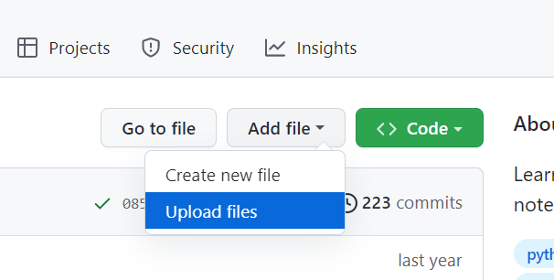

* There are some small exercises inside each section, you don’t have to do them or hand them in. Hand each exercise on a separate module unless the exercises are dependent on each other.
* Use the file names in this format – <week>.<part>.<exercise name>.py
  + For example, for "זו הדרך" , the file name would be - “5.1.thats_the_way.py”.
* **Pay attention, .ipynb file format will not be accepted, only .py files.**

As usual, feel free to contact me using slack, whatsapp (this week only) or mail for further questions.