Assignment

Stage One Submission

2805ICT/3815ICT/7805ICT

Student name: Mohammad Mari Student ID: s5185052 Enrolled Course Code: 7805ICT

Student name:____________ Student ID:___________ Enrolled Course Code: _________

Student name:____________ Student ID:___________ Enrolled Course Code: _________

Student name:____________ Student ID:___________ Enrolled Course Code: _________

# Table of Contents

Table of Contents 2

1.0 Project Planning and Documentation 3

1.1 Time Schedule 3

1.2 Total working hours 3

1.3 Effort and contribution table 3

1.4 Version Control System 4

2.0 Requirements Analysis 4

2.1 Functional requirements 4

2.2 Non-functional requirements 4

2.3 Use case diagram 4

2.4 Full use case description 4

2.5 Requirement - use case traceability matrix 4

3.0 Design and software architecture 4

3.1 Class diagram 4

3.2 Sequence diagram 4

3.3 Activity diagram 5

3.4 C & C View 5

3.5 Implementation style view 5

3.6 Deployment style view 5

4.0 Video link 5

# 1.0 Project Planning and Documentation

## 1.1 Time Schedule

This table should reflect who did what, how long you expected sections to take and the actual hours it took to perform the tasks.

|  |  |  |  |  |  |  |  |  |
| --- | --- | --- | --- | --- | --- | --- | --- | --- |
| **Task** | | **Plan** | | | | **Actual** | | |
| # | Task Name | Student | Planed Time | Cumulative  Time | Finished Date | Time | Cumulative Time | Finished Date |
| 1 | Project plan |  |  |  |  |  |  |  |
|  |  |  |  |  |  |  |  |  |
| 2 | Identify Functional Requirement |  |  |  |  |  |  |  |
|  |  |  |  |  |  |  |  |  |
|  |  |  |  |  |  |  |  |  |
|  |  |  |  |  |  |  |  |  |
|  |  |  |  |  |  |  |  |  |
|  |  |  |  |  |  |  |  |  |
|  |  |  |  |  |  |  |  |  |
|  |  |  |  |  |  |  |  |  |
|  |  |  |  |  |  |  |  |  |

## 1.2 Total working hours

|  |  |  |
| --- | --- | --- |
| **Student Name (#ID)** | **Plan (hours)** | **Actual (hours)** |
|  |  |  |
|  |  |  |
|  |  |  |
|  |  |  |
| **Total working hours** |  |  |
| **Average working hours per person** |  |  |

## 1.3 Effort and contribution table

|  |  |  |  |
| --- | --- | --- | --- |
| **Student** | **Effort Level\***  (Rating from 0 – 5, the information is filled by the group) | **Contribution Level\***  (Rating from 0 – 5, the information is filled by the group) | **Justification**  If a student received level rating of 3 or less, your group need to give explanation for the low level rating |
|  |  |  |  |
|  |  |  |  |
|  |  |  |  |
|  |  |  |  |
| **Total** |  |  |  |

* *Level ratings, 5 = excellent, 4 = good, 3 = reasonable, 2 = poor, 1 = unacceptable, 0 = none

## 1.4 Version Control System

[Your group needs to use a version control system (VCS) to manage the source code development. Please use screenshot to demonstrate that a suitable VCS system has been applied in developing this project. ]

# 2.0 Requirements Analysis

## 2.1 Functional requirements

## 2.2 Non-functional requirements

## 2.3 Use case diagram

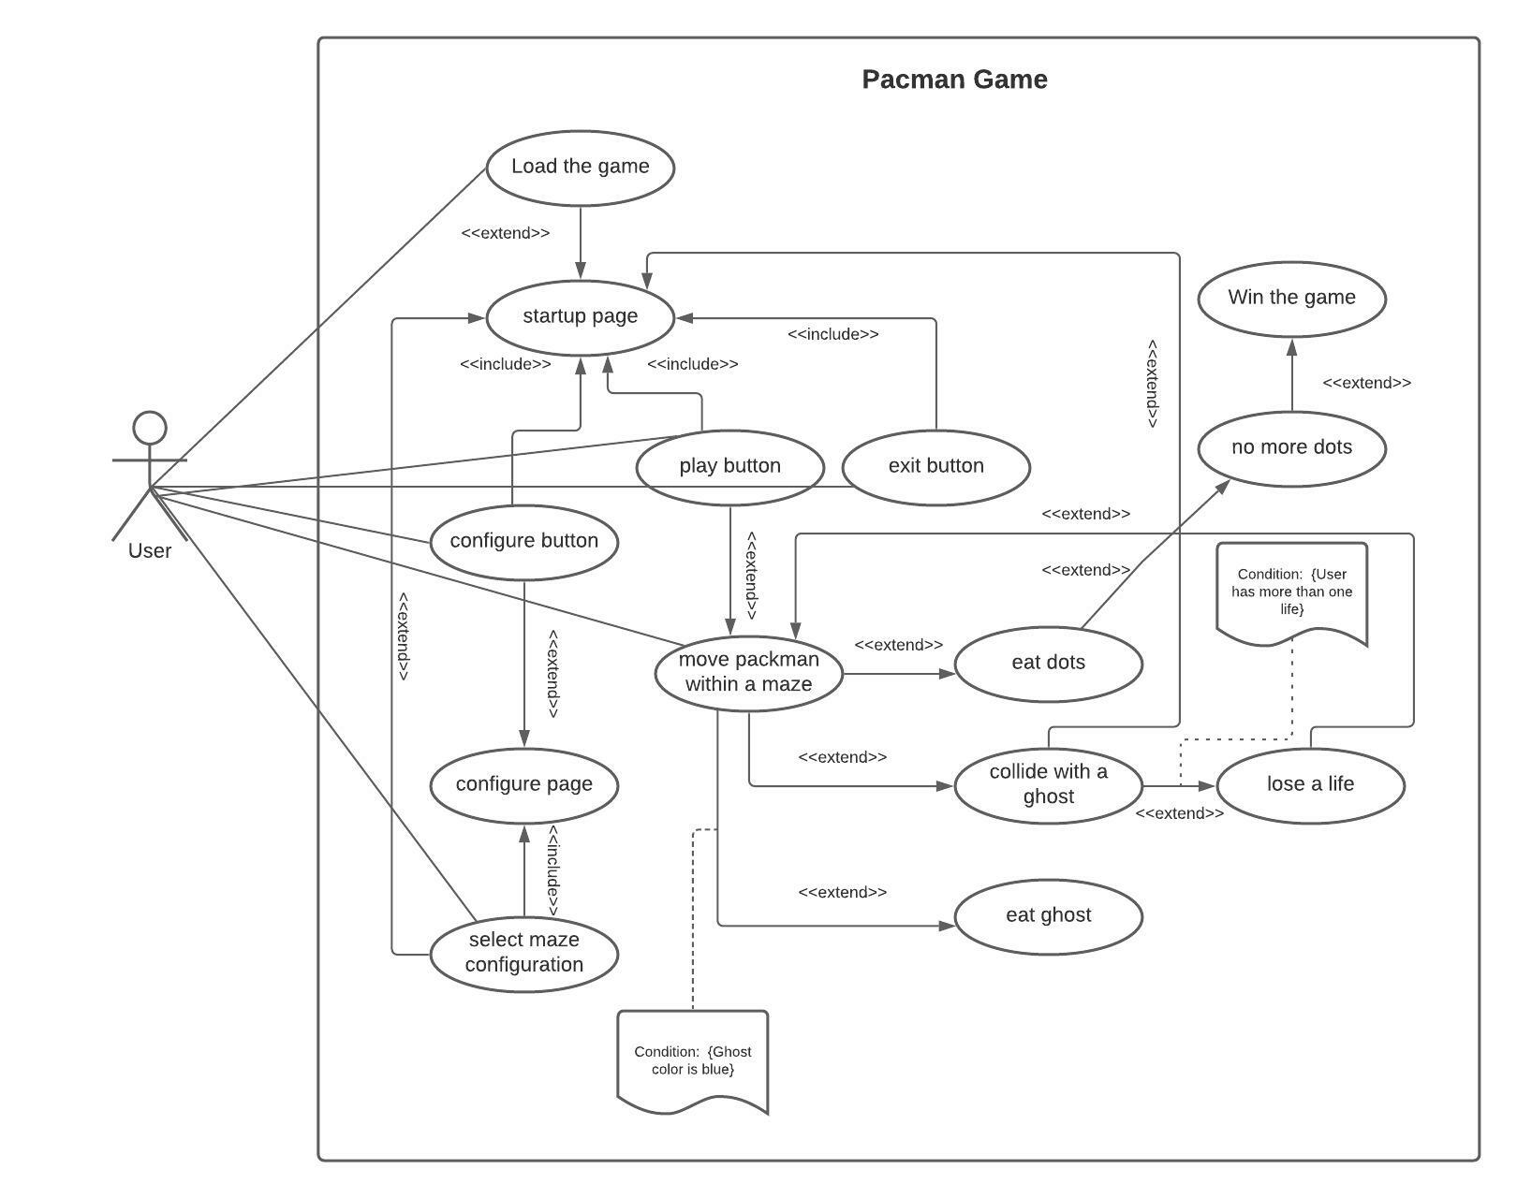

## 2.4 Full use case description

## 2.5 Requirement - use case traceability matrix

# 3.0 Design and software architecture

## 3.1 Class diagram

## 3.2 Sequence diagram

## 3.3 Activity diagram

## 3.4 C & C View

## 3.5 Implementation style view

## 3.6 Deployment style view

# 4.0 Video link

[please put the URL link of your video, please make sure the video can be viewed by the assessor]