**北京邮电大学软件学院**

**2017-2018学年第一学期实验报告**

**课程名称：** C#程序设计实践

**项目名称： Unity开发-仿Doodle Jump游戏**

**项目完成人：**

**姓名： 刘浩博 学号： 2015212086**

**姓名： 张昕夏 学号： 2015212040**

**姓名： 张帅 学号： 2015211976**

**指导教师：**___________卢本捷___________

**日 期： 2018年 1月 8日**

1. **实验目的**

通过这次实践项目，理解C#语言的特点及特性，并在Unity引擎中使用C#脚本进行开发，达到熟练掌握及运用C#的目的。

1. **实验内容**

利用Unity引擎，通过现有的素材包，来开发一个仿doodle jump游戏。具体内容包括场景搭建、场景跳转、人物动作实现、基本游戏功能实现、特殊道具实现、排行榜功能等。

1. **实验环境**

Unity 2017.2.0f3，Visual Studio 2017，MonoDevelop

1. **实验结果**
2. 进入游戏

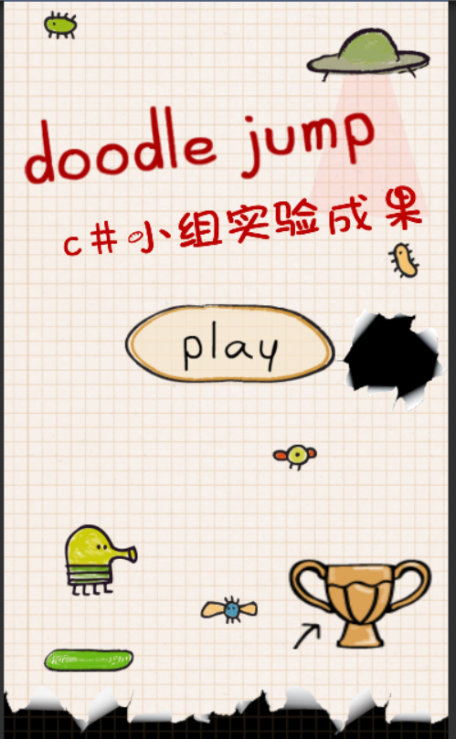

1. 游戏界面

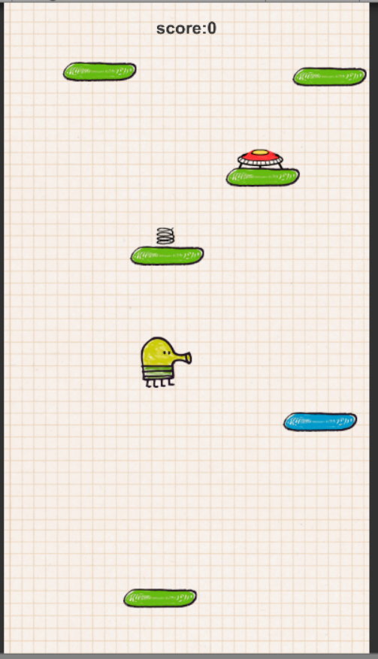

1. 道具生成

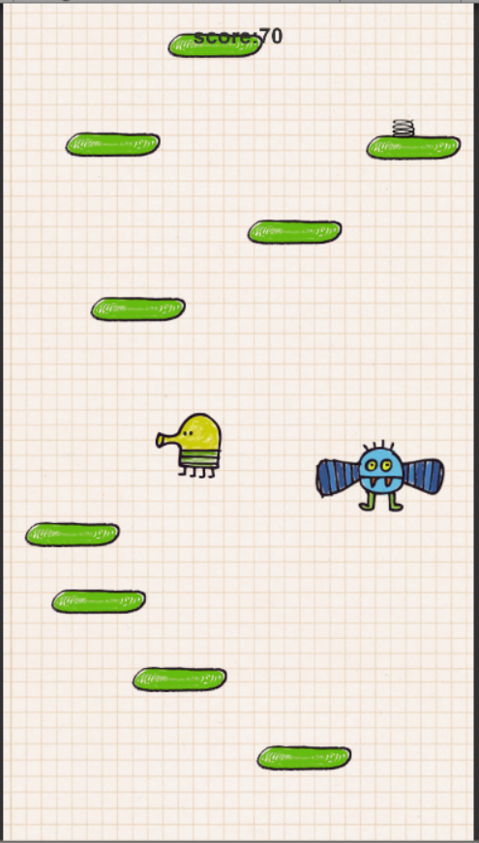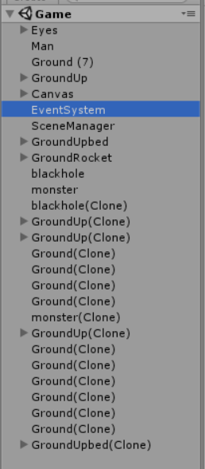

右面即为生成的道具实例

1. 死亡结算

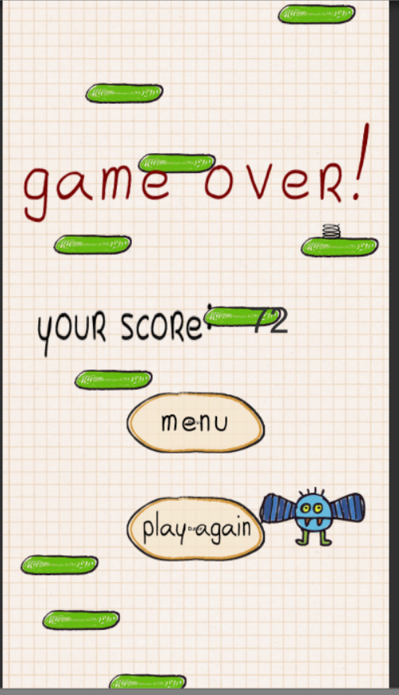

1. 排行榜

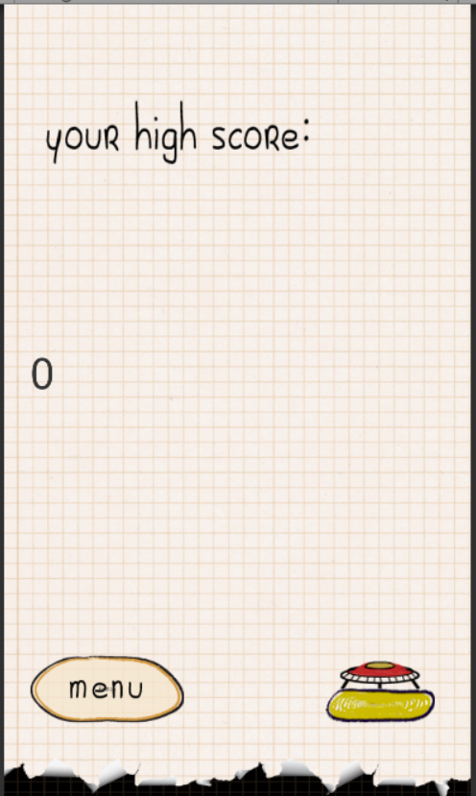

1. **附录**

部分代码

ManUP.cs://控制人物跳跃及判断

using System.Collections;  
using System.Collections.Generic;  
using UnityEngine;  
using UnityEngine.UI;  
  
public class MANUP : MonoBehaviour {  
  
    public bool Ground = false,IsHit=false;  
    public int Velocity = 400, LRVelocity = 10;  
    private int score,high;  
    private float height=0;  
  
    public Text text;  
    public Text s;  
    public Image lose;  
    public Image lose1;  
    public Button again;  
    public Button menu;  
  
    private GameObject foot = null;  
    Rigidbody2D GetR;  
    BoxCollider2D GetB;  
    void Start()  
    {  
        score = 0;  
  
        text.text = "score:0";  
        lose.gameObject.SetActive(false);  
        lose1.gameObject.SetActive(false);  
        again.gameObject.SetActive(false);  
        menu.gameObject.SetActive(false);  
        s.gameObject.SetActive(false);  
        GetR = transform.GetComponent<Rigidbody2D>();  
        GetB = transform.GetComponent<BoxCollider2D>();  
    }  
  
  
    void Update()  
    {  
        height = transform.position.y;  
        if( high < height)  
        {  
            high = (int)height;  
            if (high > score)  
            {  
                score = high;  
                text.text = "score:" + score.ToString();  
            }  
        }  
        if(transform.position.x > 2.8f)  
        {  
            transform.position = new Vector2(-2.8f, transform.position.y);  
        }  
        if(transform.position.x < -2.8f)  
        {  
            transform.position = new Vector2(2.8f, transform.position.y);  
        }  
        if (Ground)  
        {  
            GetR.AddForce(Vector2.up*Velocity);  
            Ground = false;  
        }  
        if (GetR.velocity.y > 0)  
        {  
            GetB.isTrigger = true;  
        }  
        else  
        {  
            if(IsHit==false)  
                GetB.isTrigger = false;  
        }  
        if (Input.GetKey(KeyCode.A))  
        {  
            GetR.AddForce(Vector2.left * LRVelocity);  
            transform.rotation = new Quaternion(0, 180, 0, 0);  
        }  
        if (Input.GetKey(KeyCode.D))  
        {  
            GetR.AddForce(Vector2.right * LRVelocity);  
            transform.rotation = new Quaternion(0, 0, 0, 0);  
        }  
        GameObject[] floors = GameObject.FindGameObjectsWithTag("Floor");  
        if (floors.Length < 20)  
        {  
            transform.GetComponent<Map>().OnGround();  
        }  
    }  
    void OnCollisionStay2D(Collision2D other)  
    {  
        if (other.gameObject.CompareTag("Floor"))  
        {  
              
            GetR.velocity = new Vector2(GetR.velocity.x, 0);  
            Ground = true;  
        }  
    }  
    void OnCollisionEnter2D(Collision2D other)  
    {  
        */\**  
*if (other.gameObject.CompareTag("Floor") && !other.gameObject.Equals(foot))*  
*{*  
*foot = other.gameObject;*  
*transform.GetComponent<Map>().OnGround();*  
*transform.GetComponent<Map>().OnGround();*  
  
*}*  
*\*/*  
        if (other.gameObject.CompareTag("Floor"))  
            transform.GetComponent<MANAnime>().OnAni();  
    }  
    void OnTriggerEnter2D(Collider2D other)  
    {  
        IsHit = true;  
        if (other.gameObject.CompareTag ("Up")) {  
            other.gameObject.GetComponent<Animator> ().SetTrigger ("HitUp");  
            Ground = true;  
            GetR.AddForce(Vector2.up * Velocity*3/2);  
            Destroy (other.gameObject);  
        }  
        if (other.gameObject.CompareTag("Upbed"))  
        {  
            other.gameObject.GetComponent<Animator>().SetTrigger("Upbed");  
            Ground = true;  
            GetR.AddForce(Vector2.up * Velocity * 2);  
            Destroy(other.gameObject);  
        }  
        if (other.gameObject.CompareTag("Rocket"))  
        {  
            other.gameObject.GetComponent<Animator>().SetTrigger("Rocket");  
            Ground = true;  
            GetR.AddForce(Vector2.up * Velocity * 3);  
            Destroy(other.gameObject);  
        }  
        if (other.gameObject.CompareTag("blackhole"))  
        {  
            other.gameObject.GetComponent<Animator>().SetTrigger("blackhole");  
            print("die");  
            s.text = score.ToString();  
            lose.gameObject.SetActive(true);  
            lose1.gameObject.SetActive(true);  
            again.gameObject.SetActive(true);  
            menu.gameObject.SetActive(true);  
            text.gameObject.SetActive(false);  
            s.gameObject.SetActive(true);  
        }  
        if (other.gameObject.CompareTag("monster"))  
        {  
            other.gameObject.GetComponent<Animator>().SetTrigger("monster");  
            print("die");  
            s.text = score.ToString();  
            lose.gameObject.SetActive(true);  
            lose1.gameObject.SetActive(true);  
            again.gameObject.SetActive(true);  
            menu.gameObject.SetActive(true);  
            text.gameObject.SetActive(false);  
            s.gameObject.SetActive(true);  
        }  
        if (other.gameObject.CompareTag("Die"))  
        {  
            print("die");  
            s.text = score.ToString();  
            lose.gameObject.SetActive(true);  
            lose1.gameObject.SetActive(true);  
            again.gameObject.SetActive(true);  
            menu.gameObject.SetActive(true);  
            text.gameObject.SetActive(false);  
            s.gameObject.SetActive(true);  
        }  
    }  
    void OnTriggerExit2D(Collider2D other){  
        IsHit = false;  
    }  
}

Map.cs://地图生成

using System.Collections;  
using System.Collections.Generic;  
using UnityEngine;  
  
public class Map : MonoBehaviour {  
  
    public GameObject Ground,BlueGround,GroundUp,GroundUpbed,GroundRocket,blackhole,monster;  
    public int i=1;  
    GameObject Top;  
    GameObject Target,Man;  
  
    *// Use this for initialization*  
    void Start () {  
        Top = GameObject.Find("GroundTop");  
        Man = GameObject.Find ("Man");  
    }  
      
    *// Update is called once per frame*  
    void Update () {  
        if (Man.transform.position.y > Top.transform.position.y) {  
            OnGround ();  
        }  
    }  
  
    public void OnGround()  
    {  
        i=Random.Range (1,100);*//1 ~ 9*  
        if (i <= 4)  
        {  
            Target = GroundUp;  
        }  
        else if (i <= 6)  
        {  
            Target = GroundUpbed;  
        }  
        else if (i <= 8)  
        {  
            Target = GroundRocket;  
        }  
        else if (i <= 10)  
        {  
            Target = blackhole;  
        }  
        else if (i <= 12)  
        {  
            Target = monster;  
        }  
        else if (i >= 90)  
        {  
            Target = BlueGround;  
        }  
        else  
        {  
            Target = Ground;  
        }  
        GameObject Groundins = Instantiate(Target) as GameObject;  
        Groundins.transform.position = new Vector3(Random.Range(-2.3f, 2.3f), Top.transform.position.y + Random.Range(0.7f, 1.2f), 0);  
        Top = Groundins;      
    }  
}

ManCamera.cs://控制镜头移动

using System.Collections;  
using System.Collections.Generic;  
using UnityEngine;  
  
public class MANCamera : MonoBehaviour {  
  
    GameObject Eyes, Man;  
    Vector2 CameraPos, ManPos;  
    public int velocity = 1;  
     
  
    *// Use this for initialization*  
    void Start () {  
        Eyes = GameObject.Find("Eyes");  
        Man = GameObject.Find("Man");  
    }  
      
    *// Update is called once per frame*  
    void Update () {  
        CameraPos = Eyes.transform.position;  
        ManPos = Man.transform.position;  
        if(ManPos.y>CameraPos.y)  
        {  
            Eyes.transform.position = Vector2.MoveTowards(CameraPos, new Vector2(CameraPos.x, ManPos.y),velocity);  
        }  
    }  
}