编译原理第二次实验——语法分析器

姓名：平雅霓 学号：2017211949

文法：

E —> E+T | E-T | T

E —> T * F | T / F | F

E —> ( E ) | num

1. 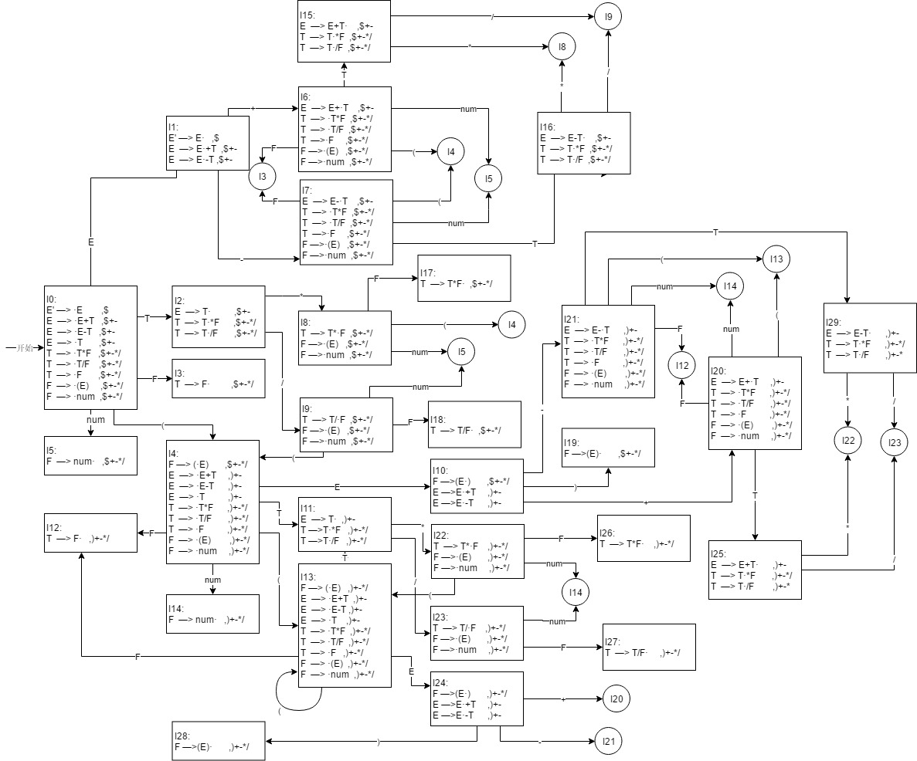**识别该文法的DFA**
2. **LR分析表**

|  |  |  |  |  |  |  |  |  |  |  |  |
| --- | --- | --- | --- | --- | --- | --- | --- | --- | --- | --- | --- |
| 状态 | action | | | | | | | | goto | | |
| ( | ) | + | - | * | / | num | $ | E | T | F |
| 0 | S4 |  |  |  |  |  | S5 |  | 1 | 2 | 3 |
| 1 |  |  | S6 | S7 |  |  |  | ACC |  |  |  |
| 2 |  |  | R3 | R3 | S8 | S9 |  | R3 |  |  |  |
| 3 |  |  | R6 | R6 | R6 | R6 |  | R6 |  |  |  |
| 4 | S13 |  |  |  |  |  | S14 |  | 10 | 11 | 12 |
| 5 |  |  | R8 | R8 | R8 | R8 |  | R8 |  |  |  |
| 6 | S4 |  |  |  |  |  | S5 |  |  | 15 | 3 |
| 7 | S4 |  |  |  |  |  | S5 |  |  | 16 | 3 |
| 8 | S4 |  |  |  |  |  | S5 |  |  |  | 17 |
| 9 | S4 |  |  |  |  |  | S5 |  |  |  | 18 |
| 10 |  | S19 | S20 | S21 |  |  |  |  |  |  |  |
| 11 |  | R3 | R3 | R3 | S22 | S23 |  |  |  |  |  |
| 12 |  | R6 | R6 | R6 | R6 | R6 |  |  |  |  |  |
| 13 | S13 |  |  |  |  |  | S14 |  | 24 | 11 | 12 |
| 14 |  | R8 | R8 | R8 | R8 | R8 |  |  |  |  |  |
| 15 |  |  | R1 | R1 | S8 | S9 |  | R1 |  |  |  |
| 16 |  |  | R2 | R2 | S8 | S9 |  | R2 |  |  |  |
| 17 |  |  | R4 | R4 | R4 | R4 |  | R4 |  |  |  |
| 18 |  |  | R5 | R5 | R5 | R5 |  | R5 |  |  |  |
| 19 |  |  | R7 | R7 | R7 | R7 |  | R7 |  |  |  |
| 20 | S13 |  |  |  |  |  | S14 |  |  | 25 | 12 |
| 21 | S13 |  |  |  |  |  | S14 |  |  | 29 | 12 |
| 22 | S13 |  |  |  |  |  | S14 |  |  |  | 26 |
| 23 | S13 |  |  |  |  |  | S14 |  |  |  | 27 |
| 24 |  | S28 | S20 | S21 |  |  |  |  |  |  |  |
| 25 |  | R1 | R1 | R1 | S22 | S23 |  |  |  |  |  |
| 26 |  | R4 | R4 | R4 | R4 | R4 |  |  |  |  |  |
| 27 |  | R5 | R5 | R5 | R5 | R5 |  |  |  |  |  |
| 28 |  | R7 | R7 | R7 | R7 | R7 |  |  |  |  |  |
| 29 |  | R2 | R2 | R2 | S22 | S23 |  |  |  |  |  |

1. **分析程序的运行结果**

输入字符串为：(num*num)+(num/num)$

