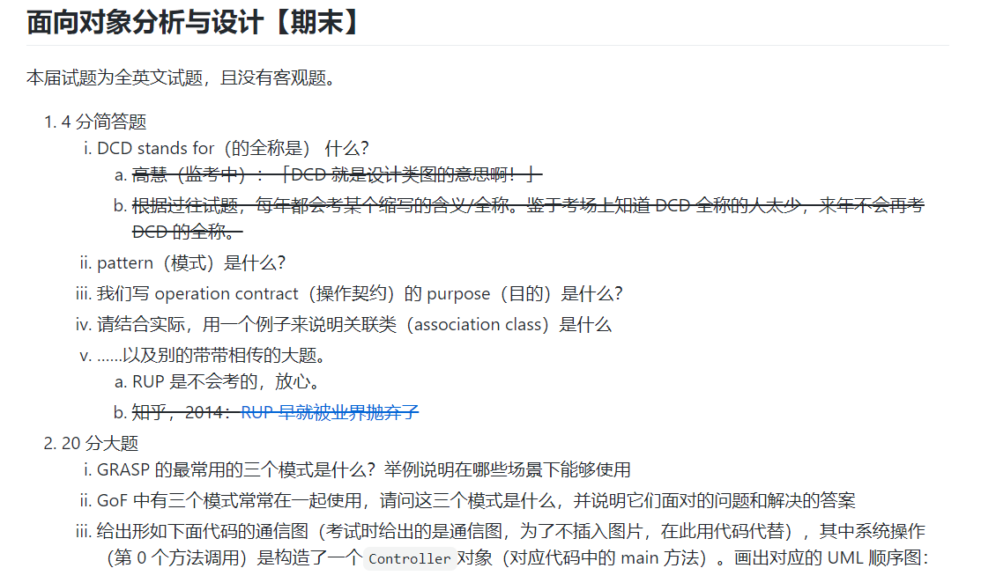

// 你接下来看到的不是代码而是 UML 通信图

// 请脑补这张通信图的样子...

class Register {

public Register(ProductCatalog catalog) {

// do something...

}

}

class Controller {

public Controller() {

var catalog = new ProductCatalog();

var register = new Register(catalog);

}

}

class ProductCatalog {

private Map<int, Product> products;

public ProductCatalog() {

products = new Map<int, Product>();

this.createSpec();

}

public void createSpec() {

while (true) {

// 你不需要管 id, price, name 是从哪来的

var prod = new Product(id, price, name);

products.put(id, prod);

}

}

}

class Product {

public Product(int productId, int price, String name) {

// 省略...

}

}

// ......

public static void main(String[] args) {

var controller = new Controller();

}

题目参考来源：https://github.com/ipid/BuptSse-2016-AllExam