# What is the difference between Transient and Temp tables ?

* **Temporary Tables in Snowflake:**
  + **Visible only to the current session.**
  + **Automatically dropped when the session ends.**
  + Cannot be converted to other types of tables.
  + Useful for session-related tasks or operations.
  + **Integration with Time Travel (up to 1-day retention) and Fail-safe not supported.**
  + Example: **CREATE TEMPORARY TABLE**.
* **Transient Tables in Snowflake:**
  + **Wider visibility, persists beyond the current session.**
  + **Requires explicit dropping to remove.**
  + Cannot be converted to other types of tables.
  + Ideal for data needed for longer than a single session.
  + **Integration with Time Travel (up to 1-day retention) but not with Fail-safe.**
  + Example: **CREATE TRANSIENT TABLE**.
* **Integration with Time Travel and Fail-safe:**
  + Both temporary and transient tables can have Time Travel enabled (up to 1-day retention).
  + Neither supports Fail-safe.
  + dropped when the session ends.
  + Transient tables persist after the session unless explicitly dropped.

# What are Permanent Tables ?

* + **Purpose:** Permanent tables are used for long-term storage of data. They persist across sessions and can be queried and modified over time.
  + **Scope:** Permanent tables are stored in Snowflake's cloud storage and remain available even if the user logs out or the session ends.

1. 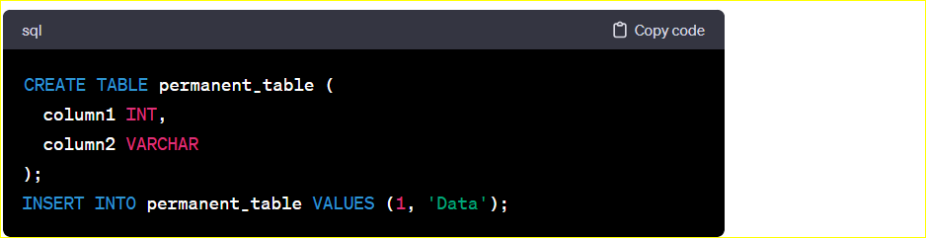

**Time Travel Retention Period in permanent tables :-**

In Snowflake, the Time Travel retention period for permanent tables is determined by the "Data Retention Time" (DRT) setting at the table level. The Data Retention Time specifies how long historical versions of rows are retained for Time Travel queries.

Here are the key points regarding Time Travel retention for permanent tables:

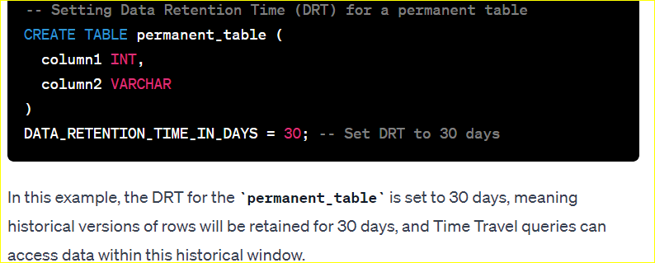

# What is fail safe feature in Snowflake ?

* **Fail-safe Period:**
  + Fail-safe is a feature in Snowflake associated with the Data Retention Time (DRT) setting at the table level.
  + It provides protection for historical versions of rows, preventing modifications or deletions during the specified Fail-safe period.
  + The Fail-safe period is configured independently of the Time Travel retention period and is set in hours, with a maximum of 7 days.
* **Protection Against Modifications:**
  + Fail-safe ensures the integrity of historical data by preventing accidental or intentional changes within the Fail-safe period.
  + Modifications or deletions that could impact historical versions of rows are restricted during this protective window.
* **Configuration Example:**
  + The Fail-safe period is configured using the **FAILSAFE_PERIOD** parameter during table creation or alteration.
  + It is specified in hours, and the maximum Fail-safe period allowed is 7 days.
  + Example: **CREATE TABLE my_table (column1 INT, column2 VARCHAR) FAILSAFE_PERIOD = 48;** sets a Fail-safe period of 48 hours for the table.

# **No, Fail-safe is not enabled by default in Snowflake**. It's an optional feature that you can choose to configure when creating or altering a table. If you don't explicitly set a Fail-safe period for a table, it won't have Fail-safe protection.