1. **Basic SQL Knowledge:**
   * SQL (Structured Query Language) is a domain-specific language used for managing and manipulating relational databases. It is used in data warehousing for querying, updating, and managing data.
2. **Snowflake Architecture:**
   * Snowflake uses a multi-cluster, shared data architecture. It separates storage and compute, enabling scalable and flexible processing. Snowflake utilizes a cloud-based object store for storage and virtual warehouses for compute resources.
3. **Data Loading and Unloading:**
   * Data can be loaded into Snowflake using various methods, including Snowflake Data Loading utilities, COPY command, or third-party ETL tools. Unloading data is done using the UNLOAD command.
4. **Virtual Warehouses:**
   * A virtual warehouse in Snowflake is a compute resource for running queries. It can be scaled up or down based on the workload. Auto-suspend automatically suspends a virtual warehouse after a period of inactivity, and auto-resume automatically resumes it when needed.
5. **Snowflake Tables and Schema:**
   * Tables are created using the CREATE TABLE statement. Schema is a logical container for database objects. It is used to organize and manage objects within a Snowflake database.
6. **Snowflake Functions:**
   * Snowflake provides various SQL functions, including DATE_PART, DATE_TRUNC, TO_VARIANT, etc. Date and time functions include DATEADD, DATEDIFF, CURRENT_TIMESTAMP, etc.
7. **Security in Snowflake:**
   * Snowflake provides role-based access control. Data is secured through authentication, encryption, and access controls. Roles define sets of privileges that can be assigned to users.
8. **Snowflake Storage and Clustering:**
   * Snowflake organizes data into micro-partitions, and metadata clustering is used to group related data. Clustering improves query performance by reducing the amount of data that needs to be scanned.
9. **Snowflake Performance Optimization:**
   * Query performance can be optimized by using proper indexing, efficient query design, and utilizing clustering. Snowflake also provides features like materialized views and automatic clustering.
10. **Data Sharing in Snowflake:**
    * **Snowflake allows sharing of data between different accounts using secure views.** Data can be shared read-only or with the ability to perform DML operations.
11. **Concurrency Control in Snowflake:**
    * Snowflake handles concurrency through virtual warehouses. Each warehouse operates independently, allowing multiple queries to run concurrently. The concept of a warehouse helps manage and allocate resources effectively.
12. **Backup and Recovery:**
    * Snowflake provides automatic and continuous backup of data. Time travel allows accessing historical versions of data, and fail-safe ensures data durability even in the case of a regional outage.

**Additional Information:**

1. **Snowflake Architecture:**
   * Utilizes a cloud-based object store for storage and virtual warehouses for compute resources.
2. **Setting Concurrency Limit:**
   * Concurrency limit is determined by the number of provisioned virtual warehouses and workload management settings.
3. **Significance of MAX_CONCURRENCY_LEVEL:**
   * **MAX_CONCURRENCY_LEVEL** in **ALTER WAREHOUSE** sets the maximum concurrent queries for a virtual warehouse, preventing excessive resource consumption and ensuring optimal performance.

**Data Sharing in Snowflake:**

1. **Snowflake Data Sharing:**
   * Create a Secure View in the provider account to define shared data without physically moving it.
   * Grant SELECT privileges on the secure view to the consumer account, allowing controlled access.
2. **Another Way to Share Data:**
   * External Tables: Create external tables referencing data in an external stage shared between different Snowflake accounts, providing access to the same external data.

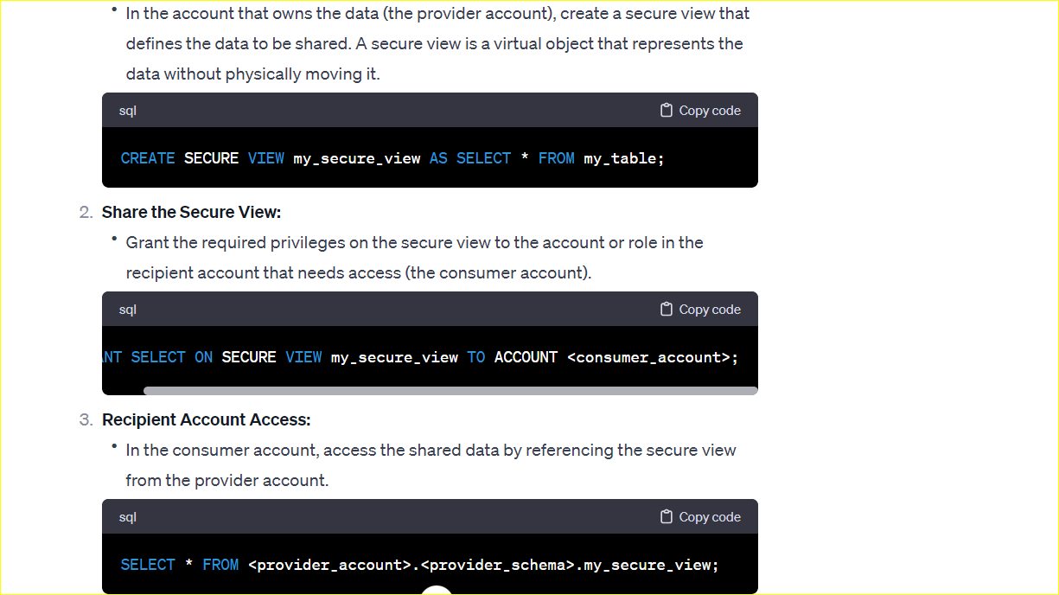

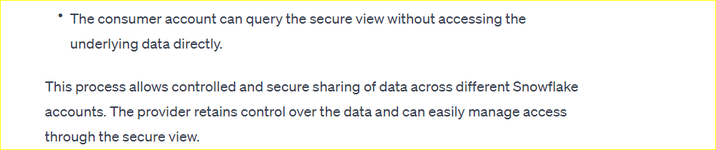

**GIVE ME AN EXAMPLE OF ROLE BASED ACCESS METHODS IN SNOWFLAKE?**

* + In Snowflake, role-based access control (RBAC) is a fundamental mechanism for managing access to databases and objects within the database. Here's an example of how role-based access can be implemented in Snowflake:

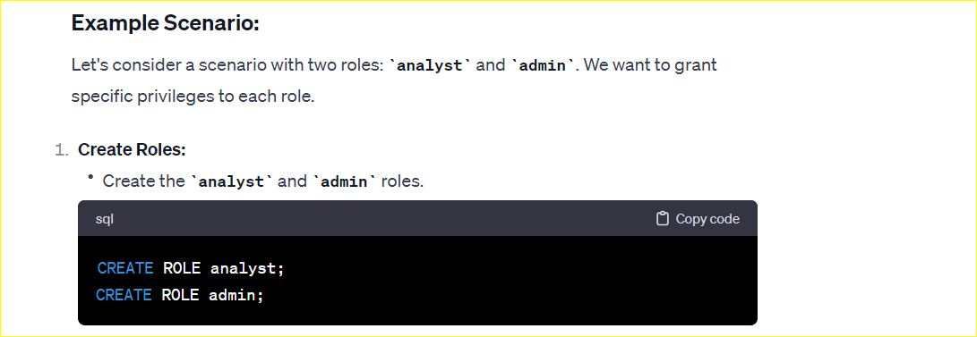

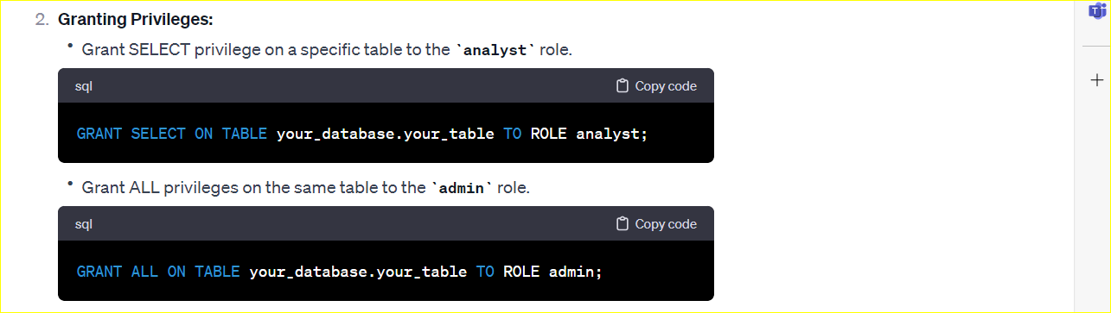

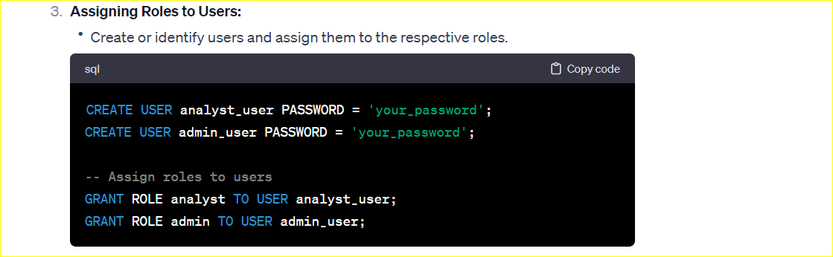

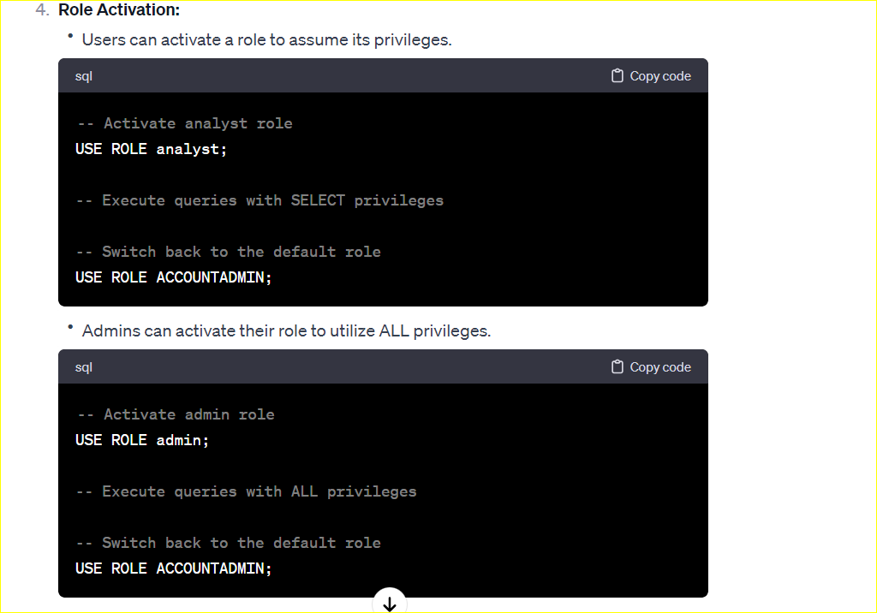

This example demonstrates how role-based access control works in Snowflake. Users are assigned roles, and the roles are granted specific privileges on database objects. Users then activate roles to assume those privileges when interacting with the database. This approach allows for a flexible and scalable management of access in Snowflake.