**In practical terms, when you want to load data into Snowflake or export data from Snowflake, you specify a stage as part of the process. This stage indicates where the data files are located. Whether internal or external, a stage facilitates the movement of data between Snowflake and external storage, enabling efficient data loading and unloading operations.**

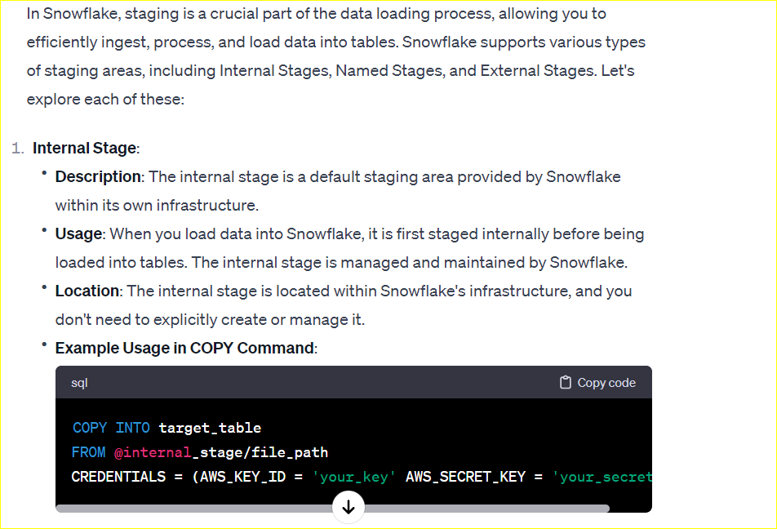

**Named stage:-**

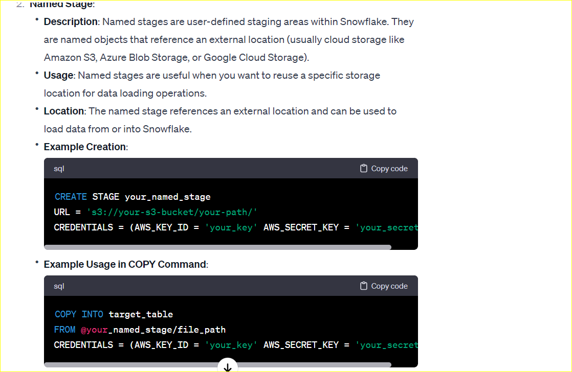

**EXTERNAL STAGE**

