**DATA TRANSFER SNOWFLAKE TO SQL AND VICE VERSA**

***ALL THE PROCESSES ARE FULL REFRESH

DAG NAME FOR BIG DATA TRANSFER

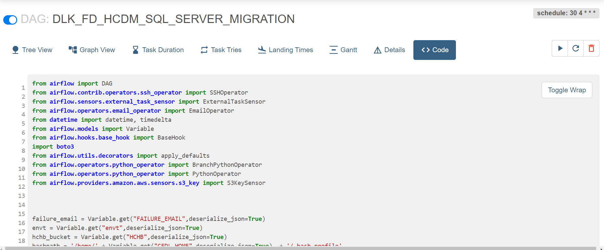

CODES ASSOSCIATED WITH IT:

TASK NAMES ASSOCIATED WITH THE PROCESS

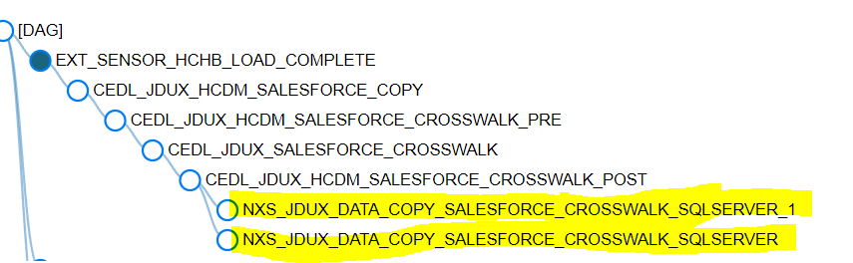

**AJINKYA IS AWARE OF ALL PLACES WHERE THIS IS AVAILABLE

DLK_FD_HCDM_AST_WIDE_HOSPICE

cd /AppPrd/CEDL/py; python3 etl_load_to_multiple_dbs_copy.py 8282

cd /AppPrd/CEDL/py; python3 etl_load_to_multiple_dbs_copy.py 8276

DLK_FD_HCDM_LOAD_OASIS_INPATIENT

cd /AppPrd/CEDL/py; python3 etl_load_to_multiple_dbs_copy.py 8273

DLK_FD_HCDM_LOAD_PAYOR

cd /AppPrd/CEDL/py; python3 etl_load_to_multiple_dbs.py 8267

DLK_FD_HCDM_LOAD_STAFF_PRODUCTIVITY

cd /AppPrd/CEDL/py; python3 etl_load_to_multiple_dbs.py 8283

cd /AppPrd/CEDL/py; python3 etl_load_to_multiple_dbs.py 8284

cd /AppPrd/CEDL/py; python3 etl_load_to_multiple_dbs.py 8285

DLK_FD_HCDM_SALESFORCE_CROSSWALK

cd /AppPrd/CEDL/py; python3 etl_load_to_multiple_dbs.py 8269

cd /AppPrd/CEDL/py; python3 etl_load_to_multiple_dbs.py 8270

DLK_FD_HCDM_TIME_BASED_EPISODE

cd /AppPrd/CEDL/py; python3 etl_load_to_multiple_dbs.py 8274

cd /AppPrd/CEDL/py; python3 etl_load_to_multiple_dbs.py 8275

**IN CASE YOU HAVE MEMORY ISSUES THEN CONVERT THE FOLLOWING PROCESS AND THIS TO THE FOLLOWING DAG

DLK_FD_HCDM_SQL_SERVER_MIGRATION

MAIN CRUX OF THE CODE SNOWFLAKE TO SQL SERVER

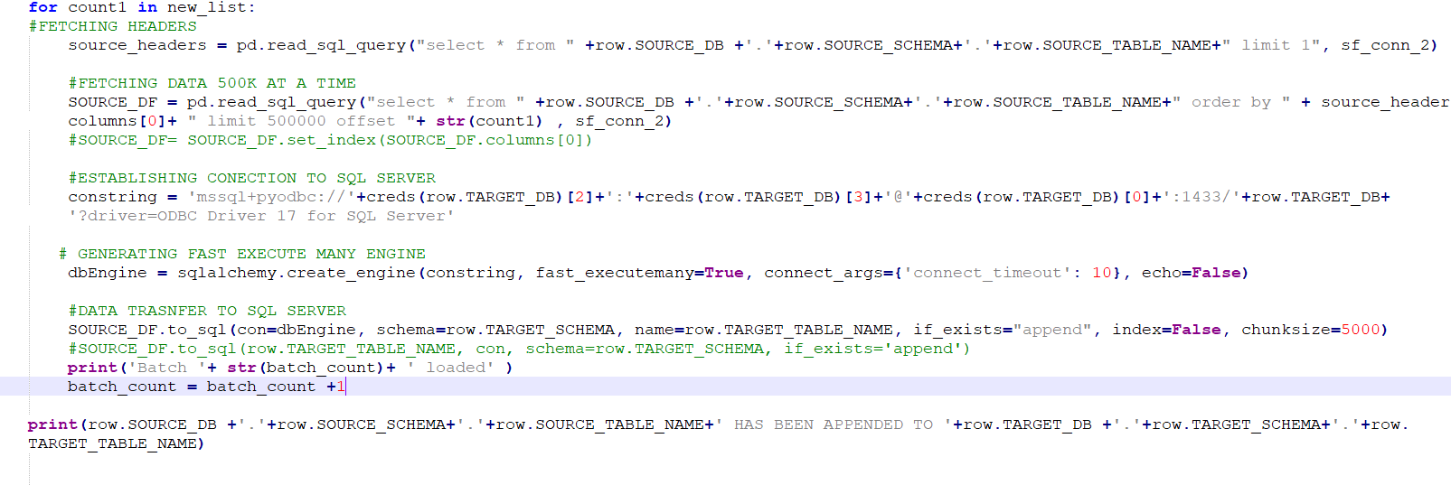

***FAST EXECUTE MANY FUNCTIONALITY USED TO CREATE ISSUES IN TERMS OF CERTAIN FIELDS IN CERTAIN TABLES WITH AN ERROR STATING NULLS CANNOT BE INSERTED

SO BACKUP OF THIS PROCESS WAS CREATED WHICH IS : etl_load_to_multiple_dbs_copy.py

MAIN CRUX SNOWFLAKE TO SLWOFLAKE

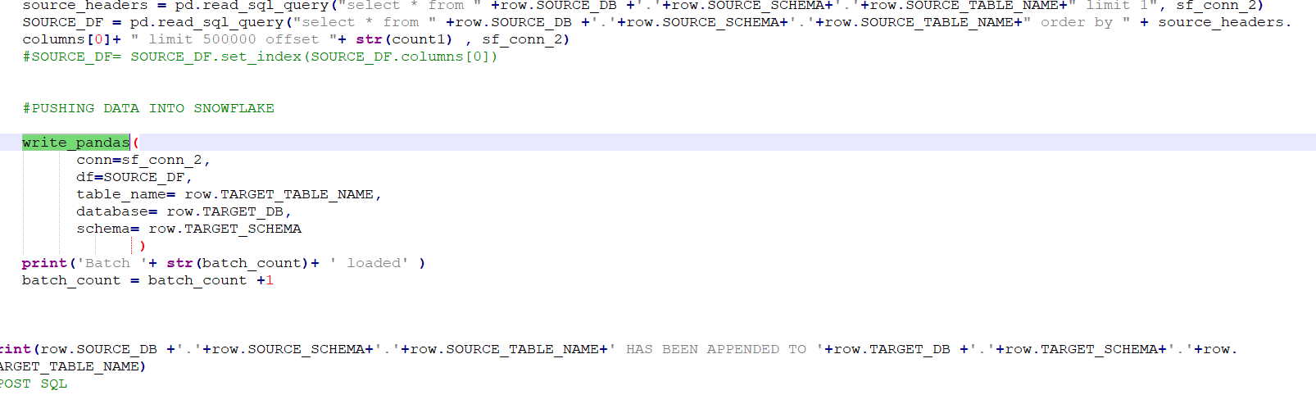

KEY points

**ALWAYS ADD TABLE NAME , DB NAME AND SCHEMA IN UPPERCASE

def snowFlakeConnection_2():

try:

conn = sf_c.connect(

user=creds(row.SOURCE_DB)[0],

password=creds(row.SOURCE_DB)[1],

account=creds(row.SOURCE_DB)[2],

warehouse=creds(row.SOURCE_DB)[3],

database=’NEXUS’,

schema=’DW_OWNER’,

# client_session_keep_alive=True

)

print("connected to SNOWFLAKE Database.")

return conn

except Exception as e:

print("Error connecting to SNOWFLAKE Database. " + str(e))

DF = ‘SELECT * FROM DLAKE.CHOICE.FCT_CLAIM_MI’

YES , IT WILL STILL WORK

WRITE PANDAS

write_pandas(

conn=sf_conn_2,

df=SOURCE_DF,

table_name= row.TARGET_TABLE_NAME,

database= DLAKE,

schema= CHOICE

NO, IT WILL NOT WORK

**ISSUES