1. CREATE TABLE STUDENTS_17 (

S_NUM BIGINT PRIMARY KEY,

S_FAM VARCHAR(20),

F_IMA VARCHAR(20),

S_OTH VARCHAR(20),

STIP INT DEFAULT(90)

);

1. ALTER TABLE STUDENTS_17

ADD COURS INT, TELEPHONE CHAR(15);

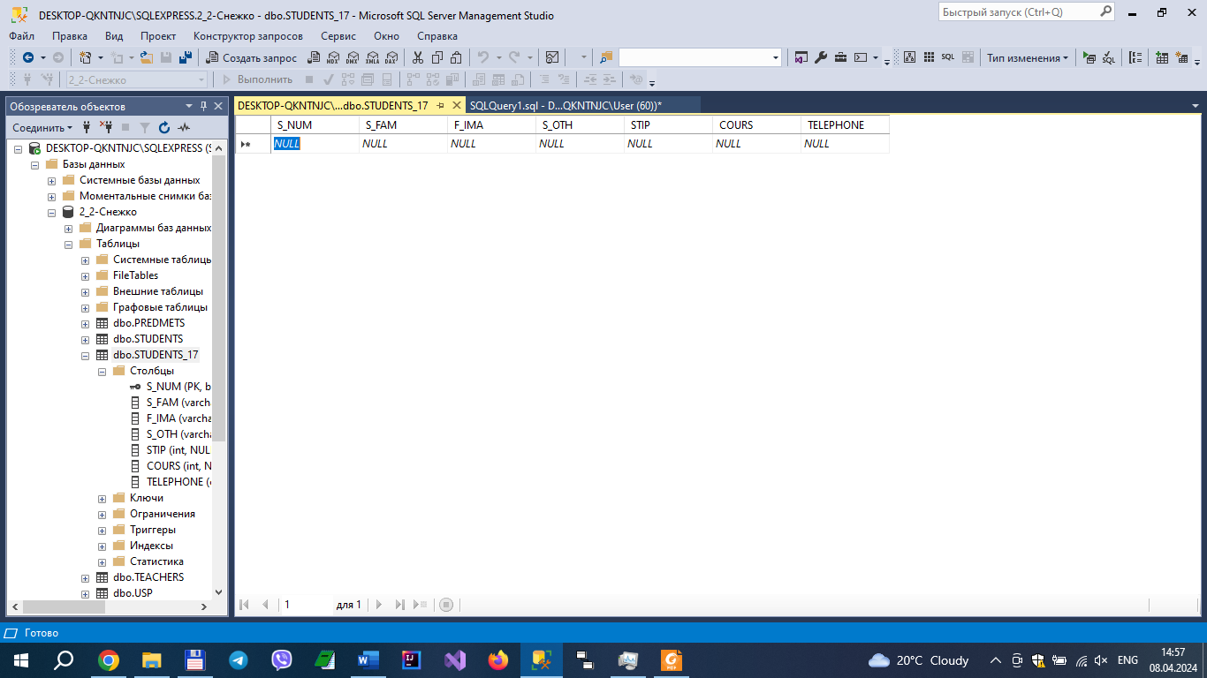

1. ALTER TABLE STUDENTS_17

DROP COLUMN COURS, TELEPHONE;

1. USE [2_2-Снежко]

EXEC sp_adddatatype TELEPHONE, 'VARCHAR(20)', 'NOT NULL';

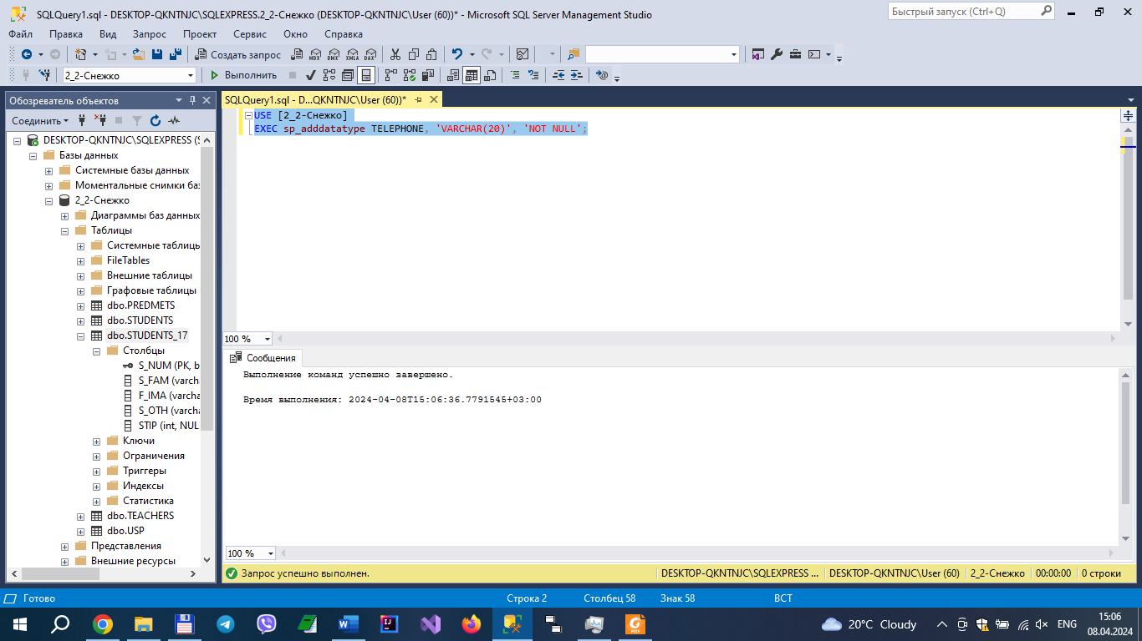

1. CREATE INDEX IX_SFAM ON STUDENTS_17 (S_FAM);

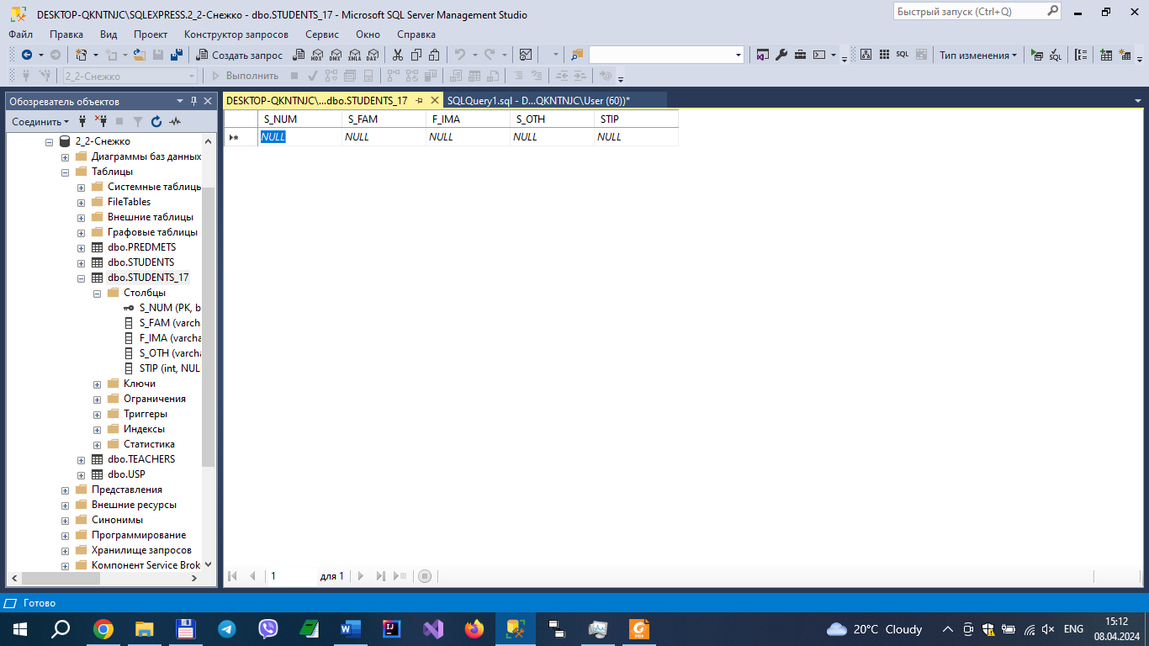

1. create table predmets_17 (

PNUM smallint NOT NULL,

PNAME VARCHAR(20) NOT NULL,

HOURS SMALLINT,

COURSE TINYINT,

TNUM, int

);

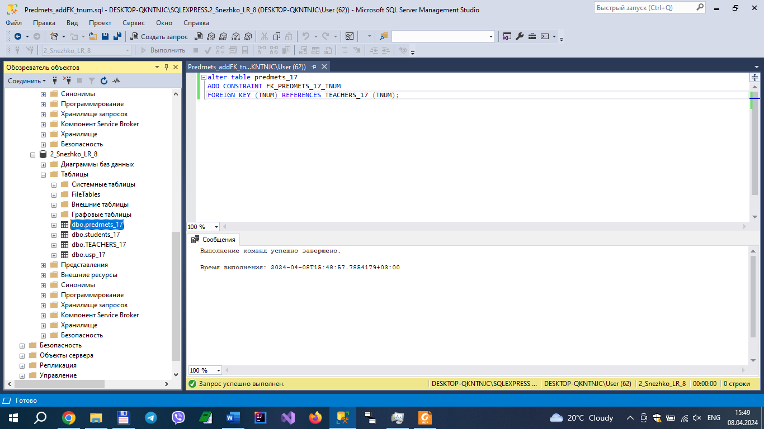

7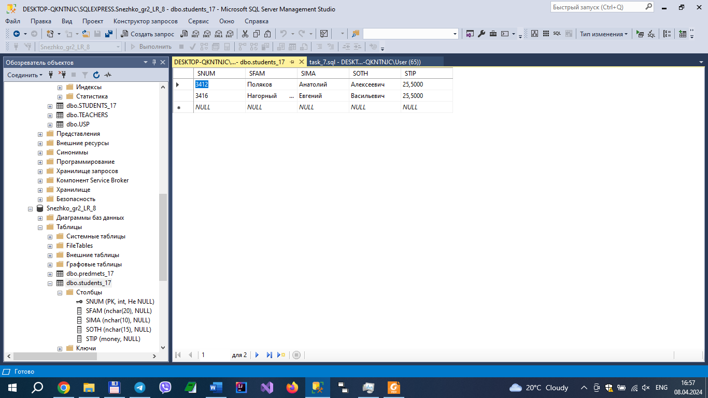

1. 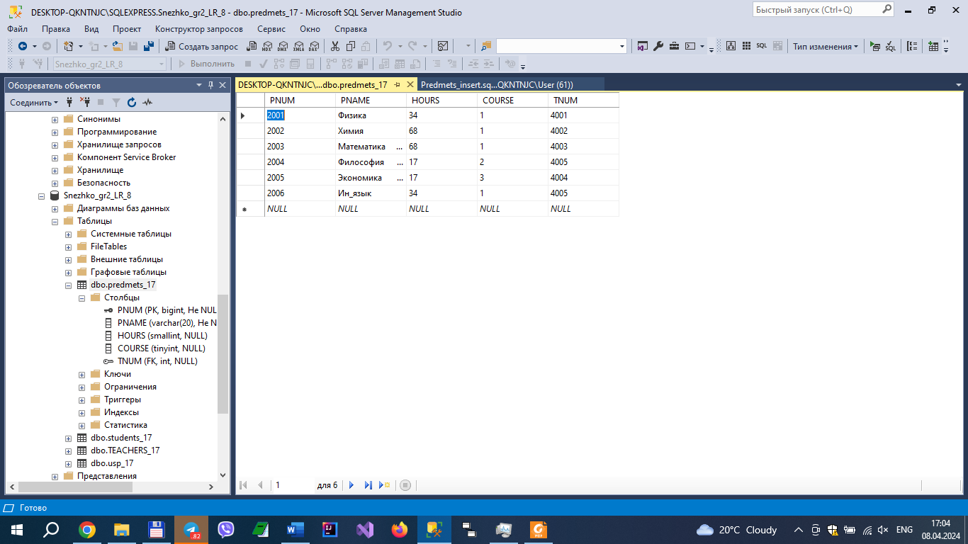

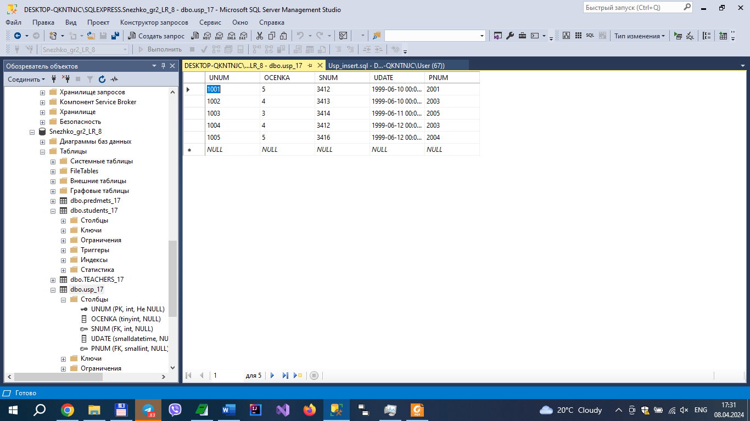

9.

10. 