HW 4

1.

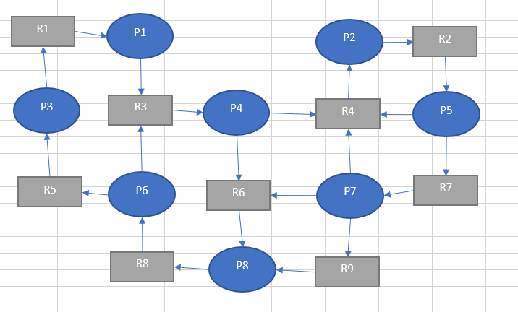There is a deadlock of P2 -> R2 -> P5 -> R4, thus this is impossible to finish executing. Thus, this is not a safe state

2.

1. Thus,

Ended processes:

1. Thus,

Ended processes: and

1. Thus,

Ended processes: , and

1. Thus,

Ended processes:

1. Thus,

Ended processes:

Ended processes:

**Thus, the system will be in safe state after execution because above allocation sequence shows that all processes can be executed and finished.**