Instructions for getting GunSmoke Effect to work:

1. As you cloned the project, open its folder and locate the “Changed_Plugin” folder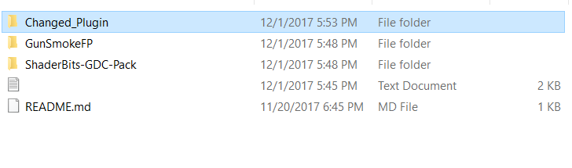
2. Copy “Changed_Plugin” folder and paste it in Plugin folder located in the Engine: 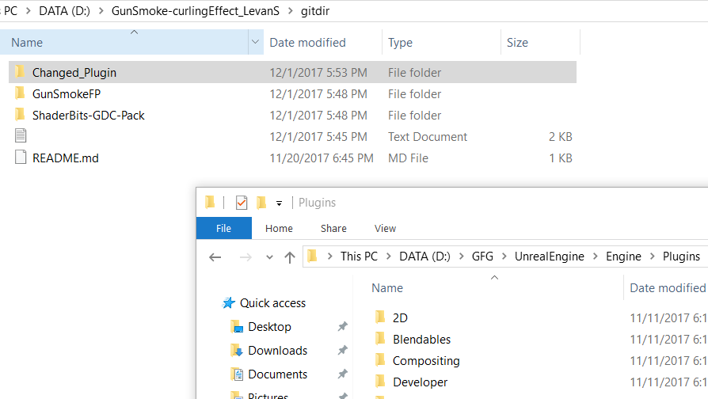

More on the next page…

1. Now open the project and go to Settings->Plugins, search for ShaderBits-GDC-Pack and enable it up there (UE4 must be restarted after that, for it to be enabled): 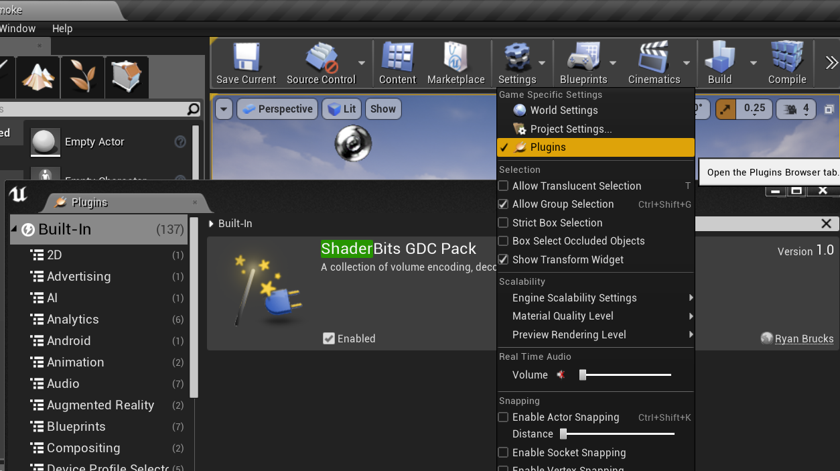
2. Finally, locate to the project folder and open GunSmoke Map:

