Layout & Grids

I decided to do my topic on Layouts and Grids. I chose this topic to get a little more understanding about this. If I remember correctly it was around WIU when this was talked about. So going back and learning a little more can definitely help me out in the long run.

From what I read 2 types of Layouts: landscape and vertical. As well as two kinds of grids: one has an odd number of columns and the other has an even set. We have all learned that is very important that we pay attention to the type of grid we use because we all have misplaced content or something just looked out of place. There is a set of rules that helps when discussing this and they are:

The Rule of Thirds: split the image into thirds creating 9 equal parts and place the content inside of the intersecting lines.

Golden Ratio and Fibonacci Sequence:

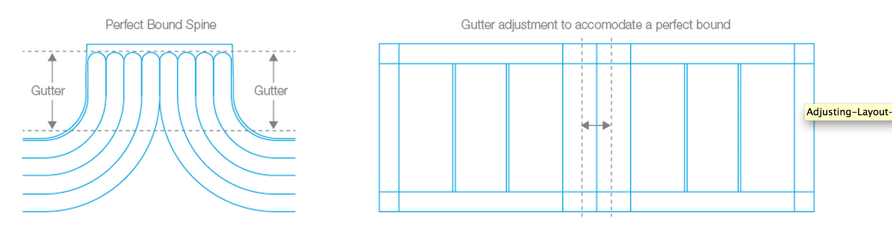

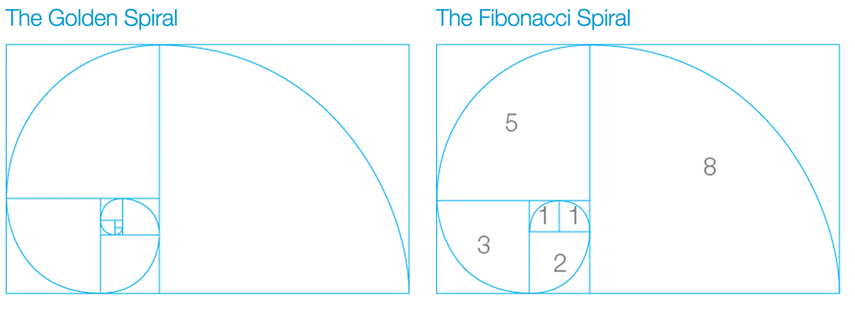

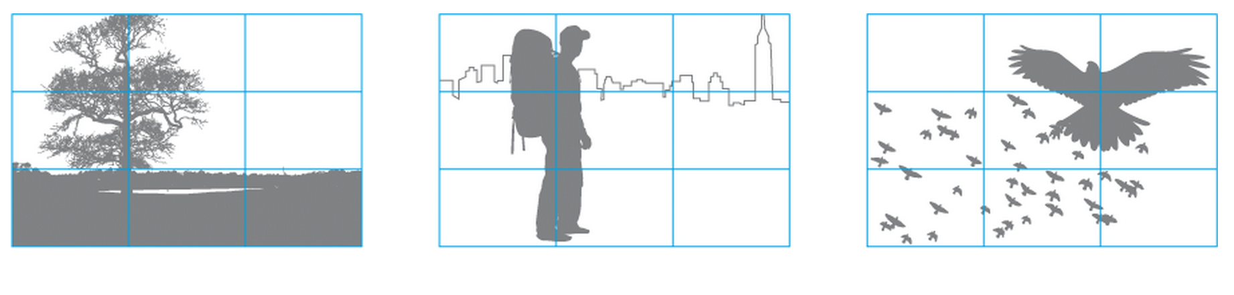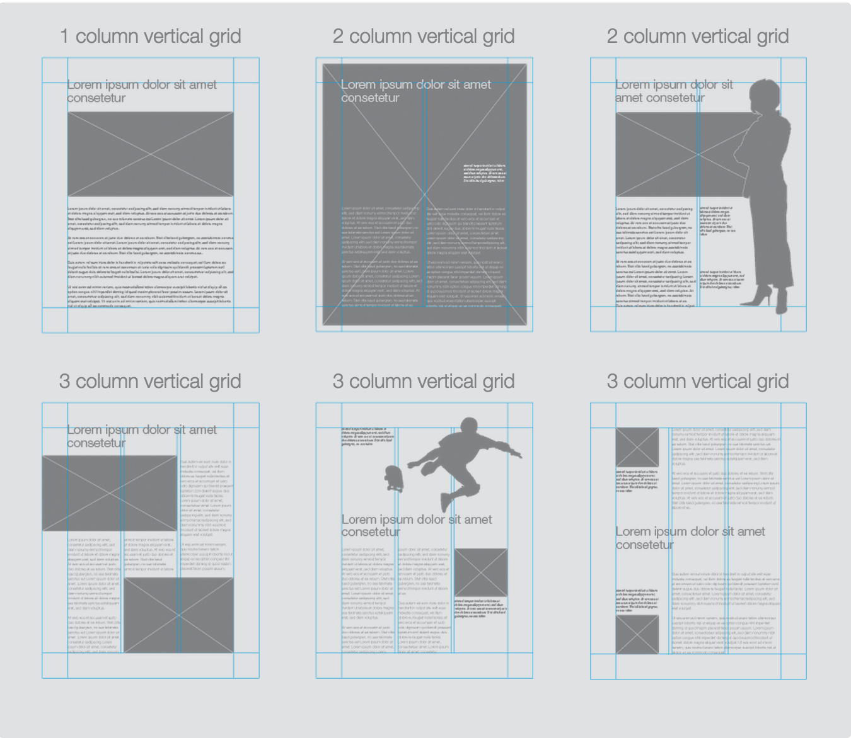

<http://www.creativebloq.com/web-design/grid-theory-41411345>

<http://www.designersinsights.com/designer-resources/using-layout-grids-effectively>