Course Work
Levani Babukhadia

I decided to keep the project simple, but interactive. For that purpose, I decided to create a horizontal list view that would be able to react to users input. Input in my case is a tapping. By tapping an user can move the list of cars side ways. There are just 3 cars for demonstration purposes, but the code can accommodate as many cars as the memory can afford with minimal changes to the code. One just has to add pictures of cars in the relevant folder which is “Assets.xcassets” in “Levani-course-project”.
Here is the screenshot of the final results:

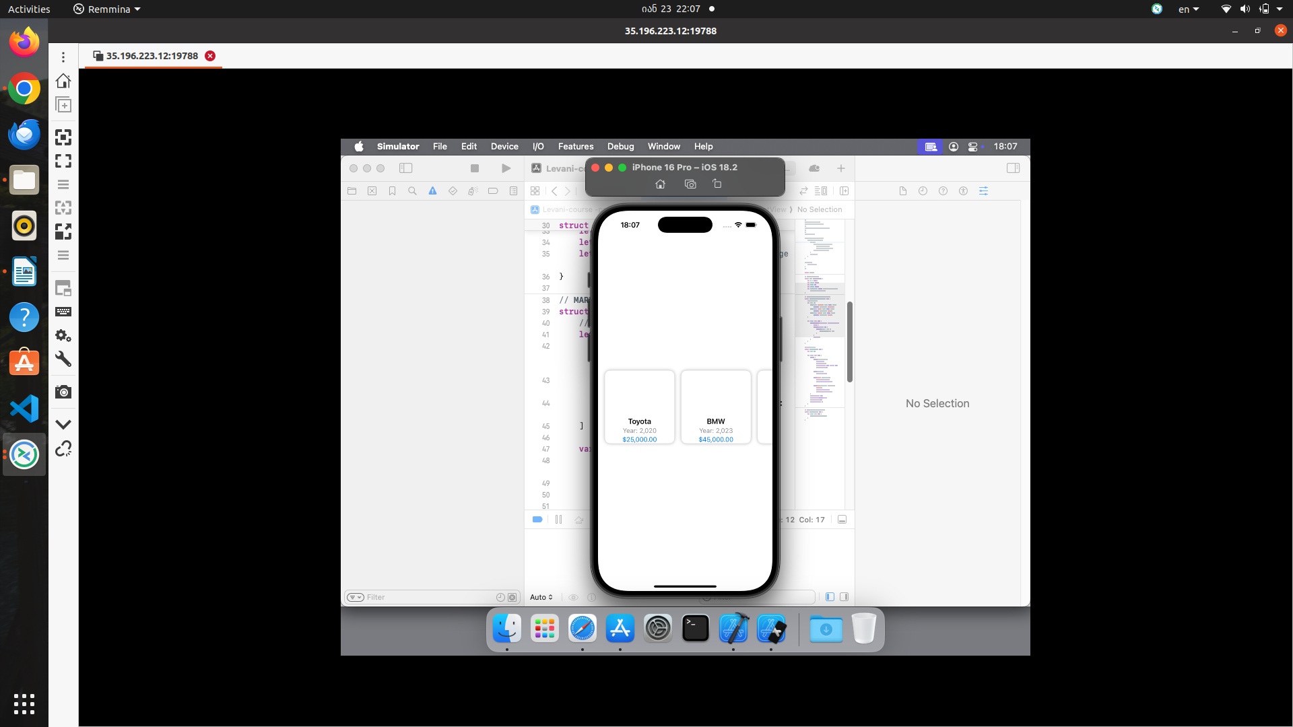
(Note:I use remote VM).
Also, one can move the cars sideways:

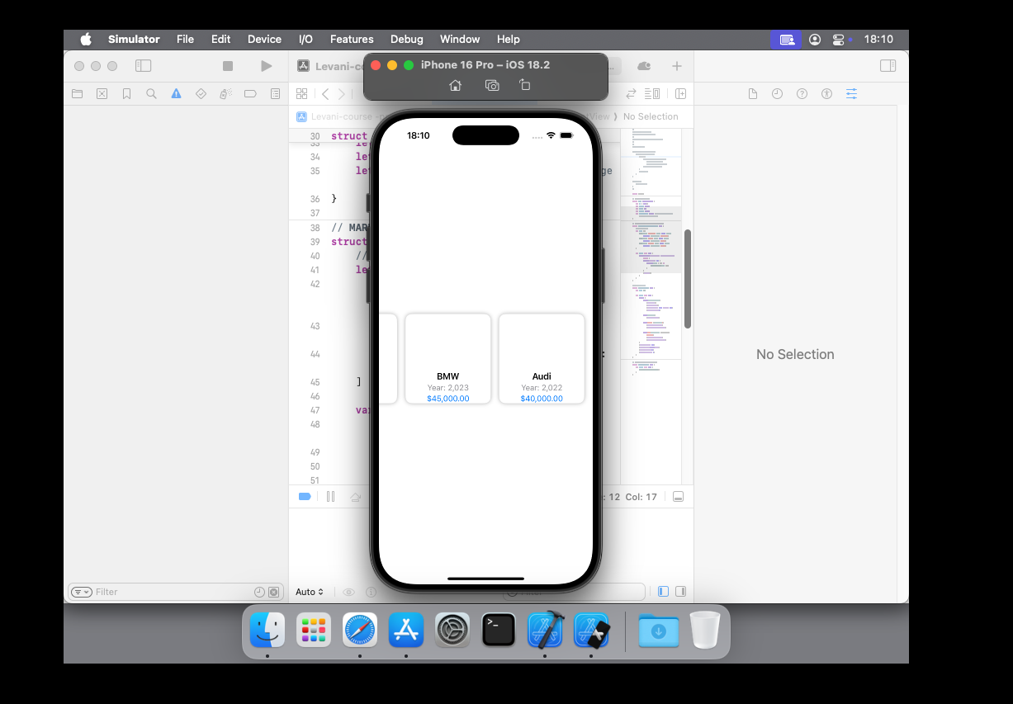
.
Here is the code:

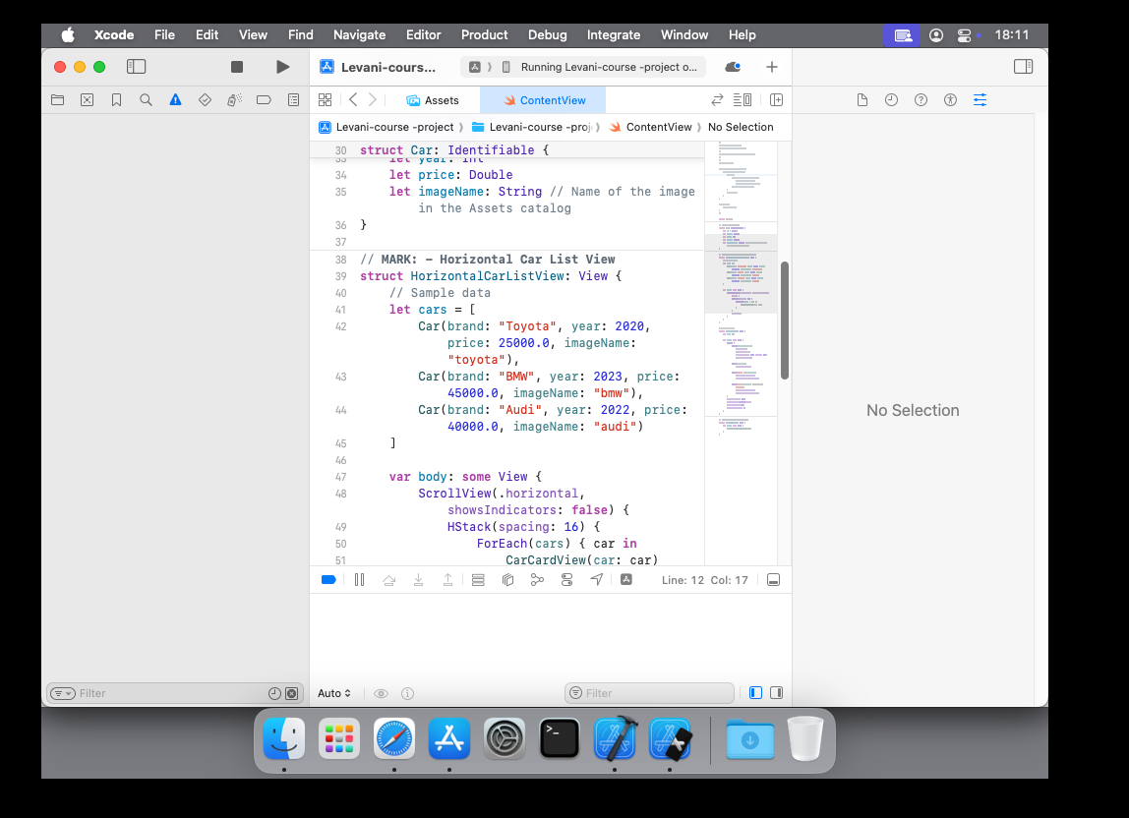
.
ScrollView has been used to make the list movable.

The whole code is this:

import SwiftUI

// MARK: - Car Model
struct Car: Identifiable {
let id = UUID()
let brand: String
let year: Int
let price: Double
let imageName: String // Name of the image in the Assets catalog
}

// MARK: - Horizontal Car List View
struct HorizontalCarListView: View {
// Sample data
let cars = [
Car(brand: "Toyota", year: 2020, price: 25000.0, imageName: "toyota"),
Car(brand: "BMW", year: 2023, price: 45000.0, imageName: "bmw"),
Car(brand: "Audi", year: 2022, price: 40000.0, imageName: "audi")
]

var body: some View {
ScrollView(.horizontal, showsIndicators: false) {
HStack(spacing: 16) {
ForEach(cars) { car in
CarCardView(car: car)
}
}
.padding()
}
}
}

// MARK: - Car Card View
struct CarCardView: View {
let car: Car

var body: some View {
VStack {
Image(car.imageName)
.resizable()
.scaledToFit()
.frame(width: 150, height: 100)
.cornerRadius(8)

Text(car.brand)
.font(.headline)

Text("Year: \(car.year)")
.font(.subheadline)
.foregroundColor(.gray)

Text("$\(car.price, specifier: "%.2f")")
.font(.subheadline)
.foregroundColor(.blue)
}
.frame(width: 160)
.background(Color.white)
.cornerRadius(12)
.shadow(radius: 4)
}
}

// MARK: - Main Content View
struct ContentView: View {
var body: some View {
HorizontalCarListView()
}
}

Unfortunately, I have lost connection to the VM that I used because free time has expired. I just lost car pictures.

