NAME: ONOJA STEVEN
PERIOD: SET25
PROJECT: AUTOMATED CAPSTONE PROJECT WITH TERRAFORM
DATE: 13th December 2025
Overview
This project aims to build a highly available, highly scalable, and secure cloud environment for deploying an image sharing application. The application will be deployed within an aws cloud environment in a specified region, within a virtual private cloud environment.
They are two availability zones to guarantee high availability and cloud level security features that will be set up to handle inter security and traffic within the VPC. The cloud environment consists of 4 subnets, both public and private subnets shared evenly. Within the public subnets contain a NAT gateway that prevents direct access to from the internet into the private subnet, an application load balancer that balances traffic (load) coming from users trying to access the image sharing application, the servers actively operating within individual subnets that host the application.
The private subnets contain the Amazon RDS database that stores users’ data and application’s information. The Database is configured to synchronize everyday within a specific time of the day.
To ensure high scalability, there is an auto-scaling group that automatically scales out the servers when CPU threshold has been exceeded.
The cloud system also consists of other services such as; storage buckets that store the application codes, media files, and logs. The cloud metric alarm system that triggers when CPU utilization threshold has been exceeded, Simple Notification Service that sends notification to the creators email address, secret manager to store the database credentials as a secret, aws route 53 that transforms the servers Ip addresses into user friendly names and a CloudFront distribution service that cache images from the media bucket to an edge location storage (cache) with the goal of quick image retrieval and to reduce the general traffic to the media storage bucket.
A security tool called Chekov is incorporated into to scan the cloud infrastructure to ensure good configuration and secured architecture.

AIMS & OBJECTIVES
Aims:
- The first aim of this project is to design a highly available, highly scalable, and secure environment.
- The second aim is to develop an image sharing application with an edge location storage (cache) with the goal of quick image retrieval and to reduce the general traffic to the media storage bucket.
Objectives:
- Create all the Terraform code used to provision the cloud infrastructure.
- Set up the cloud metric alarm and monitoring system.
- Configure the SNS, Secret manager, and S3 buckets with their policies.
- Configure the WordPress environment and build the image sharing application.

Architectural Diagram
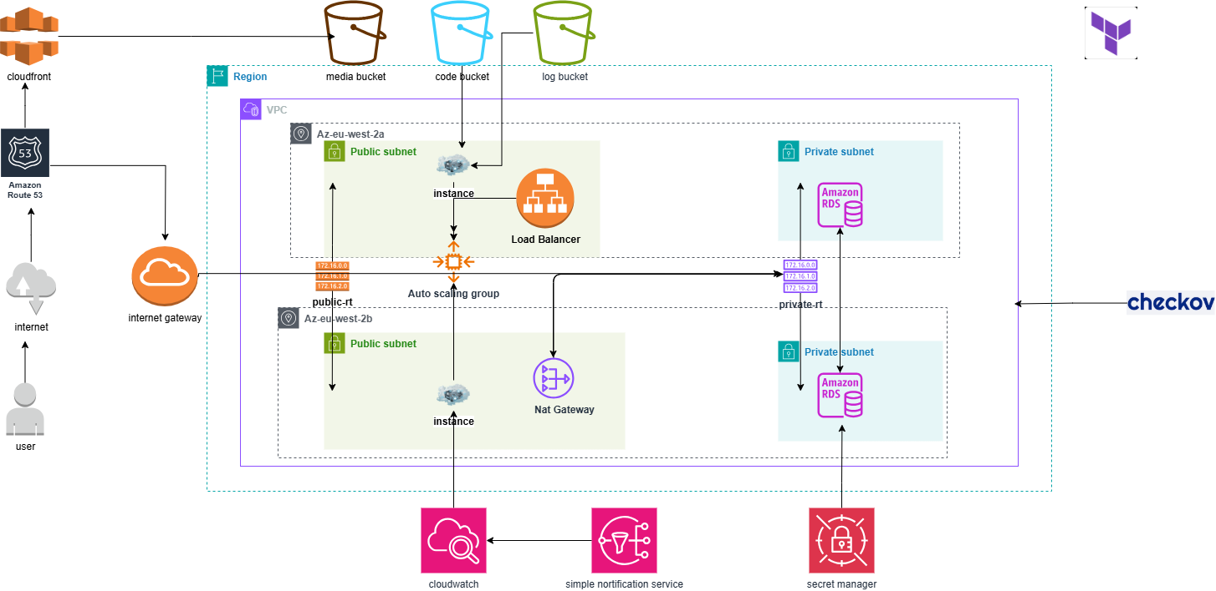

PROJECT WORK-FLOW
HIGHLIGHTS
From the image above, the application is being hosted in the cloud with AWS as our cloud provider.
- There are two availability zones for high availability, all contained within our virtual private cloud.
- Public subnets that host the load balancers, NAT gateway, application servers.
- NAT gateway that blocks direct public access to our private subnet.
- Private subnets that host the Amazon Relational Database IRDS)
- CloudFront synchronizes with the media storage bucket to serve image contents
- Checkov for security scanning.

FLOW
To set up this project, the first step is to create the cloud environment and all its resources. Then, set up the word press application and ensure there is seamless communication with the database servers. Upload an image on the application to test the CloudFront distribution service to confirm that images are being cached. Simulate a spike to test the auto-scaling group time to respond. While this is ongoing, the SNS service and cloud metric alarm system will also be tested to see if it monitors the server and applications metrics.

