EKS · Helm · Argo CD Learning Project
Deploying KubeMart to Amazon EKS
Terraform, GitHub Actions (OIDC), Amazon ECR, Helm, Argo CD, PostgreSQL HA, Prometheus, Grafana and Loki

Who this is for: The engineer who will provision the infrastructure and run the GitHub Actions and Argo CD pipelines.
Region used in examples: eu-west-2 (London) · Kubernetes 1.35 · Helm 3 · Argo CD 3

Contents
1. What you are going to build
2. Before you start
3. Values you must change first
4. Step-by-step deployment
5. Run tonight's backup now and see it arrive in S3
6. Rehearse a failover in stage: find the Leader, delete it, watch a replica take over
7. How the Terraform is organised
8. Running it day to day
9. Costs
10. Tearing everything down
11. Troubleshooting

What you are going to build
This guide takes you from an empty AWS account to the KubeMart shop running on Amazon EKS, delivered the GitOps way: GitHub Actions builds and tests, Argo CD deploys from Git, a 3-member PostgreSQL cluster and Valkey hold the shop's data inside the cluster, Prometheus and Grafana watch the numbers and send alerts to Slack, and Loki keeps every log line and Kubernetes event, searchable in the same Grafana. Every step explains what you do and why.
In plain English: GitHub Actions is the factory: it turns code into tested container images, on machines GitHub lends you for each run. Git is the order book: it says which image versions should run where. Argo CD is the warehouse manager inside the cluster: it reads the order book and makes the shelves match. PostgreSQL is the filing cabinet, copied into three rooms so a fire in one loses nothing. Grafana is the control room: a wall of gauges (Prometheus) next to the archive of every service's diary (Loki).

Words you will meet
Word | Simple meaning
GitHub Actions | GitHub's built-in automation: YAML files in .github/workflows/ run on every push, on GitHub's own servers
Workflow / job / step | A workflow is one YAML file; it contains jobs (each on a fresh machine) made of steps (commands)
Matrix | One job run several times in parallel, here once per changed service
OIDC | A way for a workflow to prove "I am repository X" to AWS and get temporary credentials, so no AWS keys are stored anywhere
Environment (GitHub) | A named target (production, infrastructure) that can require a person's approval before a job runs
Argo CD | A program inside the cluster that keeps the cluster the same as what Git says
GitOps | Deploying by changing files in Git instead of running deploy commands
Loki / Alloy | Loki stores logs (in S3) and is searched from Grafana; Alloy is the collector on every server that sends it every container log and Kubernetes event
Prometheus / Grafana / Alertmanager | Collects numbers (metrics) / draws them / sends alerts on
postgres-operator | A program in the cluster that builds and looks after PostgreSQL clusters, including failover
Promotion | Moving tested versions from stage to production

The DevOps architecture
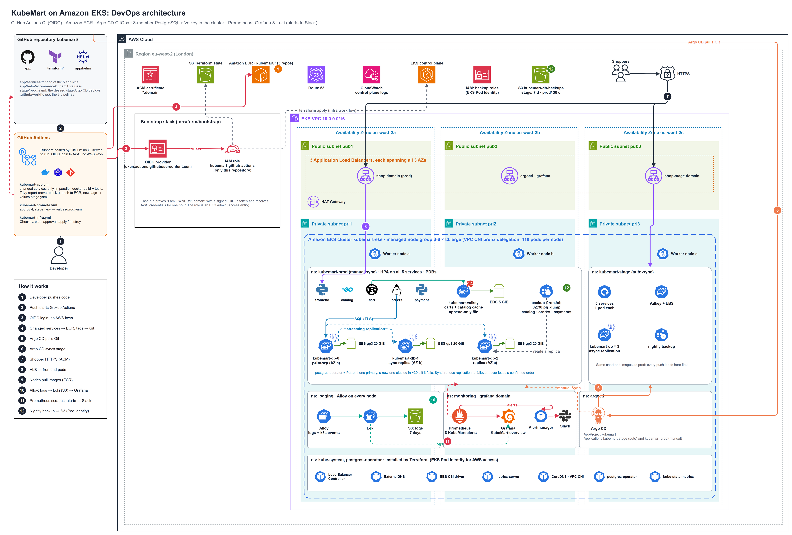
Figure 1: KubeMart DevOps architecture: GitHub Actions, AWS services, VPC across three Availability Zones, EKS with stage and prod (services, PostgreSQL, Valkey), Argo CD, monitoring and logging
Full-size PNG and editable draw.io file: see the architecture or diagrams folder of this project.

Follow the numbers in the picture:
- A developer pushes code to GitHub.
- GitHub Actions starts by itself (no webhook or server to set up) and logs in to AWS with OIDC.
- It builds, tests and scans only the services that changed, and pushes their images to ECR.
- It writes the new image tags into values-stage.yaml and pushes that commit.
- Argo CD, inside the cluster, pulls the change from Git.
- Argo CD syncs the stage namespace automatically. Production waits for an approved promotion and a person pressing Sync.
- Shoppers connect over HTTPS (ACM certificate) to the shop load balancer.
- The load balancer sends them to the frontend pods.
- The worker servers download images from ECR.
- Alloy sends every container's logs and the Kubernetes events to Loki (stored in S3); Grafana searches them.
- Prometheus scrapes the services, PostgreSQL and Valkey; Grafana shows the dashboard and Alertmanager posts alerts to Slack.
- Every night each environment's backup job writes a copy of every database to the S3 backup bucket.

The same platform as logical layers
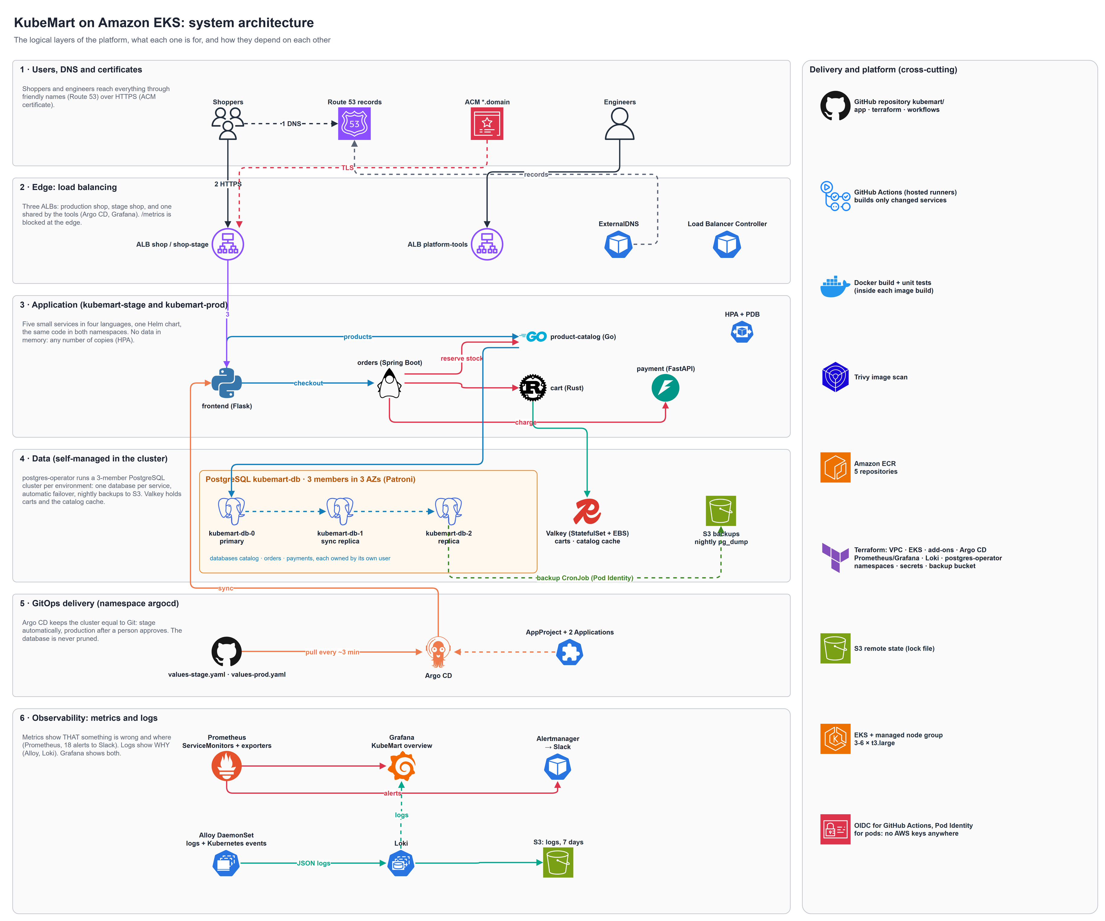
Figure 2: system architecture: users, edge, application, data, GitOps delivery, metrics and logs

The delivery pipeline
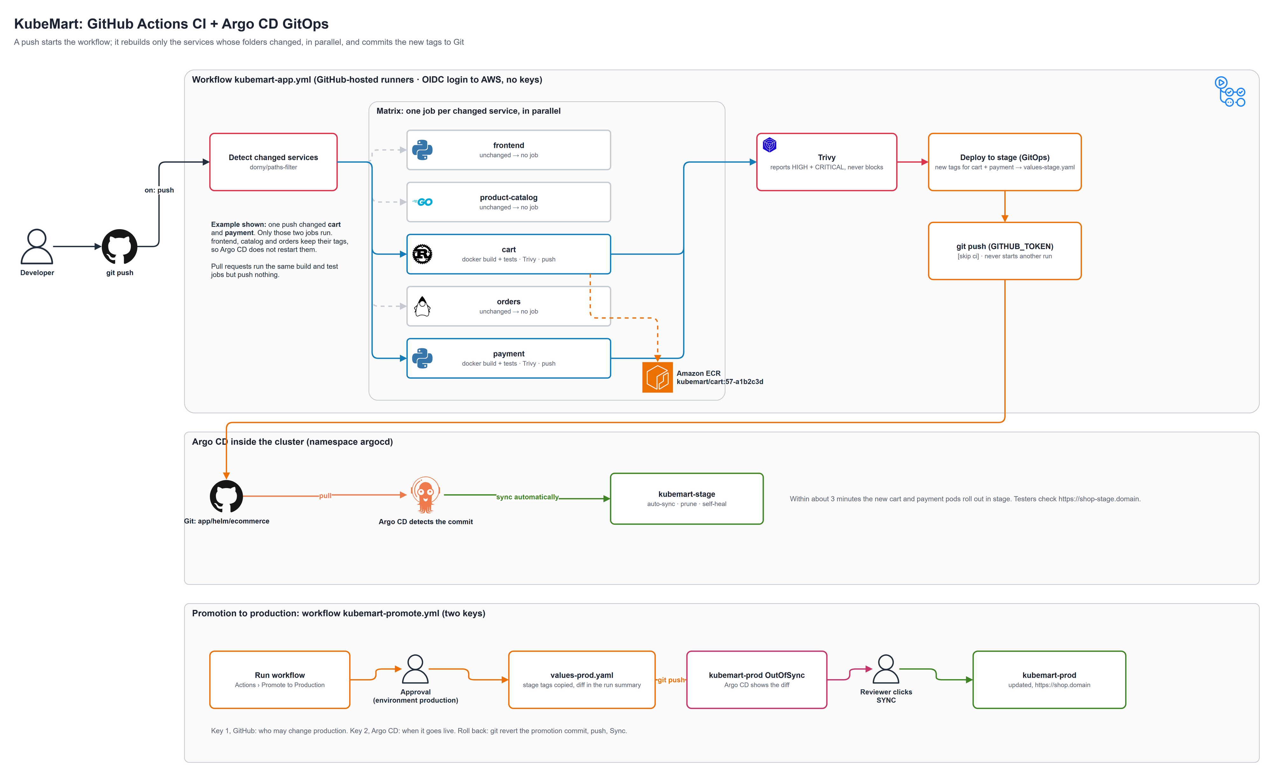
Figure 3: GitHub Actions rebuilds only the changed services; Argo CD deploys stage automatically and prod after approval
Full-size PNG and editable draw.io file: see the architecture or diagrams folder of this project.

What gets built, and by what
Layer | Resources | Created by
State | S3 bucket (versioned, encrypted, private) with S3 native locking | create-remote-state.sh
CI login | GitHub OIDC provider and the IAM role kubemart-github-actions (only your repository may use it) | bootstrap/ stack
Certificate | Wildcard ACM certificate *.<domain>, validated through Route 53 | bootstrap/ stack
Network | VPC 10.0.0.0/16, 3 public and 3 private subnets, NAT Gateway, load-balancer subnet tags | module/vpc
Cluster | EKS 1.35, managed node group (3-6 × t3.large), add-ons (VPC CNI with prefix delegation: up to 110 pods per server), access entry for the GitHub Actions role | module/eks
Registry | 5 ECR repositories: kubemart/frontend, product-catalog, cart, orders, payment | module/ecr
Platform add-ons | AWS Load Balancer Controller, ExternalDNS, metrics-server, gp3 StorageClass | module/eks-addons
App namespaces | kubemart-stage, kubemart-prod (Pod Security labels), frontend-secret and valkey-secret in each, S3 backup bucket, one backup IAM role per environment (EKS Pod Identity), db-backup-config | module/app-namespaces
Databases | Zalando postgres-operator (namespace postgres-operator) | module/postgres-operator
Metrics | kube-prometheus-stack: Prometheus (30 GB disk, 10 days), Alertmanager, Grafana (grafana.<domain>), node-exporter, kube-state-metrics | module/monitoring
Logging | Loki (one pod, logs in an S3 bucket, 7 days), Grafana Alloy on every server (container logs) and one Alloy for Kubernetes events; Loki is a data source in Grafana | module/logging
GitOps | Argo CD (argocd.<domain>), AppProject kubemart, Applications kubemart-stage and kubemart-prod | module/argocd
Application | Per environment: 5 microservices, the 3-member PostgreSQL cluster kubemart-db, Valkey, the nightly backup job, ServiceMonitors, 18 alerts, the Grafana dashboard | Argo CD, reading Git

The repository
Everything KubeMart needs is in one folder, kubemart/, and that folder is the GitHub repository: GitHub only runs workflows from .github/workflows/ at the top of a repository.
kubemart/ <- repository root
├── app/ services, Helm chart (helm/ecommerce), Argo CD files, docker-compose
├── terraform/ all infrastructure (+ bootstrap/)
├── .github/workflows/
│ ├── kubemart-infra.yml Terraform: scan, plan, approval, apply / destroy
│ ├── kubemart-app.yml changed services: build + test, scan, ECR, new tags -> stage
│ └── kubemart-promote.yml approval, then stage tags -> prod
├── architecture/ diagrams
└── docs/ this guide and the application guide

Before you start
You need | Why
An AWS account with admin rights for the first setup | Creates IAM, network, cluster and servers
A public Route 53 hosted zone for your domain | Certificate validation, and addresses for argocd, grafana and the shop
A GitHub account and an empty repository (for example kubemart) | The workflows run there; Argo CD deploys from it
On your computer: AWS CLI v2, Terraform 1.10+, jq, git | To run the one-off setup script

Warning: this platform costs roughly USD 14 per day while it runs (see Costs). Destroy it after each study session.

Values you must change first
What | File(s)
State bucket name (unique worldwide) | terraform/create-remote-state.sh, destroy-remote-state.sh, provider.tf, bootstrap/provider.tf
Domain | terraform/variable.tf (domain_name), bootstrap/variable.tf (domain), and the host names in values-stage.yaml / values-prod.yaml
GitHub repository allowed to deploy | terraform/bootstrap/variable.tf (github_repository, OWNER/REPO, exact spelling)
Git repository address for Argo CD | terraform/variable.tf (git_repo_url) and app/argocd/*.yaml
Your own IAM identity (for kubectl from your computer) | terraform/variable.tf (admin_principal_arns); find it with aws sts get-caller-identity

Step-by-step deployment

Step 1: Put the project on GitHub
cd kubemart
git init && git add . && git commit -m "KubeMart on EKS"
git branch -M main
git remote add origin https://github.com/<you>/kubemart.git
git push -u origin main

The first push already starts the workflows. They stop at the AWS login (there is no role yet); that is expected.

Step 2: Create the state bucket and the GitHub login role
cd terraform
chmod +x create-remote-state.sh destroy-remote-state.sh
./create-remote-state.sh

The script creates the S3 bucket (skipped if it exists) and applies the small bootstrap/ stack: the OIDC trust between your GitHub repository and AWS, the IAM role the workflows use, and the wildcard certificate. It also handles two things that otherwise break the login:
- If your AWS account already has GitHub's OIDC provider (for example from the StatusBoard project), it reuses it instead of failing.
- If your repository uses GitHub's newer immutable subject format (repo:OWNER@id/REPO@id), it asks GitHub and trusts that format too.
What you should see: Apply complete! and a role ARN such as arn:aws:iam::123456789012:role/kubemart-github-actions.

Step 3: Configure GitHub
In the repository: Settings, Secrets and variables, Actions.
Kind | Name | Value
Secret | AWS_ROLE_ARN | The role ARN printed in Step 2
Secret (only for a private repository) | GIT_REPO_TOKEN | A fine-grained token with Contents: Read-only, so Argo CD can read the repository
Variable | DOMAIN_NAME | Your domain, for example mfon21.space

Then Settings, Environments:
Environment | Protection | Used by
infrastructure | Required reviewers: you | Terraform apply and destroy
production | Required reviewers: you | Promotion to production
stage | none | The stage GitOps commit (shows the stage URL on the run)

Tip: if a run fails with Could not load credentials from any providers, the AWS_ROLE_ARN secret is missing or misspelled. Not authorized to perform sts:AssumeRoleWithWebIdentity means github_repository in bootstrap/variable.tf does not match the repository exactly; fix it and run the script again.

Step 4: Build the platform
Open Actions, KubeMart Infrastructure, Run workflow, choose apply:
Job | What happens
Checkov IaC scan | Reads the Terraform for security weaknesses (report only)
Terraform plan | Checks the AWS secret, logs in with OIDC, fmt, init, validate, plan, saves the plan
Terraform apply | Waits for your approval (environment infrastructure), then applies the saved plan (30-35 minutes) and prints the outputs

Later, any push that changes terraform/ runs the same jobs automatically; pull requests only plan.
Terraform creates things in a safe order: network, cluster and add-ons; then the namespaces (with their secrets and backup settings), Prometheus and the postgres-operator; then Loki and Alloy; and Argo CD last, because the KubeMart chart uses resource types those modules install.
When it finishes, Argo CD is running and already deploys KubeMart. The databases and Valkey start straight away (public images): give the postgres-operator 3-5 minutes per 3-member cluster. The five service pods show ImagePullBackOff until the first application run has pushed images. That is expected.

Step 5: The first application build
Open Actions, KubeMart Application, Run workflow. A manual run builds all five services in parallel, one job each:
Job | What happens
Detect changed services | Works out which app/services/<name>/ folders changed (a manual run takes all five) and lists them in the run summary
Build <service> | docker build (the unit tests run inside it), Trivy report for HIGH, Trivy blocks CRITICAL, push to ECR as <run>-<sha7>
Deploy to stage (GitOps commit) | Writes the new tags into app/helm/ecommerce/values-stage.yaml, commits [skip ci], pushes

The first run takes 10-15 minutes (Maven and Cargo download their libraries); later runs reuse a per-service build cache. About 3 minutes after the commit, Argo CD rolls out stage.
aws eks update-kubeconfig --name kubemart-eks --region eu-west-2
kubectl get pods -n kubemart-stage
kubectl get postgresql -n kubemart-stage # STATUS Running
kubectl exec -it kubemart-db-0 -n kubemart-stage -c postgres -- patronictl list

What you should see: the five service pods, three database pods (kubemart-db-0, -1, -2) and kubemart-valkey-0, all Running. Open https://shop-stage.<domain>, add items to the basket and check out.

From now on every push builds only what changed:
What you pushed | What runs | What Argo CD deploys to stage
A change in app/services/cart-rust/ | Build cart only | New cart pods; others untouched
Changes to orders and payment | Two build jobs in parallel | New orders and payment pods
Only app/helm/ (chart, values, alerts, dashboard) | Helm lint + render; no image build | The chart change itself, straight from Git
Documents or terraform/ only | The application workflow does not start | Nothing
A pull request | Builds and tests the changed services, pushes nothing | Nothing

Step 6: Promote to production
- Actions, KubeMart Promote to Production, Run workflow. The job waits: approve it (environment production).
- It copies the stage registry and tags into values-prod.yaml, shows the diff in the run summary and pushes.
- Open https://argocd.<domain>. kubemart-prod is OutOfSync. Click APP DIFF, read it, then SYNC.
- Open https://shop.<domain>.
In plain English: promotion is a two-key system. GitHub decides who may change the production order book (the approval); Argo CD lets a person decide when it goes live (Sync). To roll back, git revert the promotion commit, push, and Sync.

Step 7: Explore the tools
Tool | Address | Login
GitHub Actions | the repository's Actions tab | your GitHub account
Argo CD | https://argocd.<domain> | admin / output of terraform output argocd_admin_password_command
Grafana | https://grafana.<domain> | admin / output of terraform output grafana_admin_password_command
Prometheus | kubectl port-forward -n monitoring svc/kube-prometheus-stack-prometheus 9090:9090, then http://localhost:9090 | none (that is why it is not public)
Shop (stage / prod) | https://shop-stage.<domain>, https://shop.<domain> | none

Run the terraform output commands from kubemart/terraform on your computer (after terraform init), or read them at the end of the apply job's log.
In Grafana, open Dashboards, KubeMart overview and switch Environment between prod and stage. Its last row, Logs and Kubernetes events, shows error lines and warnings from Loki. For any other search use Explore, data source Loki: {namespace="kubemart-prod", level="error"}.
Metrics or logs? Start in Grafana to see that something is wrong, where and since when; then scroll to the log row, or open Explore > Loki, for the exact error messages.

Step 8: Check the data layer and backups
# Run tonight's backup now and see it arrive in S3
kubectl create job --from=cronjob/kubemart-db-backup first-backup -n kubemart-prod
kubectl logs -f job/first-backup -n kubemart-prod --all-containers
aws s3 ls s3://$(terraform output -raw db_backup_bucket)/prod/ --recursive

# Rehearse a failover in stage: find the Leader, delete it, watch a replica take over
kubectl exec kubemart-db-0 -n kubemart-stage -c postgres -- patronictl list
kubectl delete pod <the-Leader-pod> -n kubemart-stage
kubectl get pods -n kubemart-stage -l cluster-name=kubemart-db -L spilo-role -w

The KubeMart App Guide explains the database, the backups and how to restore one.

How the Terraform is organised
terraform/
├── create-remote-state.sh / destroy-remote-state.sh
├── main.tf / provider.tf / variable.tf / output.tf
├── bootstrap/ # GitHub OIDC provider + role, wildcard certificate (its own state)
└── module/
├── vpc/ # same module as the StatusBoard project
├── eks/ # same module
├── ecr/ # same module, 5 repositories
├── eks-addons/ # same module
├── app-namespaces/ # kubemart-stage/prod, secrets, backup bucket + IAM roles + ConfigMap
├── postgres-operator/ # same module as StatusBoard: runs the PostgreSQL clusters
├── monitoring/ # kube-prometheus-stack (Prometheus, Alertmanager, Grafana)
├── logging/ # Loki (S3 + Pod Identity), Grafana Alloy (logs, Kubernetes events)
│ └── config/ # the two Alloy pipelines
└── argocd/ # Argo CD + argocd-apps (AppProject, Applications)

Design decisions, and why
Decision | Reason
GitHub Actions instead of a CI server | Nothing to host, patch or back up; runs next to the code; approvals, logs and history in one place; about USD 90 a month cheaper than a Jenkins server and its load balancer
OIDC login to AWS | No AWS keys in GitHub; credentials last one hour; only this repository can assume the role
One app workflow with change detection and a matrix | Only changed services are rebuilt, in parallel; one tidy Git commit per run
Per-service build cache (type=gha,scope=<service>) | Maven and Cargo downloads are reused, so builds stay fast on fresh runners
Trivy blocks CRITICAL, reports HIGH | A fixable critical vulnerability never reaches the cluster, without blocking every release on lesser issues
Commits with the built-in GITHUB_TOKEN | They never start another run, so no build loops; no personal token needed
Shared concurrency group for app and promote workflows | Two runs never edit the values files at the same moment
GitHub approval + Argo CD Sync for production | Who may promote, and when it goes live, are two separate decisions
Bootstrap stack with its own state, applied from your laptop | The workflows cannot create the role they log in with
Argo CD Applications created through the `argocd-apps` chart | Terraform can create Argo CD objects without their types existing at planning time
Databases inside the cluster, run by the postgres-operator | One tool (Kubernetes) for everything, and you learn how HA databases work. Amazon RDS is the managed alternative: less to operate, more cost
3 database members in 3 zones, synchronous replication in prod | Survives the loss of a pod, a server or a data centre without losing a confirmed order
Database and Valkey marked Prune=false,Delete=false for Argo CD | A mistake in Git can never delete the shop's data
Backups through EKS Pod Identity, one IAM role per environment | No AWS keys in the cluster; stage can never touch prod's backups
Secrets never in Git | Created by Terraform or the operators; the chart only refers to them by name
Metrics and logs in one Grafana | Prometheus spots problems; Loki explains them, one click away. Loki indexes only labels and keeps logs in S3, so it needs a fraction of Elasticsearch's memory and disk
Grafana and Argo CD share one ALB; Prometheus not public | Admin tools cost one load balancer; Prometheus has no login

Running it day to day
Task | How
Deploy a code change | Push. KubeMart Application rebuilds only the changed services; stage updates automatically
Check a change before merging | Open a pull request: the changed services are built and tested, nothing is deployed
Rebuild every image (for example after base-image security fixes) | KubeMart Application, Run workflow
Promote to production | KubeMart Promote to Production, approve, then Sync in Argo CD
Roll back production | git revert the promotion commit, push, Sync
A build failed for one service | Fix it and push again, or use Re-run failed jobs on the run
Change the infrastructure | Pull request with the Terraform change (plan shows in the run), merge, approve the apply
Change the database schema | Add a Flyway file V2__....sql to orders-java/src/main/resources/db/migration; push
Grow a database disk | Raise postgres.persistence.size in the values file; push; the operator grows the EBS volume online
Restore a database | Download the dump from S3 and pg_restore it (see the App Guide, Backups)
Get alerts on Slack | Set the GitHub secret ALERT_SLACK_WEBHOOK_URL (a Slack incoming webhook) and re-run the infrastructure workflow
Read-only cluster access for a developer | Access entry with AmazonEKSViewPolicy, limited to the kubemart namespaces

Costs
Approximate on-demand prices in eu-west-2.
Item | About per month
EKS control plane | USD 73
3 × t3.large worker servers (Prometheus, Loki and 6 database pods need the memory) | USD 200-210
NAT Gateway | USD 35 + traffic
3 load balancers (shop-stage, shop-prod, tools) | USD 55-70
EBS disks (servers, Prometheus 30 GB, Loki 10 GB, databases 75 GB, Valkey 7 GB) and the Loki log bucket in S3 | USD 30
S3 backups, ECR | about USD 2
GitHub Actions | free for public repositories; private repositories include 2,000 minutes a month
Total | roughly USD 400-430 per month (about USD 14 per day)

Tearing everything down
- Actions, KubeMart Infrastructure, Run workflow, action destroy, and approve. It deletes the Argo CD applications first (so their load balancers are removed while the load balancer controller still runs), then the PostgreSQL clusters and Valkey (Argo CD is told never to delete them itself) and the disks of the databases, Valkey, Loki and Prometheus, and every load balancer; then Terraform destroys the platform, including the backup bucket (force_destroy_backups = true; set it to false once the data matters).
- From your computer: cd kubemart/terraform && ./destroy-remote-state.sh. This removes the bootstrap stack (role and certificate), then empties and deletes the state bucket.
- Make sure nothing is left: aws elbv2 describe-load-balancers, aws ec2 describe-volumes --filters Name=status,Values=available and aws ecr describe-repositories should all come back empty.
Note: if StatusBoard uses the same AWS account, its bootstrap stack owns the GitHub OIDC provider. Destroying KubeMart's bootstrap never deletes a provider it did not create.

Troubleshooting
What you see | Cause | Fix
Could not load credentials from any providers | AWS_ROLE_ARN secret missing, misspelled, or set as a variable | Add it as a repository secret (Step 3)
Not authorized to perform sts:AssumeRoleWithWebIdentity | github_repository does not match the repository exactly | Fix bootstrap/variable.tf and run create-remote-state.sh again
EntityAlreadyExists for the OIDC provider | The account already has one and the script was bypassed | Run through create-remote-state.sh, or set create_github_oidc_provider = false
data.aws_iam_role.github_actions not found | The bootstrap stack has not been applied | Run create-remote-state.sh first
The apply job waits forever | It needs an approval | Approve it in the run (environment infrastructure)
The stage commit fails with 403 | Branch protection blocks the bot, or Actions has read-only rights for this job | Allow GitHub Actions to push to main, or let the bot bypass the rule
A push built nothing | Only files outside app/services/ changed | Expected; Run workflow rebuilds everything
A build job fails in Trivy scan (block CRITICAL) | A fixable critical vulnerability in the image | Update the base image or the library, push again
Argo CD shows ComparisonError | Private repository without GIT_REPO_TOKEN, or wrong git_repo_url | Add the secret and re-run the infrastructure workflow; fix the URL
Pods ImagePullBackOff with <AWS_ACCOUNT_ID> in the image | The first application run has not happened yet | Run KubeMart Application
Loki pod stays Pending or restarts | Not enough memory, or no access to its S3 bucket | kubectl describe pod loki-0 -n logging; kubectl logs loki-0 -n logging (look for AccessDenied: check the Pod Identity association)
No logs in Grafana | Alloy cannot reach Loki, or the label filter matches nothing | kubectl logs -n logging -l app.kubernetes.io/instance=alloy-logs; in Explore try {namespace="kubemart-prod"} without other labels
No Slack messages | ALERT_SLACK_WEBHOOK_URL not set, or wrong | kubectl get secret alertmanager-slack -n monitoring; kubectl logs -n monitoring alertmanager-kube-prometheus-stack-alertmanager-0
Destroy fails with DependencyViolation | Load balancers created by Ingresses still exist | Delete k8s-* load balancers and security groups; run destroy again
Argo CD shows kubemart-db as Progressing for a long time | The operator is still building the cluster, or pods are Pending | kubectl describe postgresql kubemart-db -n <ns>; kubectl logs -n postgres-operator deploy/postgres-operator
Database pods stay Pending | Fewer than 3 servers, or not one in each zone | Keep node_min_size at 3; kubectl get nodes -L topology.kubernetes.io/zone
Argo CD sync error no matches for kind "ServiceMonitor" or "postgresql" | Argo CD synced before Prometheus or the operator was installed | Re-run the infrastructure workflow; Argo CD retries by itself afterwards
The backup job fails with AccessDenied | Pod Identity association missing | aws eks list-pod-identity-associations --cluster-name kubemart-eks; the ServiceAccount must be kubemart-db-backup
Grafana dashboard KubeMart overview missing | It is shipped by the prod environment only | Sync kubemart-prod in Argo CD

