AWS · EKS · Lambda · Argo CD Learning Project
Deploying AgriPulse to AWS
Terraform modules, GitHub Actions with OIDC, EKS with Argo CD, API Gateway and Lambda, RDS PostgreSQL Multi-AZ, CloudFront and AWS WAF

Who this is for: The engineer who will bootstrap the AWS account, run the GitHub Actions pipelines and operate the platform.
Region used in examples: eu-west-2 (London) · EKS default Kubernetes version · PostgreSQL 18.6 · Terraform ≥ 1.10

Contents
1. What you are going to build
2. Architecture
3. Before you start
4. Step 1: bootstrap (once, from your laptop)
5. Step 2: configure GitHub
6. Step 3: first deployment
7. Security controls
8. Running it day to day
9. Troubleshooting
10. Cost and teardown

What you are going to build
This guide takes you from an empty AWS account to AgriPulse running at https://agripulse.mfon21.space: an AgriTech platform with three applications. Agronomists use a web app (farms, harvests, market prices); the incident-response team uses an incident blog; farmers use a mobile app whose backend is an API. All three keep their data in one PostgreSQL database, and every public request passes one AWS WAF. Terraform creates everything; GitHub Actions tests, scans and deploys it. Every step says what you do and why.
In plain English: you will run one script on your laptop, once. It gives GitHub permission to work in your AWS account without storing any password or key. After that you only push to Git: GitHub builds the infrastructure, builds and signs the application images, Argo CD rolls them out on Kubernetes, the mobile API is released as a careful canary, and a real request is checked end to end.

Why this design
Decision | Reason
Web app and incident blog on EKS | Long-running web services with sign-in, a cache next to them and a full observability stack (Prometheus, Grafana, OpenTelemetry); GitOps with Argo CD and canary releases with Argo Rollouts
Mobile API on API Gateway + Lambda | Bursty traffic from phones in the field; pay per request; the Cognito authorizer checks every token before any code runs
One RDS PostgreSQL (db.t3.micro, Multi-AZ) | One database engine to run, back up and secure; a standby in a second availability zone takes over in about a minute; each app has its own database and user
IAM database authentication | No database password in any app: each app's IAM role signs a 15-minute token
CloudFront + ONE AWS WAF in front of everything | The same rules (OWASP, SQL injection, bots, rate limit) protect the static images, the web apps and the mobile API; the origins accept only CloudFront
Terraform modules, two stacks | infra/aws (the AWS resources) and infra/platform (what runs inside EKS); small modules with one job each are easier to review and reuse
GitHub OIDC | Short-lived credentials per run: nothing to leak, rotate or forget

Words you will meet
Word | Simple meaning
Terraform state | Terraform's record of what it created. Stored in an S3 bucket, locked while a run is in progress
Module | A folder of Terraform that does one job (network, database, edge...); the two stacks compose them
OIDC | GitHub proves who it is to AWS and receives temporary credentials for one run
EKS | Amazon's managed Kubernetes: AWS runs the control plane, you run the worker nodes
Pod Identity | Gives one Kubernetes ServiceAccount its own IAM role (for example: read these secrets, connect as this database user)
Argo CD | Watches the gitops/ folder in Git and makes the cluster match it (GitOps)
Argo Rollouts | Releases a new version to part of the pods first and lets Prometheus decide whether to continue
Lambda alias | A name (live) that points at one Lambda version, or splits traffic between two during a canary
Multi-AZ | RDS keeps a synchronous standby in another availability zone and fails over to it automatically
IAM database authentication | PostgreSQL accepts a short-lived token signed with an IAM role instead of a password
CloudFront | AWS's CDN: the HTTPS front door for all four host names
WAF | Web Application Firewall: blocks common attacks, SQL injection and bad bots before they reach AWS compute
Cognito | AWS sign-in service: one user pool for farmers, one for staff
Kyverno | Kubernetes admission controller: rejects pods whose image is not ours or not signed
GitHub environment | A named stage (agripulse-infrastructure, agripulse-production) that requires a person's approval before a job runs

Architecture
The picture on the next page shows everything Terraform creates and how a request travels. The numbers are the order in which things happen: first the pipeline (1-4), then a user's request (5-9), then how an alert reaches you (10).

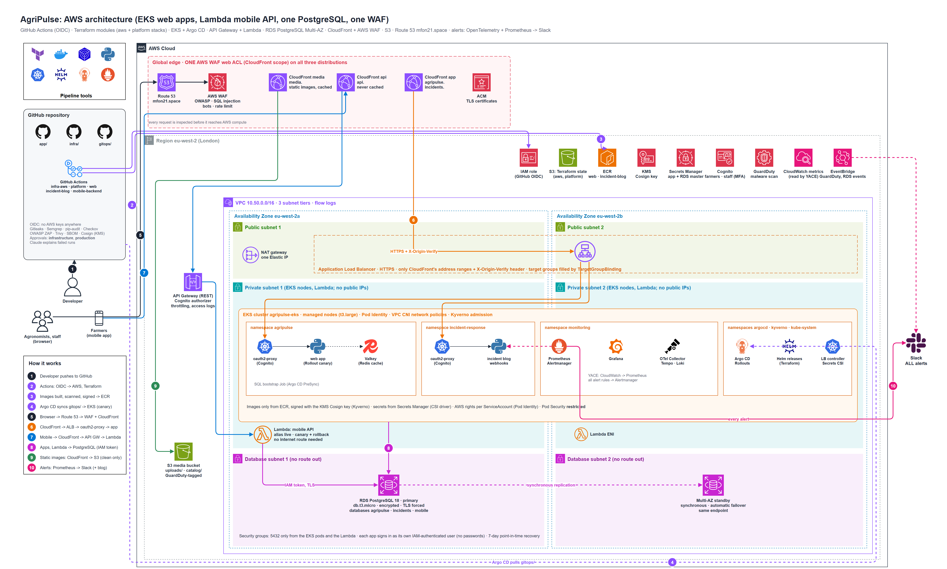
Figure 1: AgriPulse on AWS: GitHub Actions, the global edge (one WAF, three CloudFront distributions), and the VPC across two availability zones (ALB, EKS, Lambda, RDS PostgreSQL Multi-AZ)
Full-size PNG and editable draw.io file: architecture/agripulse-aws-architecture.(png|drawio) in this repository.

Follow the numbers in the picture:
- A developer pushes to GitHub.
- GitHub Actions gets temporary AWS credentials (OIDC) and runs Terraform (infra/aws, then infra/platform); the state is in S3.
- The web app and incident blog images are built, scanned (Trivy), signed with the KMS key (Cosign) and pushed to ECR.
- The pipeline commits the new image tag; Argo CD syncs gitops/ into EKS and Argo Rollouts releases it as a canary.
- A browser looks up agripulse.mfon21.space in Route 53 and reaches CloudFront; AWS WAF inspects the request.
- CloudFront forwards it over HTTPS, with the secret X-Origin-Verify header, to the ALB, which sends it to oauth2-proxy (Cognito sign-in) and then to the app.
- The mobile app calls api.mfon21.space: WAF, CloudFront, API Gateway (Cognito authorizer), then the Lambda.
- The apps and the Lambda connect to PostgreSQL with an IAM token over TLS, each to its own database.
- Static images come from media.mfon21.space: CloudFront reads them from S3, uploads only after GuardDuty marked them clean.
- Prometheus evaluates every alert rule (OpenTelemetry span metrics, the apps, and AWS metrics read from CloudWatch by YACE); Alertmanager posts every alert to Slack, and critical/warning ones also open an incident in the incident blog.

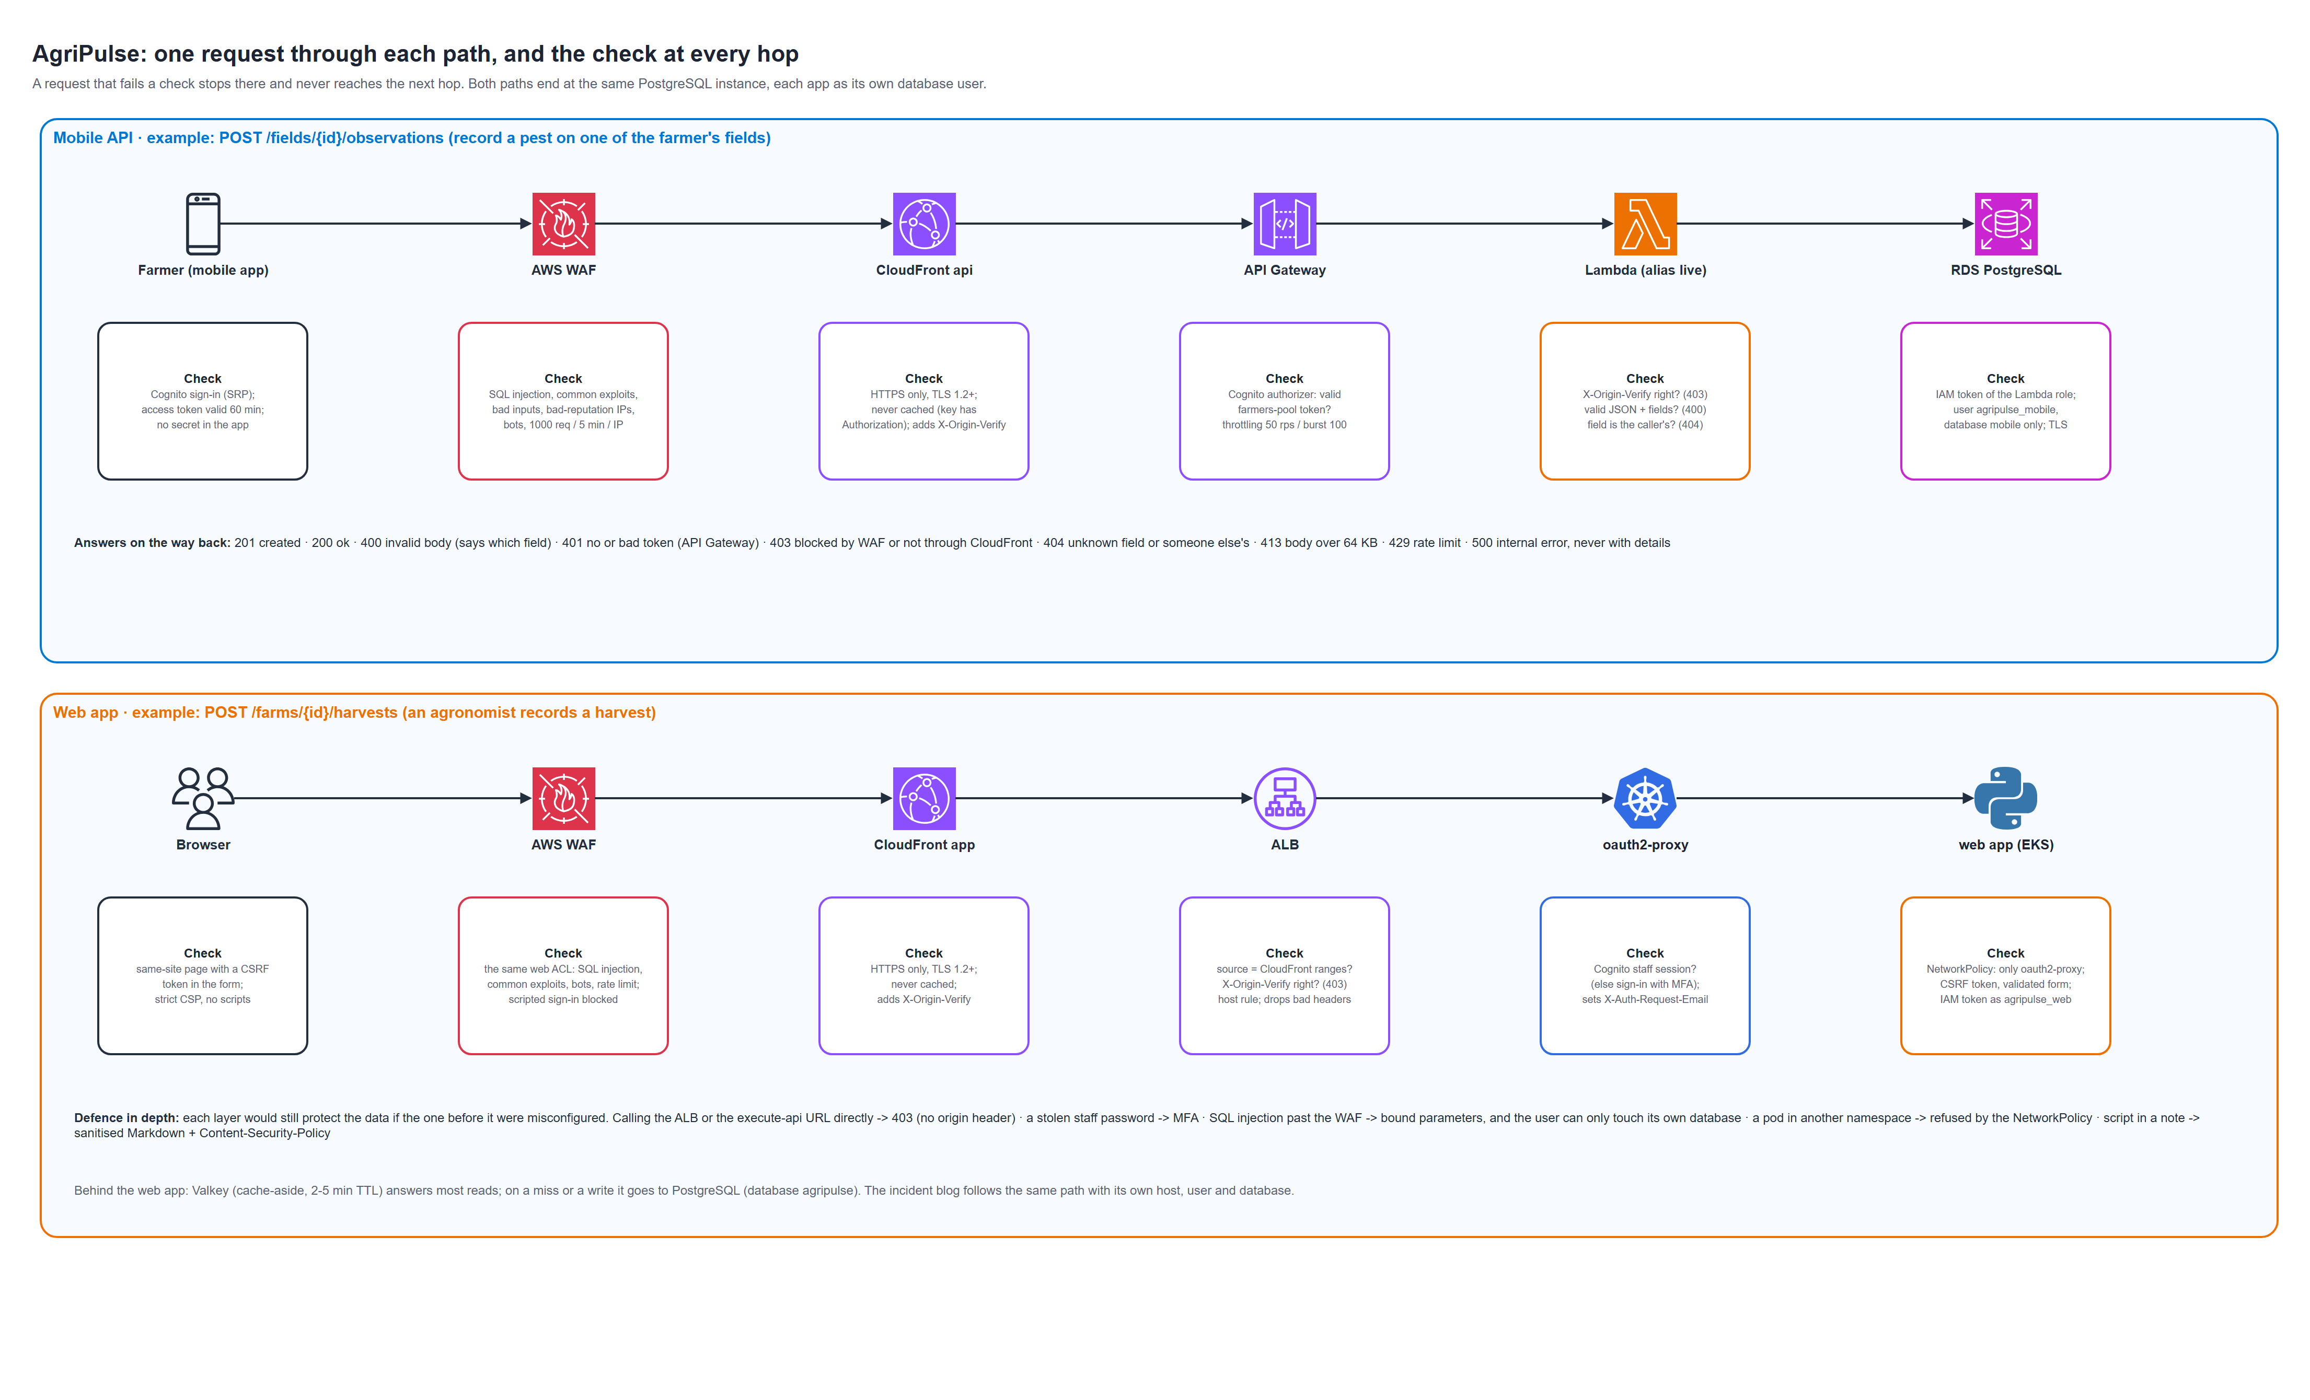
Figure 2: one request through each path, and the check at every hop
Full-size PNG and editable draw.io file: architecture/agripulse-request-flow.(png|drawio).

The pipelines
Five GitHub Actions workflows, each triggered by its own folders. A pull request runs only the checks; a push to main also deploys, after a person approves it in the matching GitHub environment.

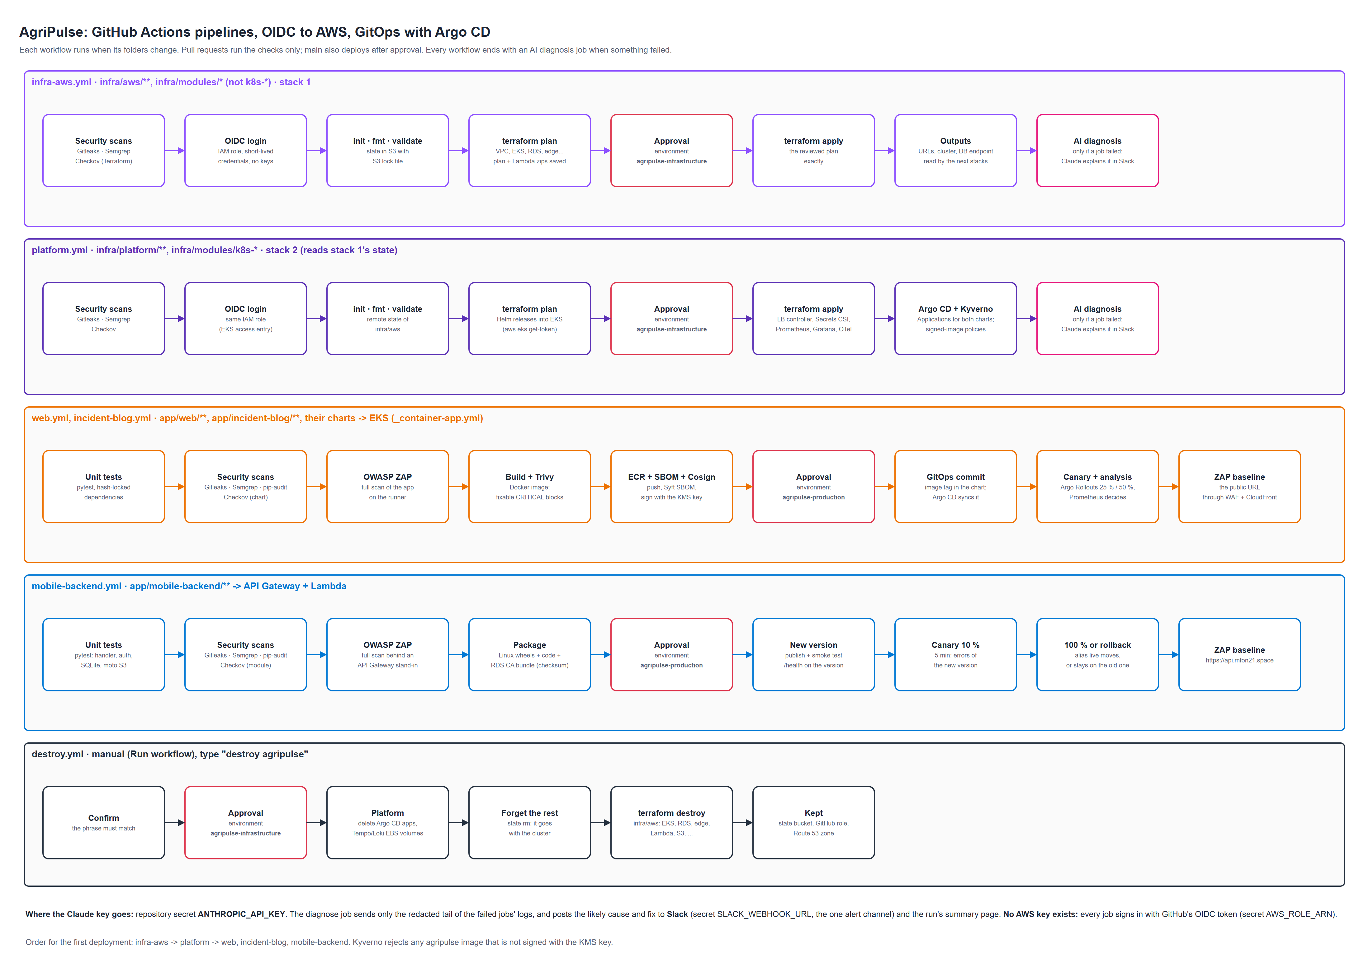
Figure 3: the GitHub Actions pipelines
Full-size PNG and editable draw.io file: architecture/agripulse-cicd-pipeline.(png|drawio).

What gets built, and by what
Layer | Resources | Created by
State | S3 bucket mfon21-agripulse-tfstate (versioned, encrypted, private), S3 lock files | bootstrap.sh
GitHub -> AWS | GitHub OIDC provider (reused if it exists), IAM role agripulse-eks-github-actions | infra/bootstrap/
Network | VPC 10.50.0.0/16, public, private and database subnets in 2 AZs, internet gateway, 1 NAT gateway, S3 gateway endpoint, flow logs | modules/network
Kubernetes | EKS agripulse-eks, managed node group (t3.large), add-ons (VPC CNI with network policies, CoreDNS, kube-proxy, Pod Identity agent, EBS CSI), access entries, Pod Identity roles | modules/eks
Database | RDS PostgreSQL 18.6 agripulse-postgres, db.t3.micro, Multi-AZ, IAM authentication, managed master secret, parameter group (TLS forced) | modules/database
Supply chain | ECR agripulse/web, agripulse/incident-blog; KMS key alias/agripulse-cosign | modules/registry
Storage | S3 media bucket, GuardDuty Malware Protection for uploads/ | modules/storage
Sign-in | Cognito pools agripulse-farmers (mobile) and agripulse-staff (hosted UI, MFA), app clients | modules/identity
Secrets | Secrets Manager agripulse/web/*, agripulse/incidents/*, agripulse/shared/*, agripulse/platform/* | modules/secrets
Mobile API | Lambda agripulse-mobile-api (alias live), API Gateway REST agripulse-mobile, Cognito authorizer | modules/mobile-api
Edge | ONE WAF web ACL, CloudFront app, api, media, ALB + target groups, ACM certificates, Route 53 records | modules/edge
AWS events | EventBridge rules and an API destination: GuardDuty malware findings and RDS failover/storage events straight to Slack (no SNS) | modules/monitoring
Inside EKS | AWS Load Balancer Controller, Secrets Store CSI, kube-prometheus-stack, OTel Collector, Tempo, Loki, Argo CD + Applications, Argo Rollouts, Kyverno + policies | infra/platform (modules/k8s-*)
Applications | Web app and incident blog images, Helm charts; the mobile API's Lambda package | web.yml, incident-blog.yml, mobile-backend.yml

Note: the two Terraform stacks are applied in order. infra/platform reads the outputs of infra/aws (cluster endpoint, target group ARNs, database endpoint, Cognito issuer) from its state in S3, so nothing is copied by hand.

Repository layout
Folder | What | Pipeline (runs only when its folder changes)
app/ | web/, incident-blog/ (FastAPI on EKS), mobile-backend/ (Lambda), dast/ (OWASP ZAP) | web.yml, incident-blog.yml, mobile-backend.yml (approval: production)
infra/aws/ | stack 1: composes the AWS modules | infra-aws.yml (approval: infrastructure)
infra/platform/ | stack 2: composes the k8s-* modules | platform.yml (approval: infrastructure)
infra/modules/ | one folder per module: main.tf, variables.tf, outputs.tf | the stack that uses it
gitops/charts/ | Helm charts Argo CD syncs into EKS | the app workflows commit image tags here
architecture/, docs/ | diagrams (draw.io + PNG) and these guides | none

Before you start

What you need
Item | Why | Check
AWS account with an administrator for the bootstrap | Bootstrap creates GitHub's IAM role and the state bucket | aws sts get-caller-identity
Route 53 public hosted zone mfon21.space, domain delegated to it | ACM validation and the four DNS names | aws route53 list-hosted-zones
GitHub repository with this code | The OIDC trust names it exactly | OWNER/REPO in the URL
AWS CLI v2, Terraform ≥ 1.10, Git, Bash (Git Bash on Windows) | To run the bootstrap script | aws --version, terraform version
kubectl (optional) | To look inside the cluster | kubectl version --client
Anthropic API key (optional) | AI diagnosis of failed workflow runs | console.anthropic.com

Warning: check two quotas in eu-west-2 first. EC2 On-Demand Standard vCPUs must be at least 8 (three t3.large nodes use 6). Lambda concurrent executions is often only 10 on a new account: enough to run (it also caps the mobile API at 10 database connections), but request 1,000 before real traffic: aws service-quotas request-service-quota-increase --service-code lambda --quota-code L-B99A9384 --desired-value 1000.

Values to edit
File | Value | Default
infra/bootstrap/main.tf, infra/bootstrap.sh | github_repository (OWNER/REPO exactly as in the URL) | Level-p/Multi-cloud-EKS-Lambda
all provider.tf, bootstrap.sh | state bucket name (globally unique) | mfon21-agripulse-tfstate
infra/aws/variables.tf | dns_zone_name, subdomains | mfon21.space; agripulse, incidents, api, media
infra/aws/variables.tf | db_instance_class, node_instance_types, node_desired | db.t3.micro, t3.large, 3
infra/aws/variables.tf | cluster_admin_arns (your IAM user, for kubectl) | empty
infra/aws/variables.tf | deletion_protection (RDS final snapshot, ALB, Cognito, images, media files) | false
infra/platform/variables.tf | enforce_image_signatures | true

Step 1: bootstrap (once, from your laptop)
aws sts get-caller-identity # the right account?
cd infra
GITHUB_REPO=Level-p/Multi-cloud-EKS-Lambda ./bootstrap.sh

The script:
- creates the state bucket mfon21-agripulse-tfstate (versioning, encryption, public access blocked), or reuses it;
- detects an existing GitHub OIDC provider in the account and reuses it;
- asks GitHub whether your repository uses the newer "immutable" OIDC subject and adapts the trust;
- applies infra/bootstrap/: the IAM role agripulse-eks-github-actions, which only this repository's workflows can assume;
- prints AWS_ROLE_ARN.
What you should see: at the end, AWS_ROLE_ARN = arn:aws:iam::<account>:role/agripulse-eks-github-actions.

Why the pipeline's role is broad
Terraform creates VPCs, EKS, RDS, IAM roles, KMS keys, CloudFront, WAF and Lambda, so the role has AdministratorAccess. The trust policy is what limits it: only GitHub's OIDC tokens for this repository can assume it. The EKS module always makes this role a cluster administrator (an access entry), so an apply from a laptop can never lock the pipeline out of the cluster.
Note: for a production account, replace AdministratorAccess with a policy scoped to the services in the table above and to agripulse-* resource names (marked as an accepted Checkov exception in the code).

Step 2: configure GitHub
In the repository: Settings > Secrets and variables > Actions.
Secret | Required | Value
AWS_ROLE_ARN | yes | printed by bootstrap.sh
ANTHROPIC_API_KEY | no | your Claude API key (sk-ant-...): failed runs get an AI diagnosis
SLACK_WEBHOOK_URL | yes | a Slack incoming webhook (https://hooks.slack.com/...): the one alert channel. Alertmanager, EventBridge and the AI diagnosis post there
GIT_REPO_TOKEN | private repo only | fine-grained PAT for this repository, Contents read-only (Argo CD clones with it)

Where the Claude key goes: the repository secret ANTHROPIC_API_KEY, and nowhere else. When a workflow run fails, its diagnose job sends only the redacted tail of the failed jobs' logs (tokens, keys, connection strings and e-mail addresses removed) to Claude and posts the likely cause and fix to Slack and the run's summary page. Without the secret it writes a plain list of the failed steps.

Variables (same page, Variables tab, optional): PRICE_ADMINS = ["you@example.com"], the people who may publish market prices in the web app.
Settings > Environments: create agripulse-infrastructure and agripulse-production, each with yourself as a required reviewer. Every apply, deployment and destroy waits for that approval.

Step 3: first deployment
git push -u origin main

A push starts only the workflows whose folders changed. The first time, run them by hand in this order (Actions > workflow > Run workflow), because each one needs the one before it:
Order | Workflow | Takes | Result
1 | infra-aws | 40-60 min | VPC, EKS, RDS Multi-AZ, ECR, S3, Cognito, API Gateway + Lambda (placeholder), WAF, CloudFront ×3, ALB, DNS, EventBridge -> Slack
2 | platform | 10-15 min | controllers, Prometheus/Grafana/OpenTelemetry, YACE and the alert rules, Kyverno, Argo CD and the two Applications
3 | web, incident-blog | 15-25 min each | images built, scanned, signed, pushed; Argo CD deploys them; the first sync runs the SQL bootstrap Job (databases and users)
4 | mobile-backend | about 10 min | the Lambda package replaces the placeholder through the canary

What the runs look like
- infra-aws / platform: plan runs on every push and pull request; the apply job waits for your approval, then applies exactly the plan you reviewed (it is passed between the jobs as an artifact).
- web / incident-blog: tests, scans and a ZAP scan; then build, Trivy, push, SBOM, Cosign signature; approval; a commit of the new image tag; the observe job waits until the Argo Rollouts canary is Healthy (or fails the run if the analysis aborted it); a ZAP baseline of the public URL.
- mobile-backend: tests, scans, ZAP; the Lambda zip; approval; a new version is published, smoke-tested on /health, given 10 % of the traffic for 5 minutes, then 100 % or rolled back.
Note: on the very first web run the SQL bootstrap Job creates the three databases and their users. If the incident blog synced first, its pods wait (not ready) until that Job has run once; they recover by themselves.

First users
Staff (web app and incident blog) are invited by an administrator; there is no self sign-up and MFA is required at first sign-in. email_verified=true matters: oauth2-proxy only accepts verified addresses.
POOL=$(aws s3 cp s3://mfon21-agripulse-tfstate/eks/aws.tfstate - | jq -r .outputs.staff_user_pool_id.value)
aws cognito-idp admin-create-user --user-pool-id "$POOL" --username you@example.com \
--user-attributes Name=email,Value=you@example.com Name=email_verified,Value=true

Farmers sign up through the mobile app (farmers pool). For a test token, create a user in agripulse-farmers, set a password with admin-set-user-password and call initiate-auth with the mobile client id (output mobile_client_id).

Check that it works
curl -s https://api.mfon21.space/health # {"status": "ok"}
curl -s -o /dev/null -w '%{http_code}\n' https://api.mfon21.space/fields # 401 (no Cognito token)
aws eks update-kubeconfig --region eu-west-2 --name agripulse-eks
kubectl get rollout -n agripulse # agripulse-web Healthy
kubectl get pods -A | grep -v Running # nothing but the header

Then open https://agripulse.mfon21.space in a browser: you are sent to the Cognito sign-in page, then to the farm dashboard. Add a farm and a harvest; open https://incidents.mfon21.space and declare a test incident.
Prove that the protections work:
# SQL injection is stopped at the edge by AWS WAF
curl -s -o /dev/null -w '%{http_code}\n' "https://agripulse.mfon21.space/?id=1%27%20OR%20%271%27=%271" # 403

# The ALB refuses anything that did not come through CloudFront
ALB=$(aws elbv2 describe-load-balancers --names agripulse-web --query 'LoadBalancers[0].DNSName' --output text)
curl -sk --max-time 5 https://$ALB/ ; echo " (time-out: only CloudFront's address ranges may connect)"

# The API Gateway URL without CloudFront's header: refused by the Lambda
API=$(aws apigateway get-rest-apis --query "items[?name=='agripulse-mobile'].id" --output text)
curl -s https://$API.execute-api.eu-west-2.amazonaws.com/prod/fields # 401 (no token), and 403 even with one

Why two codes: the API Gateway check answers 401 first because the Cognito authorizer runs before the Lambda; with a valid token but without X-Origin-Verify the Lambda answers 403.

Security controls
Layer | Control | Where
Edge | ONE AWS WAF web ACL on all three CloudFront distributions: OWASP common rules, SQL injection, known bad inputs, IP reputation, Bot Control, rate limit per IP, scripted sign-in blocked | modules/edge/waf.tf
Edge | Origins accept only CloudFront: ALB security group = CloudFront's prefix list, every listener rule needs X-Origin-Verify; the Lambda refuses requests without it | modules/edge/alb.tf, api.py
Identity | Staff: Cognito pool, admin-only sign-up, MFA required; oauth2-proxy in front of both EKS apps. Farmers: Cognito authorizer on every API route but /health | modules/identity
Application | Owner check on every field and observation (OWASP API1); bound SQL parameters; CSRF tokens, CSP, sanitised Markdown; S3 enforces upload type and size | app/
Network | Database subnets with no route out; 5432 only from the pods and the Lambda; NetworkPolicies (default deny) in EKS; VPC flow logs | modules/network, charts
Data | PostgreSQL encrypted, TLS forced and verified (verify-full); IAM authentication, one user per app, each owning only its database; S3 private, versioned, GuardDuty-scanned | modules/database, modules/storage
Secrets | No AWS keys anywhere (OIDC, Pod Identity, Lambda role); app secrets generated into Secrets Manager; the RDS master password managed by RDS and read by one Job only | modules/secrets
Cluster | IAM access entries only, KMS-encrypted Kubernetes secrets, audit logs, IMDSv2 hop limit 1, Pod Security restricted | modules/eks
Supply chain | Hash-locked dependencies, digest-pinned base images, Trivy, SBOM, Cosign signature with a KMS key; Kyverno admits only signed agripulse/* images from ECR | modules/registry, modules/k8s-policy
Pipeline | Gitleaks, Semgrep (+ AI-code rules), pip-audit, Checkov, OWASP ZAP; approvals before every apply and production deployment | .github/

SQL injection, end to end
- AWS WAF (AWSManagedRulesSQLiRuleSet) inspects query strings, bodies, cookies and paths on all four host names and blocks known patterns before they reach any AWS compute.
- The apps validate every input (Pydantic models, allow-list patterns) and use SQLAlchemy with bound parameters only; ZAP's active SQL injection scan runs against every form and API operation in CI.
- The database user can only reach its own database: agripulse_mobile cannot read agripulse or incidents, even if an injection got through.

DAST with OWASP ZAP
Every app pipeline runs a full ZAP scan (passive + active) against the app started on the runner (SQLite instead of PostgreSQL, a fixed test user), and after deployment a baseline scan (passive) of the public URL through CloudFront and WAF. Findings at medium or above fail the run unless a reviewed, expiring exception exists in app/dast/zap-policy.json. Reports are attached to each run as the zap-* artifact.

Running it day to day

Deploying changes
You change | What runs | Approval
app/web/**, gitops/charts/agripulse-web/** | web | production
app/incident-blog/**, its chart | incident-blog | production
app/mobile-backend/** | mobile-backend | production
infra/aws/**, infra/modules/* (not k8s-*) | infra-aws | infrastructure
infra/platform/**, infra/modules/k8s-* | platform | infrastructure
Anything, in a pull request | the checks only (tests, scans, plan) | none

Rolling back
- Web app / incident blog: a canary that fails Prometheus analysis is aborted automatically. After a full rollout, revert the GitOps commit (git revert <ci: deploy web r123-...>) and push, or immediately kubectl argo rollouts undo agripulse-web -n agripulse.
- Mobile API: the canary rolls back by itself on errors. After a promotion, point the alias back: aws lambda update-alias --function-name agripulse-mobile-api --name live --function-version <previous>.
- Database: point-in-time restore (last 7 days) creates a new instance: aws rds restore-db-instance-to-point-in-time .... Practise it before you need it.

Rotating secrets
# An app secret (the CSI driver syncs it within 2 minutes; restart the pods for environment variables)
aws secretsmanager put-secret-value --secret-id agripulse/web/csrf-secret --secret-string "$(openssl rand -hex 16)"
kubectl rollout restart deploy/oauth2-proxy -n agripulse

# CloudFront's origin header (CloudFront, the ALB rules and the Lambda change in one apply)
cd infra/aws && terraform apply -replace=random_password.origin_verify

# The RDS master password: rotated by RDS in Secrets Manager; the SQL bootstrap Job reads it at every sync

Where to look
What | Where
Is something failing for users? | Grafana dashboard AgriPulse services (OpenTelemetry); the Slack channel (every alert); the incident blog (critical/warning alerts open incidents)
Why is a request slow? | Grafana > Tempo: the slow trace (every SQL statement and cache call is a span), then its logs in Loki
Was a request blocked? | CloudWatch Logs aws-waf-logs-agripulse-edge in us-east-1 (blocked and counted requests only)
Mobile API | /aws/lambda/agripulse-mobile-api; X-Ray; API Gateway access logs /aws/apigateway/agripulse-mobile
Database | /aws/rds/instance/agripulse-postgres/postgresql (statements slower than 500 ms); RDS events (failover)
Deployments | Argo CD (kubectl port-forward -n argocd svc/argocd-server 8080:80); the workflow run page with Claude's diagnosis
Grafana | kubectl port-forward -n monitoring svc/kube-prometheus-stack-grafana 3000:80; password in agripulse/platform/grafana-admin-password

Alerting: everything goes to Slack
There is one alert channel, Slack, and one place where alerts are decided, Prometheus. There is no CloudWatch alarm and no SNS topic.
- The apps are instrumented with OpenTelemetry. Each request, SQL statement and cache call becomes a span; logs carry the trace id. The SDK sends them over OTLP to the OpenTelemetry Collector in the cluster.
- The Collector batches them and sends traces to Tempo and logs to Loki.
- Tempo turns spans into metrics (request rate, errors, latency histograms per service) and writes them into Prometheus, with the trace id attached as an exemplar.
- YACE reads the AWS metrics Prometheus cannot scrape (ALB, API Gateway, Lambda, RDS) from CloudWatch every 5 minutes and exposes them to Prometheus.
- Prometheus evaluates the rules in infra/modules/k8s-observability/alerts.tf: error rate, latency, slow dependencies, missing telemetry; ALB/API 5xx, Lambda errors and throttles, RDS CPU, credits, connections and storage. Anomaly rules compare the last 10 minutes with the mean + 3 standard deviations of the last 7 days.
- Alertmanager posts every alert to Slack (red for critical, amber for warning, green when resolved). Critical and warning alerts also open an incident in the incident blog.
Two kinds of AWS events are not metrics and never reach Prometheus: GuardDuty malware findings and RDS events (failover, failure, low storage). EventBridge sends those straight to the same Slack webhook through an API destination (modules/monitoring).
Check it: send a test alert: kubectl -n monitoring port-forward svc/kube-prometheus-stack-alertmanager 9093 and amtool alert add TestAlert severity=info --alertmanager.url=http://localhost:9093; it appears in Slack within a minute.

Troubleshooting
Symptom | Likely cause | Fix
infra-aws fails: Error: no matching Route 53 zone | The zone is not in this account | Create the hosted zone mfon21.space or change dns_zone_name
ACM validation waits for a long time | The domain's NS records do not point at the Route 53 zone | Fix the delegation at your registrar; dig NS mfon21.space
Lambda apply: reserved concurrency error | The account quota is 10 (all must stay unreserved) | Keep reserved_concurrency = -1 until the quota is raised
platform: Unauthorized from Kubernetes | The role is not a cluster admin | Run infra-aws once; the pipeline role always gets an access entry
Pods CreateContainerConfigError | The secret from Secrets Manager is not synced yet | Check kubectl describe pod; the SecretProviderClass and the Pod Identity association
Pod rejected: image not allowed / not signed | Kyverno: image not from ECR, or not signed with the KMS key | Deploy through the pipeline (it signs); never edit images by hand
Web app 503, readyz fails | PostgreSQL unreachable or the database user missing | Logs of the sql-bootstrap Job; security group rule from the cluster SG
Sign-in loops back to Cognito | User's email_verified is false | admin-update-user-attributes ... Name=email_verified,Value=true
Mobile API 403 for every call | Called the execute-api URL directly, or CloudFront's header changed mid-apply | Use https://api.mfon21.space; wait for the apply to finish
Many 403s from the WAF for real users | A managed rule false positive | WAF logs: find the rule, override that one rule to Count in modules/edge/waf.tf
Nothing arrives in Slack | Wrong or revoked webhook | Update the GitHub secret SLACK_WEBHOOK_URL, run infra-aws then platform (Alertmanager reads agripulse/platform/slack-webhook-url)
Alert AgriPulseCloudWatchMetricsMissing | YACE cannot read CloudWatch | kubectl logs -n monitoring -l app.kubernetes.io/name=prometheus-yet-another-cloudwatch-exporter; the yace Pod Identity association
A failed run you do not understand | - | Read the AI diagnosis on the run's summary page, then the log of the failed step

Cost and teardown

Cost (roughly, running 24/7 in eu-west-2)
Item | USD / month
EKS control plane | ~73
3 × t3.large nodes + EBS | ~200
NAT gateway (+ data) | ~35+
RDS PostgreSQL db.t3.micro Multi-AZ + 20 GiB gp3 + backups | ~30
Application Load Balancer | ~20
AWS WAF (one web ACL, managed rules, Bot Control) + requests | ~25+
CloudFront, API Gateway, Lambda, S3, Secrets Manager, CloudWatch | a few, with light traffic

Remember: run destroy when you are not using it; node_desired = 2 saves one node.

Tear down
Actions > destroy > Run workflow, type destroy agripulse and approve. It first removes what would outlive the cluster (the Argo CD apps, the EBS volumes of Tempo and Loki), then runs terraform destroy on infra/aws. It keeps the state bucket, the GitHub Actions role and the Route 53 zone; the KMS keys stay pending deletion for 7 days at no cost.
# Also remove the bootstrap (after destroy):
cd infra/bootstrap && terraform destroy
aws s3 rb s3://mfon21-agripulse-tfstate --force # only when no other project uses the bucket

