FastAPI · Lambda · PostgreSQL Learning Project
AgriPulse: the application
Four microservices and a mobile gateway: farmers sell, buyers order, the operations team keeps the incident record. How they work, where the code is, how to run, test and change them

Who this is for: Developers who will read, run or change the AgriPulse code. For the infrastructure and the pipelines, see the Deployment Guide.
Python 3.12 · FastAPI + Jinja (EKS) · AWS Lambda behind API Gateway · SQLAlchemy 2 + PostgreSQL 18 · Valkey cache

Contents
1. What AgriPulse is
2. How the application is built
3. The APIs
4. The data
5. The code, file by file
6. Run it on your laptop
7. Tests
8. Changing the application
9. Troubleshooting the application

What AgriPulse is
AgriPulse lets farms sell directly to the people who buy from them. A farmer registers, describes the farm (where it is, how big, how much it can supply each month), lists what it sells (produce such as tomatoes or eggs, and farm resources such as seedlings or equipment hire) with its own prices, and keeps farm records. A buyer registers, browses, puts items in a cart and orders; each farm confirms and delivers its part, and the buyer pays on delivery. The operations team records incidents in an incident blog, and every incident is reported to Slack.
Who | Where | What they do
Buyer | shop.mfon21.space, the mobile app | browse, cart, order, follow and cancel orders
Farmer | farm.mfon21.space, the mobile app | profile, listings, photos, farm records; orders for the farm (in the shop)
Operations | incidents.mfon21.space | declare incidents, move them through the lifecycle, write the review
Everyone | accounts.mfon21.space | register, sign in, sign out (one account for web and mobile)

Words you will meet
Word | Simple meaning
Microservice | A small service that owns one job and its own data; here accounts, farm, shop, incidents
Listing | One thing a farmer sells, with a price per unit and the quantity in stock
Reservation | Taking stock for an order at the farm service; atomic, so the last basket cannot be sold twice
Token (JWT) | A signed note from the accounts service: who you are and your role, valid 8 hours
CSRF token | A hidden form value another website cannot know, so it cannot submit forms in your name
Internal API | Routes under /internal/ that only other services may call, inside the cluster
Cache-aside | Read the cache first; on a miss read the source and fill the cache

How the application is built

The five parts
 | accounts | farm | shop | incidents | mobile gateway
Runs on | EKS | EKS | EKS | EKS | Lambda
Owns | accounts (users) | farms, listings, records | orders | incidents, posts | nothing
Database | accounts_<env> | farm_<env> | shop_<env> | incidents_<env> | -
Calls | - | S3 (photo uploads) | farm (catalog, stock); Redis | Slack | accounts, farm, shop
Who | everyone | farmers; public pages | buyers, farmers; public catalog | ops | the mobile app

Every service runs twice, in staging and in production, each in its own Kubernetes namespace with its own database. The code is the same; the settings (host names, keys, database) come from the environment.

Signing in once for everything
- A visitor opens a page that needs an account; the service redirects to accounts.<domain>/login?next=<that page>.
- The accounts service checks the password (Argon2) and signs a token with its private key (RS256).
- It sets the token as an HttpOnly, Secure cookie on the parent domain (mfon21.space, or staging.mfon21.space), so farm., shop. and incidents. of that environment all receive it, and sends the visitor back to next (only AgriPulse pages are accepted).
- Each service verifies the token with the public key (no call to the accounts service) and checks the role.
- The mobile app gets the same token from POST /auth/token and sends it as Authorization: Bearer.

One request, step by step

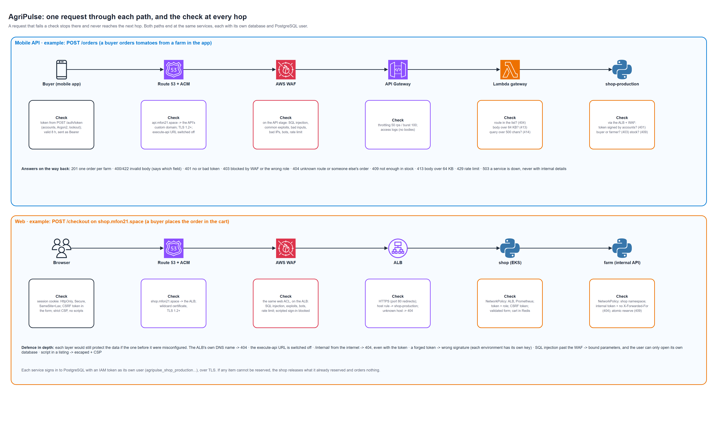
Figure 1: one request through each path, and the check at every hop
Full-size PNG and editable draw.io file: architecture/agripulse-request-flow.(png|drawio).

Placing an order
- The buyer's cart lives in Redis (cart:<user id>), in the shop's own namespace.
- At checkout the shop asks the farm service to reserve each item (POST /internal/listings/{id}/reserve); the farm service does it in one conditional UPDATE (quantity >= requested), so two buyers cannot both get the last basket.
- If any item cannot be reserved, everything already reserved is released and nothing is ordered.
- The shop writes one order per farm, with a copy of each title and price (later price changes never alter an order).
- The farmer accepts, dispatches and delivers it, or declines it; a cancelled order gives the stock back.

The APIs
Every service also serves /healthz (process up), /readyz (database reachable) and /metrics (Prometheus). JSON routes accept the token as Authorization: Bearer; pages use the session cookie and CSRF-protected forms.

accounts (https://accounts.mfon21.space)
Method and path | What it does
GET /register, POST /register | registration form (buyer or farmer) and its submission
GET /login, POST /login | sign-in form; sets the session cookie and returns to next
GET /logout, POST /logout | a confirm button, then the cookie is removed
POST /api/register | JSON {email, password, name, role, phone?} -> {token, expires_in, user}
POST /api/token | JSON {email, password} -> {token, expires_in, user}
GET /api/me | the caller's account

farm (https://farm.mfon21.space)
Method and path | What it does
GET /dashboard | the farmer's page: profile, listings, records
GET|PUT /api/profile | the farm profile: name, phone, region, address, latitude/longitude, hectares, capacity (t/month)
GET|POST /api/listings, PATCH|DELETE /api/listings/{id} | the farmer's own listings (delete hides it; past orders keep their copy)
POST /api/listings/{id}/photo | a pre-signed S3 POST for one photo (image types, at most 5 MB)
GET|POST /api/activities | farm records: date, activity, crop, quantity, notes
GET /api/catalog | PUBLIC: what is on sale (kind, q, region, limit, offset)
GET /api/listings/{id}, GET /api/farms/{owner_id} | PUBLIC: one listing; a farm's public profile
POST /internal/listings/{id}/reserve|release | INTERNAL (the shop): take or give back stock

shop (https://shop.mfon21.space)
Method and path | What it does
GET /, GET /items/{id} | the catalog and one item (cached in Redis)
POST /cart, GET /cart, POST /cart/remove, POST /checkout | the cart and the checkout (delivery address, phone)
GET /orders, POST /orders/{id}/cancel | the buyer's orders; cancel while still placed
GET /sales, POST /sales/{id}/status | the farmer's orders: accept, dispatch, deliver, decline
GET /api/catalog, GET /api/items/{id} | PUBLIC
POST /api/orders | {items: [{listing_id, quantity}], delivery_address, phone} -> one order per farm
GET /api/orders, POST /api/orders/{id}/cancel, GET /api/sales, POST /api/sales/{id}/status | the same as the pages, for the app

incidents (https://incidents.mfon21.space, ops accounts)
Method and path | What it does
GET / | all incidents with KPIs: open count, MTTA and MTTR
POST /incidents | declare an incident (title, severity SEV1-SEV4, services, summary): reported to Slack
GET /incidents/{id}, POST /incidents/{id}/transition, POST /incidents/{id}/posts | the timeline; the next lifecycle state with a note (recovered and closed are reported to Slack); an update
POST /webhooks/alertmanager | Alertmanager: a critical/warning production alert opens an incident (Bearer token), reported to Slack

The lifecycle follows NIST SP 800-61: detected -> triaged -> contained -> eradicated -> recovered -> post_incident_review -> closed, one phase at a time (an operational incident may go contained -> recovered); closing needs the written review.

Mobile API (https://api.mfon21.space)
Route | Goes to
POST /auth/register, POST /auth/token, GET /me | accounts
GET /catalog, GET /items/{id} | shop (public)
GET|POST /orders, POST /orders/{id}/cancel, GET /sales, POST /sales/{id}/status | shop
GET|PUT /farm/profile, GET|POST /farm/listings, PATCH|DELETE /farm/listings/{id}, POST /farm/listings/{id}/photo, GET|POST /farm/activities | farm
GET /health | the gateway itself

The gateway passes the user's token and the body through and returns the service's answer unchanged. Anything not in its list answers 404, so /internal/ can never be reached through it.

Errors
Code | Meaning
400 / 422 | the input is not valid (the body says which field)
401 | no valid token: sign in (pages redirect to the sign-in page instead)
403 | signed in, but the wrong role (e.g. a buyer on the farmer API), or a bad form token
404 | not found, or not yours (another farmer's listing looks exactly like a missing one)
409 | a conflict: not enough in stock, an account with that e-mail exists, a status change that is not allowed
429 | too many wrong passwords: the account is locked for 15 minutes
503 | a dependency is down (the database, the farm service, Redis for the cart)

The data
Each service creates its tables on first start (SQLAlchemy create_all) in its own database; nothing reads another service's database.
Database | Table | Key columns
accounts | users | id (uuid), email (unique), name, phone, role, password_hash (Argon2), failed_logins, locked_until
farm | farms | owner_id (the farmer's account id), farm_name, region, address, latitude, longitude, hectares, capacity_tonnes_month
farm | listings | id, owner_id, title, kind (produce|resource), category, unit, price, currency, quantity, image_key, active
farm | activities | id, owner_id, on (date), kind, crop, quantity, unit, notes
shop | orders | id, buyer_id, farmer_id, farm_name, status, delivery_address, phone, total, currency, payment
shop | order_items | order_id, listing_id, title, unit, unit_price, quantity, line_total (copies, frozen)
incidents | incidents, posts | the incident and its timeline (state changes and updates)

Redis (the shop's namespace) holds only things that can be lost: the catalog cache (60 s), items (30 s) and carts (7 days).

The code, file by file

Shared: app/common/agripulse_common/
File | What it does
auth.py | issue (accounts only) and verify tokens; requires(role) for routes; the sign-in redirect
web.py | create_app(): security headers, CSRF, /healthz, /readyz, /metrics, request metrics, the shared templates
db.py | SQLite for tests, RDS with an IAM token in EKS; TLS verified
cache.py | Redis cache-aside, never fatal when Redis is down
services.py | calls between services; require_internal for /internal/ routes
slack.py | one report to the Slack webhook, never raises
telemetry.py | OpenTelemetry traces and logs (off without OTEL_EXPORTER_OTLP_ENDPOINT)
testing.py | a throwaway key pair and real tokens for tests and the DAST scan
templates/base.html, static/style.css | the one look of every service

The services: app/<service>/app/
Service | Files
accounts | main.py (pages, API, lockout), db.py (users), admin.py (grant-ops), templates/
farm | main.py (pages, API, catalog, internal reserve/release, photo uploads), db.py, templates/
shop | main.py (catalog cache, cart, checkout, orders, sales), db.py, templates/
incidents | main.py (pages, Alertmanager webhook, Slack reports), lifecycle.py (the NIST rules), db.py, templates/

app/Dockerfile builds any of them: docker build -f app/Dockerfile --build-arg SERVICE=shop app.

Mobile gateway: app/mobile-backend/agripulse_mobile/
File | What it does
api.py | the route list, the origin check, size limits, forwarding with the user's token (standard library only)
handler.py | the Lambda entry point: API Gateway proxy event -> api.handle()

Security tests: app/dast/
start-service.sh starts a service on the CI runner with SQLite and real signed tokens (the shop with Redis and the farm service), export_openapi.py writes its OpenAPI document and seeds records, and ZAP scans every operation. mobile_local.py does the same for the gateway.

Run it on your laptop
cd app/farm
python -m venv .venv && . .venv/bin/activate # Windows: .venv\Scripts\activate
pip install --require-hashes -r requirements.txt && pip install -r requirements-dev.in
export PYTHONPATH=$PWD:$PWD/../common
eval "$(python -m agripulse_common.testing keys)" # a throwaway key pair
export DATABASE_URL=sqlite:///farm.db CSRF_SECRET=dev COOKIE_SECURE=false INTERNAL_TOKEN=dev \
ACCOUNTS_URL=http://localhost:8001 FARM_URL=http://localhost:8002 SHOP_URL=http://localhost:8003 PUBLIC_URL=http://localhost:8002
uvicorn app.main:app --port 8002
# a token to call the API as a farmer:
TOKEN=$(python -m agripulse_common.testing token farmer)
curl -s -X PUT localhost:8002/api/profile -H "Authorization: Bearer $TOKEN" -H 'Content-Type: application/json' \
-d '{"farm_name":"My farm","region":"Oyo","hectares":2,"capacity_tonnes_month":1}'

Run accounts (8001), farm (8002) and shop (8003, with FARM_INTERNAL_URL=http://localhost:8002 and the same keys) to click through the whole flow in a browser; sign-in cookies work on localhost without COOKIE_DOMAIN.

Tests
Folder | Command | Tests | What they prove
app/accounts | pytest -q | 9 | registration, sign-in, lockout, same answer for unknown e-mail, safe redirects, forged tokens refused
app/farm | pytest -q | 9 | profile first, public catalog, ownership, atomic reservations, the internal API's two locks, photo uploads
app/shop | pytest -q | 10 | orders per farm, frozen prices, all-or-nothing reservation, status rules, cart, OpenTelemetry traces
app/incidents | pytest -q | 16 | the NIST lifecycle, KPIs, sanitised Markdown, ops only, Alertmanager, Slack reports
app/mobile-backend | pytest -q | 6 | routing, the user's token passed on, the origin check, limits, a service that is down
app/dast | pytest -q tests | 12 | the ZAP gate

The services' tests run with SQLite and a throwaway key pair: no AWS account, no database server.

Changing the application

Add a field to a listing (example: organic)
- app/farm/app/db.py: organic: Mapped[bool] = mapped_column(Boolean, default=False).
- ListingIn / ListingPatch in main.py: add the field; listing_json(): return it.
- templates/dashboard.html: a checkbox; the shop's item.html: show it.
- A test in tests/test_farm.py; push. The farm pipeline releases it to staging, then (after approval) production.
Warning: create_all creates missing tables but never changes existing ones. For a new column on a table that already has data, add a migration (Alembic) or an ALTER TABLE run once; plan it before the release.

Add a mobile route
Add a line to ROUTES in app/mobile-backend/agripulse_mobile/api.py (method, path, service, target path), a test, and the operation in app/dast/openapi/mobile.yaml.

Add a service
- app/<service>/ with app/main.py built on agripulse_common.web.create_app, tests, requirements.in and the lock.
- Add it to services in infra/aws/main.tf (its host, database, role, secrets and target group follow), and the ECR repository list.
- gitops/services/<service>/values.yaml, staging.yaml, production.yaml; a workflow that calls _service.yml.

Troubleshooting the application
Symptom | Likely cause | Fix
/readyz 503 | PostgreSQL unreachable or the database missing | kubectl -n db-bootstrap logs job/db-bootstrap; the pod's log names the cause
Every page sends me back to sign in | The cookie is for the other environment, or the keys were rotated | Sign in on the same environment's accounts site
Form answers 403 invalid form token | The page was open before a secret rotation, or cookies are blocked | Reload the page
Checkout: "not enough in stock" | Another buyer took the last units | Lower the quantity; the farmer can raise the stock
"the catalog is unavailable" | The farm service of that environment is down | kubectl -n farm-<env> get pods
Cart answers 503 | The shop's Valkey is down | kubectl -n shop-<env> get pods -l app.kubernetes.io/name=shop-redis
Photo does not appear | GuardDuty has not tagged the upload yet, or found malware | Wait a few seconds; check the object's GuardDutyMalwareScanStatus tag
No Slack report for a new incident | The webhook is wrong | Alert AgriPulseIncidentReportNotSent; update SLACK_WEBHOOK_URL
Mobile app: 503 "<service> is unavailable" | The gateway cannot reach that service | Check the service's production pods and its ALB target group

