EKS · Helm · Argo CD Learning Project
Deploying StatusBoard to Amazon EKS
Terraform, GitHub Actions (OIDC), Amazon ECR, Helm, staging and production, backups, Prometheus and Grafana

Who this is for: The engineer who will provision the infrastructure and run the GitHub Actions pipelines.
Region used in examples: eu-west-2 (London) · Kubernetes 1.35 · Helm 3 · Argo CD 3

Contents
1. What you are going to build
2. Before you start
3. Values you must change first
4. Step-by-step deployment
5. How staging and production are kept separate
6. How the Terraform is organised
7. Running it day to day
8. Costs
9. Limits of this design (and the next steps)
10. Tearing everything down
11. Troubleshooting

What you are going to build
This guide takes you from an empty AWS account to StatusBoard, a public status page and incident tracker, running on Amazon EKS in two environments, staging and production, with backups and monitoring. You use Terraform (infrastructure as code) and GitHub Actions (automated pipelines). Every step explains what you do and why.
In plain English: Terraform is a written plan for your infrastructure (network, cluster, permissions). GitHub Actions is a robot that follows the plan every time you change it, builds the app's container, installs it in staging, checks that it works, and then, once a person approves, installs the very same container in production. You only ever change files in Git; the robot does the rest.

Why StatusBoard, and why two environments
StatusBoard replaced an earlier WordPress version of this project. WordPress keeps uploads and plugins on the web server's own disk, so on Kubernetes it can only run as one copy in one data centre. StatusBoard is designed the cloud-native way:
 | Old WordPress design | StatusBoard
Web tier | 1 pod (StatefulSet), its own disk | 2–10 identical pods (Deployment) spread over 3 data centres, scaled automatically
Where data lives | Web server disk and database | Only PostgreSQL: 3 synchronised copies in 3 data centres with automatic failover
Cache | None | Valkey, so most page views never touch the database
Backups | None | Nightly database dump to S3, kept 7 days (staging) / 30 days (prod)
Data for analysis | None | Monthly export to a KMS-encrypted bucket that a read-only data team group can download
Environments | One | Staging and production, same chart, same image
Releases | Straight to the live site | Staging first, smoke test, human approval, then production

Analogy: staging is the dress rehearsal. The cast, costumes and script are exactly the ones used on opening night; only the audience is different. If something goes wrong in rehearsal, the public never sees it.

Words you will meet
Word | Simple meaning
Terraform | A tool that creates cloud resources from text files, and remembers what it created in a "state" file
State file / remote state | Terraform's memory of what exists. Stored in S3 so a pipeline and people can share it safely
GitHub Actions workflow | An automated list of steps GitHub runs when something changes in the repository
OIDC | A way for GitHub to prove to AWS who it is and get temporary AWS credentials, so no passwords or keys are stored
ECR | Amazon's private registry for container images
Helm | The tool that installs the StatusBoard chart into Kubernetes
Environment (GitHub) | A named target such as staging or production. You can attach rules to it, for example "someone must approve"
Namespace | A separate area inside the cluster. Staging and prod each get their own (statusboard-staging, statusboard-prod)
Promotion | Taking the exact image that passed staging and deploying it to production, instead of building it again
Pod Identity | The EKS feature that gives one pod (here, the backup and export jobs) its own AWS permissions without storing keys
Operator | A program running in the cluster that manages a complex application for you. Here, the Zalando postgres-operator builds and looks after the PostgreSQL clusters
Patroni | Software inside each database pod that decides which copy is the primary and promotes a replica if the primary fails
Primary / replica | The primary accepts changes; replicas receive a continuous copy of every change and can take over
KMS | AWS Key Management Service: holds the encryption key that protects the data exports

The DevOps architecture
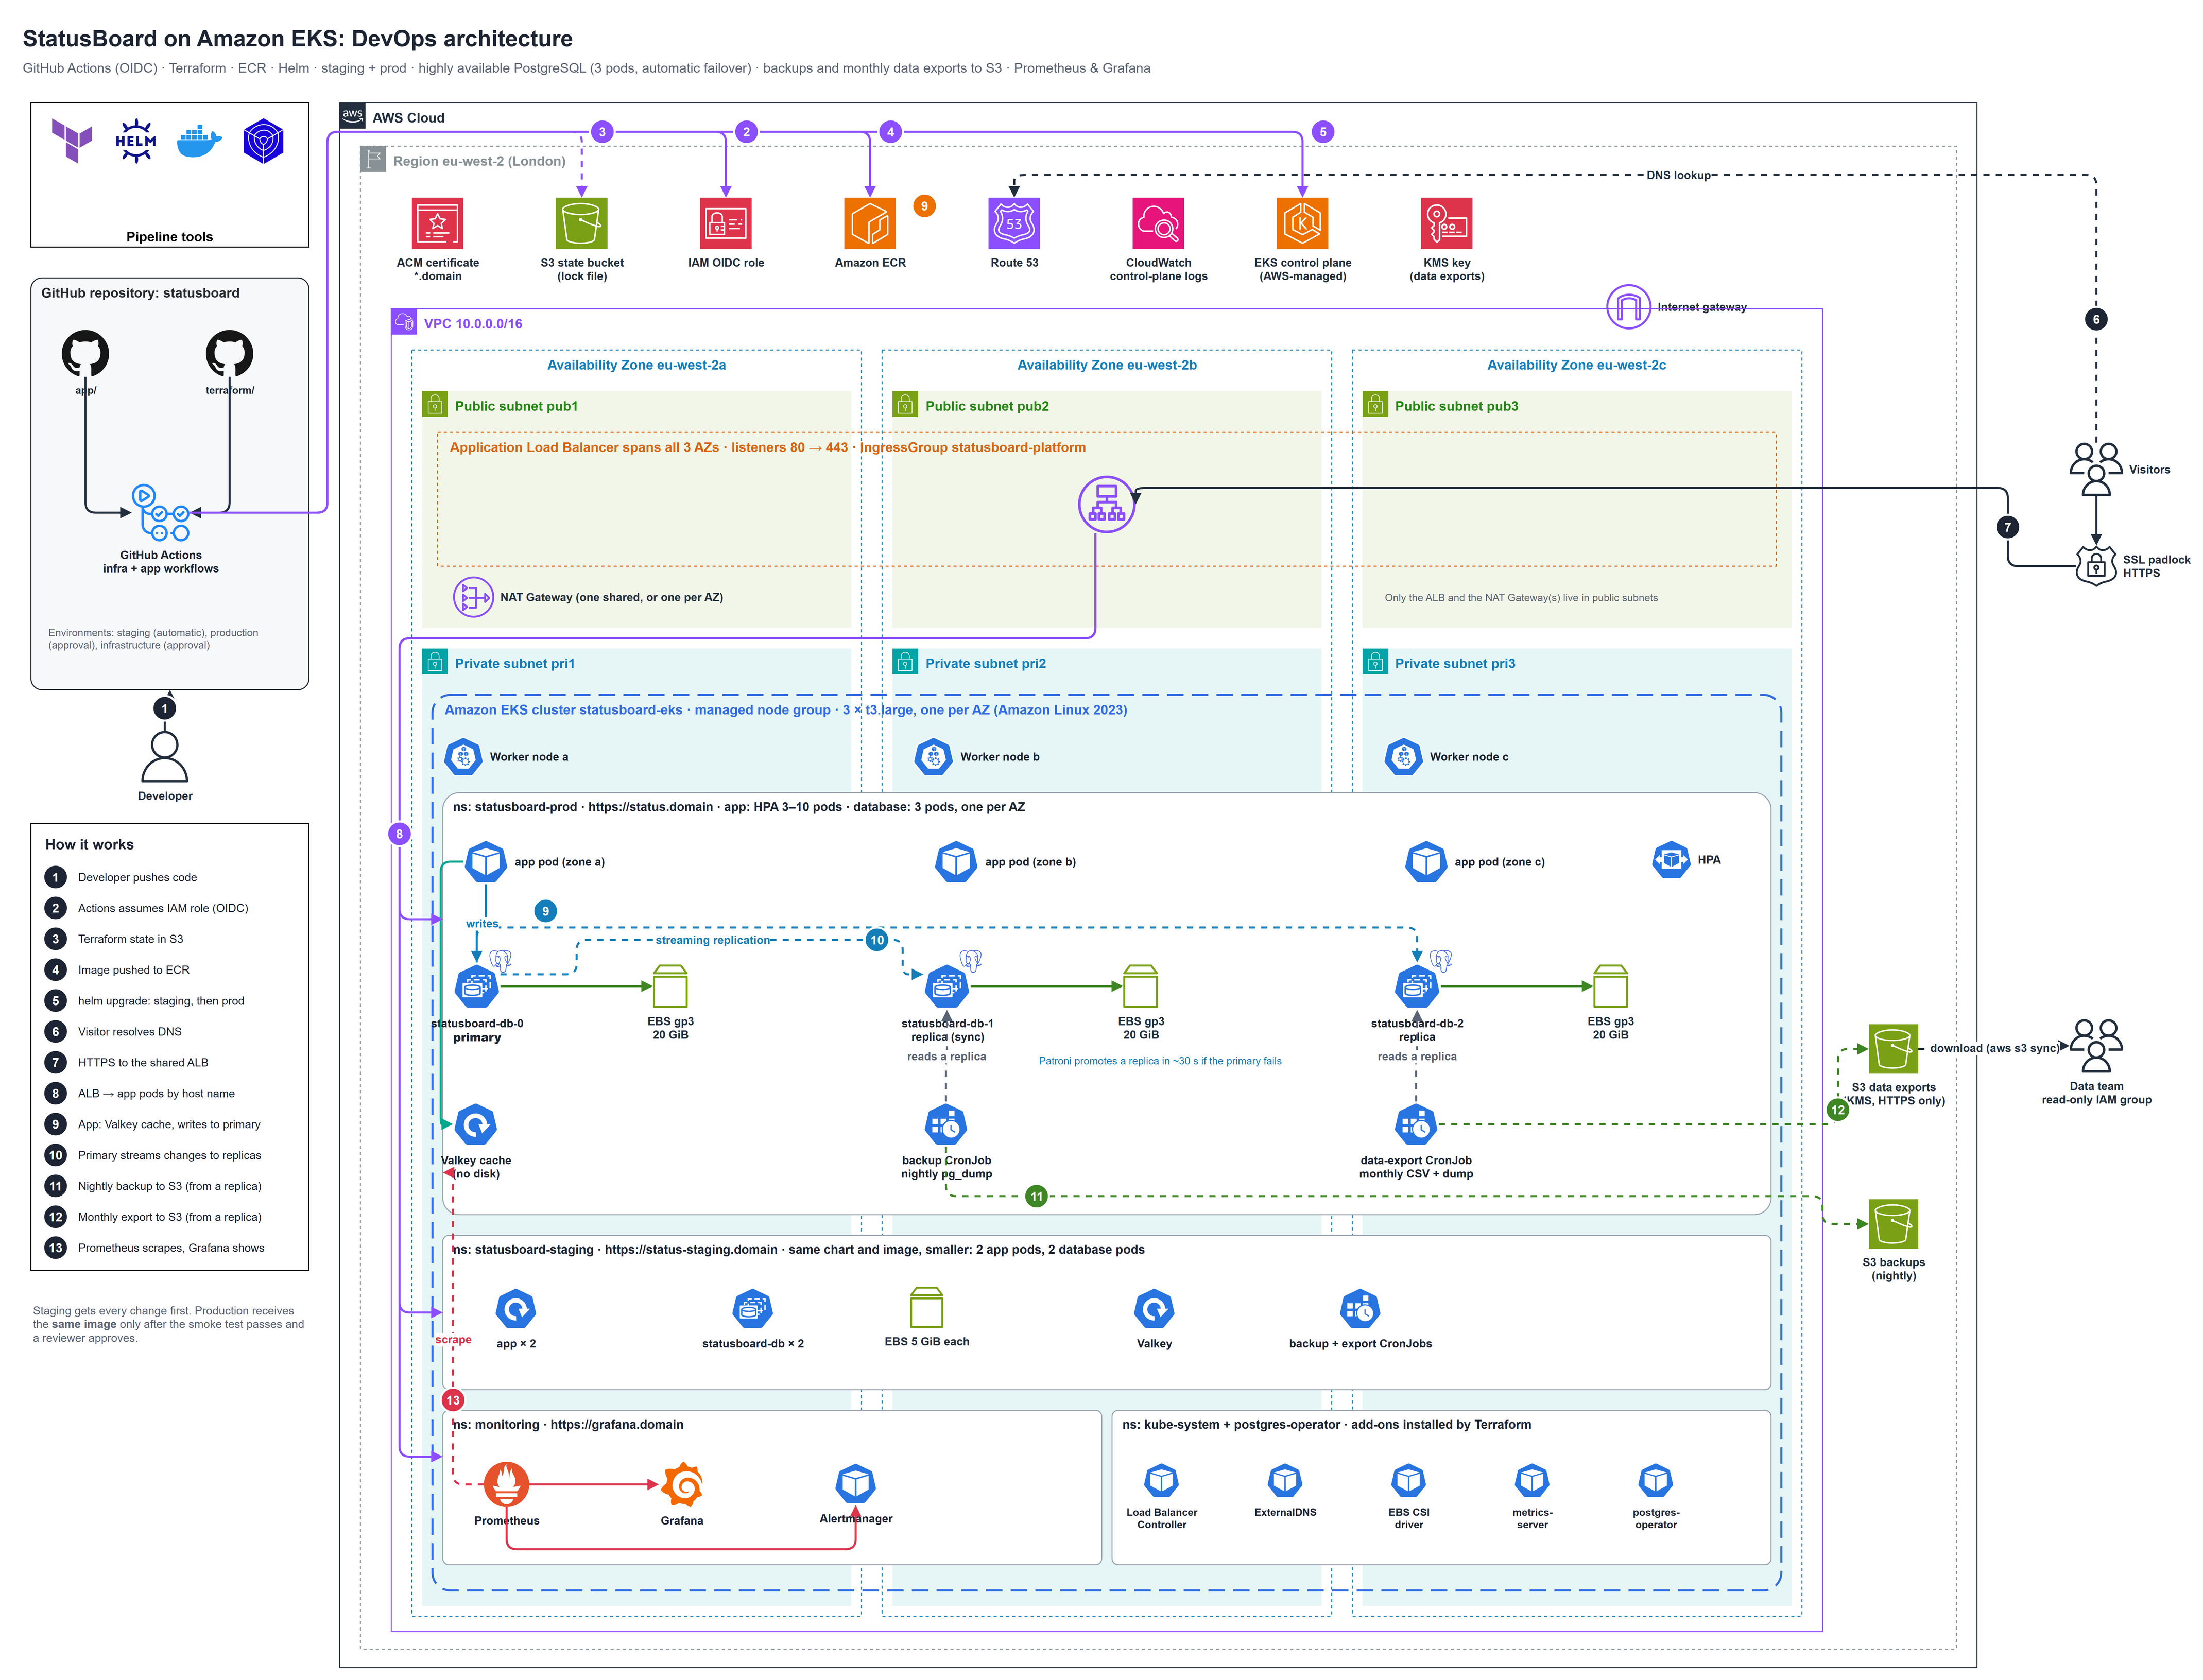
Figure 1: StatusBoard DevOps architecture: GitHub Actions, AWS services, a VPC across three Availability Zones, and one EKS cluster holding staging, prod and monitoring
Full-size PNG and editable draw.io file: see the architecture or diagrams folder of this project.

Follow the numbers in the picture:
- A developer pushes code to GitHub.
- GitHub Actions asks AWS for temporary credentials using OIDC. No access keys are stored anywhere.
- Terraform keeps its state (its memory) in an S3 bucket, protected by a lock file so two runs never collide.
- The app workflow builds the StatusBoard image once and pushes it to Amazon ECR.
- Helm installs that image into staging; after a smoke test and an approval, into prod.
- A visitor's browser asks Route 53 where status.<domain> (or status-staging.<domain>) lives.
- The visitor connects over HTTPS to the shared Application Load Balancer, which uses the ACM certificate.
- The load balancer reads the host name and sends the request straight to an app pod in the right namespace.
- The app answers from the Valkey cache when it can; it writes to the PostgreSQL primary.
- The primary streams every change to two replicas in the other data centres. If the primary fails, a replica takes over in about 30 seconds.
- Every night a backup job copies the database (read from a replica) to the S3 backup bucket.
- On the 1st of every month an export job writes CSV files and a full dump to the KMS-encrypted exports bucket, which the data team can download.
- Prometheus collects metrics from both environments; Grafana shows them.

The same platform as logical layers
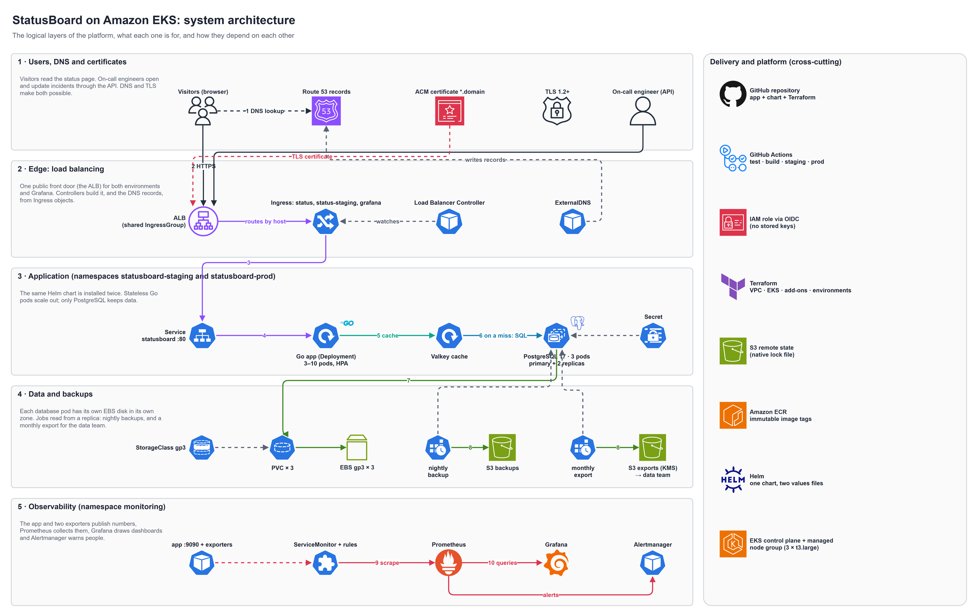
Figure 2: system architecture: what each layer is for and how the layers depend on each other
Full-size PNG and editable draw.io file: see the architecture or diagrams folder of this project.

The two delivery pipelines
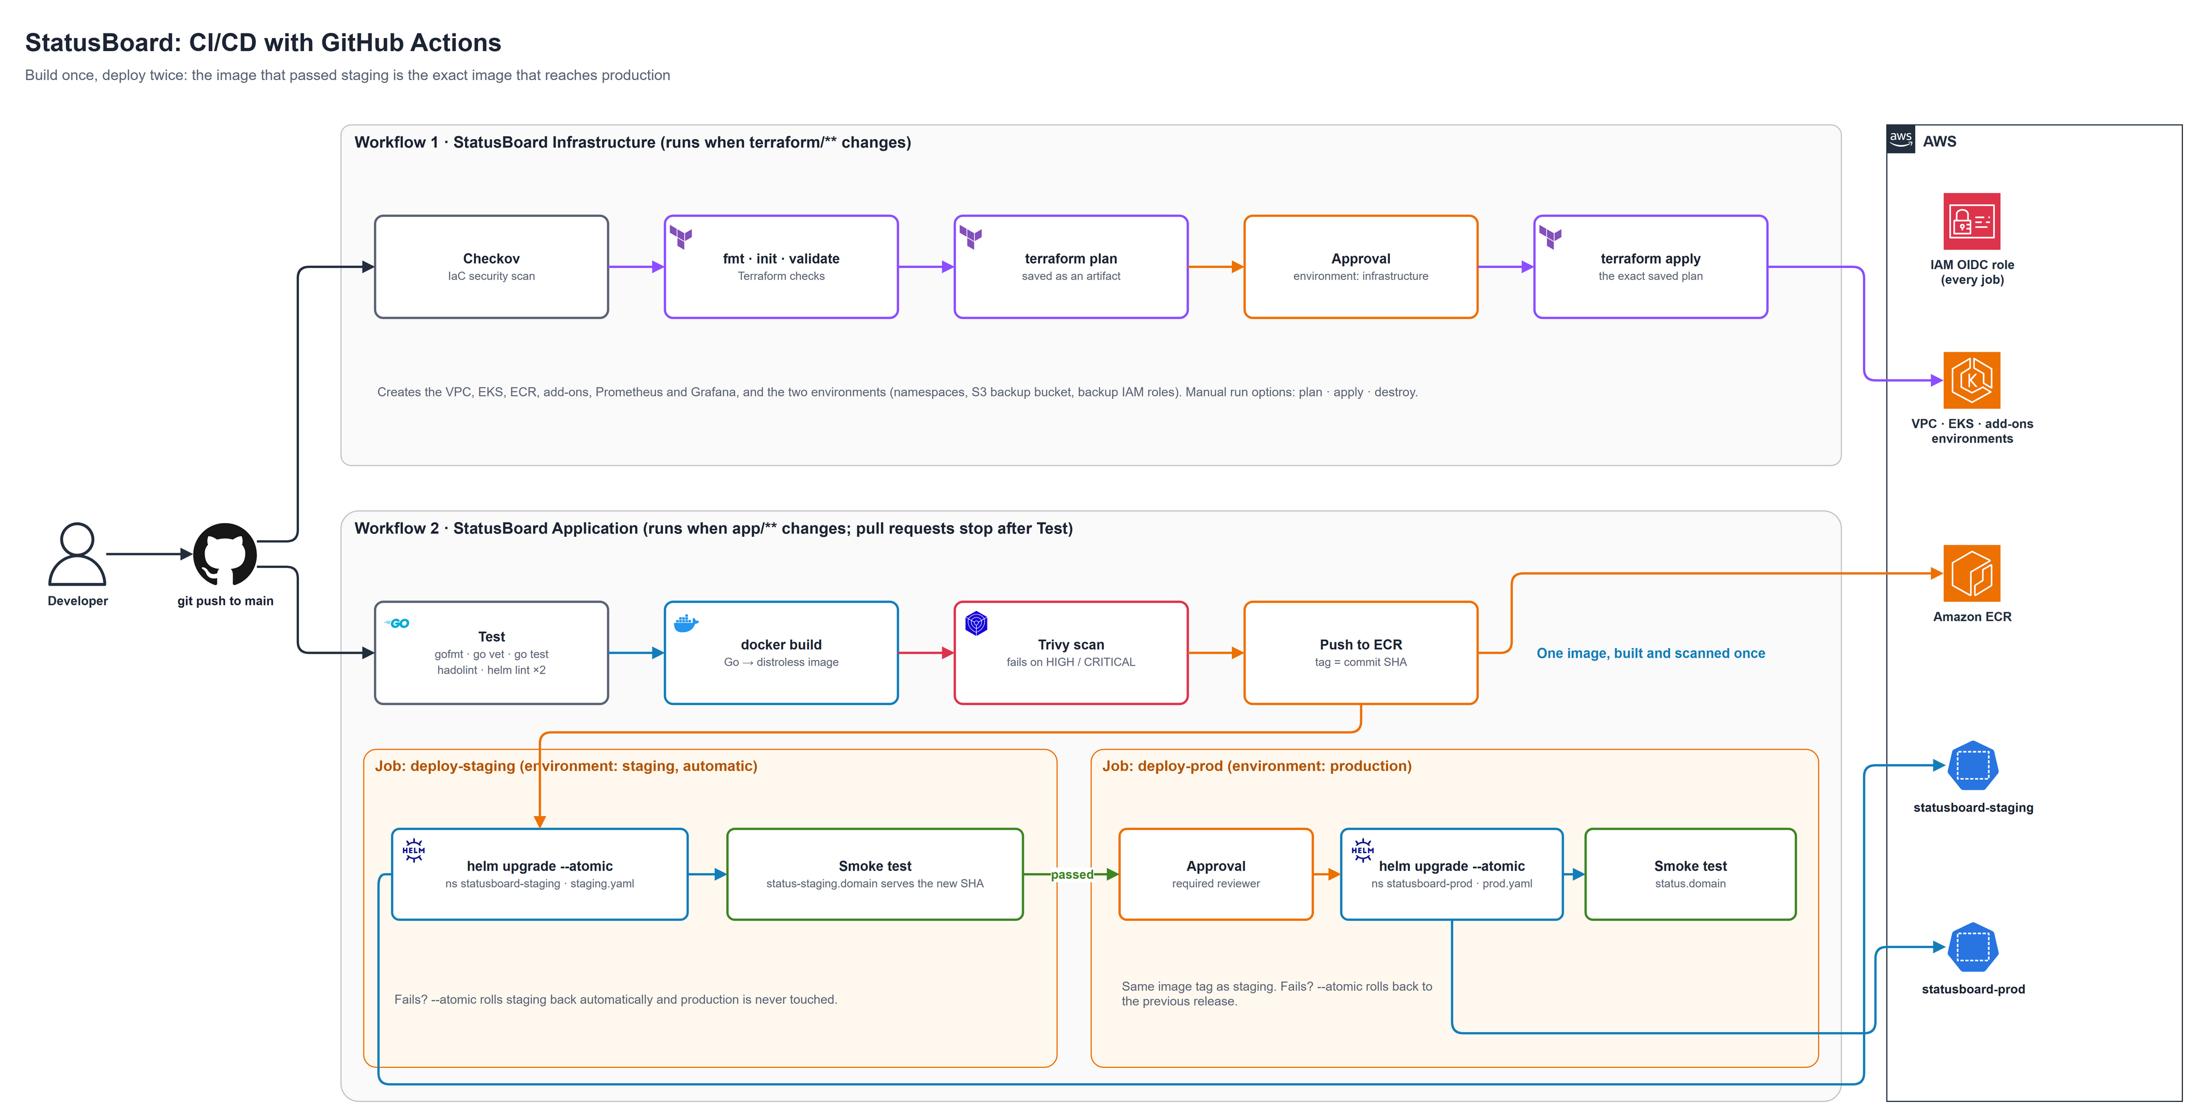
Figure 3: the infrastructure workflow (top) and the application workflow with staging, approval and production (bottom)
Full-size PNG and editable draw.io file: see the architecture or diagrams folder of this project.

What gets built, and by what
Layer | Resources | Created by
State | S3 bucket (versioned, encrypted, private) with S3 native locking | create-remote-state.sh
Bootstrap | GitHub OIDC provider, IAM role for GitHub Actions, wildcard ACM certificate | bootstrap/ stack
Network | VPC 10.0.0.0/16, 3 public and 3 private subnets in 3 data centres, internet gateway, NAT Gateway (one shared, or one per data centre), routes, load-balancer subnet tags | module/vpc
Cluster | EKS 1.35 control plane (with API and audit logs), managed node group (3 × t3.large, Amazon Linux 2023), access entries | module/eks
Core add-ons | vpc-cni, kube-proxy, coredns, eks-pod-identity-agent, aws-ebs-csi-driver (Pod Identity) | module/eks
Registry | ECR repository statusboard-eks/statusboard (tags cannot be overwritten, scanned on push, old images cleaned up) | module/ecr
Platform add-ons | AWS Load Balancer Controller, ExternalDNS, metrics-server, encrypted gp3 StorageClass | module/eks-addons
Monitoring | kube-prometheus-stack: Prometheus, Grafana, Alertmanager, all with EBS disks; Grafana behind the load balancer | module/monitoring
Database operator | Zalando postgres-operator 2.0 (Spilo images with PostgreSQL + Patroni), configured to spread each database across zones, run as non-root, and never delete database disks or passwords on its own | module/postgres-operator
Environments | Namespaces statusboard-staging and statusboard-prod (with Pod Security labels), the S3 backup bucket with a retention rule per environment, the KMS-encrypted data exports bucket, backup and export IAM roles per environment with Pod Identity links, and the read-only data team IAM group | module/app-environments
Application | App Deployment + autoscaler, the postgresql cluster (built by the operator), Valkey, backup and export CronJobs, Ingress, ServiceMonitor, alerts, dashboard (once per environment) | GitHub Actions + Helm

Before you start
You need | Why
An AWS account where you have admin rights (for the first setup) | The setup creates IAM roles, a network and a cluster
A public Route 53 hosted zone for your domain | Needed to prove domain ownership for the HTTPS certificate and to publish website addresses
A GitHub repository made from the statusboard/ folder | The pipelines live in .github/workflows/ at the top of the repository; GitHub only runs workflows from there
On your computer: AWS CLI v2, Terraform 1.10 or later, jq (and optionally kubectl and Helm) | To run the one-off setup script and to look inside the cluster
An EKS version that is in standard support | Check with aws eks describe-cluster-versions --region eu-west-2

Warning: this platform costs roughly USD 12 per day while it runs (see Costs). Plan to destroy it at the end of each study session.

Values you must change first
These are specific to the original author. Change them before you run anything.
What | File(s) | Example
State bucket name (must be unique in the whole world) | create-remote-state.sh, destroy-remote-state.sh, provider.tf, bootstrap/provider.tf | mycompany-eks-statusboard-tfstate
Domain | variable.tf (domain_name), bootstrap/variable.tf (domain), and the GitHub variable DOMAIN_NAME | example.com
GitHub repository allowed to deploy | terraform/bootstrap/variable.tf (github_repository) | my-user/statusboard
Your own IAM identity (so kubectl works from your computer) | variable.tf (admin_principal_arns) | ["arn:aws:iam::111122223333:user/steven"]
Does your account already trust GitHub? | bootstrap/variable.tf (create_github_oidc_provider = false) | Only if it already exists
Region (optional) | Provider files, scripts, subnet data centres in module/vpc/variable.tf, workflow AWS_REGION, backup.region in the chart | eu-west-2

Warning: the bucket name appears in four files. Terraform does not allow variables in its backend settings, so search and replace mfon21-eks-statusboard-tfstate everywhere.

Step-by-step deployment

Step 1: Put the project on GitHub
Everything StatusBoard needs is in one folder, statusboard/: the app, the Terraform and the GitHub Actions workflows. That folder is the repository, because GitHub only runs workflows from .github/workflows/ at the top of a repository.
statusboard/ <- repository root
├── app/ Go app, Dockerfile, Helm chart, staging.yaml / prod.yaml
├── terraform/ all infrastructure
├── .github/workflows/ statusboard-infra.yml, statusboard-app.yml
├── .github/actions/ the shared deploy steps
├── architecture/ diagrams
└── docs/ this guide and the application guide

cd statusboard
git init && git add . && git commit -m "StatusBoard on EKS"
git branch -M main
git remote add origin https://github.com/<you>/statusboard.git
git push -u origin main

This first push starts the workflows, and they fail because AWS is not set up yet. That is expected; carry on.

Step 2: Create the state bucket and the bootstrap stack
cd terraform
chmod +x create-remote-state.sh destroy-remote-state.sh
./create-remote-state.sh

What the script does, in order:
- Creates the S3 bucket for Terraform's state, or skips it if it already exists, then switches on versioning (keeps old copies), encryption and "block all public access".
- Applies the small bootstrap/ stack, which creates:
- the GitHub OIDC provider (lets AWS trust GitHub),
- the IAM role statusboard-eks-github-actions (what GitHub Actions is allowed to do),
- the wildcard HTTPS certificate *.<domain>, validated automatically through Route 53 (takes 2-5 minutes). One wildcard covers status, status-staging and grafana.
- Prints the role ARN (its unique AWS name). Copy it; you need it in step 3.
What you should see: Apply complete! and a line starting arn:aws:iam::<your-account>:role/statusboard-eks-github-actions.

Step 3: Tell GitHub about AWS, and create the three environments
In your GitHub repository open Settings, Secrets and variables, Actions and add:
Type | Name | Value
Secret | AWS_ROLE_ARN | The role ARN printed in step 2
Secret | GRAFANA_ADMIN_PASSWORD | A strong password for the Grafana admin user
Variable | DOMAIN_NAME | Your domain, for example mfon21.space

Then open Settings, Environments and create three environments:
Environment | Protection rule | Used by
staging | None: deploys happen automatically | The deploy-staging job
production | Required reviewers: add yourself (and teammates) | The deploy-prod job
infrastructure | Required reviewers: add yourself | Terraform apply and destroy

In plain English: the secrets are locked drawers only the pipeline can open. production and infrastructure are gates with your name on them: nothing reaches live users, and nothing changes the platform, until you press Approve. staging has no gate, because its whole purpose is to try things safely.

Tip: under production you can also tick Prevent self-review (so the person who pushed cannot approve their own change) and limit deployments to the main branch.

Step 4: Build the infrastructure
Open Actions, StatusBoard Infrastructure, Run workflow, choose action apply (or simply push a change under terraform/).
Job | What it does
Checkov IaC scan | Reads the Terraform and reports security weaknesses (it does not stop the run)
Terraform plan | Checks formatting (fmt), downloads providers (init), checks the code (validate), and works out the changes (plan), saving the plan as a file
Terraform apply | Waits for approval in the infrastructure environment, then applies exactly the saved plan (20-25 minutes)

What you should see: three green jobs and, at the end of the apply log, outputs such as cluster_name = "statusboard-eks", the ECR address, backup_bucket, exports_bucket, data_team_download_command, both StatusBoard URLs and the Grafana URL.

Step 5: Deploy StatusBoard to staging, then production
Open Actions, StatusBoard Application, Run workflow (or push a change under app/).
Job | What it does
Test, lint and render | gofmt, go vet and the Go unit tests; hadolint for the Dockerfile; helm lint and helm template with both the staging and the prod values
Build, scan and push | Builds the image once (Go compiled into a tiny distroless image), scans it with Trivy (the job fails on high or critical problems), pushes statusboard-eks/statusboard:<commit> to ECR
Deploy to staging | Runs helm upgrade --install --atomic into statusboard-staging with environments/staging.yaml, then a smoke test that waits until https://status-staging.<domain> reports the new commit in its footer
Deploy to production | Waits for your approval, then deploys the same image tag into statusboard-prod with environments/prod.yaml, and runs the same smoke test against https://status.<domain>

Both deploy jobs use one shared recipe (.github/actions/statusboard-deploy), so staging and prod are always deployed the same way.
What you should see: the run pauses with a yellow Waiting badge on Deploy to production. Open https://status-staging.<domain>, check that it looks right (there is a yellow "staging environment" banner), then click Review deployments, Approve and deploy.

Remember: pull requests only run the first job (tests). Nothing is built or deployed until the change is merged to main.

Step 6: Check that everything works
aws eks update-kubeconfig --name statusboard-eks --region eu-west-2 # connect kubectl
kubectl get nodes # 3 Ready servers
kubectl get deploy,statefulset,hpa,pods,pvc,cronjob -n statusboard-prod
kubectl get deploy,statefulset,pods,pvc -n statusboard-staging
kubectl get pods -n monitoring # Prometheus, Grafana, Alertmanager
curl -s https://status.<domain>/api/v1/status | head -c 300; echo

Address | What you find there
https://status.<domain> | Production StatusBoard
https://status-staging.<domain> | Staging StatusBoard (yellow banner)
https://grafana.<domain> | Grafana: user admin, password = your GRAFANA_ADMIN_PASSWORD; open StatusBoard overview and switch the Environment drop-down between prod and staging
Prometheus | Private on purpose: kubectl -n monitoring port-forward svc/kube-prometheus-stack-prometheus 9090:9090, then http://localhost:9090

Get the admin token for an environment and open a test incident in staging:
TOKEN=$(kubectl get secret statusboard-secrets -n statusboard-staging -o jsonpath='{.data.admin-token}' | base64 -d)
curl -X POST https://status-staging.<domain>/api/v1/incidents \
-H "Authorization: Bearer $TOKEN" \
-d '{"title":"Testing the pipeline","impact":"minor","message":"Just checking everything works."}'

Check the database cluster: one master and the rest replica, each pod on a different node and zone:
kubectl get postgresql -n statusboard-prod # STATUS should be Running
kubectl get pods -n statusboard-prod -l cluster-name=statusboard-db -L spilo-role,topology.kubernetes.io/zone -o wide
kubectl exec -it statusboard-db-0 -n statusboard-prod -c postgres -- patronictl list

Run the backup and the data export once instead of waiting, and look for the files in S3:
kubectl create job --from=cronjob/statusboard-backup first-backup -n statusboard-staging
kubectl logs -n statusboard-staging job/first-backup -c upload -f
aws s3 ls s3://statusboard-eks-backups-<account>/staging/

kubectl create job --from=cronjob/statusboard-data-export first-export -n statusboard-staging
kubectl logs -n statusboard-staging job/first-export -c export # row counts + manifest
aws s3 ls s3://statusboard-eks-data-exports-<account>/staging/ --recursive

Note: ExternalDNS creates the DNS records within about a minute of the load balancer appearing, but your own computer may remember "this name does not exist" for a few more minutes. If a site does not open, wait five minutes and try again.

Step 7: Give the data team access to the monthly exports
Every month the statusboard-data-export job writes a snapshot of the production database to the exports bucket (see Monthly data exports in the StatusBoard Application Guide). Terraform has already created a read-only IAM group for the analysts. Add their existing IAM users, either in variable.tf (then push and approve):
data_team_user_names = ["ana.analyst", "ben.bi"]

or in the IAM console (group statusboard-eks-data-team). Each analyst downloads with their own AWS credentials:
aws s3 sync s3://statusboard-eks-data-exports-<account>/prod/ ./statusboard-exports/

What they can and cannot do: read and decrypt production exports, nothing else. They cannot see staging exports, backups, the cluster or anything else in the account. If your organisation uses AWS IAM Identity Center (SSO) instead of IAM users, attach the policy from the data_team_policy_arn output to a permission set instead.

Running Terraform from your computer instead
cd terraform
export TF_VAR_grafana_admin_password='S0me-Strong-Pass'
terraform init
terraform plan -out tfplan
terraform apply tfplan

Your own IAM ARN must be in admin_principal_arns; otherwise the Helm and Kubernetes steps fail with Unauthorized right after the cluster is created.

How staging and production are kept separate
Both environments live in one EKS cluster, separated by namespaces. This is a common, cost-effective pattern for small teams.
Separation | How it is done
Different addresses | status-staging.<domain> and status.<domain>, each with its own Ingress rule on the shared load balancer
Different data | Each namespace has its own PostgreSQL cluster, its own disks, its own Valkey and its own generated passwords and admin token
Different sizes | environments/staging.yaml (2 app pods, 2 database pods of 5 GiB) and environments/prod.yaml (3–10 app pods with autoscaling, 3 database pods of 20 GiB with synchronous replication, bigger limits)
Different backups and exports | Separate folders (staging/, prod/) in the backup and exports buckets; each environment's IAM roles may only write to its own folder; the data team can only read prod/ exports
Different alerting | Prod alerts are labelled critical, staging alerts warning, so you can route them differently in Alertmanager
Different release gates | Staging deploys automatically; production waits for a reviewer

Note: a stricter setup gives production its own cluster (or even its own AWS account), so a mistake in staging can never affect production at all, at about twice the cost. See Limits of this design below.

How the Terraform is organised
The layout follows the sock-shop project: one main stack that calls local modules, plus a small bootstrap stack applied by a script.
terraform/
├── create-remote-state.sh / destroy-remote-state.sh
├── main.tf # connects the modules together
├── provider.tf # aws, helm and kubernetes providers + the S3 backend
├── variable.tf # region, domain, Kubernetes version, admins, environments, NAT choice
├── output.tf # useful values printed after apply
├── bootstrap/ # GitHub OIDC role + ACM certificate (its own state)
└── module/
├── vpc/ # network (NAT Gateway shared or one per data centre)
├── eks/ # cluster, servers, add-ons, access entries
├── ecr/ # image registry
├── eks-addons/ # load balancer controller, DNS, metrics, disk type
├── monitoring/ # kube-prometheus-stack
├── postgres-operator/ # Zalando postgres-operator (highly available PostgreSQL)
└── app-environments/ # staging + prod namespaces, backup bucket and roles,
# exports.tf: KMS key, exports bucket, export roles, data team group

The environments are a single Terraform variable, so adding a third (for example qa) is one line:
environments = {
staging = { backup_retention_days = 7 }
prod = { backup_retention_days = 30 }
qa = { backup_retention_days = 3 }
}

Tip: the diagrams are in architecture/ at the top of the repository, saved as .drawio files. Open them at diagrams.net (or the draw.io desktop app) to edit them, then export a new PNG.

Design decisions, and why
Decision | Reason
S3 native locking (use_lockfile = true) instead of a DynamoDB table | No lock table to create, pay for or delete by mistake. Needs Terraform 1.10+
GitHub OIDC instead of access keys | Short-lived credentials, only usable from your repository
Build once, promote the same image | What you tested in staging is byte-for-byte what runs in production
`--atomic` deploys and a version-checking smoke test | A release that never becomes healthy is rolled back automatically, and production is never touched if staging fails
Access entries (authentication_mode = "API") | The old aws-auth file is outdated; access is now managed in Terraform
bootstrap_cluster_creator_admin_permissions = false | Admins are listed explicitly; nobody becomes admin by accident just because they ran Terraform
Pod Identity for EBS CSI, the Load Balancer Controller, ExternalDNS and the backup job | Simpler than IRSA; no per-cluster OIDC setup
Least-privilege backup and export roles | Each environment's jobs can only add files to their own folder; they cannot read or delete anything
PostgreSQL through an operator (Zalando postgres-operator + Patroni) | Replication, failover, Services that follow the primary and PodDisruptionBudgets are handled by mature, widely used software instead of hand-written scripts. It keeps PostgreSQL as a real StatefulSet
Synchronous replication in prod | A write is only confirmed once a replica has it, so a failover loses no confirmed data. Costs a few milliseconds per write
Operator never deletes disks or passwords (enable_persistent_volume_claim_deletion: false, enable_secrets_deletion: false) plus helm.sh/resource-policy: keep | A wrong helm uninstall or kubectl delete postgresql cannot destroy the data; the destroy workflow removes it on purpose
Node group minimum of 3 | The three database pods must sit in three different zones
Backups and exports read from a replica | Heavy reads never slow down the primary that serves the site
Exports: own bucket, KMS key, HTTPS-only policy, read-only group | Analysis data is protected as carefully as the database, and analysts get exactly the access they need
upgrade_policy = STANDARD | Avoids the extended-support price (about six times the normal control plane cost)
One shared ALB via an IngressGroup | Staging, prod and Grafana share it, saving about USD 16+ per month per extra ALB
nat_gateway_per_az = false by default | Cheaper for learning; set it to true for a production-grade network that survives the loss of a data centre
Pod Security labels on the app namespaces | Privileged pods are refused; anything below the "restricted" standard produces a warning
Prometheus not public | It has no login page; use a port-forward or add an authentication proxy first
Chart versions pinned | Every apply installs exactly the same versions (LBC 3.5.0, ExternalDNS 1.23.0, kube-prometheus-stack 91.9.0)
Monitoring depends on the add-ons module | Ingresses are created after the load balancer controller is ready, and deleted before it on destroy

Running it day to day
Task | How
Release a change | Push to main; check staging; approve the production deployment
Roll back production | helm rollback statusboard <revision> -n statusboard-prod, or re-run the application workflow on an older commit and approve it
Change server size or count | Edit node_instance_types (or node sizes in the module "eks" call), push, approve
Upgrade Kubernetes | Raise kubernetes_version by one minor version, push, approve
Survive a data-centre outage | nat_gateway_per_az = true (adds about USD 70 per month)
Make Prometheus public | expose_prometheus = true (add authentication first)
Change the Grafana password | Update the GitHub secret, run the infrastructure workflow again
Give a teammate kubectl access | Add their ARN to admin_principal_arns, or create a view-only access entry
Restore a backup | See Restoring a backup in the StatusBoard Application Guide
Move the database primary before maintenance | kubectl exec -it statusboard-db-0 -n statusboard-prod -c postgres -- patronictl switchover
Make the database disks bigger | Raise postgres.persistence.size in environments/prod.yaml and release; the operator grows every disk online
Give an analyst export access | Add their IAM user name to data_team_user_names, push, approve

Costs
Approximate on-demand prices in eu-west-2. Check the AWS Pricing Calculator for current figures.
Item | About per month
EKS control plane | USD 73
3 × t3.large worker servers | USD 200-210
NAT Gateway (per hour, plus per GB of traffic) | USD 35 + traffic (about USD 105 with one per data centre)
Application Load Balancer (shared) | USD 18-25
EBS disks (servers 150 GB + database disks 3 × 20 + 2 × 5 GB + monitoring about 45 GB) | USD 20-25
KMS key for exports | USD 1
S3 backups and exports, CloudWatch logs, ECR storage, Route 53 | A few dollars
Total | roughly USD 350-380 per month (about USD 12 per day)

Tip: for practice, build it in the morning and destroy it in the evening. Staging and prod share the cluster, so the second environment costs almost nothing extra.

Limits of this design (and the next steps)
This project is a realistic, production-style setup, but it makes some deliberate trade-offs to stay affordable and easy to learn from. Knowing them is part of the lesson.
Limit | Why it is like this | Production-grade next step
The database runs inside the cluster you also upgrade and operate | Keeps everything in Kubernetes and shows how an operator works | Amazon RDS or Aurora PostgreSQL, Multi-AZ: AWS runs failover, patching and backups. The app only needs a different DATABASE_URL
Backups run once a night, so a restore can lose up to a day | Simple and cheap; replication already covers hardware failures | Turn on the operator's continuous WAL archiving to S3 for point-in-time restore (to any second)
Everything is in one AWS region | Cost and simplicity | A standby cluster in a second region (the operator supports standby clusters)
Staging and prod share one cluster | Half the cost | A separate cluster, or a separate AWS account, for production
Pipeline pushes into the cluster (push-based CD) | Matches the GitHub Actions brief for this project | GitOps with Argo CD, as in the KubeMart project: the cluster pulls from Git and undoes manual drift
Secrets are generated by Helm and live only in the cluster | No extra services needed | AWS Secrets Manager + External Secrets Operator
One shared NAT Gateway by default | Cost | nat_gateway_per_az = true
No web application firewall or CDN | Cost and scope | CloudFront in front of the ALB, with AWS WAF rules

Tearing everything down
- Actions, StatusBoard Infrastructure, Run workflow with action destroy, then approve. The job:
- uninstalls the StatusBoard release in both namespaces, deletes the PostgreSQL clusters, their disks and passwords (they are protected from accidental deletion, so this step removes them on purpose) and the load balancer,
- destroys the monitoring stack, then deletes its disks,
- runs terraform destroy for everything else, including the postgres-operator and the backup and exports buckets (set force_destroy_backups = false in the module if you want to keep them).
- On your computer: ./destroy-remote-state.sh. This removes the bootstrap stack (OIDC role and certificate) and empties and deletes the state bucket.
- Make sure nothing is left: aws elbv2 describe-load-balancers and aws ec2 describe-volumes --filters Name=status,Values=available should both return empty lists.
Why this order matters: load balancers and disks are created by Kubernetes, not directly by Terraform. If the cluster disappears first, nobody is left to delete them, and they block the network from being deleted while still costing money.

Troubleshooting
What you see | Cause | Fix
Not authorized to perform sts:AssumeRoleWithWebIdentity | The role only trusts a different repository | Fix github_repository (OWNER/REPO) and apply the bootstrap stack again
EntityAlreadyExists for the OIDC provider | Your account already trusts GitHub | Set create_github_oidc_provider = false
no certificate found for data.aws_acm_certificate.cert | Bootstrap not applied yet, or the domains differ | Run create-remote-state.sh; use the same domain everywhere
Helm or Kubernetes step says Unauthorized | The identity running Terraform has no access entry | Add it to admin_principal_arns (the GitHub role is added automatically)
Deploy fails with namespaces "statusboard-staging" not found | The infrastructure (which creates the namespaces) has not been applied | Run the infrastructure workflow first
Deploy to production never starts | It is waiting for approval, or the production environment does not exist | Open the run and click Review deployments; create the environment (step 3)
Smoke test keeps printing saw: nothing | DNS is not there yet, or the pods are not ready | Wait a few minutes; kubectl get pods,ingress -n statusboard-<env>
postgresql object stuck in Creating / database pods Pending | Fewer than 3 nodes, or no node in one of the zones (each member needs its own zone) | kubectl get nodes -L topology.kubernetes.io/zone; operator logs: kubectl logs -n postgres-operator deploy/postgres-operator
Export job: AccessDenied on PutObject or kms:GenerateDataKey | Pod Identity association missing, or the bucket name differs | aws eks list-pod-identity-associations --cluster-name statusboard-eks; compare with terraform output exports_bucket
Analyst gets AccessDenied | Not in the data team group, or reading staging/ | aws iam list-groups-for-user --user-name <name>; only prod/ is readable
Backup job: AccessDenied on PutObject | Pod Identity association missing, or the bucket name differs | aws eks list-pod-identity-associations --cluster-name statusboard-eks; compare with terraform output backup_bucket
Apply stops at aws_eks_addon.coredns | Servers cannot join the cluster (network routes or NAT) | Check the node group in the EKS console and the private route tables
The Ingress has no address | The load balancer controller cannot find subnets or the certificate | kubectl logs -n kube-system deploy/aws-load-balancer-controller
No DNS record appears | ExternalDNS lacks Route 53 permission or the domain filter does not match | kubectl logs -n kube-system deploy/external-dns
Destroy fails with DependencyViolation | A load balancer or network card left behind by an Ingress | Delete load balancers and security groups named k8s-*, then destroy again
State lock error | Another run is active, or one crashed | Wait, or run terraform force-unlock <id>

