VENDORHUB: MULTI-VENDOR MARKETPLACE PLATFORM
23CS54C – MODERN WEB TECHNOLOGIES
Submitted by
HARIHARASUDHAN M (2403957610421120)
In partial fulfillment for the award of the degree
of
BACHELOR OF ENGINEERING/TECHNOLOGY
in
COMPUTER SCIENCE AND ENGINEERING

NATIONAL ENGINEERING COLLEGE
(An Autonomous Institution affiliated to Anna University, Chennai)
K.R.NAGAR, KOVILPATTI - 628503
OCTOBER - 2026

1
NATIONAL ENGINEERING COLLEGE
(An Autonomous Institution affiliated to Anna University, Chennai)
K.R.NAGAR, KOVILPATTI - 628503
BONAFIDE CERTIFICATE
This is to certify that this project report, “Store Management System”, is the bonafide work of HARIHARASUDHAN M (2403957610421120) who carried out the project work under my supervision.
Course Instructor/Guide
Submitted to the 23CS54C – MODERN WEB TECHNOLOGIES Viva-Voce examination held at National Engineering College, K.R.Nagar, Kovilpatti on ____________
Internal Examiner Co Examiner

TABLE OF CONTENTS
CH NO | TITLE | PAGE NO
1 | INTRODUCTION | 3
2 | OBJECTIVES | 5
3 | DESCRIPTION | 6
4 | CLASS DIAGRAM | 7
5 | TABLE STRUCTURES | 8
6 | ER DIAGRAM | 15
7 | TECH STACK & ARCHITECTURE | 16
8 | MODULES | 18
 | 8.0 Design Approach & Shared System Baseline | 18
 | 8.1 Folder Structure | 20
 | 8.2 User Authentication & Multi-Role Access Control (RBAC) | 26
 | 8.3 Vendor Onboarding, Storefront Builder & Catalog Governance | 30
 | 8.4 Physical Product Catalog & Warehouse Inventory Management | 33
 | 8.5 Multi-Vendor Cart, Split Orders & Checkout (Razorpay/UPI/COD) | 36
 | 8.6 Real-Time Logistics Dispatch & 4-Digit OTP Doorstep Handover | 39
 | 8.7 Post-Delivery Dispute Resolution, Claims & Warranty Arbitration | 42
 | 8.8 Executive Dashboard, Vendor Settlements & Subscriptions | 45
 | 8.9 Hub Assistant AI, Real-Time Messaging & Multilingual Localization | 49
9 | CONCLUSION | 55
CHAPTER 1
INTRODUCTION
- In the fast-growing e-commerce and retail sector, modern digital commerce has evolved from single-merchant webshops into distributed, multi-vendor marketplaces. In conventional marketplaces, retail operations face severe friction: disjointed vendor onboarding, high incidence of 'ghost inventory' (where unverified sellers list out-of-stock or non-existent items), lack of transparent administrative product verification, uncoordinated multi-vendor fulfillment, and vulnerable delivery handoffs prone to customer claim disputes. Handling catalog governance, merchant commissions, physical stock reservations, and post-delivery claims through disparate spreadsheets and unintegrated software causes severe delivery delays, financial leakage, and eroded customer trust.
- VendorHub is an enterprise-grade, full-stack multi-vendor marketplace and logistics governance platform engineered to digitize, unify, and automate the end-to-end lifecycle of multi-merchant commerce. Built exclusively for physical inventory, VendorHub bridges local independent merchants, automated warehouse logistics, administrative quality auditors, and end consumers under a synchronized digital ecosystem.
- The platform is architected into four core functional domains: Multi-Tenant Master Data Management, which governs verified merchant profiles, tax identifiers (GSTIN), categorized physical products, and customer directories; Transaction Management, which coordinates multi-vendor cart splitting, atomic warehouse stock decrements, Razorpay payment capture, dynamic UPI QR generation, and Cash on Delivery (COD) workflows; Logistics & Delivery Governance, which enforces tamper-proof doorstep handoffs authenticated through automated 4-digit one-time passwords (OTP); and Mediation & Analytics, providing two-tier dispute resolution, merchant revenue settlements, subscription tier control, and real-time executive telemetry.
- VendorHub is constructed as a modern Single-Page Application (SPA) leveraging React 18 and Vite for ultra-fast client reactivity, coupled with a stateless Node.js and Express RESTful API backend, and a high-throughput MongoDB Atlas document database. The application incorporates Role-Based Access Control (RBAC) across Customer, Vendor, and Super Administrator portals, dual-mode resilient in-memory database fallback, native multilingual support in six Indian languages, and comprehensive audit activity logging. This report details the complete engineering specification, schema design, architectural patterns, and functional modules of VendorHub.
CHAPTER 2
OBJECTIVES
● To Digitize and Unify Multi-Vendor Retail: Replace fragmented seller software, manual order books, and disparate delivery tools with a unified digital multi-merchant platform to maximize operational transparency.
● To Enforce Physical Inventory Integrity (Zero-Ghost Inventory): Ensure every listed SKU represents physically stocked merchandise in verified merchant warehouses, backed by real-time atomic decrements on checkout to eliminate overselling.
● To Centralize Master Data Management: Maintain strict, synchronized records across multi-tenant merchant storefronts, product specifications, physical SKU barcodes, categories, and customer accounts.
● To Implement Two-Tier Product Catalog Governance: Enforce an administrative inspection and approval queue where every merchant submission is scrutinized before public marketplace publication, with complete rejection audit trails.
● To Deliver High-Speed Omnichannel Checkout: Support seamless customer transactions through Razorpay payment gateway integration, instant dynamic UPI QR codes, and Cash on Delivery.
● To Enforce Tamper-Proof Doorstep Delivery Handover: Protect merchant shipments and customer orders against fraudulent claims by automating encrypted 4-digit doorstep delivery OTP verification during handover.
● To Automate Courier Dispatch and Order Tracking: Provide automated dispatch stage transitions (Confirmed, Packed, Out for Delivery, Delivered) with live status timelines for customers and vendors.
● To Provide Post-Delivery Dispute Mediation & Claims Arbitration: Implement a formal dispute resolution portal allowing customers to file claims with evidence, enabling vendors to offer explanations, and empowering administrators to arbitrate settlements.
● To Enforce Role-Based Access Control (RBAC): Protect sensitive operations using JSON Web Tokens (JWT) and guarded routing across Customer, Merchant Vendor, and Super Administrator tiers.
● To Deliver Real-Time Executive & Vendor Financial Analytics: Present live dashboards with Gross Merchandise Value (GMV), platform fee cuts, merchant payouts, low-stock alerts, and automated GST-compliant tax invoices.
● To Provide Multilingual Regional Accessibility: Deliver 100% UI translation and regional accessibility across six Indian languages (English, Tamil, Hindi, Malayalam, Telugu, Kannada) to empower diverse merchant and consumer demographics.
● To Deploy a Modular, Scalable, and Resilient Architecture: Implement a decoupled MERN stack with stateless REST APIs, MongoDB connection pooling, automated in-memory fallback, and rate limiting to ensure 99.9% operational uptime.

CHAPTER 3
DESCRIPTION
VendorHub is a full-stack, enterprise-grade web application developed to coordinate and automate multi-tenant merchant commerce, physical warehouse inventory, and secure delivery logistics. The system comprises five primary operational pillars:
1. Master Data & Multi-Tenant Merchant Management
This pillar governs verified merchant profiles, business licensing credentials, GSTIN identifiers, customer directories, and multi-level product categories. It provides vendors with an interactive Storefront Builder to customize their digital storefront branding while maintaining strict platform compliance.
2. Inventory & Physical Warehouse Operations
This module enforces a zero-ghost inventory model. Every listed SKU is tracked with warehouse location tags, physical stock counts, and low-stock reorder thresholds. The system executes atomic MongoDB decrements upon checkout and logs all adjustments into an immutable stock movement audit trail.
3. Checkout, Split Payments & Secure Logistics Delivery
Customers browse products from multiple merchants within a unified cart. The checkout engine calculates item taxes, platform commissions, and multi-vendor splits. Transactions are fulfilled via Razorpay, dynamic UPI QR, or Cash on Delivery. Orders are linked to automated dispatch workflows requiring an encrypted 4-digit OTP at the customer's doorstep.
4. Dispute Governance, Invoicing & Financial Settlement
Post-delivery customer grievances (damaged goods, incorrect items) are processed through an interactive dispute resolution center with document evidence upload. Platform administrators inspect audit logs, arbitrate claims, and execute vendor chargebacks or refunds. The module also generates GST-compliant invoices and calculates vendor subscription tiers.
5. Technology, Security & Scalable Deployment
The application combines React 18, Vite, and custom CSS tokens on the client with Node.js, Express, and MongoDB on the server. Security is fortified with bcrypt password hashing, stateless JWT session tokens, Helmet security headers, CORS origin whitelisting, and express-rate-limit brute force guards.

CHAPTER 4
CLASS DIAGRAM
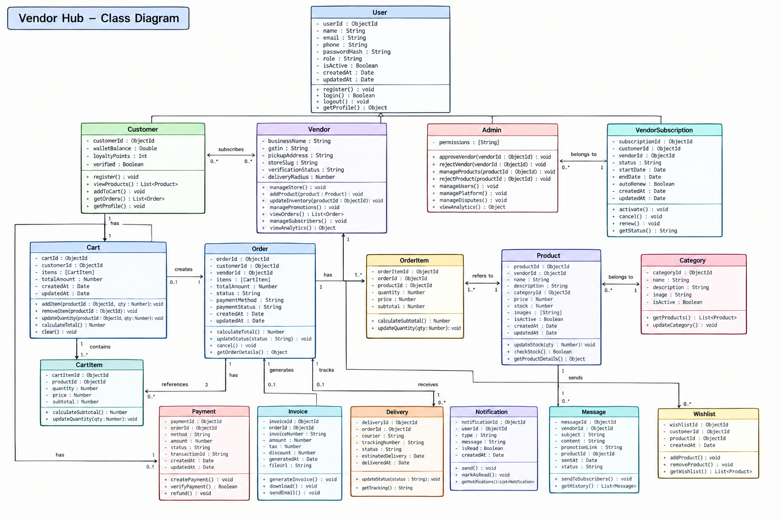
Fig 4.1 VendorHub Unified Object-Oriented Class Architecture Diagram

CHAPTER 5
TABLE STRUCTURES
VendorHub utilizes a highly normalized and performant MongoDB document schema managed through Mongoose ODM. Schemas are architected for rapid catalog reads, multi-vendor order aggregations, and strict atomic consistency during stock reservations. The detailed schema definitions are tabulated below:
Users Collection (users) :
Field Name | Data Type | Constraints | Description
_id | ObjectId | Primary Key | Unique identifier for the user account
name | String | Required, Trim | Full name of the user or authorized representative
email | String | Required, Unique, Lowercase | Unique login email address
password | String | Required (Hashed) | Bcrypt hashed password (cost factor = 10)
role | String | Enum (customer, vendor, admin) | Role-based access level for system authorization
phone | String | Optional | Contact phone number for notifications and OTP
vendorProfile | Subdoc | Optional | Business name, GSTIN, store description, logo, address
status | String | Enum (active, suspended, pending) | Account status; default is active
isVerified | Boolean | Default: false | Email / KYC verification status flag
createdAt / updatedAt | Date | Timestamps | Automatic creation and audit modification timestamps
Products Collection (products) :
Field Name | Data Type | Constraints | Description
_id | ObjectId | Primary Key | Unique identifier for the product item
vendor | ObjectId | Ref: User, Required, Index | Merchant owning the listed merchandise
name | String | Required, Index | Official product title and trade name
sku | String | Required, Unique, Uppercase | Unique merchant Stock Keeping Unit identifier
barcode | String | Required, Unique, Index | EAN-13 / UPC physical barcode string
category | String | Required, Index | Category taxonomy (Electronics, Fashion, Grocery...)
price | Number | Required, Min: 0 | Selling retail price in INR (₹)
mrp | Number | Required, Min: 0 | Maximum Retail Price for discount calculations
stock | Number | Required, Min: 0 | Current physical warehouse quantity on-hand
lowStockThreshold | Number | Default: 5 | Trigger threshold for low-stock vendor notifications
approvalStatus | String | Enum (pending, approved, rejected) | Admin catalog governance status; default: pending
rejectionReason | String | Optional | Mandatory audit explanation when admin rejects listing
images | Array[String] | Required | Array of high-resolution product image URLs
isPhysical | Boolean | Default: true | Enforces physical inventory logistics compliance
createdAt / updatedAt | Date | Timestamps | Automatic creation and audit modification timestamps
Orders Collection (orders) :
Field Name | Data Type | Constraints | Description
_id | ObjectId | Primary Key | Unique identifier for the order record
orderNumber | String | Required, Unique, Index | Human-readable order tracking ID (e.g., ORD-2026-9821)
customer | ObjectId | Ref: User, Required, Index | Customer who placed the purchase
items | Array[Subdoc] | Required, Non-empty | List of SKUs, vendor ID, quantity, unit price, tax
totalAmount | Number | Required, Min: 0 | Net payable order value in INR (₹)
paymentMethod | String | Enum (razorpay, upi, cod) | Chosen payment channel for the order
paymentStatus | String | Enum (pending, paid, failed) | Payment gateway confirmation state
deliveryStatus | String | Enum (Processing, Dispatched, Delivered, Cancelled) | Logistics fulfillment lifecycle status
deliveryOtp | String | 4-digit String, Encrypted | Tamper-proof OTP required for doorstep handover
deliveryAddress | Subdoc | Required | Street, city, postal code, recipient phone
courierPartner | String | Optional | Assigned logistics carrier (BlueDart, Delhivery, etc.)
trackingNumber | String | Optional | Consignment tracking number for courier dispatch
createdAt / updatedAt | Date | Timestamps, Index | Transaction and modification timestamps
Vendor Applications Collection (vendorapplications) :
Field Name | Data Type | Constraints | Description
_id | ObjectId | Primary Key | Unique identifier for the onboarding application
userId | ObjectId | Ref: User, Required, Unique | User account requesting merchant registration
businessName | String | Required, Trim | Registered enterprise or storefront name
gstin | String | Required, 15-char Regex | Government GST Identification Number
panNumber | String | Required, 10-char Regex | Permanent Account Number for tax audits
storeCategory | String | Required | Primary business merchandise category
pickupAddress | Subdoc | Required | Physical warehouse address for courier pickups
status | String | Enum (pending, approved, rejected) | Application review status; default: pending
rejectionNotes | String | Optional | Auditor feedback explaining rejection reason
reviewedBy | ObjectId | Ref: User, Optional | Admin account that reviewed the application
createdAt / updatedAt | Date | Timestamps | Application submission and decision dates
Stock Movements Collection (stockmovements) :
Field Name | Data Type | Constraints | Description
_id | ObjectId | Primary Key | Unique identifier for the stock movement ledger entry
product | ObjectId | Ref: Product, Required, Index | Target product SKU modified
vendor | ObjectId | Ref: User, Required | Merchant owning the inventory
movementType | String | Enum (intake, order_deduct, audit_adjust, return_restock) | Categorization of stock balance change
quantityDelta | Number | Required | Signed change in inventory (+/- integer units)
stockAfter | Number | Required, Min: 0 | Resulting physical balance after the movement
referenceId | String | Optional | Order ID, intake consignment, or dispute ticket
reason | String | Optional | Audit explanation for manual corrections
performedBy | ObjectId | Ref: User, Required | User or automated worker initiating update
createdAt | Date | Index, Default: Date.now | Timestamp of inventory transaction

Disputes Collection (disputes) :
Field Name | Data Type | Constraints | Description
_id | ObjectId | Primary Key | Unique identifier for the customer dispute ticket
order | ObjectId | Ref: Order, Required, Index | Associated order containing disputed items
customer | ObjectId | Ref: User, Required | Customer who initiated the grievance
vendor | ObjectId | Ref: User, Required | Merchant responsible for the merchandise
reason | String | Enum (Damaged, Wrong Item, Missing Item, Defective) | Official category of customer grievance
description | String | Required | Detailed explanation of customer claim
evidenceImages | Array[String] | Optional | URLs of unboxing photos or damage evidence
status | String | Enum (open, vendor_responded, resolved, rejected) | Lifecycle status of dispute ticket
vendorResponse | String | Optional | Merchant's clarification or resolution offer
resolutionOutcome | String | Enum (Refund Issued, Replacement Sent, Claim Dismissed) | Final arbitration decision by Admin
resolvedBy | ObjectId | Ref: User, Optional | Admin superuser who resolved the claim
createdAt / updatedAt | Date | Timestamps | Filing and resolution audit timestamps
Invoices Collection (invoices) :
Field Name | Data Type | Constraints | Description
_id | ObjectId | Primary Key | Unique identifier for the tax invoice document
invoiceNumber | String | Required, Unique, Index | Sequential GST invoice ID (e.g., INV-2026-0045)
order | ObjectId | Ref: Order, Required | Order reference for the invoice
vendor | ObjectId | Ref: User, Required | Merchant entity issuing the tax invoice
customer | ObjectId | Ref: User, Required | Billing customer recipient
subtotal | Number | Required | Taxable merchandise total (₹)
cgstAmount | Number | Required | Central GST tax calculated (e.g., 9%)
sgstAmount | Number | Required | State GST tax calculated (e.g., 9%)
totalAmount | Number | Required | Gross invoice value inclusive of all taxes
pdfUrl | String | Optional | Storage URL for downloadable PDF tax invoice
createdAt | Date | Timestamps, Index | Date and time of invoice generation
Vendor Subscriptions Collection (vendorsubscriptions) :
Field Name | Data Type | Constraints | Description
_id | ObjectId | Primary Key | Unique identifier for merchant subscription tier
vendor | ObjectId | Ref: User, Required, Unique | Subscribed merchant user account
planName | String | Enum (Starter, Professional, Enterprise) | Active tier determining catalog SKU limits
productLimit | Number | Required | Maximum physical SKUs allowed (50 / 500 / Unlimited)
commissionRate | Number | Required | Platform commission percentage (e.g., 5%, 8%, 12%)
startDate | Date | Required | Start timestamp of current billing cycle
renewalDate | Date | Required, Index | Expiration and renewal due date
paymentStatus | String | Enum (Active, Past Due, Cancelled) | Subscription billing status
createdAt / updatedAt | Date | Timestamps | Automatic audit timestamps
Platform Activity Logs Collection (platformactivitylogs) :
Field Name | Data Type | Constraints | Description
_id | ObjectId | Primary Key | Unique identifier for the audit event log
actionType | String | Required, Index | Category: LOGIN, PRODUCT_APPROVAL, DISPUTE_RESOLVE...
user | ObjectId | Ref: User, Optional | Account performing the action
ipAddress | String | Optional | Client IPv4 / IPv6 address for security audit
details | Object | Optional | Arbitrary structured JSON metadata of the event
createdAt | Date | Index, Default: Date.now | Timestamp of audit event creation
Otps Collection (otps) :
Field Name | Data Type | Constraints | Description
_id | ObjectId | Primary Key | Unique identifier for temporary OTP record
emailOrPhone | String | Required, Index | Recipient target for OTP delivery
otpCode | String | Required (Hashed) | Bcrypt hashed 4-digit or 6-digit verification code
purpose | String | Enum (signup, password_reset, delivery_handover) | Context of verification
expiresAt | Date | TTL Index (expires: 0) | Automatic MongoDB expiry eviction time (5-15 mins)

CHAPTER 6
ER DIAGRAM
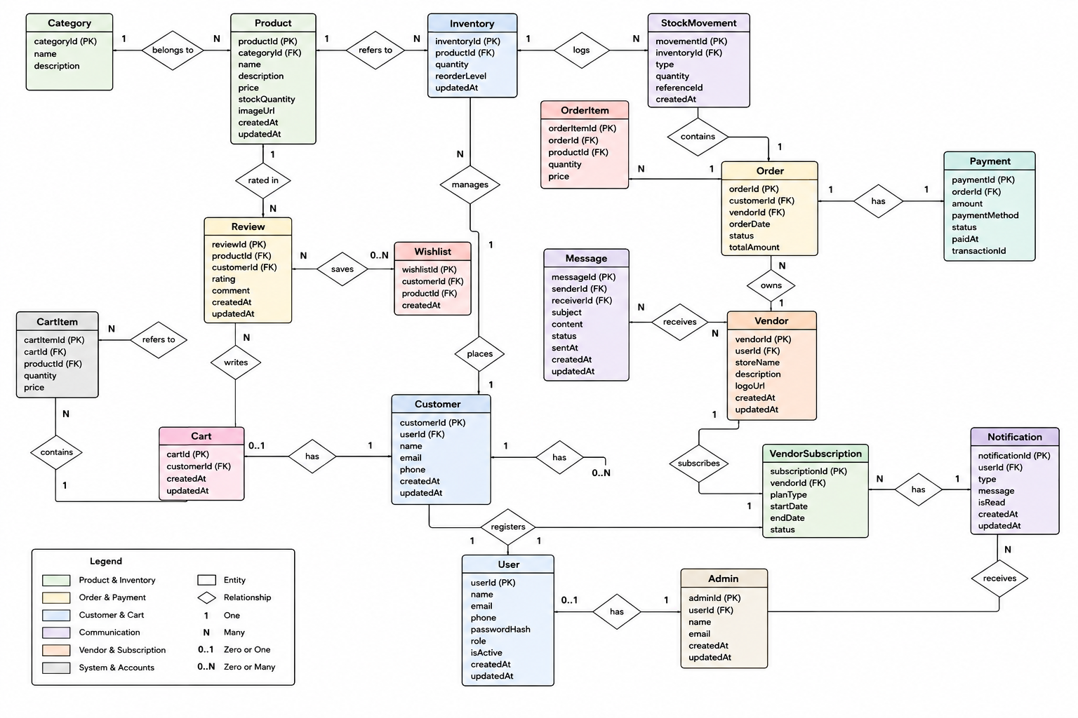
Fig 6.1 VendorHub Entity-Relationship (ER) Schema Diagram

CHAPTER 7
TECH STACK
7.1 TECH STACK BREAKDOWN
Layer | Technology | Purpose / Architectural Role
Frontend SPA Framework | React.js 18 (Vite Bundler) | Component-driven reactive user interface, fast hot module replacement, and modern virtual DOM
Styling & Design System | Vanilla CSS + Custom Design Tokens | Ultra-responsive CSS variables, glassmorphic accents, dark/light theme engine, and zero CSS runtime overhead
Icons & Assets | Lucide React | Comprehensive SVG icons for status badges, logistics pins, currency symbols, and navigational drawers
State Management | React Context API (8 Providers) | Modular stores: AuthContext, ProductContext, CartContext, DisputeContext, LanguageContext, ThemeContext, CompareContext, ToastContext
HTTP Client | Axios | REST communication with automatic JWT Authorization header injection and 401 unauthenticated interceptor
Payment Gateway | Razorpay.js + Dynamic UPI QR | PCI-DSS compliant hosted checkout, card tokenization, UPI intent deep-linking, and server-side HMAC-SHA256 signature verification
Backend Runtime & API | Node.js (LTS) + Express.js 4 | High-throughput asynchronous non-blocking event-driven RESTful micro-controllers
ODM & Data Layer | Mongoose 8 + MongoDB Atlas | Schema validation, strict type casting, compound indexing, population of references, and resilient in-memory fallback
Authentication & Security | JWT (jsonwebtoken) + bcryptjs | Stateless bearer token authentication with 12-hour validity and salted password hashing (cost factor = 10)
Security Hardening | Helmet, CORS, express-rate-limit | HTTP security headers, restrictive origin whitelisting, and brute-force protection (15 attempts / 15 min per IP)
Internationalization (i18n) | Custom Multilingual Engine | Native 6-language dictionary (English, Tamil, Hindi, Malayalam, Telugu, Kannada) with instant zero-reload script switching
7.2 ARCHITECTURE OVERVIEW (MVC PATTERN)

Layer | Technology | Purpose
Model | Mongoose ODM + MongoDB Atlas | Defines relational document schemas, enforces validation rules, manages indexes, and handles data persistence
View | React.js 18 + Context API | Renders component UI across Customer, Vendor, and Admin portals; handles reactive state and emits Axios HTTP requests
Controller | Node.js + Express.js Micro-Controllers | Processes incoming API calls, executes business rules (stock decrements, OTP generation, payment verification), and returns JSON payloads
Middleware | Auth Guards, Rate Limiter, Error Interceptors | Verifies JWT tokens, enforces RBAC route protection, throttles requests, and captures exceptions centrally
Services | Razorpay, OTP Hasher, Activity Logger | Encapsulates reusable external integrations and transactional business helper functions

CHAPTER 8
MODULES
8.0 Design Approach & System-Wide Baseline
Each module of VendorHub is documented here using a standardized, seven-step system design methodology. This rigorous format ensures architectural comparability, highlights trade-offs, and details both the algorithmic backend design and client-facing interfaces.

Step | Question it answers | Presented in each module as
1. Functional Requirements | What must the module accomplish? | Section 8.x.1 (Sections 8.2.1 – 8.9.1)
2. Non-Functional Requirements | Performance latency, availability, security, and CAP theorem trade-offs | Section 8.x.2 (Sections 8.2.2 – 8.9.2)
3. Tech Stack Breakdown | Which frameworks and libraries solve this domain, and why? | Section 8.x.3 (Sections 8.2.3 – 8.9.3)
4. Back-of-the-Envelope Estimation | Capacity planning: users, requests/sec, payload size, and storage growth | Section 8.x.4 (Sections 8.2.4 – 8.9.4)
5. Low-Level Architecture | Component interaction flow, middleware chain, and request lifecycle | Section 8.x.5 (Diagram + Request Flow)
6. API Design | REST endpoints, HTTP methods, authorization, and JSON contracts | Section 8.x.6 (API Contracts)
7. DB Design | Collections, indexes, schema references, and consistency semantics | Section 8.x.7 (Database Schemas)
8. Screenshots & User Interface | Visual output screens and feature interface walkthrough | Section 8.x.8 (UI Screenshots)

System-Wide Shared Baseline: Every HTTP request travels through Helmet security headers, CORS origin verification, JSON payload size capping (10MB), express-rate-limit throttling, and JWT authentication middleware before reaching business controllers. VendorHub prioritizes Strong Consistency over Availability (CP in CAP theorem): an order or inventory operation is immediately aborted rather than allowing conflicting or oversold physical inventory balances.
Sizing Baseline (Working Assumptions) :
Metric | Estimate | Basis
Registered Vendors | ≈ 500 active merchants | Regional multi-vendor onboarding projection
Active Customers | ≈ 50,000 users | Target regional marketplace consumers
Orders per Day | ≈ 2,500 orders / day | Combined multi-merchant daily order throughput
Vendor Inventory Updates | ≈ 5,000 operations / day | Warehouse stock intake, adjustments, and updates
Peak Transaction Load | ≈ 35 - 50 req / second | Festival flash sales and evening shopping spikes

A single clustered Node.js instance backed by MongoDB Atlas handles this load comfortably. Because session authentication is completely stateless (via client-held JWT tokens), horizontal scaling is achieved effortlessly by deploying additional containerized Node.js workers behind an Nginx reverse proxy.
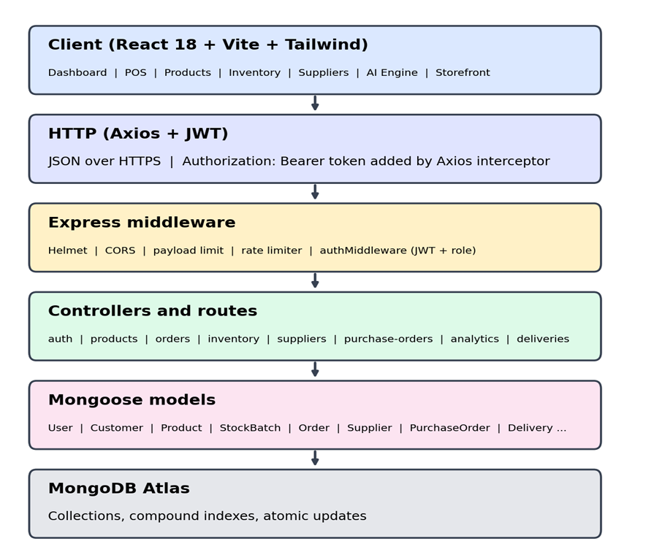
Fig 8.0 Overall System Request & Middleware Flow of VendorHub

The client application emits HTTPS requests with Bearer JWT tokens, passing through Helmet, CORS, Rate Limiting, and Auth Middleware before reaching route controllers and MongoDB Atlas collections.
8.1 FOLDER STRUCTURE
VendorHub adopts a clean separation of concerns with isolated backend and frontend directory structures.
8.1.1 Backend Directory Architecture :
Directory / File | Contents & Architectural Role
config/ | Database connection scripts (db.js) and environment configuration
controllers/ | Micro-controllers: auth, product, order, dispute, inventory, analytics, vendorApplication, store, subscription, invoice, message
middleware/ | authMiddleware (JWT & RBAC verification), rateLimiters, uploadMiddleware, errorHandler
models/ | Mongoose schemas: User, Product, Order, Dispute, StockMovement, VendorApplication, VendorSubscription, Invoice, ActivityLog, OTP
routes/ | Express routers: /api/auth, /api/products, /api/orders, /api/disputes, /api/inventory, /api/analytics, /api/vendor-applications
utils/ | activityLogger.js, razorpay.js, tokenGenerator.js, otpGenerator.js, emailService.js
server.js | Main application entry point configuring middleware pipeline, database connection, and API mounting
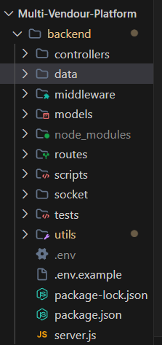
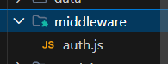
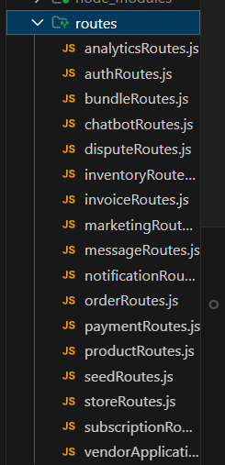
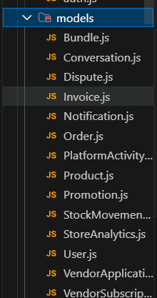
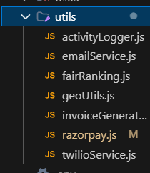
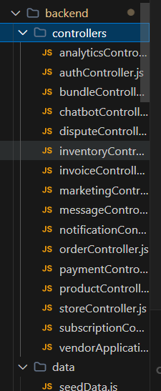
Fig 8.1.1 Backend Folder Structure in IDE
High-level view of the backend directory showing modular controllers, middleware, models, routes, and utilities.

8.1.2 Frontend Directory Architecture :

Directory / File | Contents & Architectural Role
src/components/admin/ | AdminDashboard.jsx, AdminVendors.jsx, AdminProducts.jsx, AdminDisputes.jsx, AdminLogin.jsx
src/components/vendor/ | VendorDashboard.jsx, VendorProducts.jsx, AddProduct.jsx, SmartInventory.jsx, VendorOrders.jsx, StoreBuilder.jsx, VendorAnalytics.jsx, VendorDisputes.jsx
src/components/customer/ | ProductListing.jsx, ProductDetail.jsx, Cart.jsx, Orders.jsx, UpiQrCode.jsx, ProductComparison.jsx, DisputeModal.jsx, StoreDirectory.jsx
src/contexts/ | AuthContext, ProductContext, CartContext, DisputeContext, LanguageContext, ThemeContext, ComparisonContext, ToastContext
src/services/ | api.js (Axios instance configured with Bearer JWT interceptors and error handling)
src/styles/ & index.css | Modern vanilla CSS design tokens, responsive variables, dark/light theme properties, and micro-animations
src/App.jsx & main.jsx | Root application shell configuring React Router DOM v6 role-guarded routes and global context providers
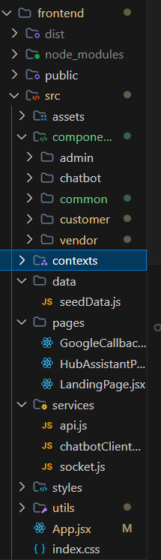
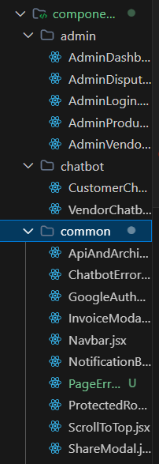
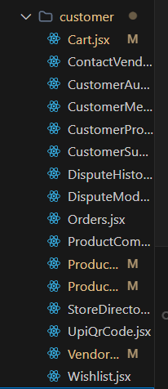
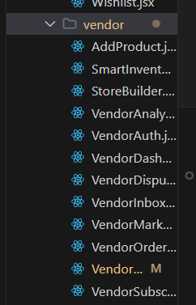
Fig 8.1.2 Frontend Folder Structure in IDE
High-level view of the frontend directory showing components segregated into admin, vendor, and customer domains alongside context providers.
8.2 USER AUTHENTICATION & MULTI-ROLE ACCESS CONTROL (RBAC)
8.2.0 Purpose & Scope: Provides secure user authentication, role-based authorization (Customer, Vendor, Super Administrator), credential encryption, and session preservation. Guarantees endpoint isolation so that merchants cannot access other vendors' data and customers cannot invoke administrative APIs.
● 8.2.1 Functional Requirements: Users authenticate with email/password; receives signed JWT token (12-hour expiry) with user profile; automated role detection routes users to customer storefront, vendor merchant suite, or admin console; password changes require old credential validation; new customer signups support instant account creation.
● 8.2.2 Non-Functional Requirements: Passwords hashed via bcryptjs with salt rounds = 10; brute-force protection caps login attempts at 15 per 15 minutes per IP address; token verification completes in under 1 ms; strict CORS prevents unauthorized cross-origin credential sharing.

Concern | Choice | Why it fits this module
Password Hashing | bcryptjs (10 rounds) | Pure JS implementation providing salted password hashing resistant to rainbow table attacks
Tokenization | jsonwebtoken (JWT) | Stateless bearer tokens carrying user ID, role, and expiration timestamp in Authorization header
Rate Limiting | express-rate-limit | Memory-efficient IP-based request throttling against brute-force attacks
Route Guards | React Router v6 + ProtectedRoute | Client-side guard components redirecting unauthorized roles to appropriate login screens
Quantity | Estimate | Basis
Active User Accounts | ≈ 50,000 documents (≈ 30 MB) | 50k customers + 500 merchants + 5 administrators
Daily Login Invocations | ≈ 6,000 logins / day | Customer shopping sessions and merchant dashboard logins
Bcrypt Verification Latency | ≈ 80 - 120 ms CPU time | Intentionally compute-intensive to thwart brute-force cracking
JWT Token Size | ≈ 220 bytes | Compact token footprint stored in localStorage
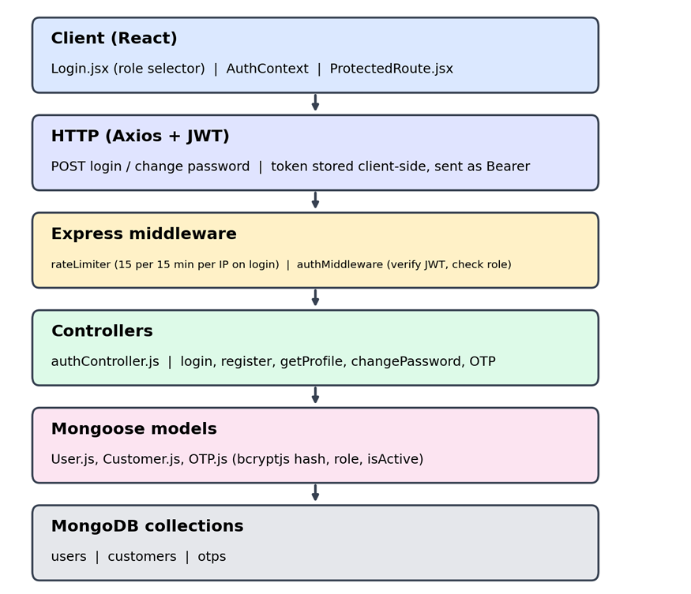
Fig 8.2.A Low-Level Architecture Flow — User Authentication & RBAC
Request lifecycle showing client login dispatch, rate limiter middleware, bcrypt password comparison, JWT token signing, and client-side storage.
Method | Endpoint | Purpose / Contract
POST | /api/auth/login | Public. Body: {email, password, role}. Validates credentials and returns JWT bearer token + user profile.
POST | /api/auth/register | Public. Body: {name, email, password, role, phone}. Creates new customer or vendor account.
GET | /api/auth/profile | Protected (JWT). Returns current authenticated user profile, role, and vendor metadata.
PUT | /api/auth/change-password | Protected (JWT). Body: {currentPassword, newPassword}. Verifies old password and saves new hash.
Collection | Keys & Indexes | Key Fields Stored
users | PK: _id, UNIQUE: email | _id, name, email, password (hashed), role, phone, vendorProfile, status, createdAt
platformactivitylogs | PK: _id, Index: actionType, createdAt | _id, actionType (LOGIN), user, ipAddress, details, createdAt
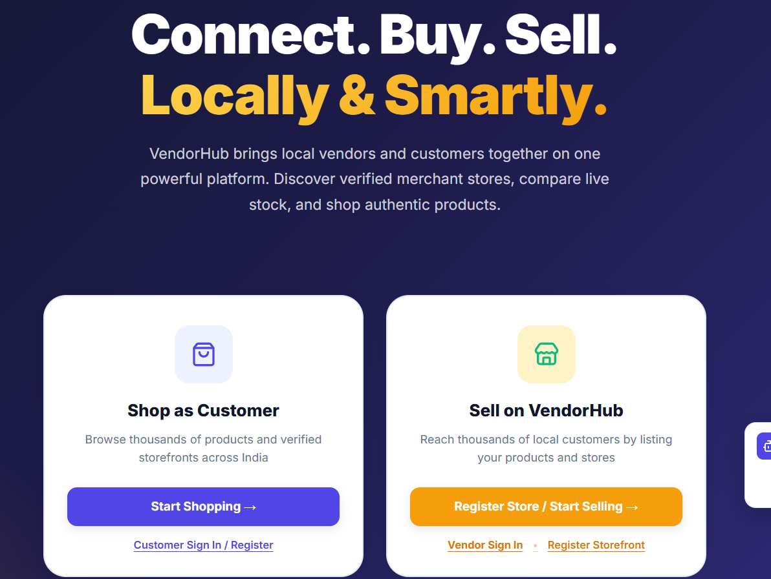
Fig 8.2.1 Secure Authentication and Role Selection Portal
Login interface featuring role switching tabs (Customer / Vendor / Admin), email and password input fields, and secure JWT session creation.
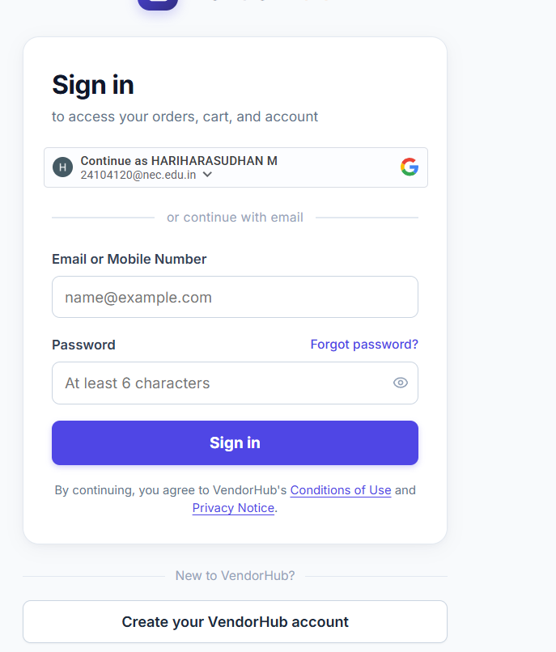

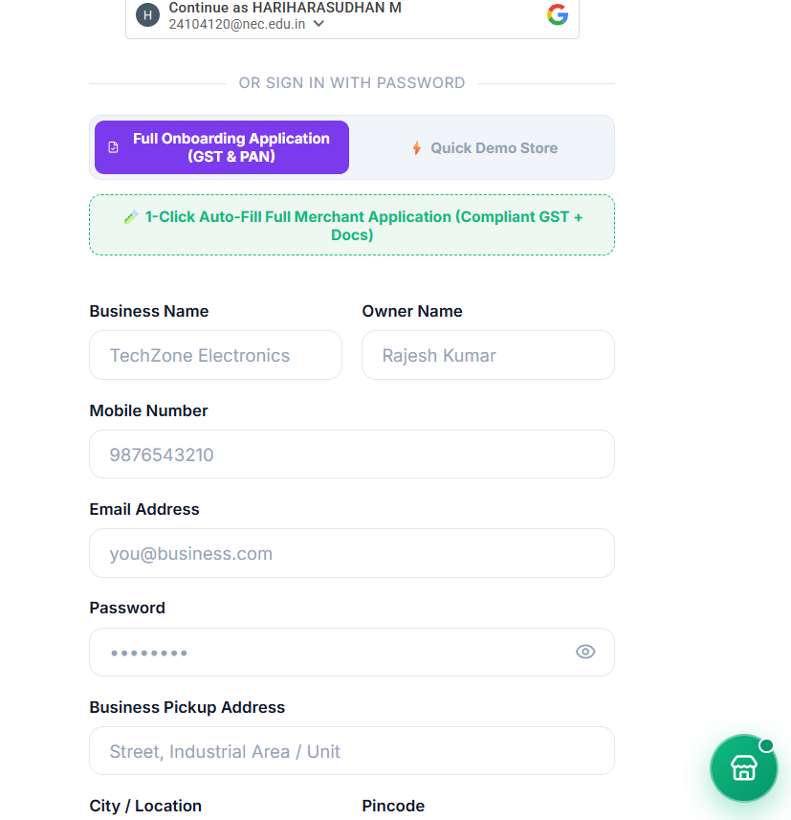

Fig 8.2.2 Customer and Merchant Registration Screen
Onboarding registration form capturing full name, email, mobile number, password, and account role selection.
8.3 VENDOR ONBOARDING, STOREFRONT BUILDER & CATALOG GOVERNANCE
8.3.0 Purpose & Scope: Coordinates merchant KYC registration, GSTIN verification, custom storefront customization, and administrative product catalog moderation to guarantee zero-counterfeit listings.
● 8.3.1 Functional Requirements: Vendors submit business profiles including GSTIN, PAN, and warehouse pickup addresses; admin reviews vendor applications with approve/reject options; vendors access Store Builder to define banner graphics, store bio, and featured SKUs; newly added SKUs enter a pending governance queue; admin audits and approves/rejects with mandatory feedback.
● 8.3.2 Non-Functional Requirements: GSTIN validation enforced via 15-character statutory regex; catalog approvals reflect instantaneously across marketplace; audit trail logs all admin decisions.
Concern | Choice | Why it fits this module
Form Validation | Regex + Schema Rules | Strict client and server validation of 15-digit GSTIN and 10-digit PAN tax identifiers
Storefront Branding | Vanilla CSS Custom Tokens | Dynamic brand theme injection allowing vendors to customize store accent colors
Governance Audit | PlatformActivityLog | Immutable audit logging capturing admin ID, timestamp, and rejection reasons
Quantity | Estimate | Basis
Merchant Applications | ≈ 500 records (≈ 1 MB) | Total registered merchant storefront applications
Catalog Submissions | ≈ 100 new SKUs / day | Daily batch submissions requiring administrative auditing
Admin Audit Queue | < 25 pending items at peak | Two-tier verification queue maintained by platform moderators
Request flow showing vendor KYC application submission, admin review queue, status update to approved, and catalog visibility unlock.
Method | Endpoint | Purpose / Contract
POST | /api/vendor-applications | Protected (Vendor). Body: {businessName, gstin, pan, address}. Submits merchant KYC application.
GET | /api/vendor-applications | Protected (Admin). Query: {status}. Fetches pending or approved vendor applications.
PUT | /api/vendor-applications/:id/status | Protected (Admin). Body: {status, rejectionNotes}. Approves or rejects merchant application.
PUT | /api/products/:id/approval | Protected (Admin). Body: {approvalStatus, rejectionReason}. Moderates physical catalog SKU.
Collection | Keys & Indexes | Key Fields Stored
vendorapplications | PK: _id, UNIQUE: userId | _id, userId, businessName, gstin, panNumber, pickupAddress, status, rejectionNotes
products | PK: _id, Index: approvalStatus, vendor | _id, vendor, name, sku, price, stock, approvalStatus, rejectionReason
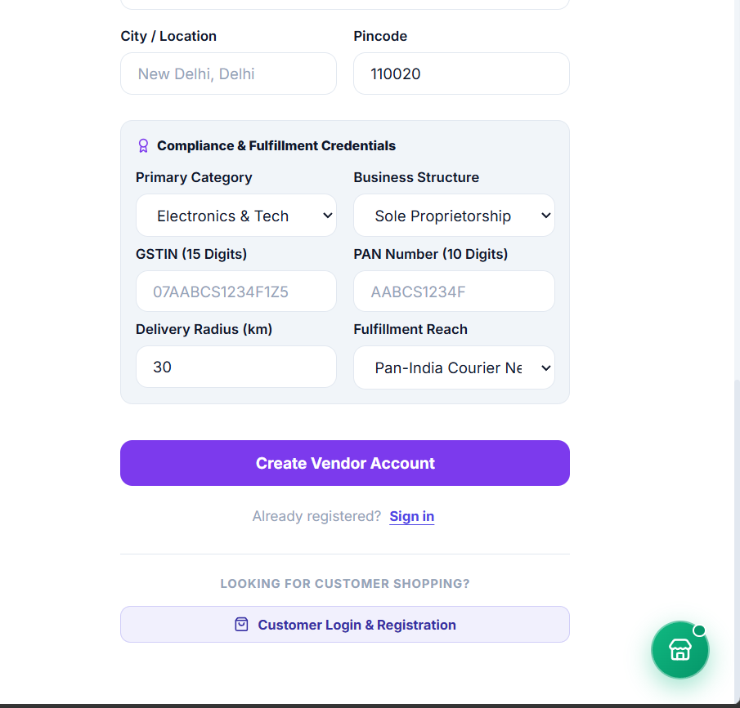
Fig 8.3.1 Vendor Onboarding and KYC Verification Screen
Interface for submitting business name, GSTIN, PAN, and warehouse pickup location for administrative review.
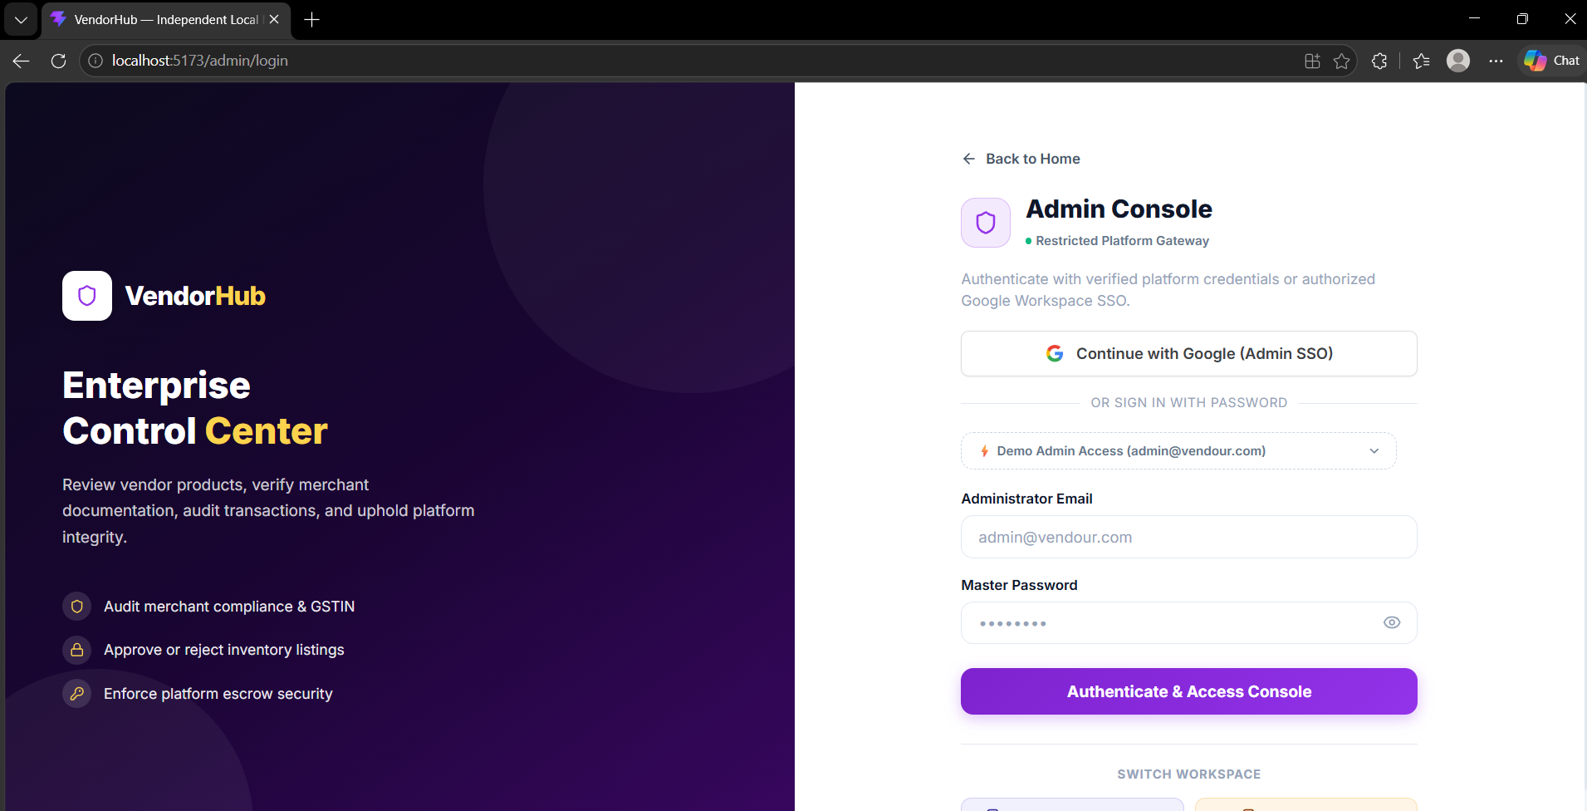
Fig 8.3.2 Admin Catalog Governance & Product Moderation Queue
Admin panel displaying pending merchant product submissions with actions to approve, reject with notes, or inspect specifications.
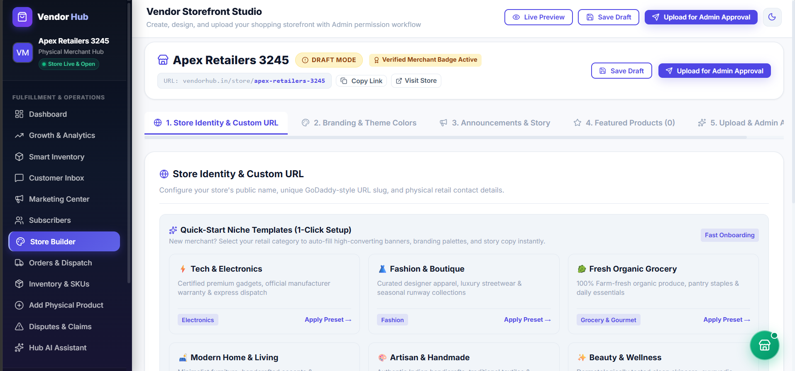
Fig 8.3.3 Vendor Storefront Builder Interface
Merchant portal enabling store banner customization, storefront bio editing, and featured product selection.
8.4 PHYSICAL PRODUCT CATALOG & WAREHOUSE INVENTORY MANAGEMENT
8.4.0 Purpose & Scope: Coordinates physical SKU specifications, barcode indexing, category filters, and real-time warehouse inventory balances. Enforces the platform's core zero-ghost inventory promise.
● 8.4.1 Functional Requirements: Vendors create, update, and manage physical products with unique SKUs and barcodes; products categorized across Electronics, Fashion, Grocery, etc.; real-time stock balances displayed with Low Stock (< 5) and Out of Stock badges; merchants execute manual stock adjustments with mandatory audit reason logging.
● 8.4.2 Non-Functional Requirements: Product list paginated (12 items per page) to ensure < 200 ms response times; unique indexes on SKU and barcode prevent inventory collisions; atomic updates prevent race conditions during concurrent orders.
Concern | Choice | Why it fits this module
Catalog Browsing | React Virtual Cards + Search | Responsive product cards with live search, price filters, and stock badges
Atomic Decrements | Mongoose findOneAndUpdate | Guarantees race-condition-free stock reservations: {$inc: {stock: -qty}}
Audit Tracking | StockMovement Collection | Immutable audit log recording every inventory intake, sale decrement, and adjustment
Quantity | Estimate | Basis
Total Marketplace SKUs | ≈ 10,000 products (≈ 15 MB) | Inventory across 500 active merchant stores
Catalog Browsing Requests | ≈ 80,000 requests / day | Customer shopping, search, and category filter views
Stock Balance Query Latency | < 25 ms | Served via indexed MongoDB queries on category, vendor, and approvalStatus
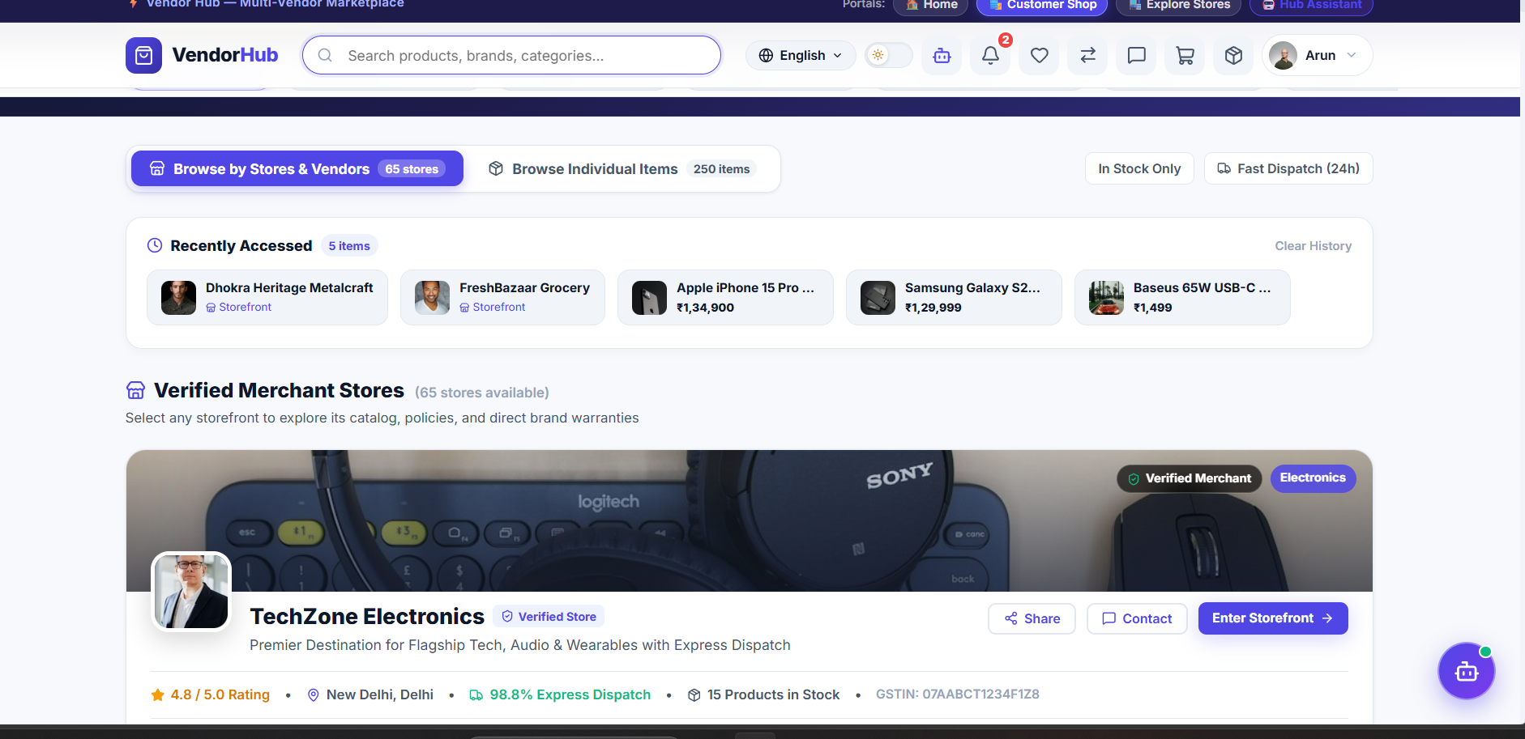
Fig 8.4.A Low-Level Architecture Flow — Product Catalog & Inventory Reservation
Flow diagram showing product creation by vendor, barcode lookup, and atomic inventory update upon customer order placement.
Method | Endpoint | Purpose / Contract
GET | /api/products | Public. Query: {search, category, vendor, page, limit}. Fetches approved products with pagination.
POST | /api/products | Protected (Vendor). Body: {name, sku, barcode, price, mrp, stock, category, images}. Creates new SKU.
PUT | /api/products/:id | Protected (Vendor). Body: updated product fields. Modifies pricing, stock threshold, or imagery.
POST | /api/inventory/adjust | Protected (Vendor). Body: {productId, delta, reason}. Records stock movement and updates balance.
Collection | Keys & Indexes | Key Fields Stored
products | PK: _id, UNIQUE: sku, barcode, Index: category | _id, vendor, name, sku, barcode, price, mrp, stock, approvalStatus
stockmovements | PK: _id, Index: product, vendor, createdAt | _id, product, vendor, movementType, quantityDelta, stockAfter, reason
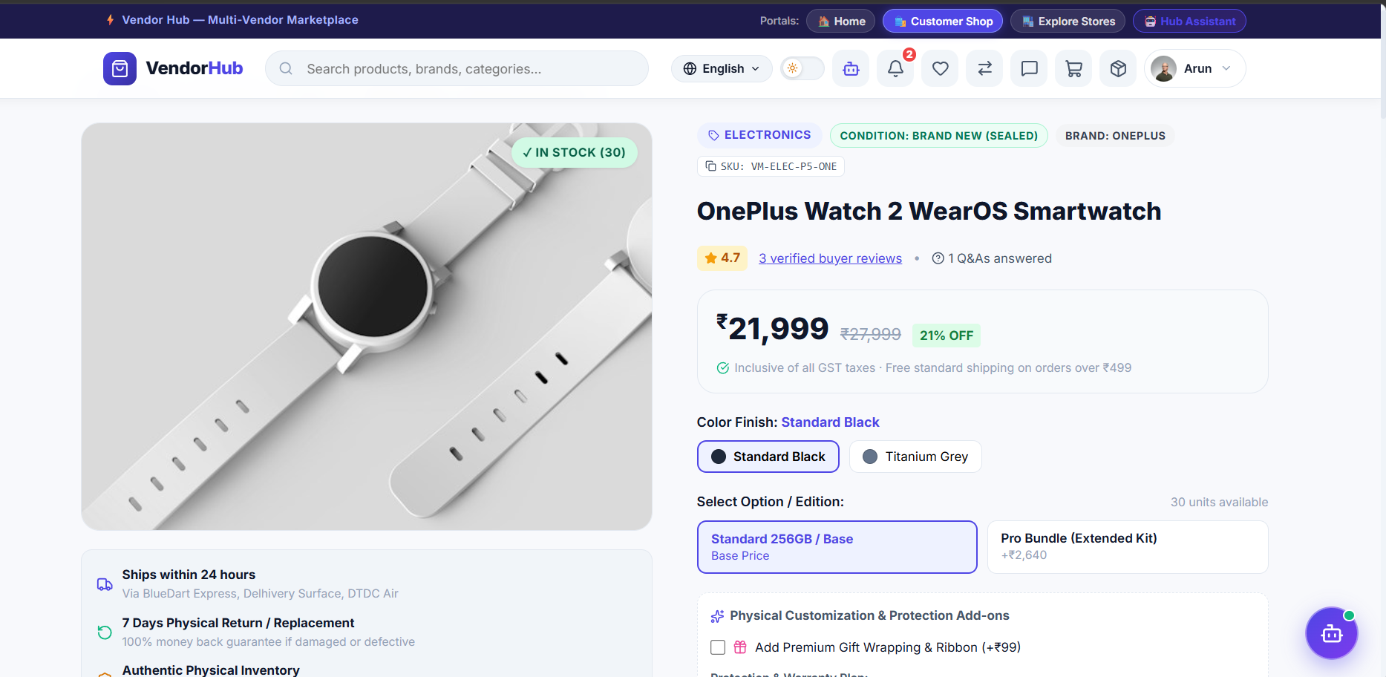
Fig 8.4.1 Enterprise Product Catalog Grid with Multi-Facet Filters
Marketplace product catalog displaying product image, price, discount badge, stock availability, and merchant name.
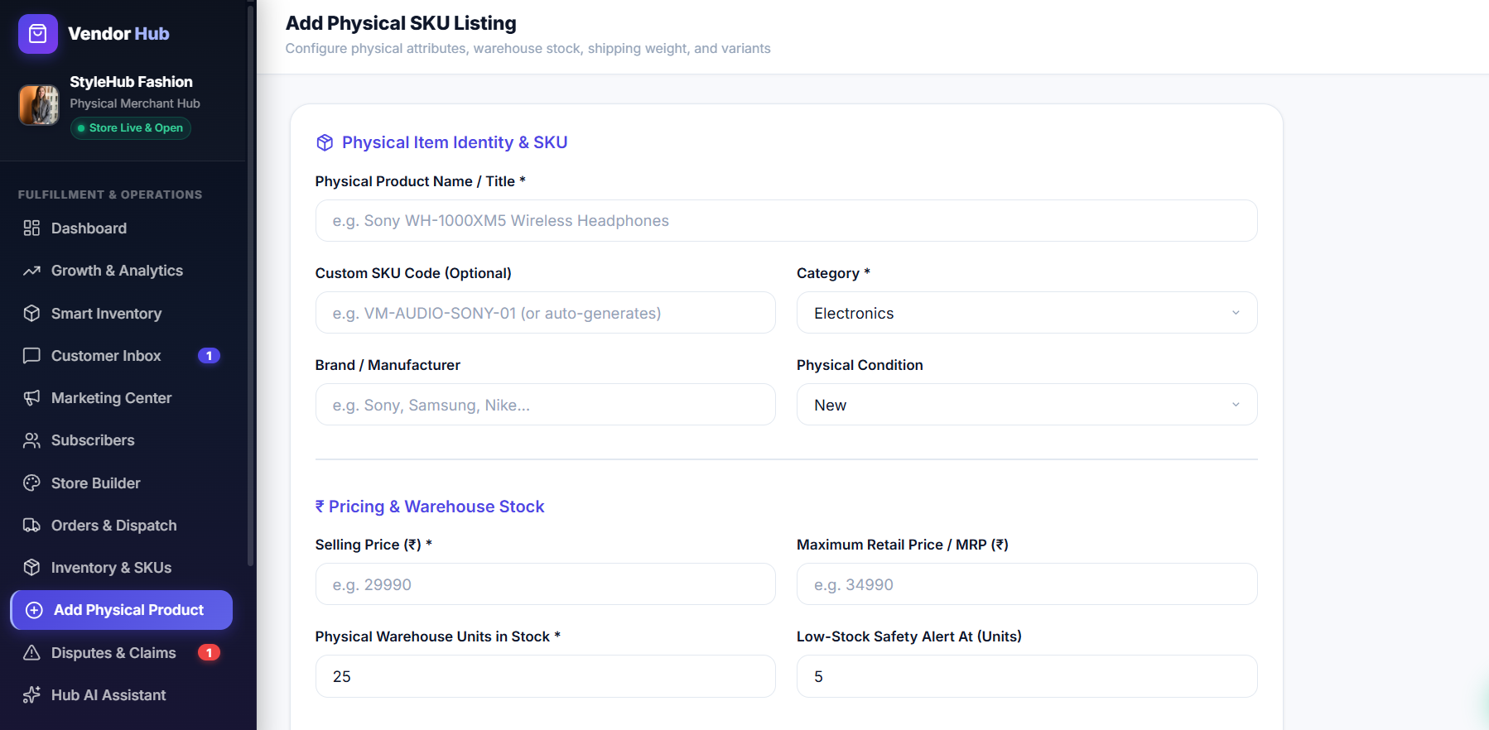
Fig 8.4.2 Add Physical Product & SKU Creation Portal
Merchant form capturing product name, brand, SKU code, barcode, warehouse stock count, pricing, and image upload.
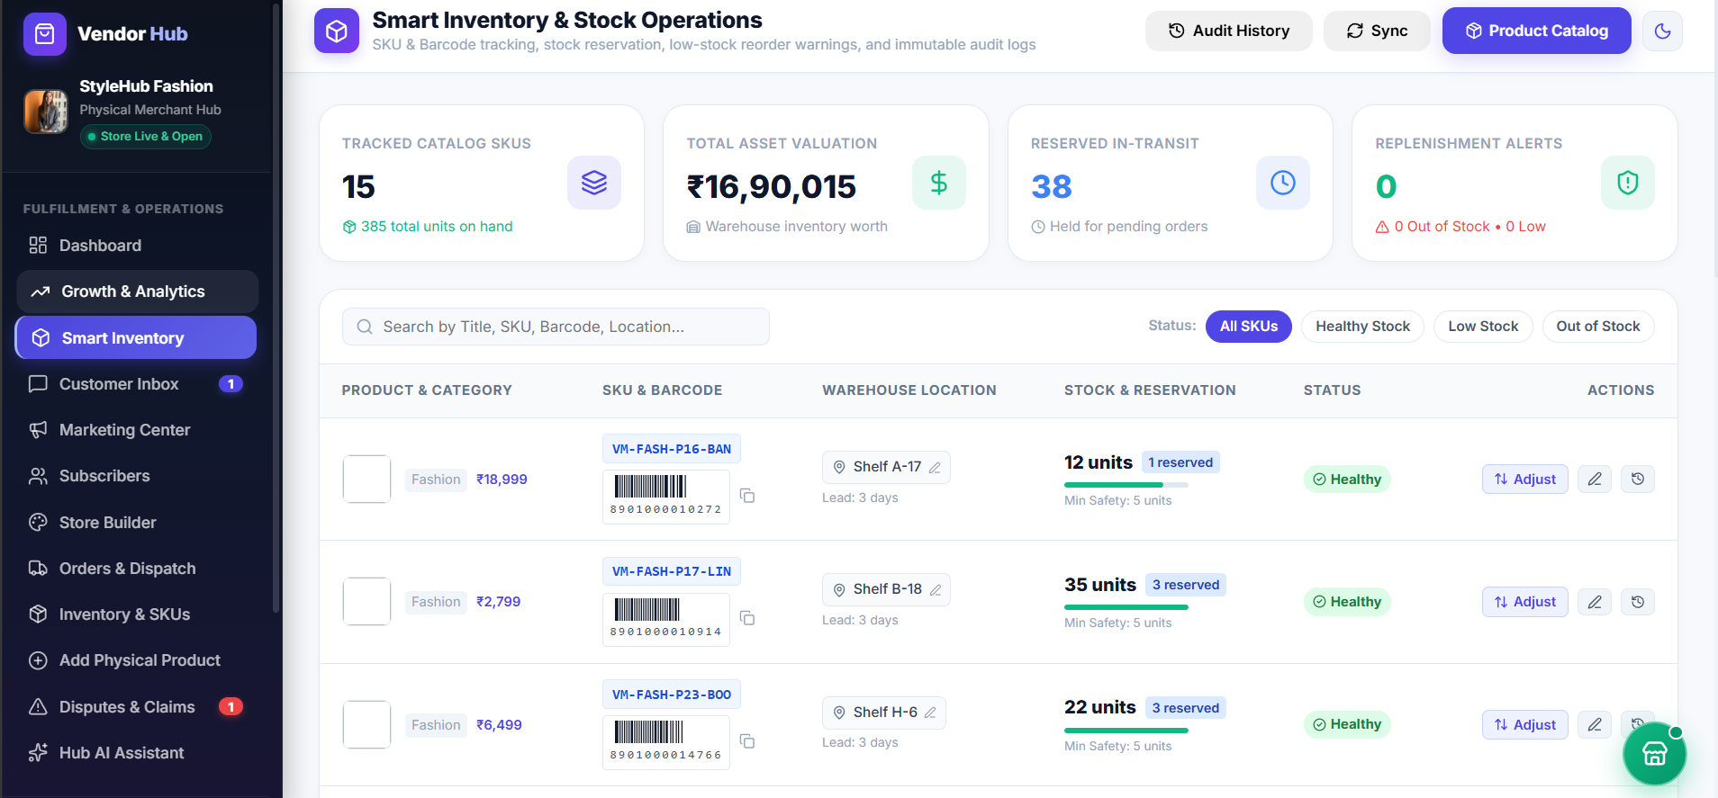
Fig 8.4.3 Smart Inventory Management & Stock Adjustment Console
Warehouse stock table with low-stock badges, current balance, and quick stock adjustment modal.
8.5 MULTI-VENDOR CART, SPLIT ORDERS & CHECKOUT (RAZORPAY / UPI / COD)
8.5.0 Purpose & Scope: Coordinates multi-merchant shopping baskets, calculates taxes and delivery fees, provides flexible payments (Razorpay, UPI QR, COD), and generates cryptographically protected 4-digit handover OTPs.
● 8.5.1 Functional Requirements: Customers add items from multiple merchants into a unified cart; cart groups line items per merchant; checkout calculates subtotal, GST, and total; payment choices include Razorpay online payment, dynamic UPI QR code, and Cash on Delivery (COD); order creation triggers 4-digit delivery OTP generation.
● 8.5.2 Non-Functional Requirements: Razorpay webhook / signature verification validates payment tamper-proofing; checkout execution completes in < 150 ms; atomic stock deduction rollback occurs if payment authorization fails.
Concern | Choice | Why it fits this module
Cart State | React Context API (CartContext) | Persistent client-side basket preserved across browser navigation and refreshes
Payment Gateway | Razorpay API + Webhooks | Industry-standard payment processing supporting UPI, credit/debit cards, and netbanking
Dynamic UPI QR | Custom SVG QR Generator | Encodes merchant UPI VPA, order amount, and transaction reference into instant scannable QR
Quantity | Estimate | Basis
Daily Checkout Invocations | ≈ 2,500 completed orders / day | Combined online transactions across the platform
Cart Items per Order | ≈ 3.5 items average | Typical multi-merchant shopping basket
Payment Verification Latency | < 300 ms round-trip | Server-to-Razorpay API cryptographic signature check
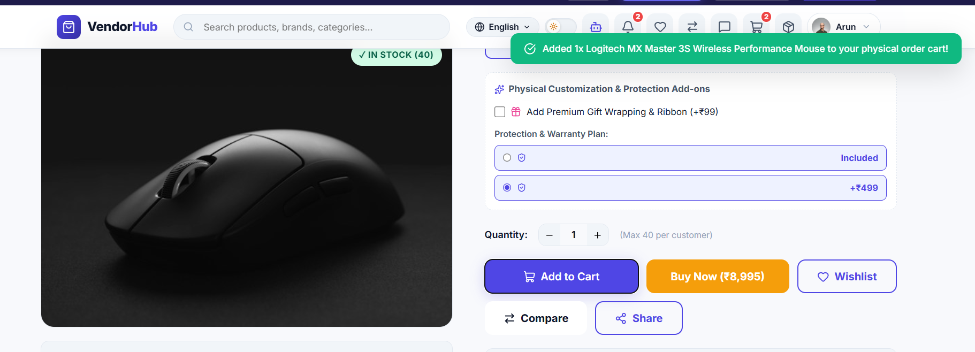
Fig 8.5.A Low-Level Architecture Flow — Checkout & Multi-Channel Payment
Request sequence: Cart submission, Razorpay order generation, client signature capture, server-side HMAC validation, and order database insertion.
Method | Endpoint | Purpose / Contract
POST | /api/payment/create-order | Protected (Customer). Body: {amount, currency}. Generates a Razorpay order ID.
POST | /api/payment/verify | Protected (Customer). Body: {razorpay_order_id, razorpay_payment_id, razorpay_signature}. Verifies HMAC.
POST | /api/orders | Protected (Customer). Body: {items, shippingAddress, paymentMethod, paymentDetails}. Creates order & OTP.
GET | /api/orders/my-orders | Protected (Customer). Fetches logged-in customer's complete order history with live status.
Collection | Keys & Indexes | Key Fields Stored
orders | PK: _id, UNIQUE: orderNumber, Index: customer | _id, orderNumber, customer, items, totalAmount, paymentMethod, paymentStatus, deliveryOtp
invoices | PK: _id, UNIQUE: invoiceNumber, Index: order | _id, invoiceNumber, order, vendor, customer, subtotal, cgstAmount, sgstAmount, totalAmount
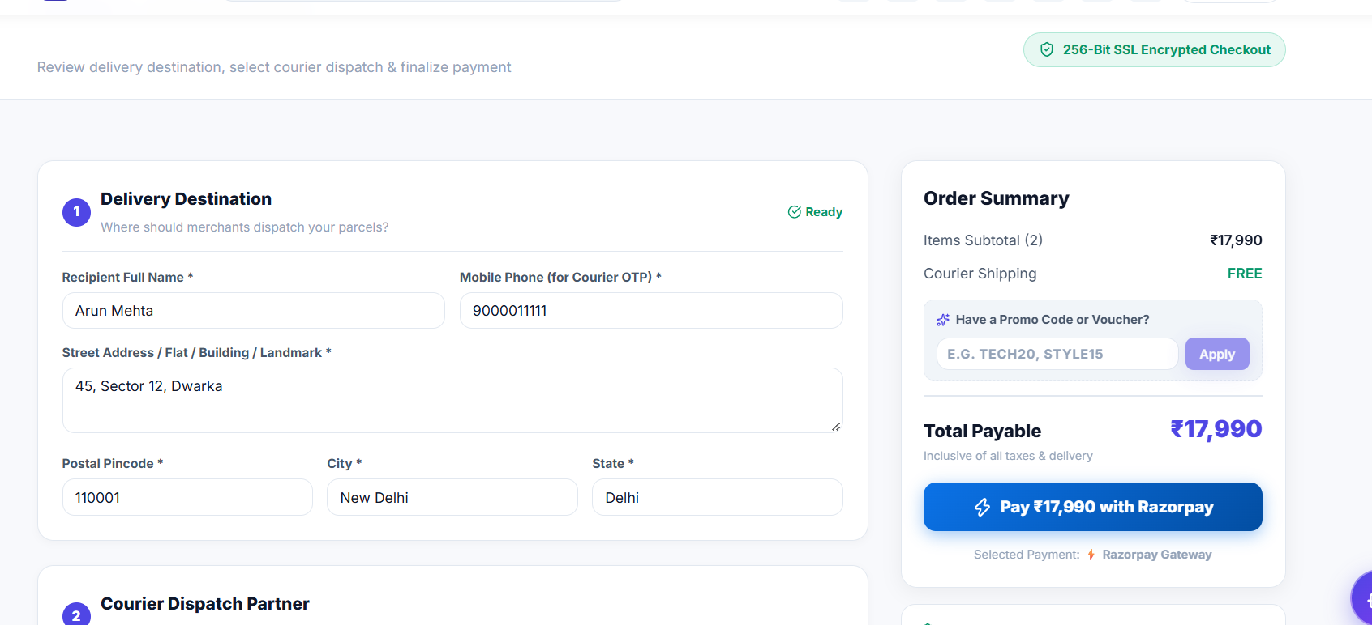
Fig 8.5.1 Multi-Vendor Interactive Cart & Price Summary Panel
Shopping cart screen showing items grouped with quantity counters, price breakdown, and checkout action.
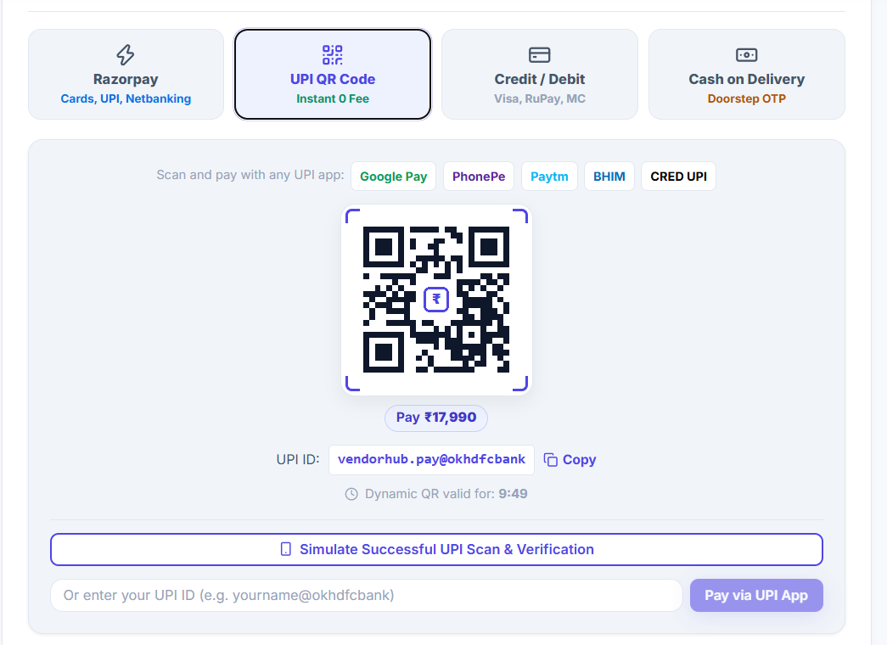
Fig 8.5.2 Dynamic UPI QR Code Payment Modal
Instant UPI payment dialog displaying dynamic QR code with order reference and transaction amount.
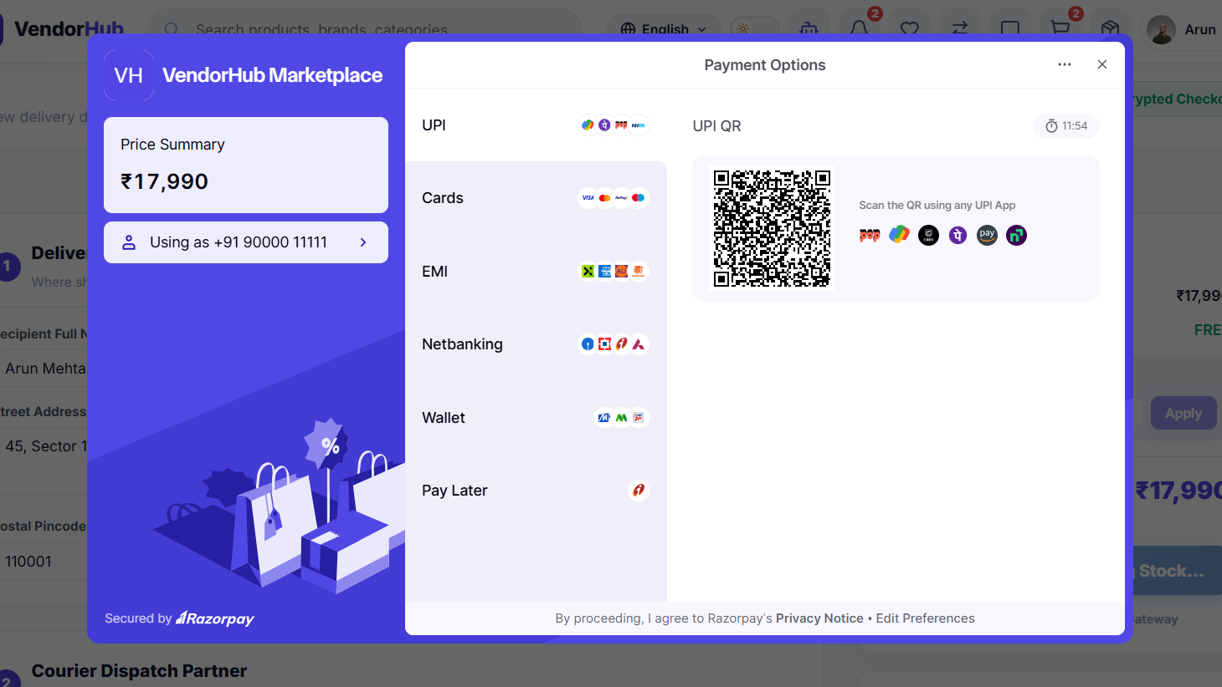
Fig 8.5.3 Razorpay Hosted Payment Gateway Checkout Screen
Razorpay secure payment checkout modal with cards, UPI, netbanking, and wallet options.
8.6 REAL-TIME LOGISTICS DISPATCH & 4-DIGIT OTP DOORSTEP DELIVERY
8.6.0 Purpose & Scope: Automates courier logistics dispatch, provides real-time shipment status tracking, and enforces tamper-proof delivery completion via 4-digit OTP verification at the customer's doorstep.
● 8.6.1 Functional Requirements: Vendors pack orders and assign courier partners; tracking lifecycle transitions: Processing -> Dispatched -> Out for Delivery -> Delivered; customer view displays tracking timeline; delivery agent enters customer's 4-digit OTP to complete handover; successful verification marks order as Delivered.
● 8.6.2 Non-Functional Requirements: OTP stored using bcrypt hash to prevent inspection; verification requests rate-limited to 5 tries to prevent brute-forcing; tracking timeline polls every 15 seconds.
Concern | Choice | Why it fits this module
Logistics Tracking | SVG Timeline Component | Visual milestone tracker representing fulfillment stages with timestamp tooltips
OTP Handover Verification | Bcrypt Comparison Engine | Ensures delivery agent cannot finalize delivery without customer providing physical OTP
Courier Integration | Consignment Reference Tracker | Stores courier partner metadata and external AWB tracking codes
Quantity | Estimate | Basis
Active Deliveries in Transit | ≈ 800 packages concurrently | Daily active delivery pipeline across regions
OTP Verifications / Day | ≈ 2,500 handoffs / day | One verification attempt per successful delivery
Tracking Page Refresh Calls | ≈ 15,000 requests / day | Customer order tracking page visits and status checks
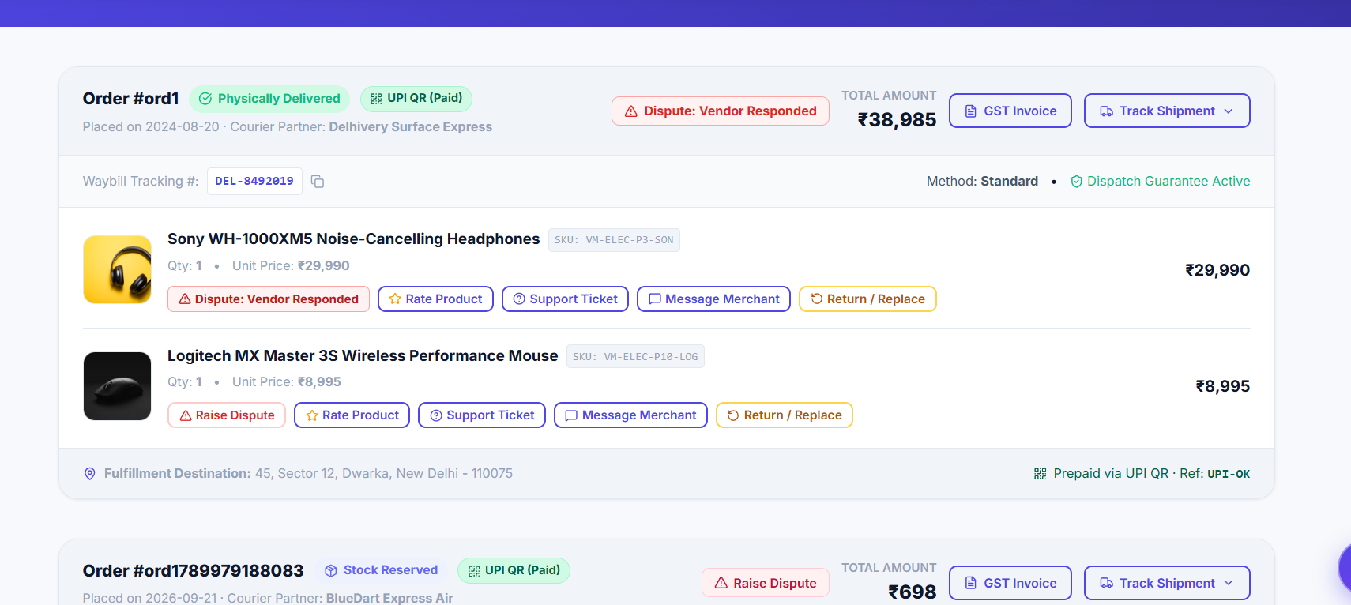
Fig 8.6.A Low-Level Architecture Flow — Logistics Dispatch & Doorstep OTP Handover
Flow showing vendor dispatch assignment, customer receiving 4-digit OTP, delivery agent submitting OTP, server bcrypt check, and order completion.
Method | Endpoint | Purpose / Contract
PUT | /api/orders/:id/dispatch | Protected (Vendor). Body: {courierPartner, trackingNumber}. Advances order to Dispatched.
GET | /api/orders/:id/tracking | Protected (Customer/Vendor). Returns fulfillment milestone history and tracking details.
POST | /api/orders/:id/verify-delivery | Protected. Body: {otp}. Compares provided OTP with order hash and marks Delivered.
Collection | Keys & Indexes | Key Fields Stored
orders | PK: _id, Index: deliveryStatus, trackingNumber | _id, orderNumber, deliveryStatus, deliveryOtp, courierPartner, trackingNumber, updatedAt
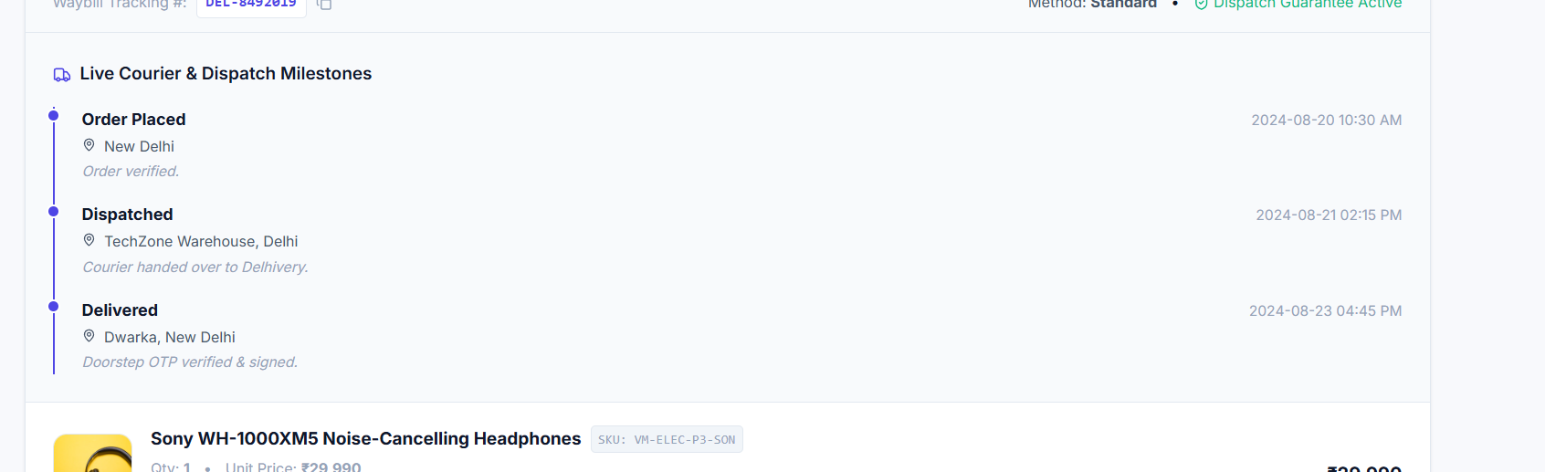
Fig 8.6.1 Real-Time Order Tracking Timeline & Delivery Status
Customer tracking view displaying fulfillment progress from Order Placed to Out for Delivery.
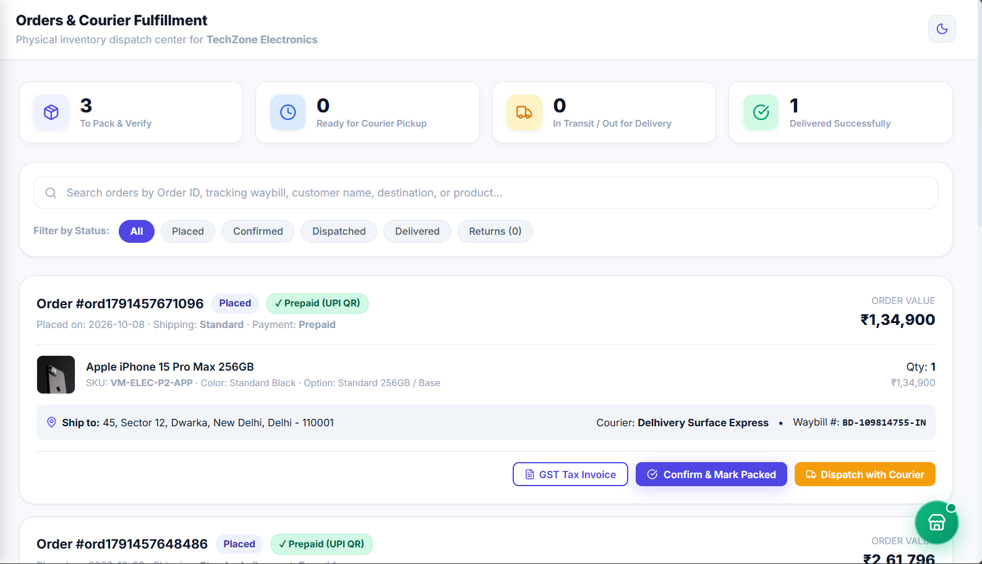
Fig 8.6.2 Vendor Order Fulfillment & Courier Dispatch Console
Merchant management panel for packing orders, printing shipping labels, and updating carrier details.
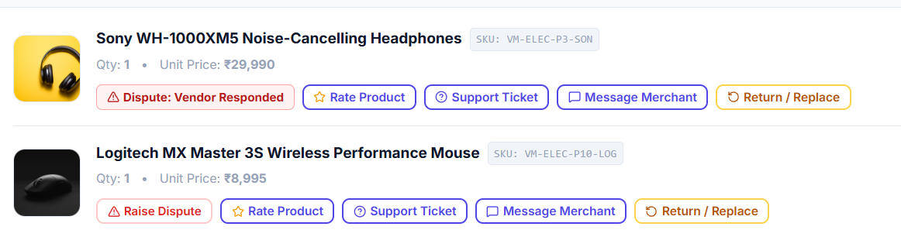
Fig 8.6.3 Doorstep Delivery 4-Digit OTP Handover Verification Dialog
Delivery confirmation dialog prompting courier agent for the customer's 4-digit verification code.
8.7 POST-DELIVERY DISPUTE RESOLUTION, AUDIT & WARRANTY CLAIMS
8.7.0 Purpose & Scope: Provides a centralized dispute arbitration system allowing customers to report damaged or incorrect items, enabling vendors to respond, and empowering administrators to resolve claims.
● 8.7.1 Functional Requirements: Customers file disputes within 7 days of delivery with reason and photo evidence; vendor alerted and submits explanation; admin reviews case history and arbitrates outcome (Refund, Replacement, Dismissal); platform automatically executes ledger updates upon refund approval.
● 8.7.2 Non-Functional Requirements: Evidence image URLs securely stored; dispute status changes trigger immutable audit logs; dispute resolution SLA monitored on admin dashboard.
Concern | Choice | Why it fits this module
Dispute Workflow | React Context (DisputeContext) | Synchronizes active claim status across customer, merchant, and admin consoles
Evidence Storage | Cloudinary / S3 Image URLs | Secure hosted image assets displaying unboxing photos and damage proof
Arbitration Engine | Mongoose Dispute Controller | Enforces state machine transitions: Open -> Vendor Responded -> Resolved
Quantity | Estimate | Basis
Dispute Claims Ratio | ≈ 1.5% of total orders | Industry standard return/damage claim frequency (≈ 35 claims/day)
Average Resolution Time | < 24 hours | Platform SLA for dispute mediation and arbitration
Evidence Payload Size | ≈ 2 - 4 MB per ticket | 2-3 compressed photos documenting packaging and product damage
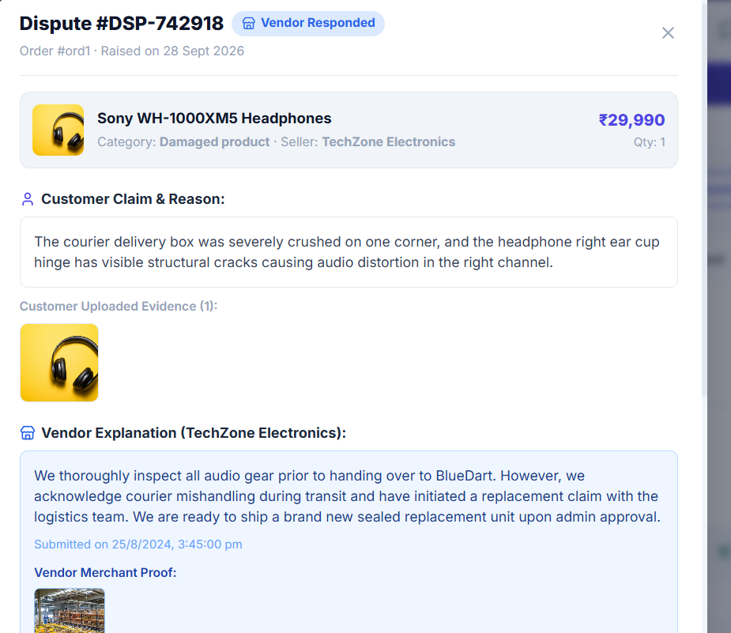
Fig 8.7.A Low-Level Architecture Flow — Dispute Mediation & Resolution
Flow diagram: Customer grievance submission, merchant notification, vendor response, admin arbitration, and financial ledger settlement.
Method | Endpoint | Purpose / Contract
POST | /api/disputes | Protected (Customer). Body: {orderId, reason, description, evidenceImages}. Creates dispute ticket.
GET | /api/disputes/vendor | Protected (Vendor). Returns disputes raised against the merchant's orders.
PUT | /api/disputes/:id/respond | Protected (Vendor). Body: {vendorResponse}. Submits merchant rebuttal or explanation.
PUT | /api/disputes/:id/resolve | Protected (Admin). Body: {outcome, notes}. Arbitrates claim and issues refund or closure.
Collection | Keys & Indexes | Key Fields Stored
disputes | PK: _id, Index: order, customer, vendor, status | _id, order, customer, vendor, reason, description, evidenceImages, status, resolutionOutcome
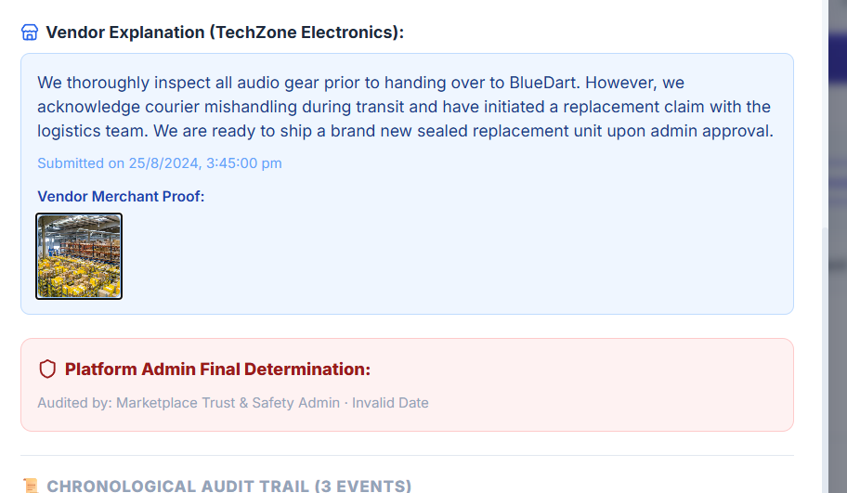
Fig 8.7.1 Customer Dispute Filing Modal with Evidence Upload
Customer modal allowing selection of dispute category (Damaged / Wrong Item), description, and photo attachments.
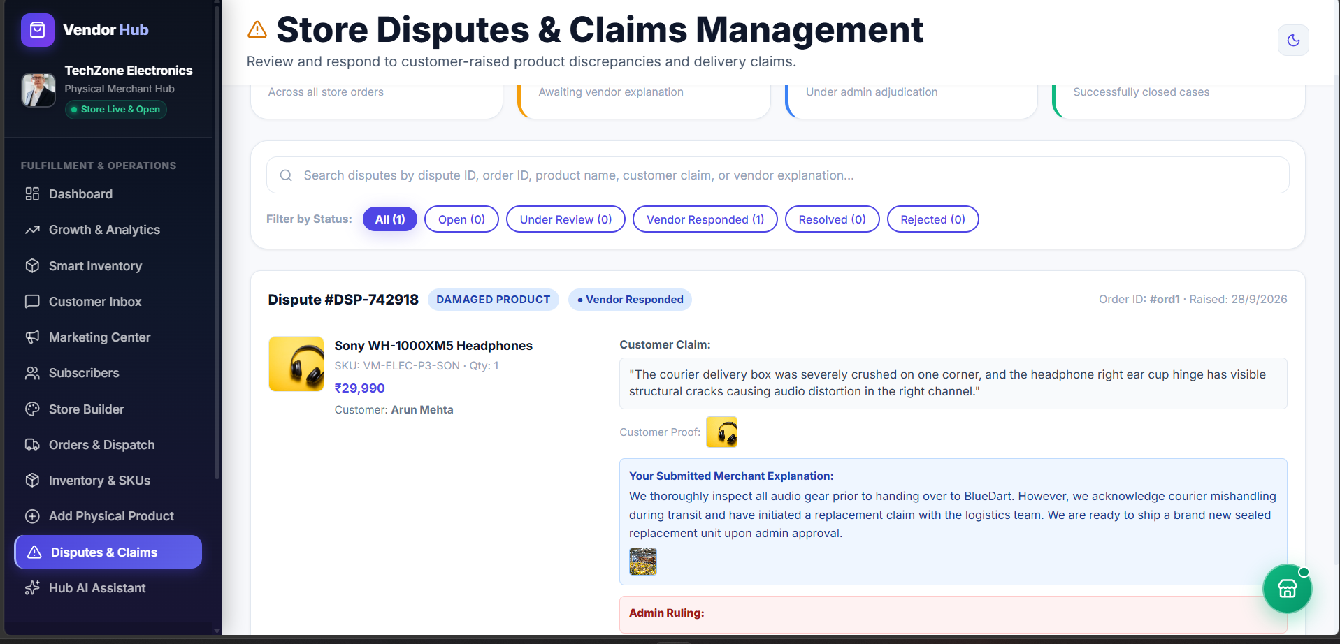
Fig 8.7.2 Vendor Dispute Management & Response Portal
Merchant console showing incoming customer claims with options to provide counter-evidence or accept returns.
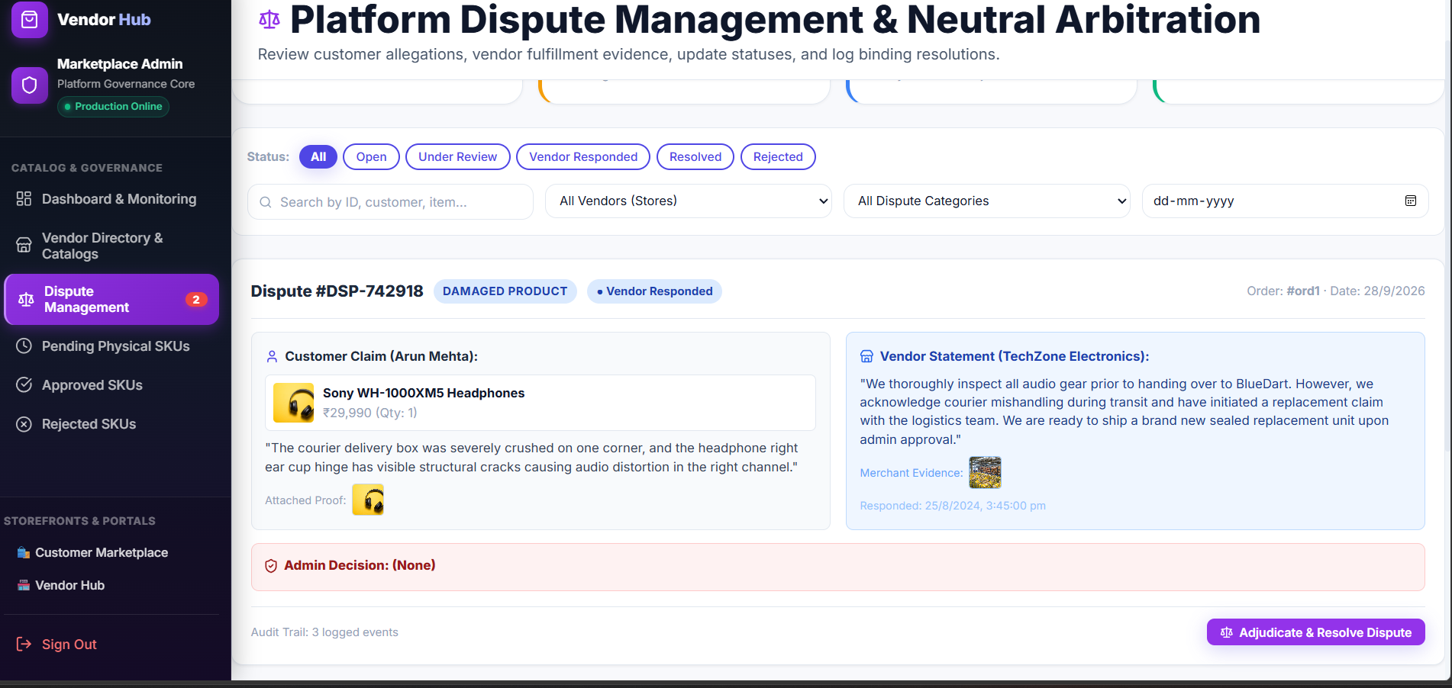
Fig 8.7.3 Admin Dispute Arbitration & Refund Resolution Console
Administrative panel displaying full case history, evidence gallery, and arbitration actions (Issue Refund / Dismiss).
8.8 EXECUTIVE DASHBOARD, VENDOR REVENUE SETTLEMENTS & SUBSCRIPTIONS
8.8.0 Purpose & Scope: Delivers real-time executive analytics for platform administrators and merchants, tracking Gross Merchandise Value (GMV), platform fee commissions, net payouts, subscription tiers, and tax invoices.
● 8.8.1 Functional Requirements: Admin dashboard displays total revenue, active vendors, orders, and dispute rates; vendor dashboard presents net sales, payout balance, and sales velocity; system automates platform commission deductions based on subscription tier (Starter, Pro, Enterprise); generates downloadable GST tax invoices.
● 8.8.2 Non-Functional Requirements: Dashboard analytics compute in < 150 ms using MongoDB $facet aggregations; financial numbers rounded to two decimal places; role guards restrict executive figures to authorized personnel.
Concern | Choice | Why it fits this module
Analytics Engine | MongoDB $facet Pipeline | Executes multi-dimensional KPI aggregations, revenue trends, and top vendor metrics in a single database round-trip
Charts & Visuals | Custom SVG Interactive Charts | Lightweight, responsive line, bar, and donut charts with zero external charting library bloat
Tax Invoicing | Automated GST Calculation | Enforces 9% CGST + 9% SGST split on intra-state merchant transactions
Quantity | Estimate | Basis
Daily Financial Aggregations | ≈ 2,500 transactions / day | Aggregated across 500 merchant accounts
Commission Invoices / Month | ≈ 500 vendor payout statements | Generated at the conclusion of monthly settlement cycles
Analytics Query Latency | < 60 ms | Optimized with compound indexes on orders: {createdAt: -1, totalAmount: 1}
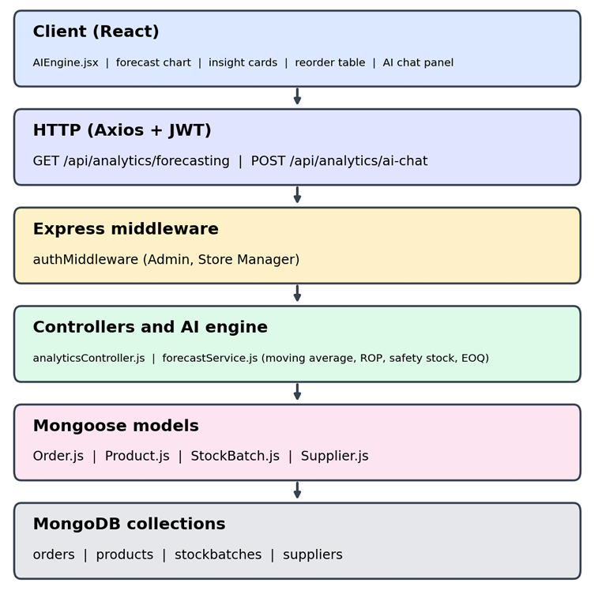
Fig 8.8.A Low-Level Architecture Flow — Analytics & Merchant Financial Settlement
Flow showing transaction aggregation pipeline, platform fee calculation, merchant wallet crediting, and invoice document generation.
Method | Endpoint | Purpose / Contract
GET | /api/analytics/admin | Protected (Admin). Returns platform-wide GMV, vendor counts, order volume, and dispute metrics.
GET | /api/analytics/vendor | Protected (Vendor). Returns merchant sales trend, net earnings, and fast-moving SKUs.
GET | /api/subscriptions | Protected (Vendor). Fetches active subscription plan, product limits, and renewal dates.
GET | /api/invoices/:id | Protected. Returns GST tax invoice details with tax breakdown.
Collection | Keys & Indexes | Key Fields Stored
vendorsubscriptions | PK: _id, UNIQUE: vendor | _id, vendor, planName, productLimit, commissionRate, startDate, renewalDate
invoices | PK: _id, UNIQUE: invoiceNumber, Index: order, vendor | _id, invoiceNumber, order, vendor, customer, subtotal, cgstAmount, sgstAmount, totalAmount
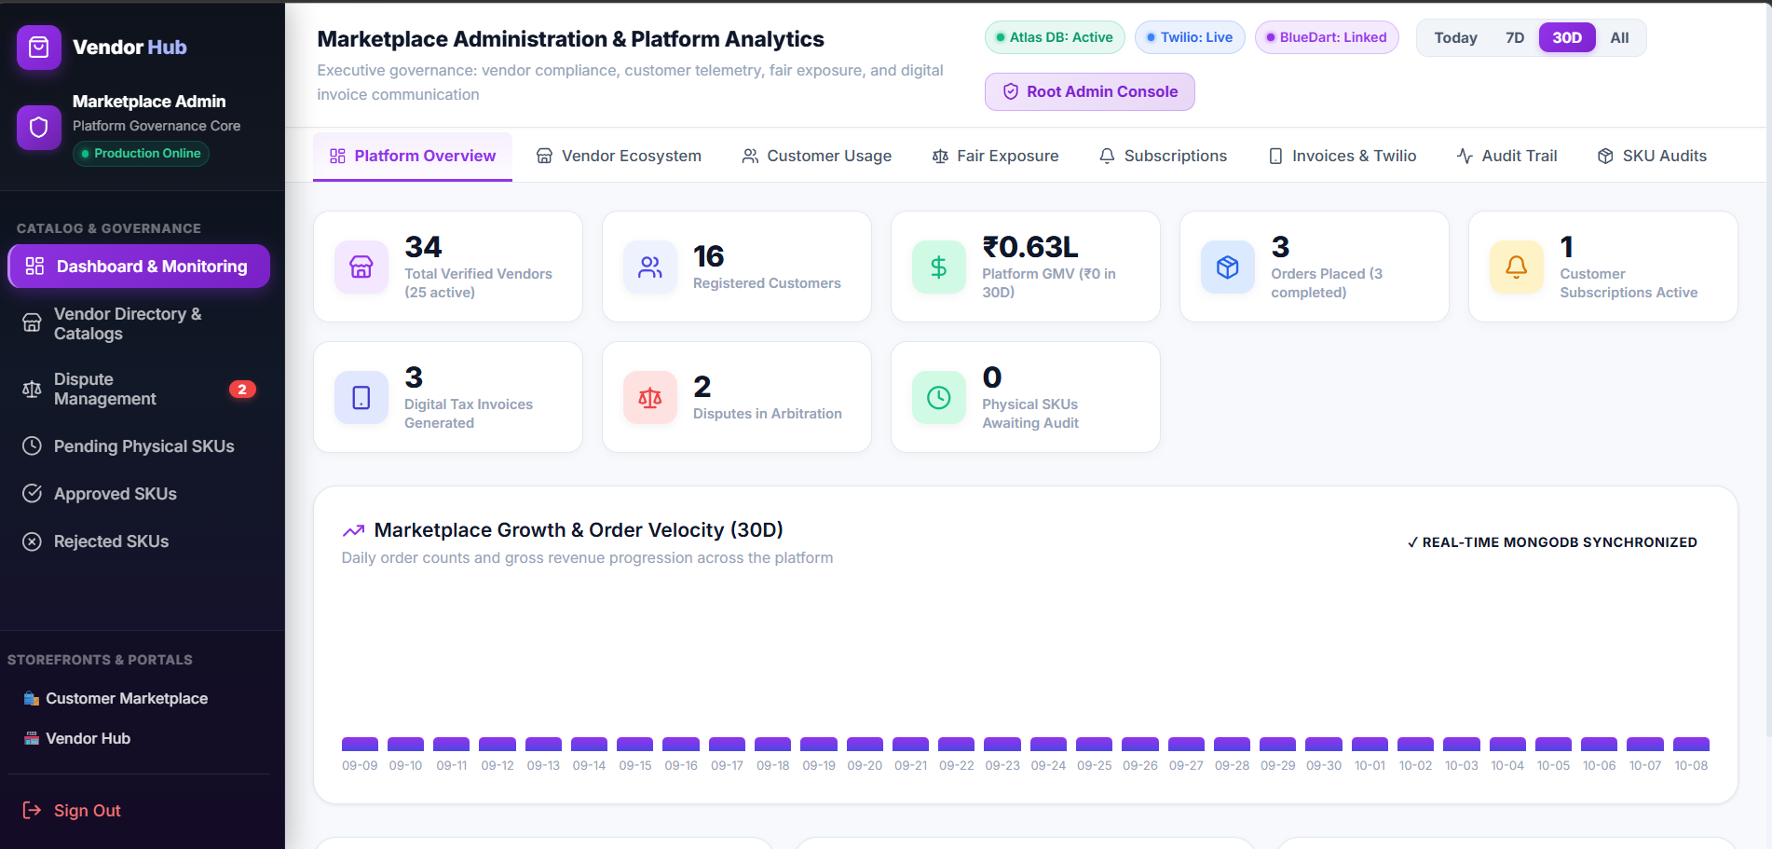
Fig 8.8.1 Super Administrator Executive Overview Dashboard
Admin console presenting platform GMV, active merchant counts, live order totals, and critical platform alerts.
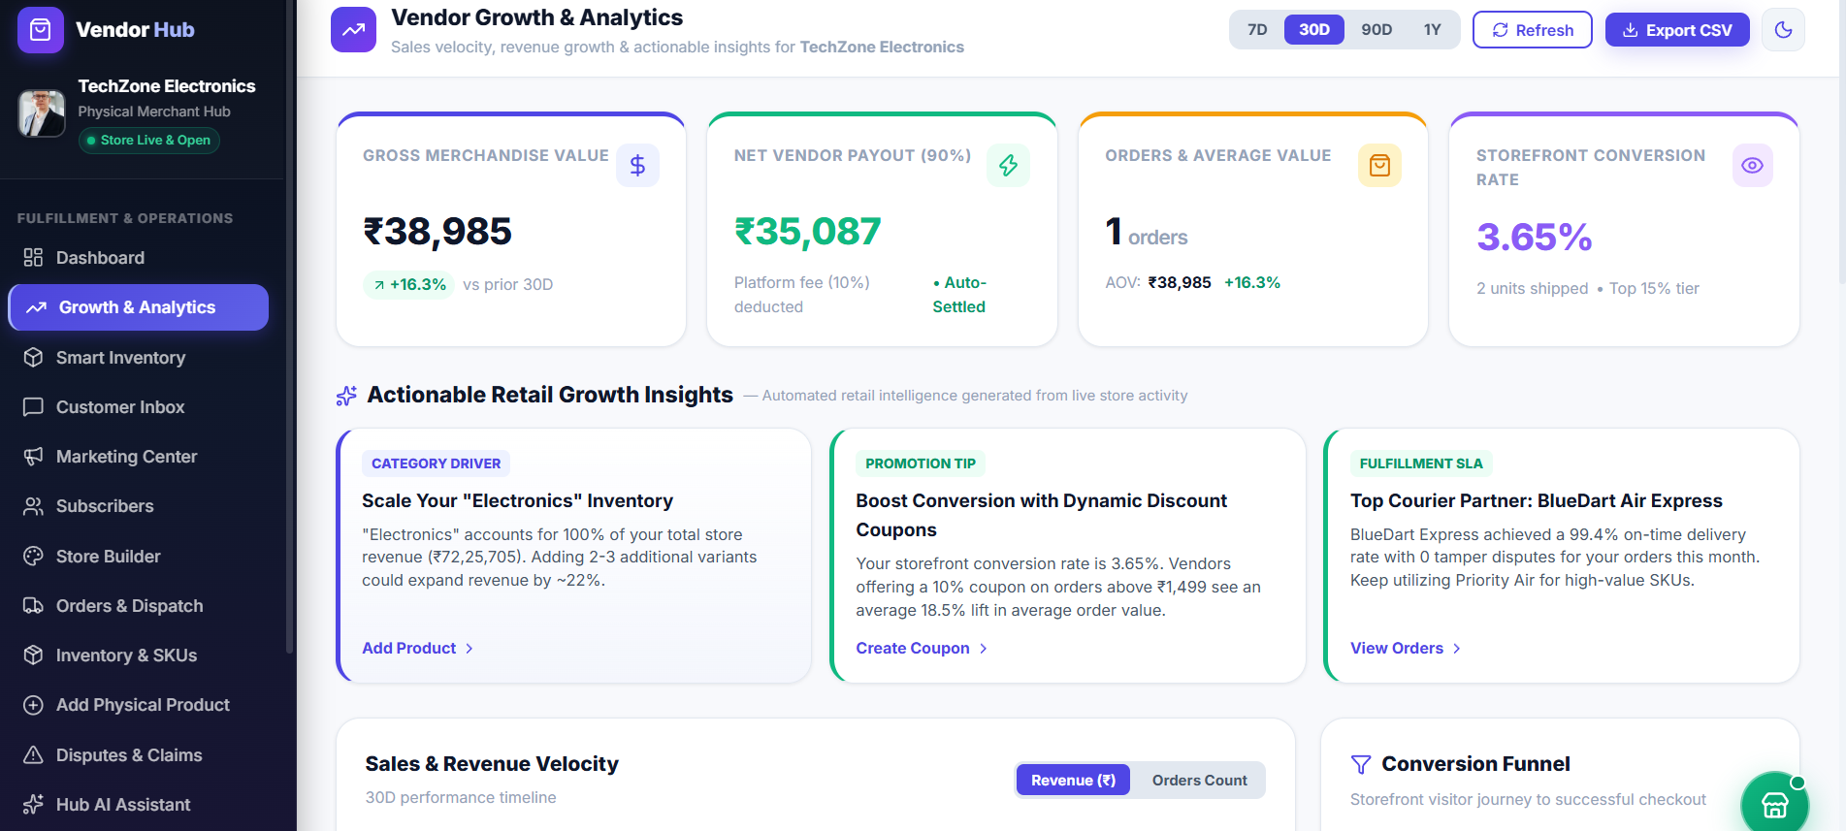
Fig 8.8.2 Vendor Merchant Financial Analytics & Sales Performance
Merchant dashboard displaying monthly earnings, commission deductions, net payout balances, and sales velocity charts.
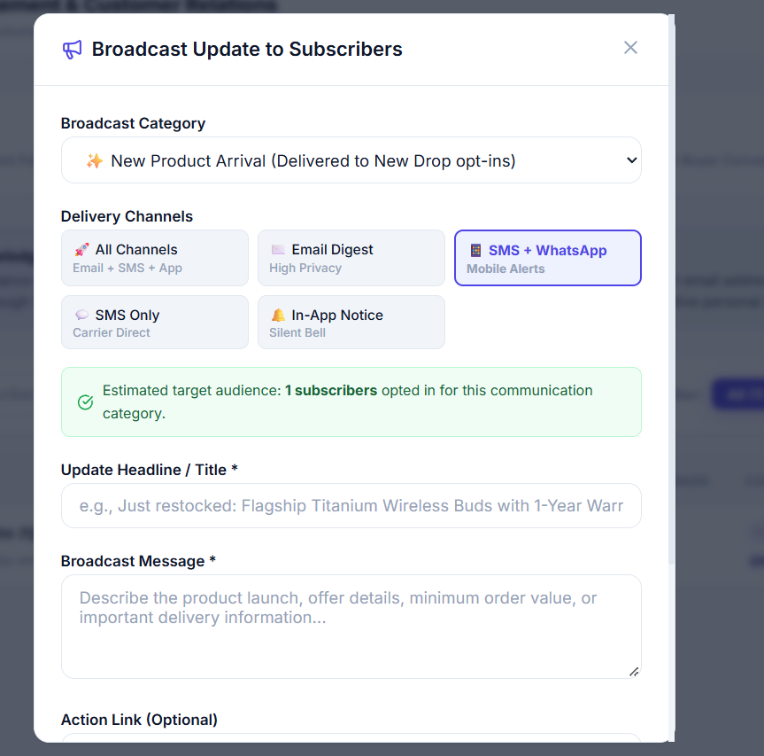
Fig 8.8.3 GST-Compliant Official Tax Invoice Preview
Formal tax invoice showing buyer/seller GSTIN, line-item pricing, CGST/SGST tax split, and authorized digital stamp.
8.9 HUB ASSISTANT AI, REAL-TIME MESSAGING & MULTILINGUAL LOCALIZATION
8.9.0 Purpose & Scope: Powers an intelligent automated customer assistant, enables real-time customer-to-vendor messaging, and delivers native multilingual localization in 6 Indian languages for regional inclusivity.
● 8.9.1 Functional Requirements: Hub Assistant answers queries regarding order tracking, return policies, and stock availability; customer-vendor chat enables direct communication; 6-language switcher provides instant UI translation in English, Tamil, Hindi, Malayalam, Telugu, and Kannada with zero reload.
● 8.9.2 Non-Functional Requirements: Language switching updates state in < 10 ms across the entire component tree; translation dictionary stored in client bundle for zero latency; chat message payloads sanitized to prevent XSS.
Concern | Choice | Why it fits this module
Assistant Engine | Rule & Pattern Matching NLP | Instant client-side query classifier resolving FAQs, delivery ETAs, and policy inquiries
Localization (i18n) | LanguageContext + JSON Dictionaries | Native multi-script language engine supporting 6 regional Indian languages
Messaging UI | Real-Time Chat Components | Clean message drawer with timestamps, read receipts, and role identification
Quantity | Estimate | Basis
Assistant Queries Handled | ≈ 4,000 inquiries / day | Automated FAQ and order tracking resolutions
Supported Languages | 6 Indian Languages | English, Tamil, Hindi, Malayalam, Telugu, Kannada
Translation Lookup Latency | < 1 ms in-memory | Zero API calls required for UI translation switching
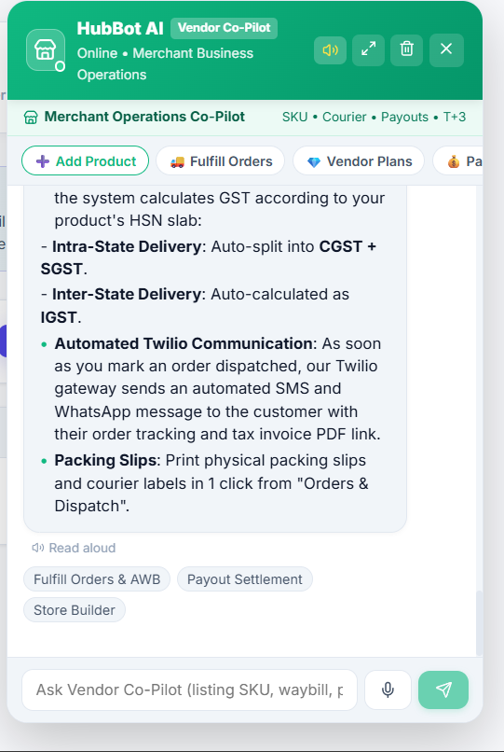
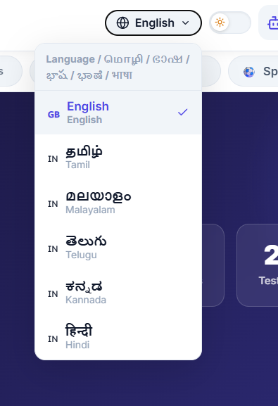
Fig 8.9.A Low-Level Architecture Flow — Assistant NLP & Multilingual Dispatch
Request sequence: User query entry, client intent classification, order database lookup, translated response rendering.
Method | Endpoint | Purpose / Contract
POST | /api/chatbot/query | Public / Protected. Body: {query, context}. Evaluates customer query and returns contextual assistance.
GET | /api/messages/:conversationId | Protected. Fetches message history between customer and vendor.
POST | /api/messages | Protected. Body: {recipientId, content}. Sends real-time message.
Collection | Keys & Indexes | Key Fields Stored
conversations | PK: _id, Index: participants | _id, participants, lastMessage, updatedAt
messages | PK: _id, Index: conversationId, createdAt | _id, conversationId, sender, content, readStatus, createdAt
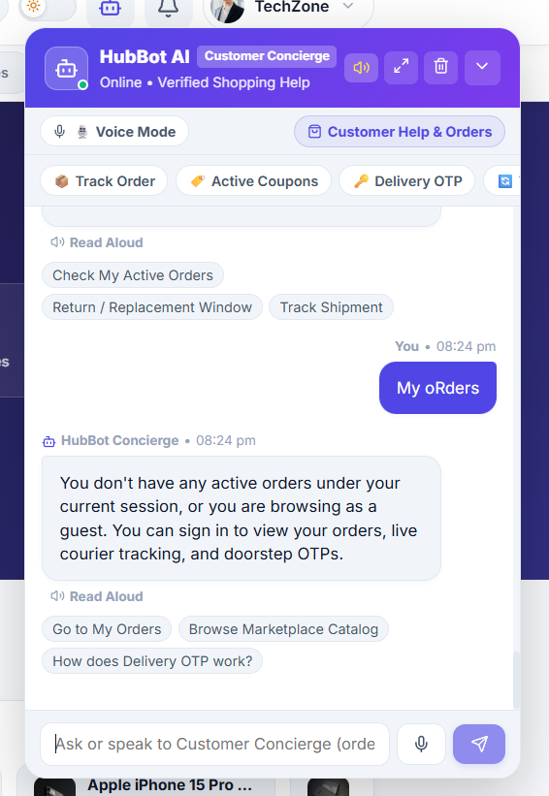
Fig 8.9.1 Hub Assistant Intelligent Automated Chatbot Interface
Floating chat drawer responding to customer queries with suggested quick actions, order lookup, and store links.
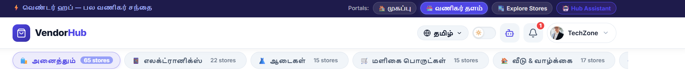
Fig 8.9.2 Six-Language Regional Script Switcher in Action
Marketplace header showing active language dropdown and the UI rendered in native Tamil, Hindi, and Malayalam scripts.
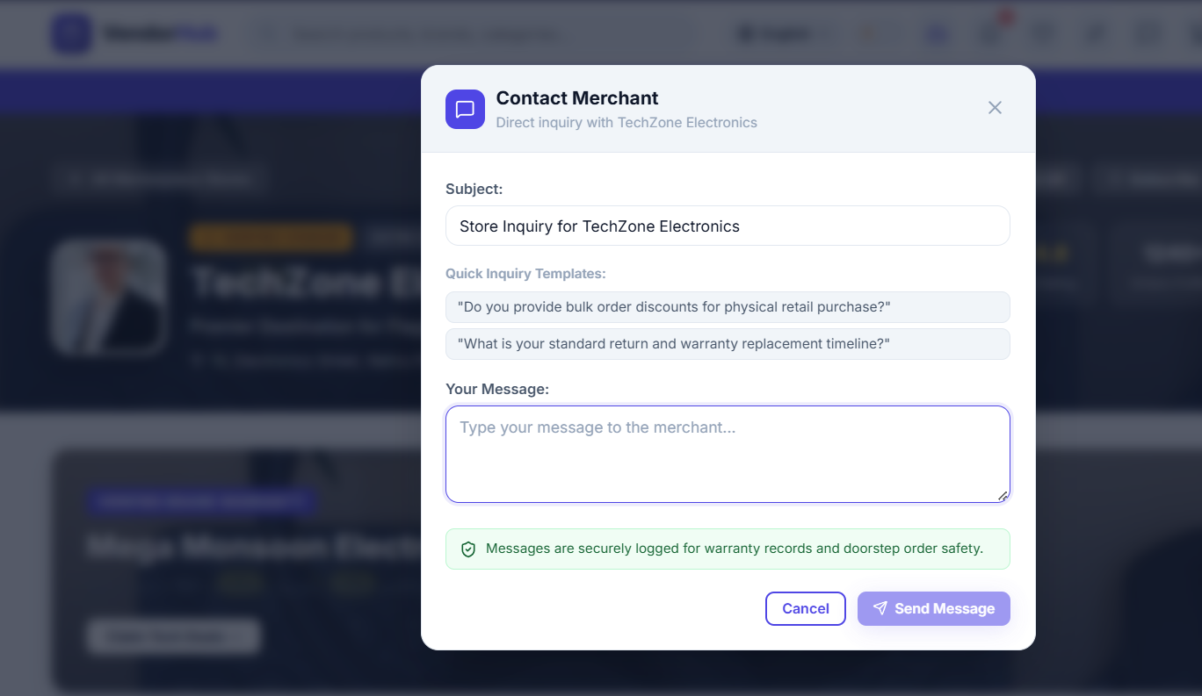
Fig 8.9.3 Customer to Merchant Direct Messaging Console
Interactive messaging dialog facilitating product queries and custom order discussions between buyer and vendor.

CHAPTER 9
CONCLUSION
VendorHub delivers an end-to-end, enterprise-grade digital solution designed to overcome the critical operational challenges of contemporary multi-vendor e-commerce. By establishing a rigorous zero-ghost physical inventory framework, the platform guarantees that every listed product corresponds to verified stock residing within merchant warehouses. The implementation of an administrative two-tier verification queue successfully eliminates counterfeit listings and elevates catalog standards across all merchant storefronts.
The platform's three-tier client-server architecture—leveraging React 18 and Vite for an ultra-responsive frontend, Node.js and Express for scalable RESTful backend services, and MongoDB Atlas for high-throughput document persistence—provides robust performance, maintainability, and horizontal elasticity. Security has been engineered into every tier through salted bcrypt password hashing, stateless JSON Web Token authentication, granular Role-Based Access Control, Helmet HTTP hardening, and express-rate-limit brute force defense.
Through features such as flexible multi-channel payments (Razorpay, dynamic UPI QR, and Cash on Delivery), tamper-proof doorstep delivery verification using encrypted 4-digit OTPs, post-delivery dispute arbitration, and native multilingual accessibility across six Indian languages, VendorHub bridges the divide between local merchants and digital consumers. The system effectively mitigates shipping fraud, reduces operational friction, and provides management with real-time financial transparency. VendorHub stands as a scalable, secure, and modern foundation for next-generation multi-merchant retail commerce.

