Neptun kód: | UJI470 |  | Név: | Nagy Levente
Beadás verziószáma: | 1.  Később kiegészítéssel(!)  2. (javított Uf…)  3. (javított Algoritmus)

Feladat
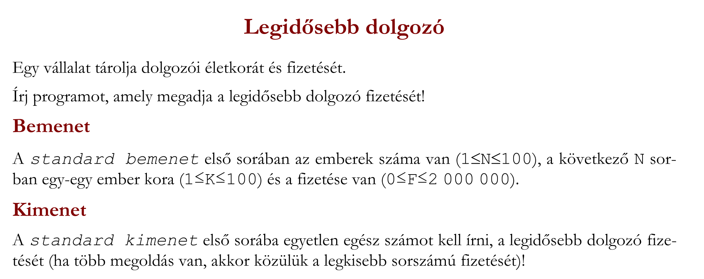

Specifikáció
https://progalap.elte.hu/specifikacio/?data=H4sIAAAAAAAAA6WRS26DMBCGrzLyKpFQxDMQq0Rqpa6iZlepErCA2Imch6kCldJEkbrMVXqO3qQnqcEQTEjaRb2Bsf%2BZ%2Bb%2BZA8pe6YzN2SzOWcoRRg8UA0ng%2B3SCqQYhB3FIul6k%2B3RV3k7SLSNpYAwGJIk0KZB34ENvlW7xFHYwZ3ua0wxP%2ByGfMAxruuDx4j1NzqU38Y5xQndKLJJlFPLHORa%2FH6yMq2YYesLZGHT4%2BswKk3c%2BGHoVVRYDFg2KMmfVxb1Mka4v3yvPMPavJNePooCpl0eQPQuXT%2FcvvaVfOtSajGXZrl%2BMpAatEfsQc6IOxG%2FSam3TD2lIfPIM4eCASJzHYkckwWCFPOR1HoZAIh2K%2BYOla%2BcFgF2aPWqqwLQUgXlFYKsVLCkIeVT0rC2WFiRRoQ95Q1SnCO883lDhWPxtafa2zhE2jloLxP4FxPAUGyPPsswLny1S19PdDoirjsLpknqqwHBuoNoNque2Uaucf7O6zh%2Bsw1GbtbPUoYo67Eyiu%2FMroEYD6jptUOnpBmd0%2FAFAsaueSwQAAA%3D%3D

Sablon
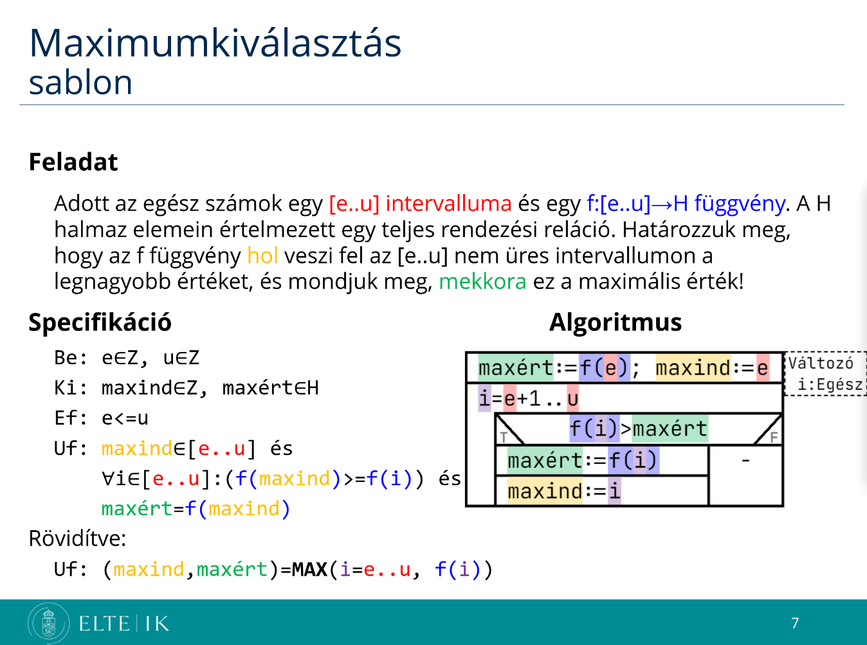

Visszavezetés
dolgozok[db] | MAX(j=1..db, dolgozok[j].kor) = (maxindex, maxkor) | legnagyobb
1 | 1, 30 | 400000
2 | 2, 23 | 200000
3 | 3, 40 | 300000

Algoritmus
https://progalap.elte.hu/stuki/?data=H4sIAAAAAAAAA61VXU%2FbMBT9K5GR0CYiFNLSNDAmwR6gIEAFaWxDfXDs69ZKakPi0g%2FU%2Fz47jV0XmDQ2%2FJKbY%2Fuce49vnGfEKTpA0W7SarfanTjdS6O4lUYtFKKRfIKyp6fFpChCVEEBRAE1CLqMe3e%2FfoxzvUxIChU6eEbnRaJO09m1iWtWB4ToAZcg1JpsxCkFgQ4YLioIkZo%2FgN5QweMEBAG9gYx4QfWeHtXc9%2BgbdK6Pk0czM80vsqckX%2BjQZTFYhuslVt7bs5b3k%2FpDEgorGOvleoWCmdIQFyqgWRhQWQzlQub3NBvs5rJ8gTC%2BAAVVGIzxjAsKszqCUkEeBgUMBR7OZZZ9ycqvSCfcIfu9Xnx%2B5hJ2wEbCXr3vdW3K%2B%2F27O17U%2FjgeK%2BcRv8efqdaotaSgXHEpGoN4cBREh%2FqxXahDbZcOd3bqWkOUSTq%2FbdLsbZSqE%2BvK6pyx6qdLzAGbPthi3u%2FD3rwd94%2B7cz2T35ze8OrqtrYkYQRf0pOpU3bARylXi%2F78IjqVqxOwPO4E1sSenNcGb8tx9tJ%2BFnxyncjr1gy2h%2BrwyPXf5%2BYgVDmBkxILMto4Ds%2FxWuqNJc4aXYjz0xbiGewV4rH%2B9admE9bN9KIi%2B9m4E7TiDvgI8fq71eLcyrkTtHIO2JDzOudfarWhVXU3m1X1Ltz%2FvMzWF5HvsS3d3WKrTIwBumeIksMSj01LPyOBx4b6EnOhWZ9wyXFWmF8A0q%2BllK9Sq0Zy%2Bn29rMnQoGeAKZQNtByYri5kWf9NVtneoy3GIj00zZZ5MtP7GiMOy6J9F7E6SqJWhOuIAGbdBA1WxZ9gkg9LORG0Ic7iLDbLzNMSA7EYJATbiNURbZMIYkNnfnofSOd5%2FIrVjKZmPeqq9LAYiy0GjJIVlqar2SjqknTfRADQph3fkeXyN4SHMmn7BwAA

