1. Make sure you can open NAS4. If not, open the Run program and type in ***\\172.20.138.143\RecordingsLeventhal04\***. You may have to login with your NAS login info (check your email).
2. Open MATLAB and navigate to where you placed the Skilled Reaching repository in GitHub. Make sure the folder labelled ***Manual_Paw_Joints_Marking*** is added to the path (*right click folder in Current Folder tab 🡪 Add to path 🡪 Selected folders and subfolders*).
3. Type ***createManualPawData_2015_06_19*** in command window of MATLAB and hit enter. This will initiate the paw point marking programs. Though all variables created will be saved along the way, **all the important data** (e.g. the manually determined start or trigger frame, the coordinates for each marker for all the frames of a video, images of the marker placements in every frame marked) **is being saved to the RatData structure, see full details in the table below:**

|  |  |
| --- | --- |
| Important Data | Location in RatData Structure |
| Filepaths to raw data for every session/date | RatData 🡪 Date Folders  Also contained in variable AllRatDateFolders |
| Information about each of the video files taken for each trial in a given session/date (name of file, date of creation, # of bytes, etc.) | RatData 🡪 VideoFiles |
| Videos in format that MATLAB can read (VideoReader Objects) | RatData 🡪 VideoFiles 🡪 Object |
| Manually determined start frames for each trial/video | RatData 🡪 VideoFiles 🡪 ManualStartFrame |
| Coordinates of every marker placed in all frames of a video file (one per trial)  (If the marker is not visible, it will appear as ‘NaN’, i.e. Not a number, here. If it was never placed, like if an error occurred, it will appear as ‘Marker Not Yet Placed’) | RatData 🡪 VideoFiles 🡪 Paw_Points_Tracking_Data 🡪 Columns 7 (x-coordinate in pixels) & 8 (y-coordinate in pixels) |
| Anatomical names of every marker placed in all frames of a video file | RatData 🡪 VideoFiles 🡪 Paw_Points_Tracking_Data 🡪 Column 6 |
| Number of frame in which every marker is placed within a video file | RatData 🡪 VideoFiles 🡪 Paw_Points_Tracking_Data 🡪 Column 2  Also:  RatData 🡪 VideoFiles 🡪 Paw_Points_Frame_Data 🡪 Column 2 (each row contains data for a different frame in Paw_Points_Frame_Data, more info below) |
| Zoomed-in images used in placing markers for a given frame and positions of those images in the larger frame | RatData 🡪 VideoFiles 🡪 Paw_Points_Frame_Data 🡪 Columns 4-9 (4: left mirror image, 5: left image position, 6: center image, 7: center image position, 8: right mirror image, 9: right image position) |
| Images of frames analyzed in a given video file (without markers placed) | RatData 🡪 VideoFiles 🡪 Paw_Points_Frame_Data 🡪 Column 10 |
| Images of frame with all markers placed up to the most recent marker (see order below)   1. Pellet center 2. Lunate-capitate-hamate joint 3. Thumb metacarpal-proximal phalanges joint 4. Thumb proximal-distal phalanges joint 5. Index finger metacarpal-proximal phalanges joint 6. Index finger proximal-middle phalanges joint 7. Index finger middle-distal phalanges joint 8. Middle finger metacarpal-proximal phalanges joint 9. Middle finger proximal-middle phalanges joint 10. Middle finger middle-distal phalanges joint 11. Ring finger metacarpal-proximal phalanges joint 12. Ring finger proximal-middle phalanges joint 13. Ring finger middle-distal phalanges joint 14. Pinky finger metacarpal-proximal phalanges joint 15. Pinky finger proximal-middle phalanges joint 16. Pinky finger middle-distal phalanges joint   Then repeated 3x for each region of the frame (left, center, right), so 48 markers/images total | RatData 🡪 VideoFiles 🡪 Paw_Points_Frame_Data 🡪 Columns 11 to 58 |

Figure Data Contained in RatData Structure

1. Follow the prompts that appear:
   1. Select the rat’s raw data folder (RatID – rawdata) from NAS4. If this is your first time marking points for this rat, MATLAB will load the file paths to all the session folders into the RatData structure and display its progress in the command window as it does so.
   2. Select the session (a.k.a. the date) you would like to analyze. If this is your first time marking points for this rat, MATLAB will load all the videos, one for each trial, into VideoReader format (the format it needs to load videos later) and display its progress as it does so.
   3. Open the video file that appears and determine the start frame.
      1. Most video files have already had their start frames determined, thanks to Maya ☺. If you navigate to the session folder in the rat’s processed data folder in NAS4 (ex. For rat R0027’s data from 05/13/2014, this would be at *\\172.20.138.143\RecordingsLeventhal04\SkilledReaching\R0027\R0027-processed\R0027_20140513a*), you’ll see a .csv file that starts with ‘*Quant Scoring’*. You can open this file in Excel and find a column labeled ‘*Start of Reach’*, usually in the first sheet, which has all the start frames listed for all videos for that day. If you can find the start frame this way, skip the next numbered item below (ii, go to iii).
      2. Alternatively, if you cannot find the start frame this way, simply copy and paste the file path displayed into Windows Explorer to open the video file in QuickTime and determine the start frame (see Figure 2 below). You’ll have *to right click* on the timer in the bottom left corner and change it to *Frame Number*, then use the indicator that indicates where in the video you are to slide to the start frame. This is the first frame in which all of the rat’s paw (i.e. all the green marked area) can be seen to breach the slit. It’s easiest to see this in one of the side mirrors: left if the rat’s dominant paw (the one marked in green) is right, and vice versa. If the rat isn’t using his dominant paw, estimate the start frame to the best of your ability.

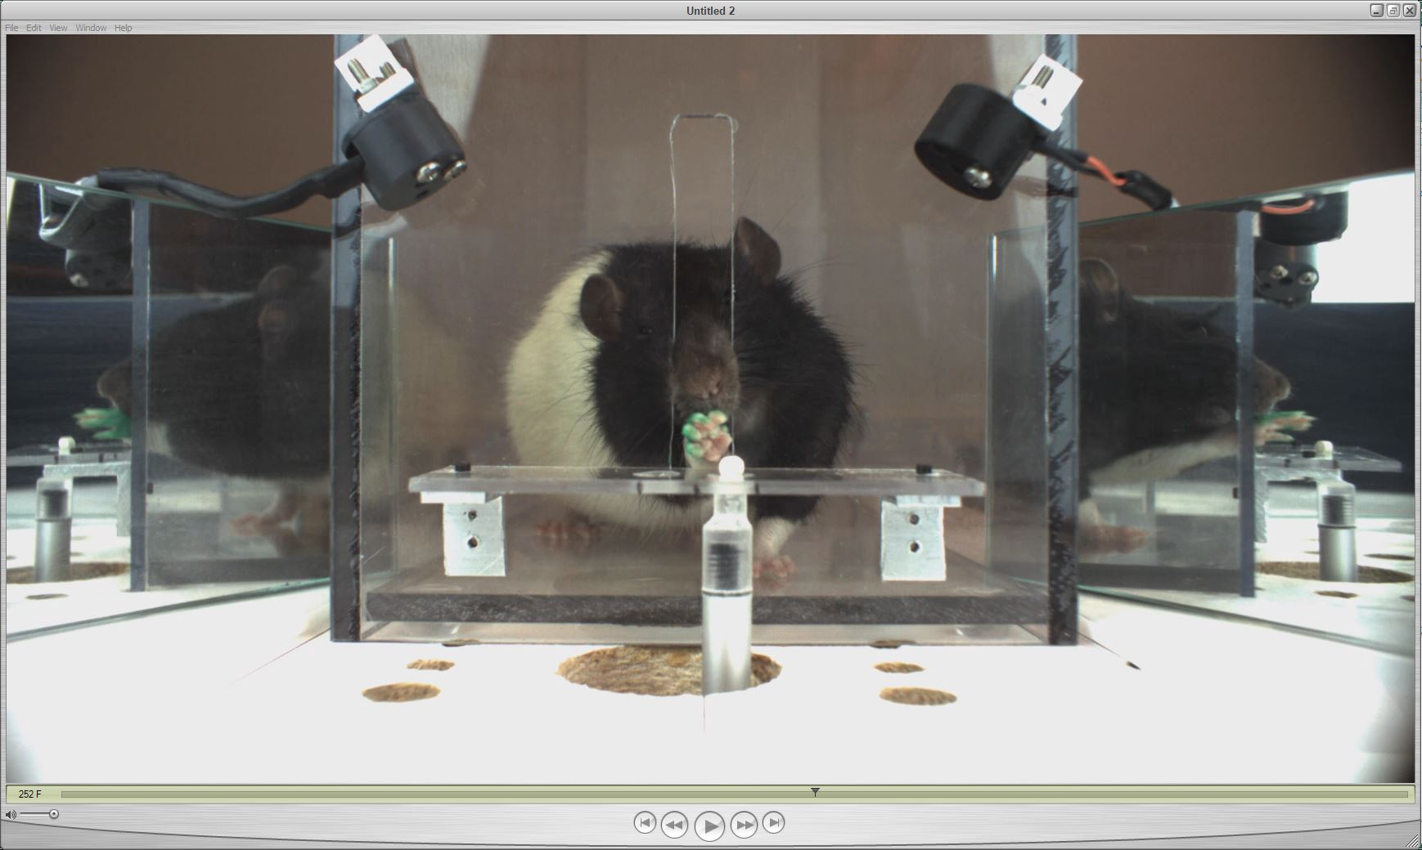

Figure Start Frame for R0027 05/13/14

* + 1. Once you’ve determined the start frame, type it into the dialog window that appeared previously and hit **Done**. If, for some reason, a start frame cannot be determined, hit **No Start Frame** (be warned that this will lead to error later on though, and you will not be to get paw point data).

1. The program for obtaining paw point data will appear in a window on the right side of the screen. ***READ THE INSTRUCTIONS CAREFULLY.*** 
   1. First it will ask you to place rectangles around the regions of the frame you would like to zoom to in order to place markers on the paw joints. It’s a good idea to be fairly generous here (i.e. don’t make tight rectangles around the paw and pellet, see Figure 3 below) so it is not too closely zoomed in when you go to place markers. The program will then create a figure with just the images contained in those three boxes.

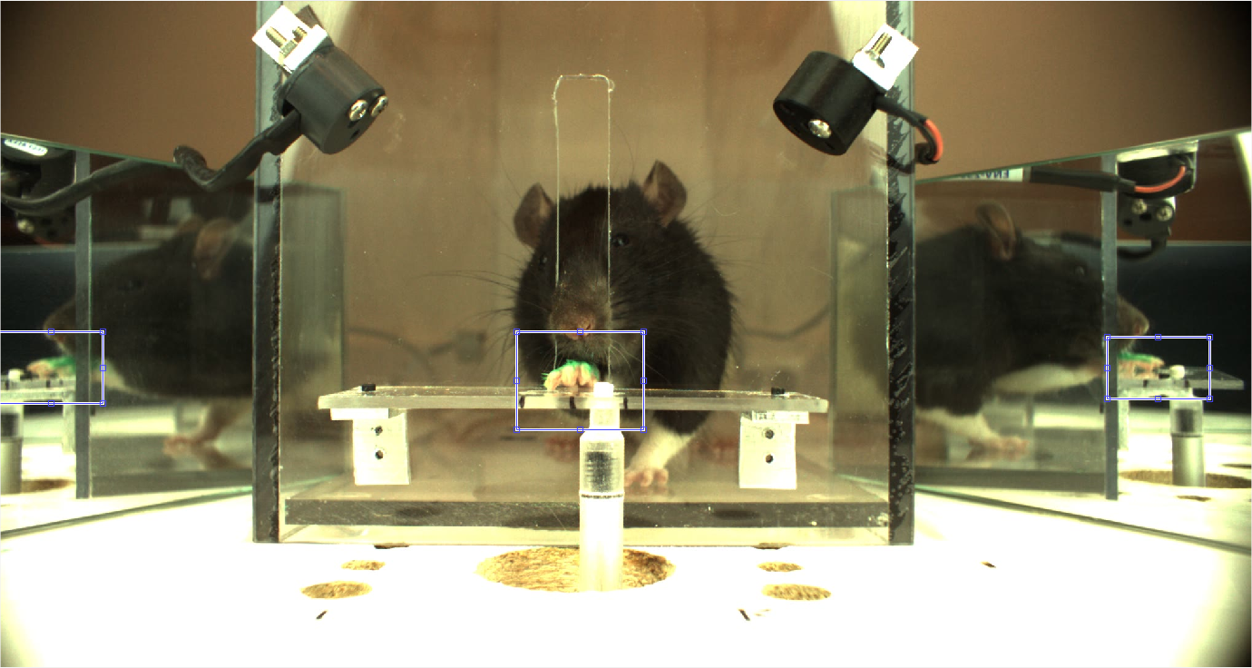

Figure Where to place rectangles for zooming

* 1. The program will then tell you which marker to mark when (the pellet center is always 1st) in the original window that appeared. Please use the image that follows as a reference. If you make a mistake while marking, you can press Delete or Backspace to re-do *that* marker. If you realize you’ve made a mistake after submitting a marker, you can click the marker(s—hold Ctrl while clicking to choose several) and hit the Redo button to redo the markers, following the prompts as indicated. All of the important information will be saved into the RatData structure, as stated in the previous table.

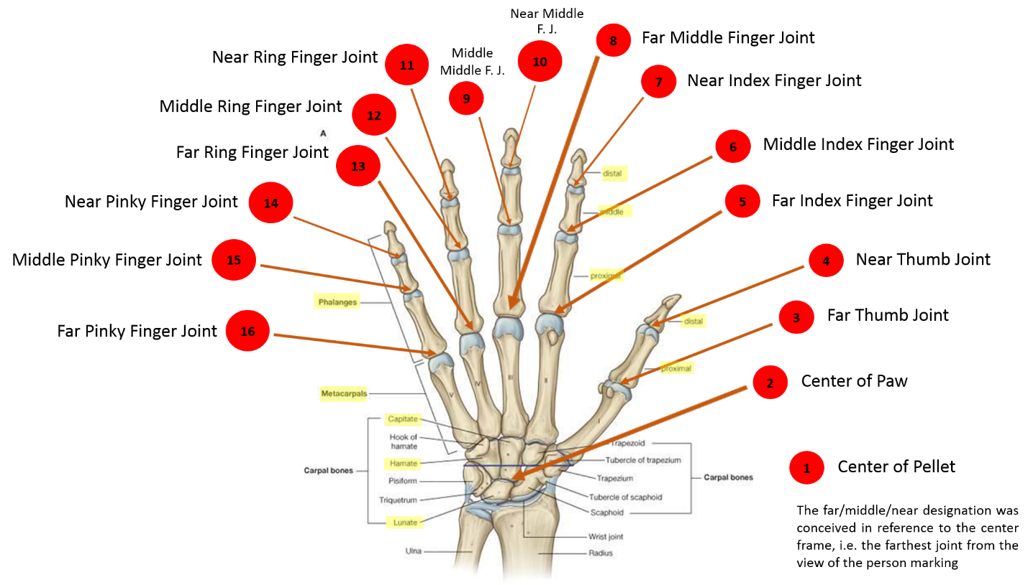

* 1. Once you place a marker, a small window will show up in the bottom left corner showing where in the larger image the marker was placed. If you want to check where that marker was placed, or need to see the frame overall to place the next marker, feel free to maximize this window—just remember that you must return to the 3 image figure to place markers. Your screen should resemble Figure 5 (below). Refer to the original paw-marking program window that appeared (on the left side of Figure 5) to know which marker to place next.