
SHANGHAI JIAO TONG UNIVERSITY
学士学位论文
BACHELOR’S THESIS


论文题目： Event Modeling to Analyze Relationships between Social Networks and Search Engines

学生姓名: 万强
学生学号: 5120309289
专 业: 计算机科学与技术
指导教师: 孔令和
学院(系): 电子信息与电气工程学院

搜索引擎与社交网络中的信息传播分析

摘要

伴随着信息爆炸时代的来临，社交网络和搜索引擎两种传媒已经成为事件传播的重要平台。社交网络由于其用户关系和用户可以自由评论的特性被人们所钟爱，而搜索引擎则对信息进行组织和处理后为用户提供检索服务。两者影响力之大，可能会在之间产生一定的相互影响关系。本文首先对事件传播的影响力进行建模，分别采用了权重求和、TF-IDF、 QueryRank三种方法对热门事件东方之星沉船和股市大跌的热度按事件分析。其中，QueryRank是基于PageRank在事件传播模型中的改进，将不同查询之间的关系用余弦相似度衡量。该方法既考虑了查询本身的数量，同时又结合了关键词之间的相互关系。对热度进行评估后，通过事件的关键词排序相似度的比对，采用RBO算法研究其在两个平台传播的特性。数据以百度作为搜索引擎代表，而新浪微博作为社交网络代表。实验表明，百度在事件传播上相对微博存在一定的滞后性。最后，提出了未来通过微博在百度上预测事件趋势的方案。

关键词：社交网络，搜索引擎，影响力，关键词，PageRank，RBO

Event Modeling to Analyze Relationships between Social Networks and Search Engines

ABSTRACT

With the advent of the information explosion era, social networks and search engines have become two important platforms for the dissemination of the event. Due to its user relationship and free comment feature, social networks are popular among people. Meanwhile, search engines are platforms to provide information with users through retrieval services. It is possible that there are some interactions and relations between these influential media. In this thesis, we first build models to describe how events disseminate among several related days. Three methods are introduced to model Eastern Star and Stock Market Crash events, including Weight Sum, TF-IDF and QueryRank. Among these three methods, QueryRank is proposed based on PageRank, whereas the edge weight is measured based on cosine similarity between two queries. This method takes into account both the number of queries itself as well as relationships between keywords. After popularity evaluation, we use RBO algorithm to compare ranked hot words lists on different platforms in the aspect of time. We select Baidu Search as a representative to search engines and Sina Weibo as to social networks. Experimental results show that Baidu has a relative delay comparing to Weibo. We would further use the delay to predict event trends using the relationships between these two platforms
Key words: Social Networks, Search Engines, Popularity, Keywords, PageRank, RBO

Contents

1. Introduction 1
1.1. Event Dissemination 1
1.2. Problem Statement 2
1.3. Contribution 2
1.4. Organization 2
2. Related Work 2
2.1. Predicting Popularity 2
2.2. Topic Model in Social Networks 3
2.3. Social Networks and Search Engines 3
3. Overview of Framework 3
3.1. Flowchart 3
3.2. Hot Words Detection 3
3.3. Popularity Model 3
3.3.1. Weight Sum 3
3.3.2. TF-IDF 4
3.3.3. QueryRank 5
3.4. RBO-based Comparison 7
4. Experiment 7
4.1. Datasets 7
4.2. Experiment 7
4.2.1. Pre-processing 7
4.2.2. Visualization 8
4.3. Discussion 8
5. Conclusion 8
References 9

- Introduction

  - Event Dissemination
Since late 1990s, information has been disseminated quickly through Internet. With the emergence of social networks and search engines, event propagation has become more and more convenient and effective.
But there are different features between social networks and search engines as tools for exploring information. When it comes to hot topics and events, people would have different expectations. Social networks are platforms where people could view the events by short-text message or direct links as well as express their feelings by retweet. Whereas search engines provide users with services that would explode events by themselves using combination of keywords.
Concurrently, the event propagation will not solely depend on one platform. Information transmission is fast so that companies desire to illustrate latest event progress to draw public attention. In any case, if a topic receives a lot of attention, there will be lots of social media that track and report it frequently throughout the whole time period. Therefore, the study on cross-platform event propagation becomes essential in understanding the event spreading process as well as roles of each platform. It can also help companies and governments to predict the trends of events for guiding their behavior, respectively.
The representative microblogging service Sina Weibo was launched in 2009 and have contributed to the rapid growth of information explosion. The term “Weibo” is the transliteration of the term “microblog” in Mandarin Chinese. Weibo allow users to publish short messages like tweets with a 140-character limit per post. Like other major companies in China and elsewhere whose business is user-generated content, the amount of content and traffic a platform can garner is crucial for its survival. It is known that microblog is usually short and has arbitrary language, which has presented challenges in the study of microblog topics.
The representative search engine Baidu Search is incorporated in 2000. It is a Chinese search engine for websites, images and other multi-media. Baidu offers several search services including a searchable keyword-based discussion forum. It is studied that Baidu are very heavily used and their quality are taken for granted by online users. The question is still controversial whether users can really satisfied with the search results. Search engines decide algorithmically what is relevant and rank the results accordingly. However, users' relevance decisions are in reality subjective and situation dependent. So sometimes we can’t deduce absolute intentions simply from bags of words. It would put extra challenge when specific topic is focused.
To summarize, we take an overview about how important and prevalent that search engines and social networks have become nowadays. It is meaningful to study how event disseminates through data analysis. And it’s more attractive to dig out potential mutual relation between them. We will discuss these issues in 1.2, followed by 1.3 we would mention our correspondent thinking and contributions.
  - Problem Statement
In the real world, microblogging platforms are significantly distinguished from search engine tools. There are tons of studies on how they facilitate popular trends separately. But we focus on two questions which seem to be significant:
I. Given the independent platform such as search engine or social network, how to describe the transmission process throughout its popular period? How to model this process intuitively?
II. How do we build models to connect social networks and search engines?
  - Contribution
To solve above problems in 1.2, we need to divide our work in two phases.
In phase I, we need to find out how to build popularity models for events on each platform. We research related work and find out the most obvious way is to count the queries on every day to represent their daily popularity. The deficiency of topic oriented ability encourages us to treat our data in the aspect of keywords. The popular TF-IDF model can highlight occurrence of sub-events because words that are not dominant but influential on single days can weight higher than dominant keywords. This mechanism can underline the influence of sub-events. Last but not least, the third option is inspired by famous link analysis algorithm PageRank. Similar like its principle, our revised QueryRank algorithm take both query number and relations between keywords into account.
In phase II, two solutions are considered. The first is to directly assume there is a constant delay between them according to observations from phase I. Another novel idea is to compare their ranked keywords. We use RBO algorithm to qualify similarity between two ranked lists.
  - Organization
The rest of the paper is organized as follows. Section 2 reviews the related work on social media and search engine. The main focus is social network for user’s actions usually play an important role in broadcasting a topic. Section 3 delineates the whole flow of our framework. The framework can be segmented into two parts as in 1.3. We formulate three algorithms to depict popularity of an event as phase I. We continue to detail different similarity between lists. Section 4 is the part where experiments are conducted and evaluated. And our conclusion is drawn in Section 5.

- Related Work
  - Predicting Popularity
Nowadays，social media has completely change the our lifestyle by allowing people to become distributors of information. Different sorts of web contents have been measured, including videos, news site and social network services. One thing that really interests people is to predict the popularity of web contents.
But predicting the popularity of web content is a challenging task. First, different factors known to influence content popularity, such as the quality of the content or its relevance to users, are difficult to measure. Then, other factors, such as the relationship between events in the physical world and the content itself are hard to capture and included in a prediction model.
There are tons of papers focusing this area and one remarkable is to study on evolution patterns of content popularity [4]. A further breakthrough is accompanied with more advanced algorithm that can extract information from different sources[5].
Various types of web content are widespread across the web. The commonality of these sources is that they have huge amount of data and time-sensitive. These similarities may be universal across the related field. So the varieties of web information are actually consistent and cross.
For instance, YouTube video is widely studied by researchers. The trends among most YouTube videos can be described by a Poisson process, many videos reveal similar activity around the peak period that can be accurately described by temporal evolution patterns [6]. In addition to YouTube, the video popularity in other platform has also been studied [7], but it turns out to have the same popularity distribution pattern as YouTube.
Another area is online news websites or media. The popularity in this field is commonly denoted as the number of comments given the fact that the number of views is usually disclosed for business reason. The trend can be simulated by power-law distributions [8].
Last but not least, social networks plays as sites where allow users to maintain relationships with either real life friends or social celebrities. People may also have special interests satisfied which become a special feature to trace a message or tweet. While there are different types of social networking services the most popular are the ones built on the idea of content sharing. Microblogs, such as Twitter and Weibo, are a specific type of social networking services that have been extensively studied. These platforms are probably the most dynamic representation of social media. Users create and share information in the form of short messages, known as tweets, containing up to 140 characters. When a user posts a (re)tweet it becomes visible to all its followers (i.e., members of the social group). Content can easily spread through the social connectivity graphs as followers can further share the content to their own list of followers. Two metrics have been used to measure the popularity of a tweet: the number of users that receive a message in their tweet feed, or most commonly, the number of retweets. The popularity of tweets is also highly skewed and can be described by a power-law distribution [9,10].
Another big concern is popularity prediction models. It can further be divided into single domain and cross domain.
Single domain refers to prediction completely relying on one web source. One typical example is to predict news articles trends in famous web site Feedzilla through SVM and Navie Bayes [12]. The authors make full use of a random classifier to predict if news will receive comments and if they do, the number of its will be relatively high or low. Another similar research is using the number of tweets as indicator of popularity [11]. In that paper, it shows that predicting exact popularity is most likely to have significant errors whereas predicting the ranges is much acceptable. Using cumulative growth method, Lee et al. [13] study the possibility of predicting whether web content will remain popular after a certain period of time. They use a revised model widely used in survival analysis that models the time until an certain events happens. Temporal analysis has been proved to be an effective approach to reduce errors rather than traditional aggregate-based models. Kong et al. propose kSAIT (top-k Similar Author-Identical historic Tweets), an algorithm that can predict the popularity of tweets one, two, or three days after publication based on the retweet information received in the first hour [14]. It focuses on users who retweet contents neither related to content itself nor the centrality of their social relations. The algorithm defeats several regression-based ones experimenting on Tencent Weibo. Zaman et al. propose a probabilistic model based on Bayesian inference to predict the popularity of Twitter messages [15]. The model is based on the assumption that Twitter users have similar actions with regard to the post of a tweet that creates a pattern in the evolution of tweets popularity.
Compared with single domain papers, predicting web content popularity from multiple resources is much more challenging. We will discuss this aspect more in 2.3.
The stimulus of popularity is essential to build a model in predicting popularity. The whole formula is still unknown but some metrics have been discovered. Identifying the elements would help us to find alternatives if original variable is hard to obtain.

  - Topic Model in Social Networks

.We now formally define a topic to be a distribution over a fixed vocabulary. We assume topics are specified before any data has been experimented. Topic model is a type of statistical model for discovering topics in a collection of documents. A topic model can capture the hidden thematic structure via a suite of algorithms

Latent Dirichlet allocation (LDA) is known the simplest kind of topic model. The intuition behind LDA is that documents exhibit multiple topics. It is most easily understood by its generative process the imaginary random process by which the model assumes the documents arose. Anna et al. [17] affirms the important role LDA in natural language processing. Unlike traditional learning which classify after learning the corpus, they combine them with unsupervised learning to optimize the outcome. Another research notes LDA is defective for handling texts like Twitter [18]. So the proposed B-LDA, combined with distinguished user behaviors and texts can outscore traditional LDA approach.

Other than LDA, latent semantic analysis (LSA) and topical hierarchy have also been well studied. Chi Wang et al. [19] propose to build a weighted graph using links between topics for multi-topic data. Then a hierarchical structure is formed by iterative generations. For a single topic, four indicators are defined to rate and experiments on Google news and DBLP show widespread applicability of the model. Yulian Yan et al. [20] apply LSA to measure the inter-sentence lexical score. Their work integrates the concept of LSA and robustness of subwords.
  - Social Networks and Search Engines

Our work desires to find cross intersections between social networks and search engines. The related previous works are well studied.

First of all, we don’t restrict our domains to these two specific platforms. Instead, we study methods used to predict web content popularity using information from multiple web sources. Oghina et al. use data from Twitter and YouTube to predict movie ratings on IMDb [21]. By training a linear regression model on several textual features extracted from Twitter and various statistics from YouTube the authors show that they can accurately predict movie ratings on IMDb. The authors indicate that the best performance is obtained by combining the ratio of likes over dislikes from YouTube activity with the subjective terms extracted from Twitter.

The algorithm proposed by Roy et al. , extracts information from Twitter to detect videos that will experience sudden bursts of popularity on YouTube [22]. The model consists of the following steps: extract popular topics from Twitter, associate these topics to YouTube videos, and compare the popularity of videos on Twitter with their popularity on YouTube. A disproportionate share of attention on Twitter compared to YouTube is then used as strong evidence that a video will experience a sudden burst of popularity.

Castillo et al. propose a prediction method that collects information about the early attention that news articles receive on social networks to predict the total number of page views on a news site [23]. The statistical method used for this task is a multiple linear regression that uses as input the following variables: number of Facebook shares, number of tweets and retweets, entropy of tweet vocabulary, and the mean number of followers sharing the articles on Twitter.

The effectiveness of cross-domain prediction methods indicate that, when information related to a web content is spread across multiple web sites, aggregating information from multiple sources can significantly improve the prediction accuracy.

Han-Teng Liao [3] presents a case study between of information engagement between Sina Weibo and Baidu. Federica et al. [2] first crawl data from Google Trends and consider it as the benchmark. After calculating longest common sequence between words, Twitter has a daily score that represents those trends’ popularities. The author noticed that there is a delay between Google and Twitter score tendency. Thus linear regression algorithm comes out to measure the delay.
- Overview of Framework
  - Flowchart

We designed our framework following the figure. When raw data accompanied with redundant information enter our flow chart, we need to store them in database in order to access them easily in the next step. SQlite3 database is constructed for its convenience and quickness.

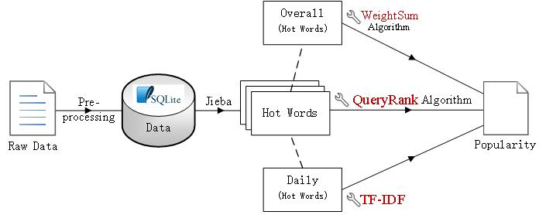

In our proposed models, hot words are widely studied. But data is composed of queries. Therefore, text segmentation is a vital step before distinct algorithms are implemented. Jieba is a powerful and competent tool for Chinese text segmentation. The details are further expanded in 4.2.1.

There are three separate approaches after hot words are extracted from data source. The first and intuitive one is to choose the most frequent words over all documents as hot words candidates. Later weight sum algorithm is implemented to describe popularity of the events. The alternative is to collect daily hot words. Given the intention that words occur frequently over the whole dataset have less impact on a specific day, TF-IDF algorithm is presented to balance the words weight.

The third option is distinguished from the former two. It is inspired that PageRank algorithm can model the relations between nodes more dynamic with graph theory. We adopt it as QueryPank algorithm by considering a query as a node as well as semantic similarity as edge. We continue to optimize our running time by merge identical nodes into one weighted node. This optimization would not destroy the inner relations among nodes and is beneficial to simplification of the task.

We summarize our three algorithms as methods to depict popularity of the events. Then we desire to build models to quantize the diffusion delay between social networks and search engines. There are two general orientations to solve this task. First we can analyze the popularity trends learned from the popularity models. The second novel idea is to study the similarity between ranked hot words. Comparing lists from different time period can possibly lead us to find the delay between these platforms. The detailed discussions are illustrated in 3.4.

  - Hot Words Detection
Our data set is composed of queries. Query hereby means a search query that consists with several keywords or a tweet.
Hot words are defined by frequent words that appear in our queries. One way to measure popularity is to directly count sum of daily queries. This approach is intuitive and simple. But it can’t reflect the differences among queries. Some queries may simply coincide with or same as others. While some of them varies a lot. Another reason why direct count is fallacious is that our data is generated by pre-defined words. In other words, word-oriented approach is natural and potent. So we would evaluate our daily popularity through words. From raw data input, we get several queries attached with create time. If we take every word into consideration, the task is tedious and inefficient. So the best scenario is to track hot words appearance.
After pre-processing and text segmentation that will be further discussed in 4.2, we add up the number of word frequency throughout the database. We set a fixed number as the number of hot words. Twenty is a proper choice for the size of hot words should neither be too big nor too small. Too many hot words would result in running time increase, as opposed to little hot words may overlook some domination words of the event. After these hot words are selected, we can use these to build models in 3.3
  - Popularity Model
In this section, we aim to illustrate three distinguished methods to measure popularity.
They are Weight Sum, TF-IDF, and QueryRank as following:
    - Weight Sum
When we get overall hot words, let’s assume there are m top hot words. Then they can be symbolized as a set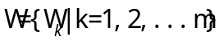. Each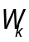 represents an overall hot word.
Then our first namely WS algorithm works as:
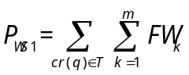
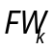 is the frequency that occurs in a query. 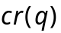 means the create time of query q. T is the time interval. It indicates the how do we split the timeline. In this case, T is divided into days. As a result, the above popularity is denoted as one day’s popularity. This algorithm is just one step ahead than counting query sum directly. However, it makes use of hot words weight rather than query itself. It’s the first advance to utilize hot words and therefore worth mentioning.
When we take a careful look on WS algorithm, it’s obvious that every hot word has the same weight. It’s not clear how to evaluate hot words weight given the fact that same hot word may play a complete different role in other events.
    - TF-IDF
To deal with hot words weight trouble, we shall adopt weight algorithm. Term frequency-inverse document frequency (TF-IDF) is a numerical statistic that is intended to reflect how important a word is to a document in a collection or corpus. It is often used as a weighting factor in information retrieval and text mining. The TF-IDF value increases proportionally to the number of times a word appears in the document, but is offset by the frequency of the word in the corpus, which helps to adjust given the fact that some words appear more frequently in general.
The aim is to weight every hot word. And two aspects are considered. On one hand, term frequency is set to the accumulative number of an individual hot word in a single day, denoted as:
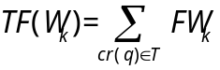
On the other hand, inverse term frequency is usually learned by extra corpus. For
simplification, the overall data is simulated as similar corpus environment. We then deduced inverse term frequency:
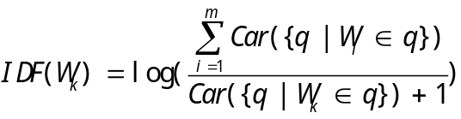
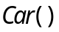 returns the cardinal number of the list. Note that we calculate the number through all time period rather than one day. Inverse term frequency can significantly punish dominant words of the event since they make a huge impact all the time. But dominant words can’t reflect the incoming sub-events. When it comes to prediction, dominant words would no longer be a crucial factor. Instead, rising words may contain information that draws people’s attention combined with event itself. And IDF factor inspire these kinds of words.
As a whole, our proposed TF-IDF algorithm functions as:
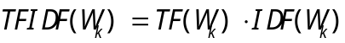
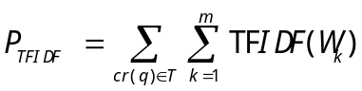
TF is indeed similar as WS algorithm, while IDF can balance the weight among different type of words. Combined together, TF-IDF algorithm is more reasonable and effective.
TF-IDF algorithm is also brutal in a sense. It assigns IDF as a mean of weight. Nevertheless, the value of IDF is bidirectional. It’s hard to decide whether IDF is beneficial to the foundation of popularity. We need to build a more complex and powerful algorithm to archive our goal. That will be QueryRank algorithm that follows.
    - QueryRank
When thinking about relations between things, PageRank (PR) is a priority to solve this kind of problem.
PageRank is an algorithm put by Google Inc. to rank websites. PageRank works by counting the number and quality of links to a page to determine a rough estimate of how important the website is. The underlying assumption is that more important websites are likely to receive more links from other websites. The PageRank algorithm outputs a probability distribution used to represent the likelihood that a person randomly clicking on links will arrive at any particular page. Given a graph 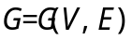 . For each vertex 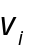, its PR value 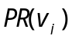 is illustrated as:
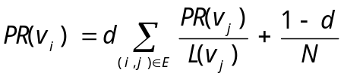
Where 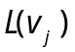 is the number of outbound links on 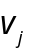 and N is the total number of vertexes.
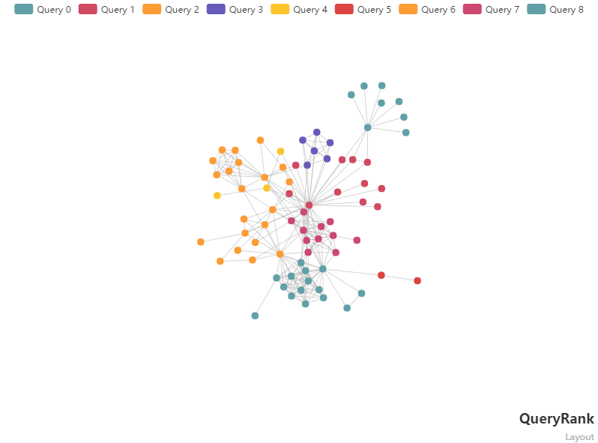
Various strategies have been conducted based on PageRank. When it comes to our problems, each query is considered to be a single node in G. But edge’s weight remains unsolved. One intuitive way is to set as similarity between two queries. The reason for that is PageRank’s edge weight represents when we reach one node, how likely we will move to the adjacent nodes. And similarity is an essential method to substantialize. There are lots of similarity measurements between two texts. We choose cosine similarity for its effectiveness. Note that query need to be segmented into words as in 4.2, then 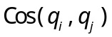 is the cosine similarity between two queries. We name this kind of construction of a PageRank graph as QueryRank.
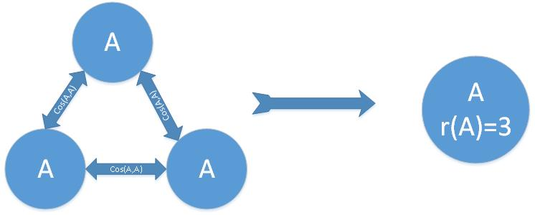
The complexity of best PageRank algorithm is 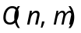 which n and m stands for the number of nodes and edges respectively. Though we can eliminate the number of edges by not adding edge when cosine similarity is 0, we have to expect m may be as bad as 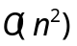 . That would lead to overall complexity. As a result, the internal storage and running time become crucial when PageRank is implemented. In order to overcome this trouble, we merge the queries that have the same contents. The degree of replications is denoted as 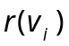 .The edge between distinguished queries now changes to:
This approach is reasonable for it decrees the complexity of the graph without destroying the meaning of the weight. It can also be viewed as compressing a complete graph into a vertex that documents its original scale. And this compressed vertex can still constitute a PR graph after weight modification. To further reduce the vertex, we can set a threshold value those nodes whose cosine similarity is not lower than this value can be combined. In our current case, this value is 1.
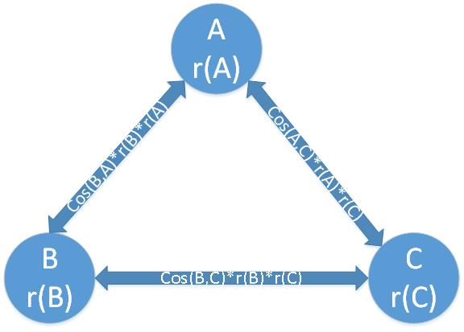
Now our QueryRank algorithm is distinct. First we need to build graph based on queries on a single day. Identical nodes are merged and edge’s weight is calculated using cosine similarity between queries. Next, PR value is calculated by PageRank algorithm. PageRank returns a list of PR value which summed to1. Normalization method is implemented and daily popularity is calculated:
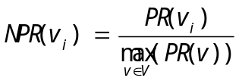
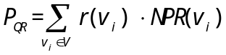

NPR stands for normalized PR value. It alters the largest PR value to 1 and changes other PR value correspondingly. The reason for doing this step is that it can guarantee our popularity is relatively comparable. In this scenario, every day’s most weighted query is fixed to 1. At the same time, other query may value between 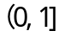 depending on how frequent they appear and how relative they are with other query. is a result of our merge strategy.
To evaluate this algorithm, it has benefits and one potential drawback. The strengths are that it not only reflect the number of queries by normalization but also discover the pattern between words. The principle is virtually finding one or several significant queries that represent different aspects of the event. In graphical view, different aspect may construct several subgraphs that have strong connections within as well as thick intersections towards other subgraphs. The complexity among words is fully mined. The potential drawback is that we can’t assure whether subgraph foundation is positive or not for popularity. For instance, the largest original PR value for two important nodes is similar. Then they are both been normalized around 1. In this case, it may indicate people are viewing the events via different aspects or simply two independent things. The former one may boost the event a lot for it may bring discussion among people. While the latter may simply reflect how people search for things and have no impact on event dissemination. Equal treatment is still a big concern in the future work.
  - Trends Comparison

After building event popularity models, we long for finding trends features for both platforms. Moreover, we want to find models that can make comparisons that lead to future prediction works. Two distinct thinks are developed: curve-based and RBO-based algorithm.
    - Curve-based

Event evolves and disseminates through time. And popularity is a fair measure to describe the current influence and states of the event. Hence analyzing the trends of popularity is reasonable.

Assuming we know the daily trends of Baidu and Weibo denoted as 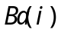 and 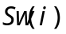 where 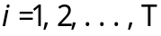 respectively. Then we aim to find 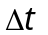 to minimize MSE of two vectors:

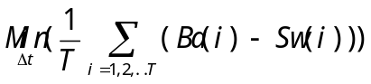

However, there is a potential trouble in this scenario. The popularity may rise and fall frequently. For an exaggerated instance, if we analyze NBA popularity through years, it’s shamed that 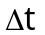 can be arbitrary years. It’s hard to tell the minimal value is helpful or not. In reality, our data may contain multiple ups and downs. We even can’t map the top of their curve definitely. Another concern is that people use social network and search engine differently in real life. That may cause different trends on some specific situations. Those may accidently result in a meaning less delay value.
    - Word-based

It seems that popularity analysis is highly arguable. Still we note that our data are selected if certain words are matched. Based on this setting, we propose a word based methods named RBO-based algorithm to measure the relations between separate contents.

Reminding of TF-IDF algorithm in 3.3.2, daily hot words are obtained by accumulating that day’s queries. There are different types of hot words. Some are dominant words that appear every day. Others may rarely appear from the perspective of whole documents. For example, ‘Li Bai’ only occurs twice in 2 days of one event. That indicates ‘Li Bai’ is likely to have some unexpected connections on those two days. We can further detect that someone creates an acrostic combined event with word ‘Li Bai’. It’s noticed that some words can imply the subevents. Subevents are almost beneficial to the boost of events and are easy to distinguish.

In conclude, we need to find hot words similarity from different days and platforms. A ranked list of hot words can contain both dominant words and newly born words.

There are different approaches to compare two ranked lists. We choose to use Rank Biased Overlap (RBO) algorithm. RBO extends the idea of average overlap in two ways. First, in order to bound the outcome, RBO uses geometric series. One nice property of geometric series that is used in RBO is that it is a type of convergent series. That is, it can be easily shown that the indefinite sum of geometric series is finite and is given as . Thus, using geometric series, RBO is able to bound the unbounded average overlap score for indefinite rank position. Another advantage of using geometric series is that since the values in geometric series decreases with the increasing depth, it allows RBO to explicitly model user’s behavior i.e. the likelihood of going from a given rank position i to i+1. This is the crux of RBO. We can give our ranked lists different predilection. Position from top can have huge impact on final outcome for it has higher weight. At the same time, position from below can also influence the outcome. Thus newly developed words can be detected.
- Experiments
  - Datasets
Our data set is supported by Opening Project of Baidu. They provided us with two hot events, namely Eastern Star and Stock Market Crash events.
Eastern Star Sink | Baidu | Sina Weibo
Data size | 42MB | 64MB
Query size | 235,065 | 67,873
Start Date | 2015-06-12 | 2015-06-12
End Date | 2015-07-01 | 2015-07-01

  - Data Managements
When raw data are given to our flowchart, we need to do data managements for transportability and convenience. To begin with, we need to design codes that are independent on events. We select Python as our programming language. Our codes are readily substituted with different raw data. The hardware environment is Lenovo Y470 with 2.5Ghz Intel Core i5-2450M and memory 8GB. Note that QueryRank algorithm requires large use of memory and is relatively slow. In reality, solving a 2000 degrees graph would lead to insufficient memory in local machine. We would address this issue more in 4.3. Our preliminary task is to achieve our flowchart and full details are shown in the rest of 4.2.
    - Pre-processing
Before conducting experiments according to theory in Section 3, our raw data need to be pre-processed. Raw data is JSON format and create time is out of order. In order to access data faster and more convenient, we store data in Sqlite3 database. The default coding is utf-8.
After storing data, we need to do text segmentation. We use open-source tool ‘jieba’ to conduct this work. There are two noticeable configurations that matter a lot. The first one is pre-load dictionary. Since every text segmentation tools can’t be perfect, especially when specific phrases are formed. For instance, ‘eastern’ and ‘star’ are likely to be segmented in most paper in Chinese. But when studying on ‘Eastern Star’ event, segmentation on these two words would most likely influence ranked hot words. People would view these two words together as a whole semantic group no matter what methods they search for ‘Eastern Star’ event. To avoid this inaccuracy, we can intelligently combine words into meaningful phrases using APE (Absolute Percentage Error).
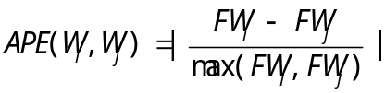
The scenario is to unite adjacent words which have low APE into phrases. Low can be determined by a little threshold value. The second one is to add stopwords dictionary. Stopwords are words that appear too frequently in most works to have no big impact on topic analysis. Stopwords is further modified by adding punctuation for social networks usually contain special mark like ‘#’
    - Visualizations

Our data source includes two major events: Eastern Sink Event and Chinese Stock Event. We will analyze their popularity and trends separately.
- Eastern Sink Event

Sinking of Eastern Star (as knowns as Dongfang zhi Xing in Chinese) was a river cruise ship that operated in the Three Gorges of inland China. It is a catastrophic maritime disaster in China’s history and causes continuous attentions in public. It capsized on 1 June 2015 and 442 deaths are confirmed on 13 June. The rescue ended on 13 June as well. Our data contains queries from 12 June to 1 July. It concentrates on the ending part of the whole event.

We first implement three separate algorithms on Baidu and Weibo independently. After text segmentation, we select 20 hot words as overall hot words. The represented hot words can be found in Fig

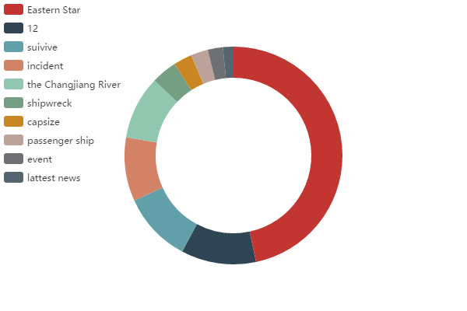

The dominant words are ‘eastern star’ with a major appearance in the dataset. ‘12’ is selected because 12 people are rescued on 13 June. It has realistic meaning thus can’t be filtered. After hot words are selected, we conduct WS algorithm on each day. The reference count of hot words is easily computed thus daily popularity is obtained after summarization. Daily hot words are given to implement TF-IDF algorithm. IDF information are stored in a dictionary in Python to reduce redundant calculate. Finally, we experiment on QueryRank algorithm by constructing several graphs. Note that our local memory is limited so words merge are first achieved. While the running time still takes more than an hour to finish. So we continue to split one day into hours. In each hour, an graph is built given the same scenario with less data. Daily popularity then requires sum of hour’s popularity. Although this split doesn’t change the complexity of QueryRank. But for a given n, the running time is linearly reduced.

To compare different algorithms, we conduct normalization on each one. The final comparisons are illustrated in Fig (solid line refers to QueryRank, dotted as to WS, dashed to TF-IDF).

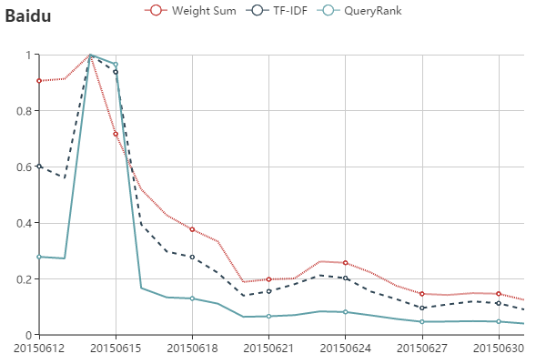

From the above figure, we notice that they both weight June 14 as peak of the given data. After the peak, the general trend is to go down. They all indicate the whole trends in real life. After June 14, the whole event cools down because the rescue work is finished and no significant progress on event itself happens.

One noticeable difference is popularity on 13 June. On that day, WS and QueryRank appears to be opposite of the event’s trends. WS emphasizes power of the overall hot words. Since ‘12’ is prevalent in a view of whole datasets. WS finds it’s extreme important and concludes that day’s popularity are relatively high. TF-IDF balance the weight of hot words. It implies that ‘12’ also appears frequently on 14 June. Thus the weight of ‘12’ is weakened. The lowest result is QueryRank. Note that QueryRank doesn’t influence the weight among days. It indicates how people search or tweet the events as well as the number of queries. On 14 June, it considers the event reaches the peek as other algorithm do. However, it hold the opinion that popularity on 13 June shouldn’t be that high. The reason for this is not completely clear given the complexity of the graph. One possible explanation is that its data are separated into fragments since the report happens in the middle of June 13. Those subgraphs indicate the incoming prevalence of the event but rank low as a whole. The potentials and metrics behind this phenomenon are further discussed in 4.3

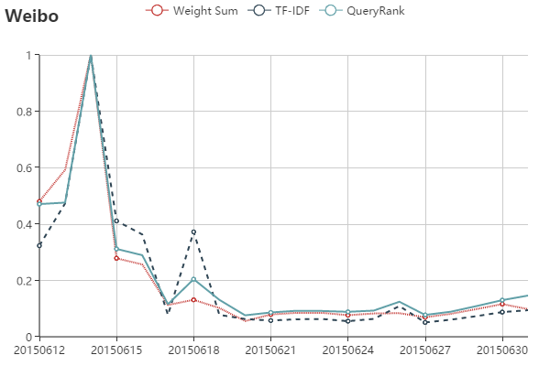

The same process are conducted on Sina Weibo. One difference is that Weibo has types of texts known as tweets and retweets. Tweets usually contain the official news or videos that relate to event. On the contrary, retweets are fulfilled with user’s comments or simply nothing. The result is shown in Fig.

Another aspect of compassion is to compare Baidu’s and Weibo’s popularity within the same algorithm.
- Chinese Stock Event
  - Discussions
- Conclusion
With the advent of the information explosion era, social networks and search engines have become two important platforms for the dissemination of the event. Due to its user relationship and free comment feature, social networks are popular among people. Meanwhile, search engines are platforms to provide information with users through retrieval services. It is possible that there are some interactions and relations between these influential media. In this thesis, we first build models to describe how events disseminate among several related days. Three methods are introduced to model Eastern Star and Stock Market Crash events, including Word Count, TF-IDF and QueryRank. Among these three methods, QueryRank is proposed based on PageRank, whereas the edge weight is measured based on cosine similarity between two queries. This method takes into account both the number of queries itself as well as relationships between keywords. After popularity evaluation, we use RBO algorithm to compare ranked hot words lists on different platforms in the aspect of time. We select Baidu Search as a representative to search engines and Sina Weibo as to social networks. Experimental results show that Baidu has a relative delay comparing to Weibo. We would further use the delay to predict event trends using the relationships between these two platforms.

References
- Tatar, Alexandru, et al. A survey on predicting the popularity of web content [J]. Journal of Internet Services and Applications 5.1, 1-20, 2014.
- Giummolè, Federica, Salvatore Orlando, and Gabriele Tolomei. Trending topics on Twitter improve the prediction of Google hot queries[C]. Social Computing (SocialCom), 2013 International Conference on. IEEE, 39-44, 2013.
- Liao, Han-Teng. What do Chinese-language microblog users do with Baidu Baike and Chinese Wikipedia? A case study of information engagement[C]. Proceedings of The International Symposium on Open Collaboration. ACM, 23, 2014.
- Ahmed, Mohamed, et al. A peek into the future: predicting the evolution of popularity in user generated content[P]. Proceedings of the sixth ACM international conference on Web search and data mining. ACM, 2013.
- Roy, Sanjay Dhar, et al. Towards cross-domain learning for social video popularity prediction[C]. Multimedia, IEEE Transactions on 15.6, 1255-1267， 2013.
- Figueiredo, Flavio. On the prediction of popularity of trends and hits for user generated videos[P]. Proceedings of the sixth ACM international conference on Web search and data mining. ACM, 2013.
- Avramova, Zlatka, et al. Analysis and modeling of video popularity evolution in various online video content systems: power-law versus exponential decay[C]. Evolving Internet, 2009. INTERNET'09. First International Conference on. IEEE, 95-100, 2009.
- Tatar, Alexandru, et al. Ranking news articles based on popularity prediction[P]. Proceedings of the 2012 International Conference on Advances in Social Networks Analysis and Mining (ASONAM 2012). IEEE Computer Society, 106-110, 2012.
- Ma, H., Qian, W., Xia, F., He, X., Xu, J., & Zhou, A.. Towards modeling popularity of microblogs[C]. Frontiers of Computer Science, 7(2), 171-184, 2013.
- Kong, S., F. Ye, and L. Feng. Predicting future retweet counts in a microblog [P]. Journal of Computational Information Systems 10.4, 1393-1404, 2014.
- Bandari, Roja, Sitaram Asur, and Bernardo A. Huberman. The pulse of news in social media: Forecasting popularity. arXiv preprint arXiv:1202.0332 , 2012.
- Tsagkias, Manos, Wouter Weerkamp, and Maarten De Rijke. Predicting the volume of comments on online news stories[P]. Proceedings of the 18th ACM conference on Information and knowledge management. ACM, 2009.
- Lee, Jong Gun, Sue Moon, and Kavé Salamatian. Modeling and predicting the popularity of online contents with Cox proportional hazard regression model. Neurocomputing 76.1, 134-145, 2012.
- Kong, S., F. Ye, and L. Feng. Predicting future retweet counts in a microblog[P]. Journal of Computational Information Systems 10.4 ,1393-1404, 2014.
- Zaman, Tauhid, Emily B. Fox, and Eric T. Bradlow. A Bayesian approach for predicting the popularity of tweets[P]. The Annals of Applied Statistics 8.3, 1583-1611, 2014.
- Blei, David M. Probabilistic topic models. Communications of the ACM55.4 , 77-84, 2012.
- Drummond, Anna, et al. Topic Models For Feature Selection in Document Clustering. SDM. 2013.
- Qiu, Minghui, Feida Zhu, and Jing Jiang. It is not just what we say, but how we say them: LDA-based behavior-topic model[P]. Proceedings of the 13th SIAM International Conference on Data Mining. 2013.
- Wang, Chi, et al. Constructing topical hierarchies in heterogeneous information networks. Knowledge and Information Systems 44.3 ,529-558, 2015.
- Yang, Yulian, and Lei Xie. Subword latent semantic analysis for texttiling-based automatic story segmentation of chinese broadcast news[P]. Chinese Spoken Language Processing, 2008. ISCSLP'08. 6th International Symposium on. IEEE, 2008.
- Oghina, Andrei, et al. Predicting imdb movie ratings using social media. Advances in information retrieval. Springer Berlin Heidelberg, 503-507, 2012.
- Roy, Sanjay Dhar, et al. Towards cross-domain learning for social video popularity prediction. Multimedia, IEEE Transactions on 15.6, 1255-1267, 2013.
- Castillo, Carlos, et al. Characterizing the life cycle of online news stories using social media reactions[P]. Proceedings of the 17th ACM conference on Computer supported cooperative work & social computing. ACM, 2014.

