George, Levi

CS44500 – Computer Security

02/15/23

Lab 4 – Return to Lib C

Env Setup.

Turning off ASLR

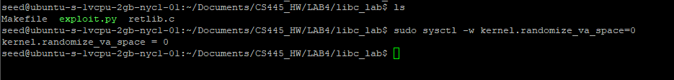

Changing from Dash to Zsh



It appears that the ret_lib.c has a vulnerability due to using strcpy in the bof function.

Additionally I see that we read in about 1000 characters from our badfile, this may affect how I construct my payload.

Compilation with no stack protector nor executable stack. (With N being 100 for the DBUF_SIZE)



TASK 1. Getting our libc function’s address in memory

Touch badfile and run gdb



Getting my libc function addresses

TASK 2. Putting shell string in the memory



Store my shell within a env variable (I can access my env vars from within my program) to use later.

I create my printenv program



Which has this code

I get this for my /bin/sh address

However, this is a 64 bit address,



I recompile for 32-bit using -m32 and get the following address



TASK 3. Launching my attack

I insert my function addresses into my python code.

I generate a gdb version of the vulnerable code via gcc using deactivated countermeasures, setting the code to 32 bit and with the buffer size as 100.



I set a breakpoint a bof (gdb command b bof, then r)

I find the address of $ebp and buffer then the difference between them.

Using this as my basis, I set my insertion points as such.

However, this failed. I got a segfault.

I checked my handout to see how the order was in the class demo and realized that I mis-ordered my commands. I set them to this:

This arrangement awarded me the root shell. (I opened my exploit to take the shot from above)

Interestingly, I did attempt to use the 64-bit address of my shell command.

But uninterestingly, it just didn’t give me a new shell. (I suspect that my system and exit command ran, but since I wasn’t getting the right address for the shell command, I didn’t get any shell.)

TASK 3b. Variation 1 – No Exit()

I set my exit command as the above and got a segmentation fault.

This must be caused by us not exiting bof when we execute our attack.

Task 3c. Variation 2 – change program name

I changed my programs name and I also returned my shell address to the original 32-bit address

This won’t succeed due to my program’s name influencing the addressing of my shell address in my env variables. Which we see below.

