Computer Vision and Digital Image Processing

Assignment 3

WEI LI

Objective
The purpose of the assignment is to explore the spatial-domain convolution while using the provided simulated cake image to determine the efficiency of the Sobel edge detection algorithm.

Background
Spatial domain convolution algorithms are widely used in image processing. By filtering out the image pixels we want, we can achieve several tasks like edge detection.

Algorithms/Functions
I use Sobel edge detection algorithm and 3x3 average filtering algorithm. Both are written in ‘sobel.c’ and ‘smooth.c’ files. I also write the read and write function in ‘wr.c’ file.

Results

Part 1 Results
Test results on the mri.pgm image.
Table 1: Results of Sobel on mri.pgm image
Original Image | Sobel Image | Binary Image  Threshold=30
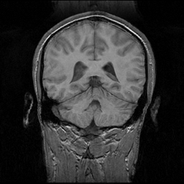 | 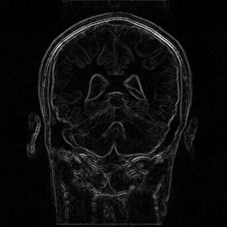 | 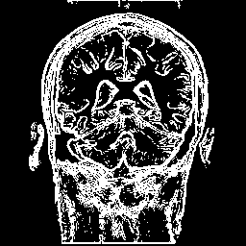

Part 2 Results

Table 2: Sobel Edge Detection Results on cake.pgm image
Noise Level | Original Image + Noise | Sobel Image | Sobel -> Binarized | Smoothed -> Sobel | Smoothed -> Sobel -> Binarized
No Noise |  | 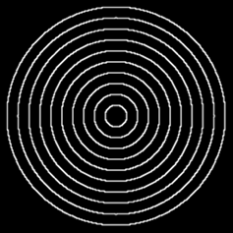 | 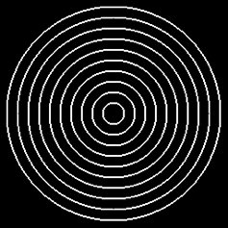 | N/A | N/A
First noise level=5 | 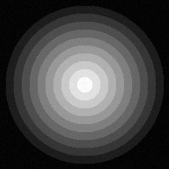 | 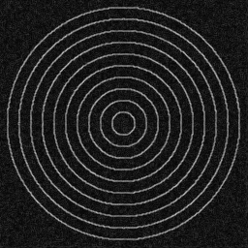 | 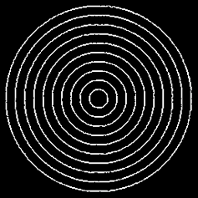 | 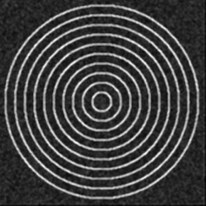 | 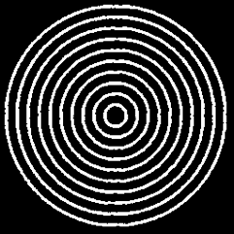
Second noise level=10 | 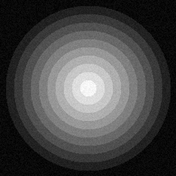 | 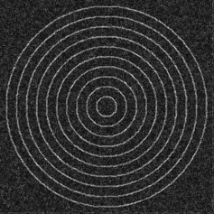 | 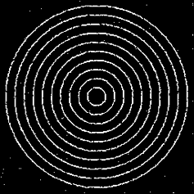 | 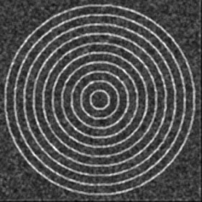 | 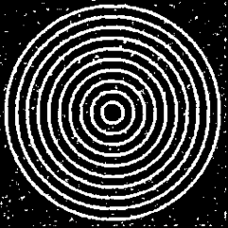
Third noise level=20 | 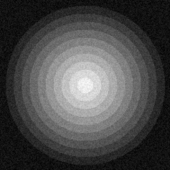 | 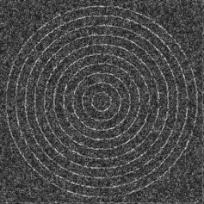 | 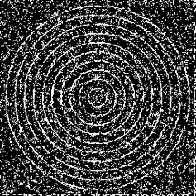 | 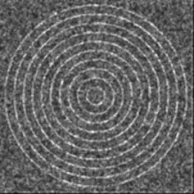 | 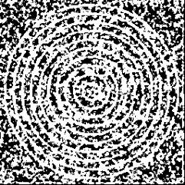

Two plots:
I use threshold = 90 to plot the accuracy based on three noise level(5,10,20)
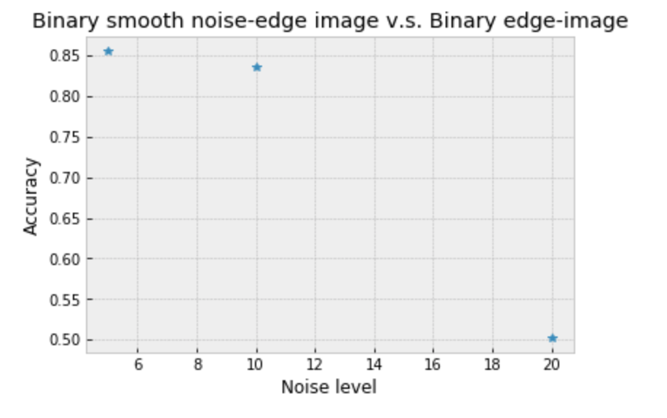
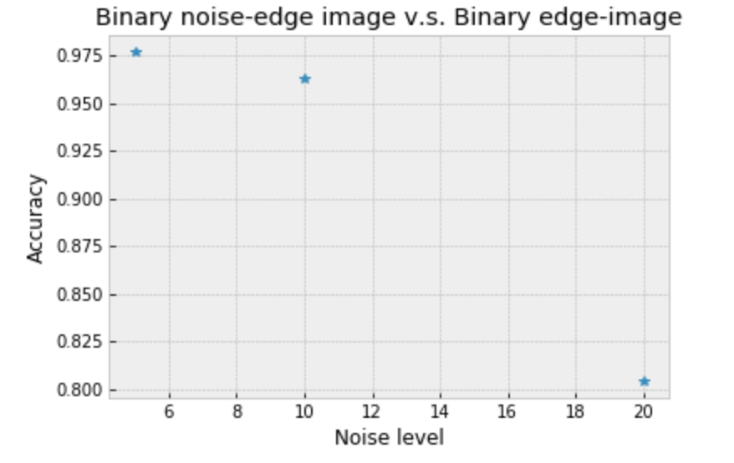

Observations
Based on the part 1 results, we can observe the differences by changing the threshold of the output binary edge image. And based on the part 2 results, we can further notice that the accuracy would drop when the noise level increases.

Conclusions
This assignment I successfully implement Sobel edge detection algorithm and try a bit on selecting the best threshold of binary edge image. And I also implement the 3x3 averaging filter on the noisy edge image to compare the accuracy with binary edge image.

Code:
Part1:
#include <stdio.h>
#include <stdlib.h>
#include <math.h>
#include <float.h>
#include <limits.h>
#include "wr.h"
#include "sobel.h"

int main(int argc, char *argv[]){
int min = INT_MAX; //set minimum doubled value
int max = 0; //set maximum doubled value

unsigned sizeX; //image width
unsigned sizeY; //image height
unsigned levels; //image brightness
unsigned char *image; //image 1D array
unsigned char *outputMRI; //mri image output
int *data; //data type can be either int or float
int *data_sobel;
int *data_sobel_t;

//read image from file
readImage("mri.pgm", &sizeX, &sizeY, &levels, &image);

data = (int*)calloc(sizeof(int),(sizeX+2)*(sizeY+2)); //allocate 258x258
data_sobel_t = data_sobel =(int*)calloc(sizeof(int),(sizeX+2)*(sizeY+2));
outputMRI = (unsigned char *)malloc(sizeX*sizeY);

/************************* Image Processing *******************************/

//put original image pixel values in data array, prepare for the padding
if(data){
for(int i=1; i<sizeX+1; i++){
for(int j=1; j<sizeY+1; j++){
data[i*(sizeX+2) + j] = image[(i-1)*sizeX + (j-1)];
}
}
}

//Apply Sobel filter
sobel(data, data_sobel);

//Normalization
for(int i = 0; i < (sizeX+2)*(sizeY+2); i++){
if (data_sobel[i] < min)
min = data_sobel[i];
if (data_sobel[i] > max)
max = data_sobel[i];
}
for(int i = 0; i < (sizeX+2)*(sizeY+2); i++){
data_sobel[i] = levels*(data_sobel[i]-min)/(max-min);
}

for(int i=1; i<sizeX+1; i++){
for(int j=1; j<sizeY+1; j++){
outputMRI[(i-1)*sizeX + (j-1)] = data_sobel[i*(sizeX+2) + j];
}
}

//write sobel image to file
writeImage("EdgeImage.pgm", sizeX, sizeY, levels, outputMRI);

for(int i = 0; i < (sizeX+2)*(sizeY+2); i++){
data_sobel[i] = data_sobel[i];
}

//Set a threshold T
int T = 30;
for(int i = 0; i < (sizeX+2)*(sizeY+2); i++){
if(data_sobel[i] > T)
data_sobel[i] = levels;
else
data_sobel[i] = 0;
}

for(int i=1; i<sizeX+1; i++){
for(int j=1; j<sizeY+1; j++){
outputMRI[(i-1)*sizeX + (j-1)] = data_sobel[i*(sizeX+2) + j];
}
}

//write image to file
writeImage("BinaryEdgeImage.pgm", sizeX, sizeY, levels, outputMRI);

free(data);
}

Part2:
#include <stdio.h>
#include <stdlib.h>
#include <math.h>
#include <float.h>
#include <limits.h>
#include "wr.h"
#include "sobel.h"
#include "smooth.h"
#include "time.h"

int main(int argc, char *argv[]){
int min = INT_MAX; //set minimum value
int max = 0; //set maximum value
int T = 90; //set a threshold value for best binary image output

unsigned sizeX; //image width
unsigned sizeY; //image height
unsigned levels; //image brightness
unsigned char *outputImage, *outputImage1, *outputImage2, *outputImage3; //image output
unsigned char *outputNoise;
unsigned char *image; //image 1D array

int *data; //data type can be either int or float
int *data_sobel;
int *data_sobel_t;
int *data_smooth;
int *intImage;

//read image from file
readImage("cake.pgm", &sizeX, &sizeY, &levels, &image);

intImage = (int*)malloc(sizeof(int)*sizeX*sizeY);
data = (int*)calloc(sizeof(int),(sizeX+2)*(sizeY+2)); //allocate 258x258
data_smooth = (int*)calloc(sizeof(int),(sizeX+2)*(sizeY+2));
data_sobel_t =(int*)calloc(sizeof(int),(sizeX+2)*(sizeY+2));
data_sobel =(int*)calloc(sizeof(int),(sizeX+2)*(sizeY+2));
outputImage = (unsigned char *)malloc(sizeX*sizeY);
outputImage1 = (unsigned char *)malloc(sizeX*sizeY);
outputImage2 = (unsigned char *)malloc(sizeX*sizeY);
outputImage3 = (unsigned char *)malloc(sizeX*sizeY);
outputNoise = (unsigned char *)malloc(sizeX*sizeY);

/************************* Image Processing *******************************/
//put original image pixel values in data array, prepare for the padding
if(data){
for(int i=1; i<sizeX+1; i++){
for(int j=1; j<sizeY+1; j++){
data[i*(sizeY+2) + j] = image[(i-1)*sizeX + (j-1)];
}
}
}

//Apply Sobel filter
sobel(data, data_sobel);

//Normalization
for(int i = 0; i < (sizeX+2)*(sizeY+2); i++){
if (data_sobel[i] < min)
min = data_sobel[i];
if (data_sobel[i] > max)
max = data_sobel[i];
}
for(int i = 0; i < (sizeX+2)*(sizeY+2); i++){
data_sobel[i] = levels*(data_sobel[i]-min)/(max-min);
}

//Allocate filtered image pixels to 256x256
for(int i = 1; i < sizeX+1; i++){
for(int j=1; j<sizeY+1; j++){
outputImage[(i-1)*sizeX + (j-1)] = data_sobel[i*(sizeX+2) + j];
}
}

//write image to file
writeImage("EdgeImage.pgm", sizeX, sizeY, levels, outputImage);

//make binary image
for(int i = 0; i < (sizeX+2)*(sizeY+2); i++){
if(data_sobel[i] > T)
data_sobel[i] = levels;
else
data_sobel[i] = 0;
}

//Allocate filtered image pixels to 256x256
for(int i = 1; i < sizeX+1; i++){
for(int j=1; j<sizeY+1; j++){
outputImage1[(i-1)*sizeX + (j-1)] = data_sobel[i*(sizeX+2) + j];
}
}

//write image to file
writeImage("BinaryEdgeImage.pgm", sizeX, sizeY, levels, outputImage1);

//Convert image file to int type and generate random noise r on image pixels
for(int i = 0; i < sizeX*sizeY; i++){
int r = rand()%41 - 20; //noise from -20 to 20
//int r = rand()%21 - 10; //noise from -10 to 10
//int r = rand()%11 - 5; //noise from -5 to 5
intImage[i] = image[i];
intImage[i] = intImage[i] + r;
}

//Normalization
for(int i = 0; i < sizeX*sizeY; i++){
if (intImage[i] < min)
min = intImage[i];
if (intImage[i] > max)
max = intImage[i];
}
for(int i = 0; i < sizeX*sizeY; i++){
intImage[i] = 255*(intImage[i]-min)/(max-min);
}
//Convert int to unsigned char
for(int i = 0; i < sizeX*sizeY; i++){
outputNoise[i] = intImage[i];
}

//write noisy image to file
writeImage("NoisyImage.pgm", sizeX, sizeY, levels, outputNoise);

//put original image pixel values in data array, prepare for the padding
if(data){
for(int i=1; i<sizeX+1; i++){
for(int j=1; j<sizeY+1; j++){
data[i*(sizeY+2) + j] = intImage[(i-1)*sizeX + (j-1)];
}
}
}

//Apply Sobel filter
sobel(data, data_sobel);

for(int i=0; i<(sizeX+2)*(sizeY+2); i++){
data_sobel_t[i] = data_sobel[i];
}

//Normalization
for(int i = 0; i < (sizeX+2)*(sizeY+2); i++){
if (data_sobel[i] < min)
min = data_sobel[i];
if (data_sobel[i] > max)
max = data_sobel[i];
}
for(int i = 0; i < (sizeX+2)*(sizeY+2); i++){
data_sobel[i] = levels*(data_sobel[i]-min)/(max-min);
}

//Allocate filtered image pixels to 256x256
for(int i = 1; i < sizeX+1; i++){
for(int j=1; j<sizeY+1; j++){
outputImage[(i-1)*sizeX + (j-1)] = data_sobel[i*(sizeX+2) + j];
}
}

//write image to file
writeImage("NoisyEdgeImage.pgm", sizeX, sizeY, levels, outputImage);

//make binary image based on thredhold T
for(int i = 0; i < (sizeX+2)*(sizeY+2); i++){
if(data_sobel[i] > T)
data_sobel[i] = levels;
else
data_sobel[i] = 0;
}

//Allocate filtered image pixels to 256x256
for(int i = 1; i < sizeX+1; i++){
for(int j=1; j<sizeY+1; j++){
outputImage2[(i-1)*sizeX + (j-1)] = data_sobel[i*(sizeX+2) + j];
}
}

//write image to file
writeImage("BinaryNoisyEdgeImage.pgm", sizeX, sizeY, levels, outputImage2);

//Apply averaging filter
smooth(data_sobel_t, data_smooth);

//Normalization
for(int i = 0; i < (sizeX+2)*(sizeY+2); i++){
if (data_smooth[i] < min)
min = data_smooth[i];
if (data_smooth[i] > max)
max = data_smooth[i];
}
for(int i = 0; i < (sizeX+2)*(sizeY+2); i++){
data_smooth[i] = levels*(data_smooth[i]-min)/(max-min);
}

//Allocate filtered image pixels to 256x256
for(int i = 1; i < sizeX+1; i++){
for(int j=1; j<sizeY+1; j++){
outputImage[(i-1)*sizeX + (j-1)] = data_smooth[i*(sizeX+2) + j];
}
}

//write averaging image to file
writeImage("SmoothNoisyEdgeImage.pgm", sizeX, sizeY, levels, outputImage);

//make binary image
for(int i = 0; i < (sizeX+2)*(sizeY+2); i++){
if(data_smooth[i] > T)
data_smooth[i] = levels;
else
data_smooth[i] = 0;
}

//Allocate filtered image pixels to 256x256
for(int i = 1; i < sizeX+1; i++){
for(int j=1; j<sizeY+1; j++){
outputImage3[(i-1)*sizeX + (j-1)] = data_smooth[i*(sizeX+2) + j];
}
}

//write image to file
writeImage("BinarySmoothNoisyEdgeImage.pgm", sizeX, sizeY, levels, outputImage3);

int counter1 = 0;
float accu1, accu2;
//calculate the accuracy between binary noisy edge image and binary edge image
for(int i = 0; i < (sizeX+2)*(sizeY+2); i++){
if(outputImage1[i]==outputImage2[i]){
counter1++;
}
}
accu1 = (double)counter1/((sizeX+2)*(sizeY+2));
printf("accuracy1 : %lf \n", accu1);

int counter2 = 0;
//calculate the accuracy between binary smooth noisy edge image and binary edge image
for(int i = 0; i < (sizeX+2)*(sizeY+2); i++){
if(outputImage1[i]==outputImage3[i]){
counter2++;
}
}
accu2 = (double)counter2/((sizeX+2)*(sizeY+2));
printf("accuracy2 : %lf \n", accu2);

free(data);
}

