Levi George

03/12/2021

Prof. Amal Khalifa

CS350: Programming Language and Design

Ruby’s Iterators (HW4)

1. With the help of an example, discuss the syntax, purpose, and usage of an iterator.
   1. Iterators are methods for data structures like collections or arrays. Typically we may design a function which accesses the data in our structure. With iterators we may print the contents without defining our own method. The *each* iterator will return every item within an array, *collect* does this as well but for collections.
   2. 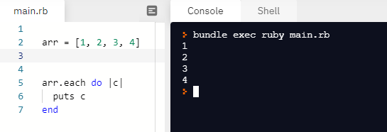
2. Describe the steps of defining an iterator for a user-defined collection.
   1. In order to create an iterator, we would first need our own collection, class, or data structure.
      1. After this, we would create our own method, using the *def* and *end* keywords to define the area that we code within. It is important to define your function as each, this improves readability.
      2. Then within our method, we would write the code that defines our iterators behavior. Here is an example of a class with an iterator that I made myself.
   2. 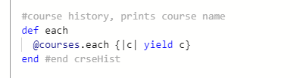
3. Give an example of user-defined collection that implement the iterator mechanism.
   1. 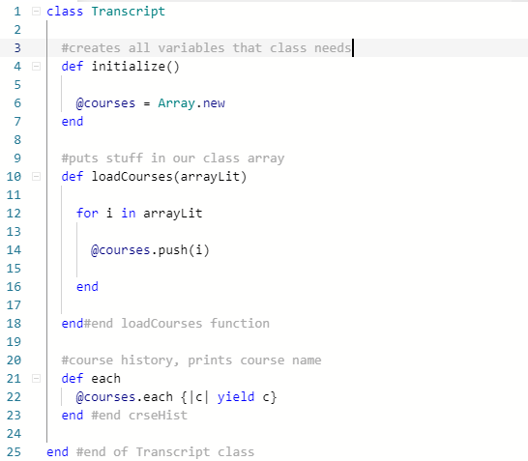
4. Create an instance of your collection storing at least 10 elements.
   1. “code example”
5. Use a loop to consume the iterator of your collection and print its elements’ data.
   1. View PDF
6. For the first three elements, manually trace how the loop used the iterator protocol in the previous part.
   1. We reach our code that prints each item, we use our iterator function *each* to receive the set of items in our array, then we run “do |c|”, which will get the element from the iterators current position, then we print. However, we only access our class once to retrieve the list of elements using our iterator.
   2. For subsequent iterations we will continue moving through the set of items that we got from out iterator and then print it using “puts c”.
   3. Thus for a list like: A, B, C. We would get A from our iterator, then print it, get B from our iterator, then print it, get C from our iterator, then print that. This pattern would continue for any subsequent items within our array.