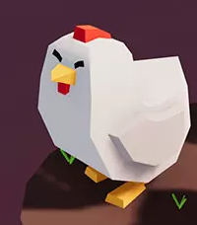

Chicken Cannon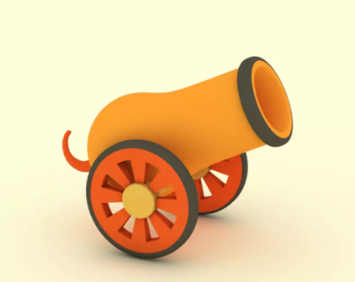

Created by: Levi Lang

Last Edited 12/7/21

Table of Contents

Game analysis_______________________________________3

Mission Statement____________________________________3

Genre______________________________________________3

Platforms____________________________________________3

Target Audience______________________________________3

Storyline/Characters___________________________________4

Gameplay

Overview

Player experience

Guidelines

Objectives/Rewards

Gameplay mechanics

Level Design

Control Scheme

Game aesthetics/UI

Schedule/tasks

Game Analysis

Chicken Cannon is a 3D shooter puzzle game where you launch chickens out of a cannon in order to knock over pins. The goal is to knock over all pins using as few chickens as possible.

Mission Statement

This game shows the player how fun it could be to shoot chickens at bowling pins. It makes the player choose which types of chickens will assist them in getting the lowest score.

Genre

Chicken Cannon is intended to be a puzzle shooter game.

Platforms

This game will shoot to be released for PC but could be easily integrated to other platforms

Target Audience

This will be aimed toward a younger audience due to the fact that there are no graphic scenes. The theme is comical so younger audiences will enjoy it.

Storyline/Characters

The game's story is very simple. The player is a chicken and they must knock down all the pins in their way.

| Character/vehicle | Background/Abilities |
| --- | --- |
|  | This is the “player” for the game |
|  | The chickens the player shoots |

Gameplay

Overview

This game is a puzzle shooter where your goal is to knock all the bowling pins off of a platform using as few chickens as possible.

Player Experience

The player will use different chickens in order to knock off all the pins as efficiently as possible.

Game Objectives/Rewards

There will be two levels with the same objective, to knock down all pins using as few chickens as possible.

| **Level** | **Rewards** | **Penalties** | **Difficulty** |
| --- | --- | --- | --- |
| Level 1 | Winning by knocking down all pins. Hit the green pin to immediately win. | Hitting red pin resets level | easy |
| Level 2 | Same as Level one | Hitting red pin resets level | medium |

Gameplay Mechanics

| **Character/Enemy type** | **Abilities** |
| --- | --- |
| Player Character  Cannon | Can move forward and back and aim up and down. Shoots 3 different chicken types |
| Pins | Sit in place waiting to be hit by a chicken |

Gamemodes

This game will contain one gamemode where the player is supposed to knocked down all the pins using as few chickens as possible.

Level Design

| **Level** | **Description** |
| --- | --- |
| 1 | Levels will be similar in design with different pin placement |
| 2 | Same as level 1 |

Control Scheme

| Input | Action Performed |
| --- | --- |
| Left arrow | Moves cannon toward screen |
| Right arrow | Moves cannon away from screen |
| Mouse | Cannon follows mouse |
| Left click | Hold to aim and release to fire chicken |

Game Aesthetics/User Interface

This game will have a low poly style with a very basic user interface.

User Interface

Very basic and will allow for movement between scenes.