ADVANCED MANUFACTURING

- Introduce User, password and select language before clicking on Log On.
- Click on Advanced Manufacturing
- Introduce Personnel number (in this case a 1), then click on submit.

HOW TO REDIRECT TO HOME
- Click on the selected tile dropdown menu (in this case “Advanced Manufacturing”).
- Click on Home
WORK INTO ADVANCED MANUFACTURING
- Click on Expand Header.
- Click on Adapt Filters.
- Select the desired filters. Ex. WBS element, Op. Plant, Sel. Profile Ord., Sel. Profile Op., Order, Operation and Material.
- Click on “OK”.
- Search based on the filters. Ex. Order: 1001970 Operation: 0010.
- Expand desired order to view its details (click on “>”).
- In the navigation of the new screen, some tiles might be greyed out (like “Traceability” in this ex.), which means that no action is required / available in this tile and prevents excessive clicks.
OPERATION CORE FUNCTIONS
Release order:
- Click on the “Release order” icon.
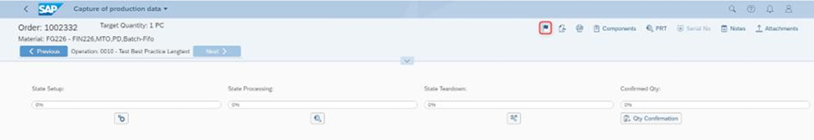
NOTE: The button is only visible if the order is not released yet.
Customizable button: Usually refers to the “Confirmation Barcode”.
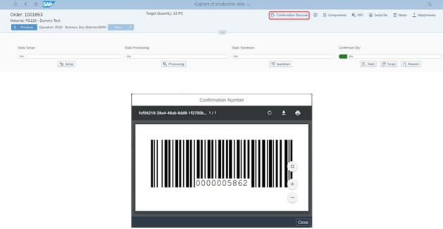

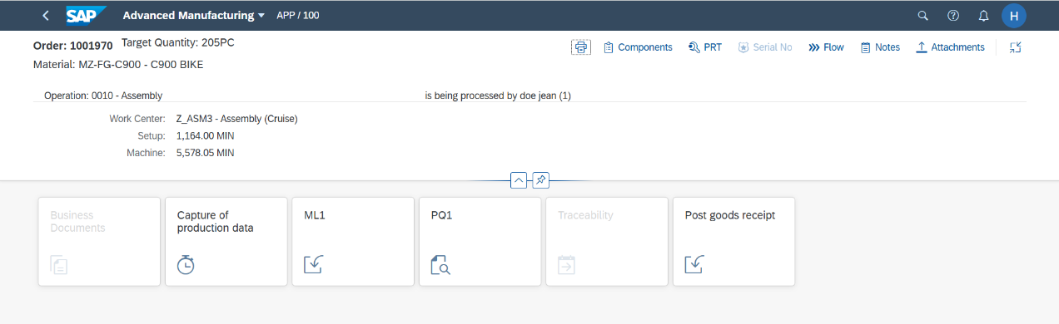
Print Order or Operation: Press the “Print Order” button.
Components: It contains all components which are assigned to the current operation

Notes:
• To see all components for all operations, use switch “Show all”.
• To add also deleted components, use switch “Show deleted”.
• If the field “Has Document” is active, the component itself has a document attached which can be viewed by clicking the button “View document” which became active.
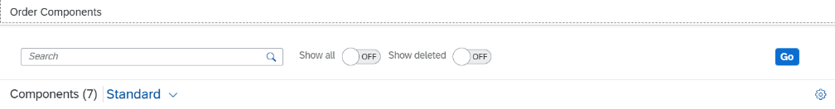
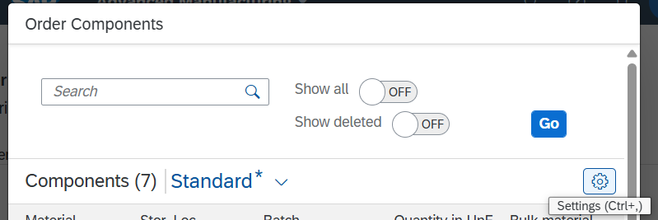
• Use settings button to design the table-layout and adjust based on visible colums, and apply sorts, filters or groups.

• Set the layout as a default (for the current user):
- Click on “Select View”.
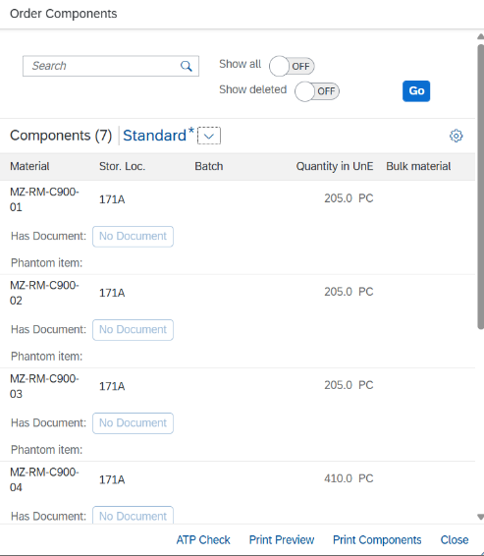
- Click on “Manage”.
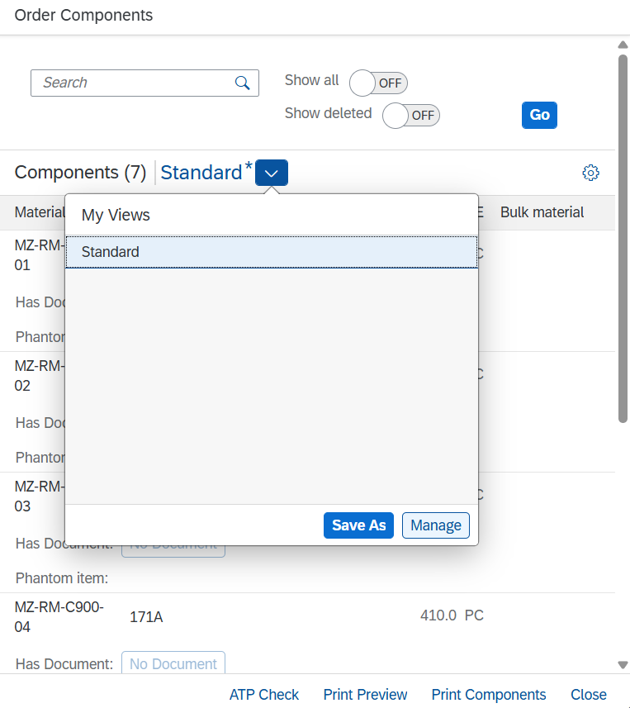
- Edit and save.
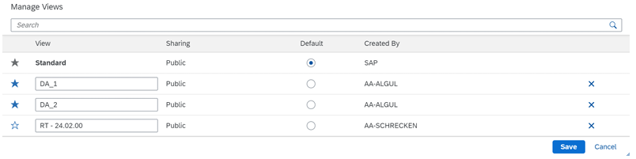

PRT (Production resources/tools):
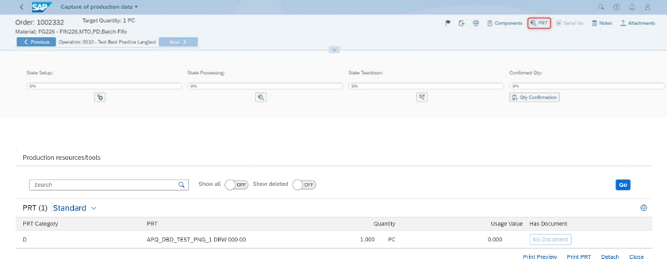
Contains all PRTs which are assigned to the current operation.

Note: The layout settings can also be changed. The change of the layout can be setted as default (Select view -> Manage->Select the desired version -> Save).
Serial Number:

