# Module 2 - Assignment 2

## Tate, Levi

### Introduction to R Markdown

This document will present my first R Markdown file in which I will go over previous topics covered in programming for analytics. (Topics include atomic vectors, data frames, and data types.) THis document was created using a plain text file format and knitted into a word document for submission.

The code below shows a basic plot of sales over the past 6 months.

library(tidyverse)

## ── Attaching packages ─────────────────────────────────────── tidyverse 1.3.0 ──

## ✓ ggplot2 3.3.2 ✓ purrr 0.3.4  
## ✓ tibble 3.0.4 ✓ dplyr 1.0.2  
## ✓ tidyr 1.1.2 ✓ stringr 1.4.0  
## ✓ readr 1.4.0 ✓ forcats 0.5.0

## ── Conflicts ────────────────────────────────────────── tidyverse_conflicts() ──  
## x dplyr::filter() masks stats::filter()  
## x dplyr::lag() masks stats::lag()

sales <- c(50, 150, 200, 100, 300, 250)  
month <- c(1, 2, 3, 4, 5, 6)  
qplot(month, sales)

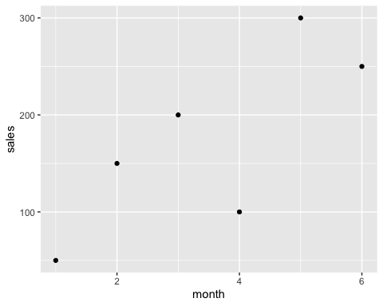

As seen in the plot, the 5th month had the largest amount of sales coming in at $300.

Yearly_Sales <- data.frame(month = c("Jan", "Feb", "Mar", "Apr", "May", "Jun", "Jul", "Aug", "Sept", "Oct", "Nov", "Dec"),  
 sales = c(150.25, 258.54, 268.55, 122.52, 987, 458.82, 667.23, 845.54, 586.78, 888.58, 756.12, 456.84)  
 )

As seen in the data frame, Yearly_Sales, the month with the most sales is May at $987.00 The month with the least amount of sales is April at $122.52.