# Module 3 - Assignment 2

## Tate, Levi

### Exploratory Data Analysis

library(tidyverse)

## ── Attaching packages ─────────────────────────────────────── tidyverse 1.3.0 ──

## ✓ ggplot2 3.3.2 ✓ purrr 0.3.4  
## ✓ tibble 3.0.4 ✓ dplyr 1.0.2  
## ✓ tidyr 1.1.2 ✓ stringr 1.4.0  
## ✓ readr 1.4.0 ✓ forcats 0.5.0

## ── Conflicts ────────────────────────────────────────── tidyverse_conflicts() ──  
## x dplyr::filter() masks stats::filter()  
## x dplyr::lag() masks stats::lag()

#### Diamond Color and Price

ggplot(data = diamonds) +  
 geom_point(mapping = aes(x = carat, y = price))

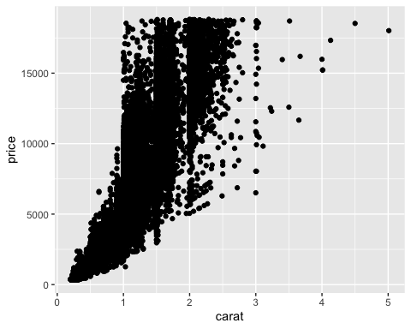 1.) What do you notice from the scatter plot as the carat size increases? As carat size increases, price increases exponentially 2.) From the scatter plot, what carats are most represented within the diamonds data set? The most represented carats range from ~.2 - ~.2.2

ggplot(data = diamonds) +  
 geom_point(mapping = aes(x = color, y = price))

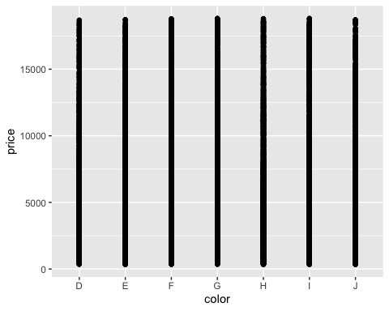

This scatter plot shows that all colors of diamonds are relatively equally distributed with color J being slightly less than all others. This information alone is not entirely useful to determine if different colors are more pricey.

ggplot(data = diamonds) +  
 geom_point(mapping = aes(x = carat, y = price, color = color))

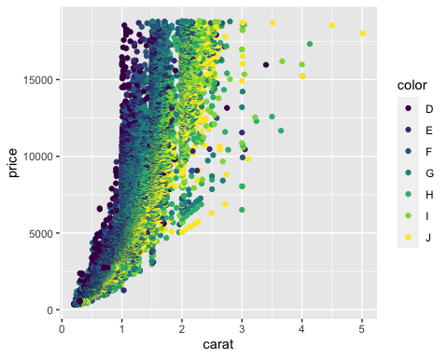

Color does not affect price of diamonds. Certain colors are associated with carat size. As carat increases, diamond color tends moves from D to J.

dsample <- diamonds[sample(nrow(diamonds), 100), ]  
  
ggplot(data = dsample, mapping = aes(x = carat, y = price, color = color)) +  
 geom_point() +  
 geom_smooth(method = "lm")

## `geom_smooth()` using formula 'y ~ x'

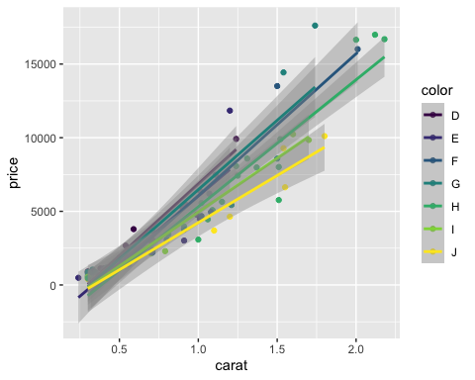

As seen in the plot above, carat and color moderately affects price. As carat increases and color moves from D to J, price tends to increase.

ggplot(data = dsample, mapping = aes(x = carat, y = color, color = price)) +  
 geom_line()

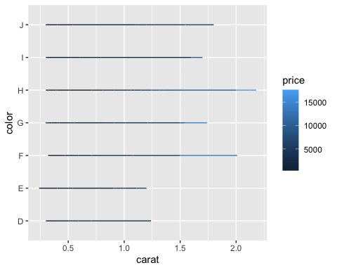 According to the plot above, only carat size seems to affect price.