# Module 3 - Assignment 3

## Tate, Levi

### More Practice with Plots

library(tidyverse)

## ── Attaching packages ─────────────────────────────────────── tidyverse 1.3.0 ──

## ✓ ggplot2 3.3.2 ✓ purrr 0.3.4  
## ✓ tibble 3.0.4 ✓ dplyr 1.0.2  
## ✓ tidyr 1.1.2 ✓ stringr 1.4.0  
## ✓ readr 1.4.0 ✓ forcats 0.5.0

## ── Conflicts ────────────────────────────────────────── tidyverse_conflicts() ──  
## x dplyr::filter() masks stats::filter()  
## x dplyr::lag() masks stats::lag()

GOOG <- read_csv("GOOG.csv", col_types = cols(Date = col_date(format = "%Y-%m-%d")))

#### Google Stock Price Plots

The following is an analysis of Google’s stock price from October of 2019 to October of 2020. This will include a scatter, line, bar, histogram and boxplot. All the plots represent the closing price on the dates listed on the x-axis.

–!Date for the x-axis and the variable Close for the y-axis.–

ggplot(data = GOOG) +  
 geom_point(mapping = aes(x = Date, y = Close))

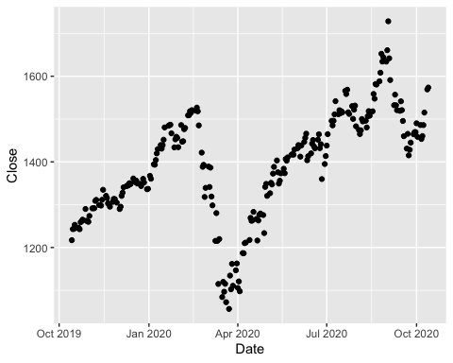

ggplot(data = GOOG) +  
 geom_line(mapping = aes(x = Date, y = Close))

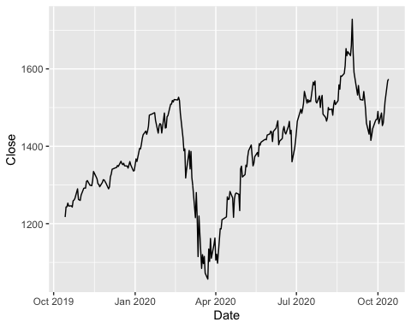

ggplot(data = GOOG) +  
 geom_col(mapping = aes(x = Date, y = Close))

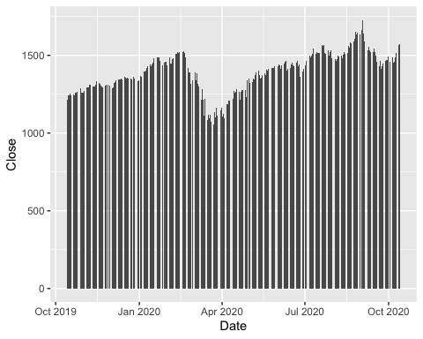

ggplot(data = GOOG) +  
 geom_histogram(mapping = aes(x = Close))

## `stat_bin()` using `bins = 30`. Pick better value with `binwidth`.

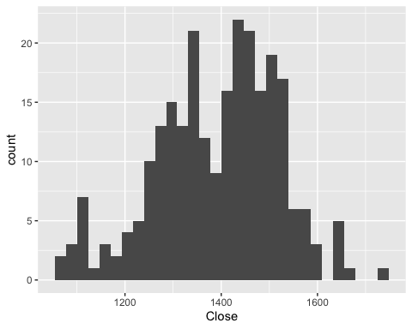

ggplot(data = GOOG) +  
 geom_boxplot(mapping = aes(x = Close))

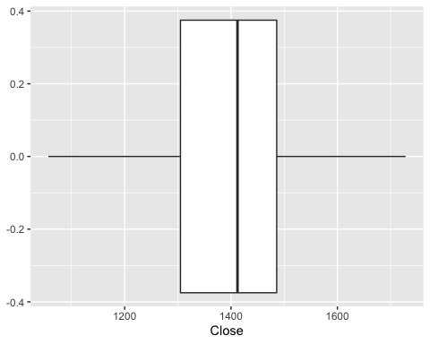

plot(GOOG$Date, GOOG$Close, type = "l")  
points(GOOG$Date, GOOG$Close)

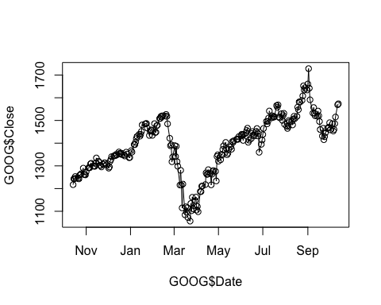

You have created many different plots of the same data but some are more helpful than others. Based on the plots you created, which one do you find most useful and why?

As someone who is moderately familiar with technical analysis of stock graphs, I can appreciate the line graph because of its clear message. Also, line Graphs are meant for displaying data over a period of time.

#### Google Stock Daily Price Comparisons

ggplot(data = GOOG) +  
 geom_line(aes(x = Date, y = High, color = "High")) +  
 geom_line(aes(x = Date, y= Low, color = "Low"))

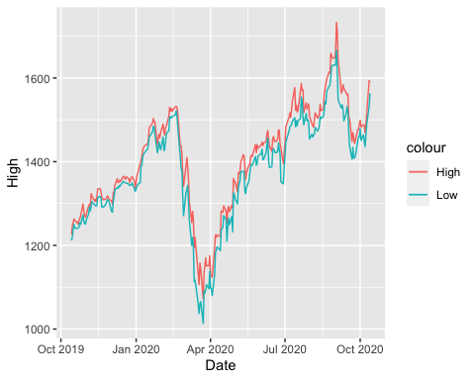

ggplot(data = GOOG) +  
 geom_line(aes(x = Date, y = Open, color = "Open")) +  
 geom_line(aes(x = Date, y= Close, color = "Close"))

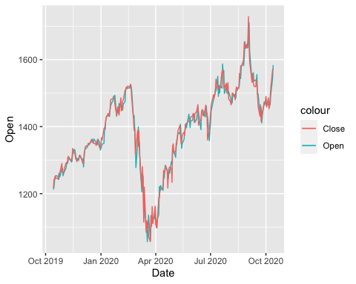

ggplot(GOOG, aes(x = Date, y = Close)) +  
 geom_area(color = "black", fill = "blue", alpha = .2)

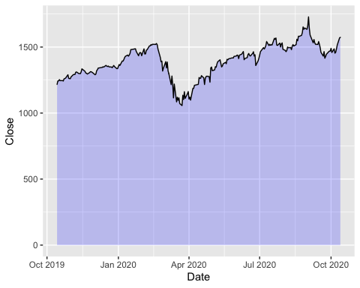

ggplot(GOOG, aes(x = Date, y = Open)) +  
 geom_area(color = "blue", fill = "green", alpha = .1)

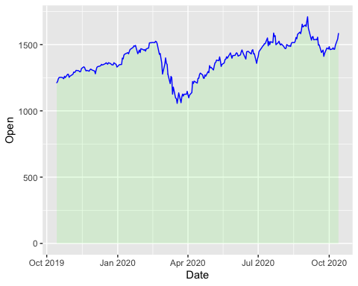

MayPrice <- subset(GOOG, Date > "2020-04-30" & Date < "2020-06-01")  
  
ggplot(MayPrice, aes(x = Date, y = Close)) +  
 geom_point() +  
 geom_text(aes(label = round(Close)), size = 3, vjust = -1)

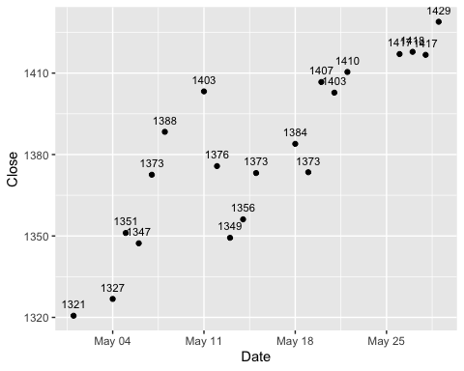

AprilPrice <- subset(GOOG, Date > "2020-03-31" & Date < "2020-05-01")  
  
ggplot(AprilPrice, aes(x = Date, y = Open)) +  
 geom_point() +  
 geom_text(aes(label = round(Open)), size = 2, vjust = 1)

