ALGORITHM

SHIFT FUNCTION
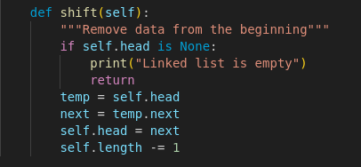
1. Check if the linked list is empty, if it is print “Linked list is empty” and end the function.
2. The head of the linked list “self.head” is assigned to “temp” variable.
3. The next element from the head in the linked list is assigned to the “next” variable.
4. Assign the variable “next” to self.head
5. Reduce the linked length by 1.

UNSHIFT FUNCTION
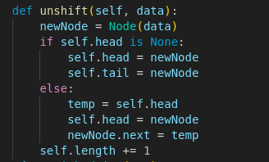
1. Create a new node with the parameter “data”.
2. If the linked list is empty, set the head and the tail of the linked list to the node “data”.
3. If not, set the node data as head.
4. Set the previous head as next of the current head

GET FUNCTION
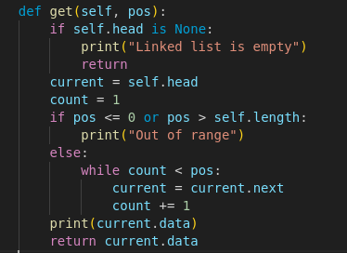
1. Check if the linked list is empty, if so, print “Linked list is empty” and stop the get function
2. Set the linked list head to variable “current” and assign 1 to variable “count”.
3. Check if the pos parameter is out of range, if so, print “Out of range”, if not, while count is less than pos variable, assign the next node from current to current and increase count variable by 1.
4. Print and return the data in current node.

SET FUNCTION
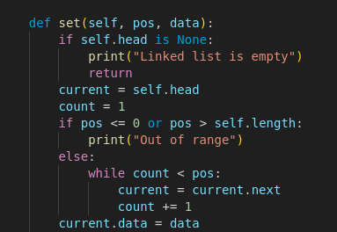
1. Check if the Linked list is empty, if so, print “Linked list is empty” and end the set function.
2. Assign the head of the linked list to variable “current” and integer 1 to variable “count”.
3. Check if the pos variable is out of range, if so, print “Out of range”
4. Else, while count is less than pos, set the next node from current to current and increase count by 1.
5. Assign argument “data” to the value of the data in current.

