Statistics: The Science of Decisions Project Instructions

**Student: Levi Zell**

Questions For Investigation

**As a general note, be sure to keep a record of any resources that you use or refer to in the creation of your project. You will need to report your sources as part of the project submission.**

1. **What is our independent variable? What is our dependent variable?**

Independent Variable: Words displayed – Congruent (words being displayed that match the color they are printer) or Incongruent (words displayed that do not match the color in which they are printed).

Dependent Variable: Time (in seconds) it takes to name the ink colors or words

1. **What is an appropriate set of hypotheses for this task? What kind of statistical test do you expect to perform? Justify your choices.**

Null Hypothesis (H0): **μcongruent = μincongruent**

The null hypothesis states that given a population we predict the time it takes to name the ink colors of works will be the same for congruent and incongruent words.

Alternative Hypothesis (HA): **μcongruent ≠** **μincongruent**

The alternative hypothesis is that given a population, the time it takes to name the ink colors of works will not be the same for congruent and incongruent words.

Based on these criteria, we would expect to perform various descriptive statistics along with a two-tailed t-Test due to us not having population parameters to compare with and the sample size is small (<30), since we have dependent samples (within-subject designs) and it will be two-tailed because our alternative hypothesis is that our congruent mean will be higher OR lower than our incongruent mean. The sample appears to be approximately normally distributed so we can apply the central limit theorem.

1. **Report some descriptive statistics regarding this dataset. Include at least one measure of central tendency and at least one measure of variability.**

|  |  |  |  |
| --- | --- | --- | --- |
| ***Congruent*** |  | ***Incongruent*** |  |
|  |  |  |  |
| **Mean** | 14.051125 | **Mean** | 22.01591667 |
| **Standard Error** | 0.726550901 | **Standard Error** | 0.979195185 |
| **Median** | 14.3565 | **Median** | 21.0175 |
| **Standard Deviation** | 3.559357958 | **Standard Deviation** | 4.797057122 |

1. **Provide one or two visualizations that show the distribution of the sample data. Write one or two sentences noting what you observe about the plot or plots.**

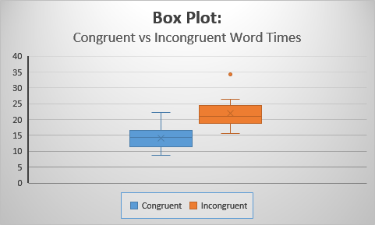

This box plot above shows the congruent and incongruent values for each subject plotted next to each other. This shows each series independently, and shows the range of the data, demonstrated by the picture below. It appears that all subjects took greater amounts of time identifying the color or incongruent words than congruent words. From here we would want to look at our statistics to see if there is any significance to these differences.

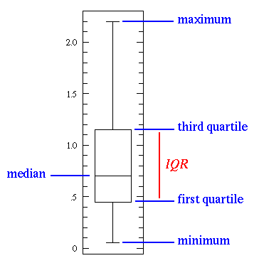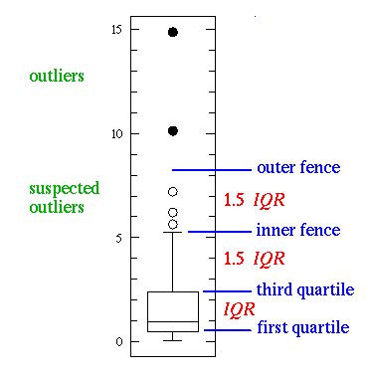

1. **Now, perform the statistical test and report your results.**

|  |  |  |
| --- | --- | --- |
| t-Test: Paired Two Sample for Means | |  |
|  |  |  |
|  | *Incongruent* | *Congruent* |
| Mean | 22.016 | 14.051125 |
| Variance | 23.012 | 12.66902907 |
| Observations | 24 | 24 |
| Pearson Correlation | 0.3518 |  |
| Hypothesized Mean Difference | 0 |  |
| Point estimate (Mean Difference) | **7.96** |  |
| Standard Deviation of Differences | **4.86** |  |
| standard error | **0.99** |  |
| 95% C.I. | (5.91, 10.01) |  |
| df | 23 |  |
| t Stat | 8.02 |  |
| P(T<=t) two-tail | 4.103E-08 |  |
| t Critical two-tail | 2.069 |  |

**What is your confidence level and your critical statistic value?**

t Critical = +/- 2.069 alpha = 0.05 (2.5% each side)

**Do you reject the null hypothesis or fail to reject it?**

Yes we reject the null hypothesis – our t value was 8.02 which is way outside of our confidence interval t values (-2.069 to + 2.0069).

**Come to a conclusion in terms of the experiment task. Did the results match up with your expectations?**

Based on these statistics, we would say with more than 95% confidence that the time it takes to report what an incongruent word is is greater than the time it takes to report a congruent word. In terms of the experiment, like one may predict, when a word that represents a color, is itself colored differently, it takes longer for someone to come to the correct conclusion to what the color of the printed word is.

1. **Optional: What do you think is responsible for the effects observed? Can you think of an alternative or similar task that would result in a similar effect? Some research about the problem will be helpful for thinking about these two questions!**

I think that it is confusion. When you read the word red, you almost see red, and therefore your instinct is to say red, despite the word being printed in a different color. I would imagine a similar task like saying what a number printed using miniature other numbers and having to correctly say what numbers are being used to construct the larger number may also cause the same level of confusion.