
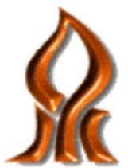

Ben-Gurion University of the Negev
Faculty of Engineering
Department of Mechanical Engineering

Introduction to Image Processing Course –
Second Assignment

Student name: Tamir Levin, 315765347

Date: 25.11.2024

Assistant Lecturer's Name: Iaroslav Grozdov

Environment Setup and Preparations

Library versions
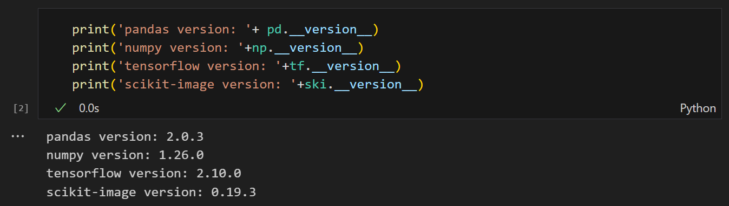
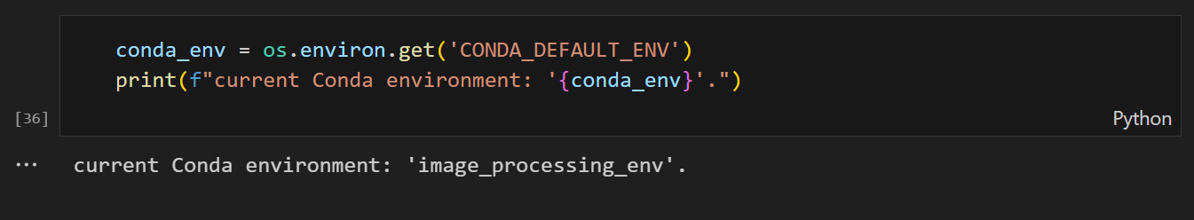

Images preparation for the course

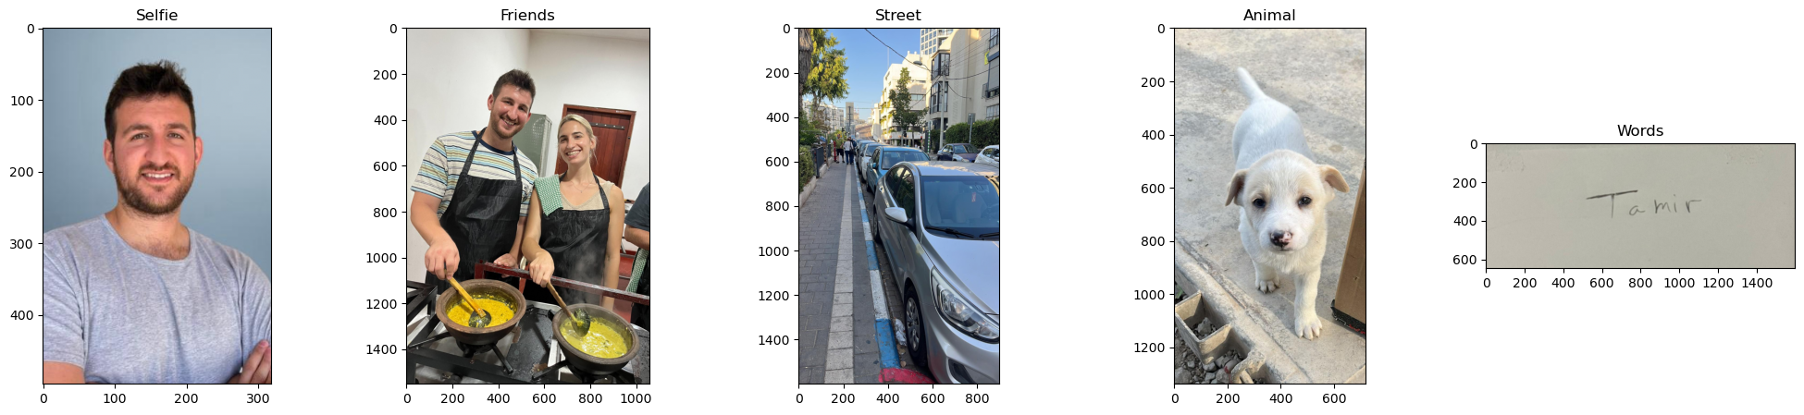

Preparing images for low and high-pass filters

Important Parameters in Creating Image Filters and Edge Detection
Image filtering and edge detection are essential for enhancing features and identifying boundaries in images. Proper tuning of parameters ensures optimal results for tasks like noise reduction, feature extraction, and object recognition.

Image Filters

Kernel size

Edge Detection

Thresholds

Morphological operations

Harris Corner Detector and Feature Matching

