


Ben-Gurion University of the Negev
Faculty of Engineering
Department of Mechanical Engineering

Introduction to Image Processing Course –
Third Assignment

Student name: Tamir Levin, 315765347

Date: 25.11.2024

Assistant Lecturer's Name: Iaroslav Grozdov

Environment Setup and Preparations

Library versions
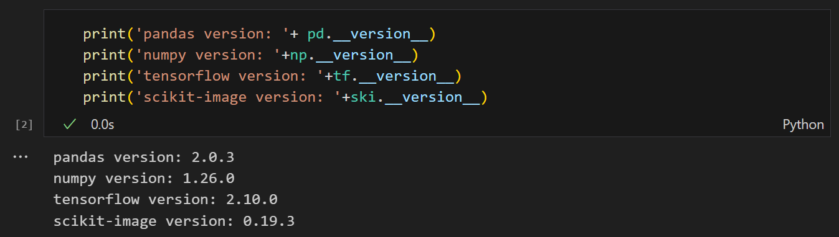
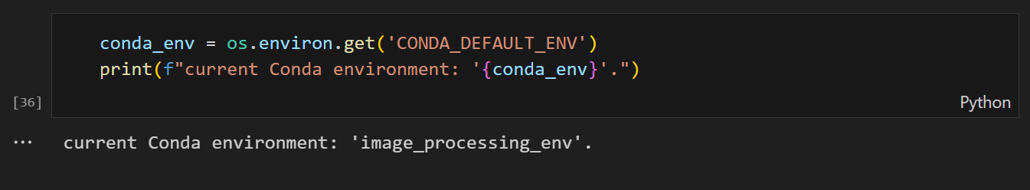

Images preparation for the course

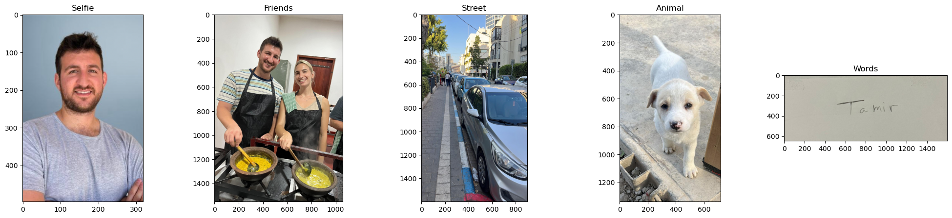

Images sizes comparison

