Contents

1 – Instruction install AI Enviroment 1

2 – Server AI server 3

2.1 - Install Apache 2.4 / PHP , MySQL 3

2.2 – API 4

3 – Oauth 2.0 server 5

3.1 - Install Apache 2.4 / PHP , MySQL 5

3.1.1 - Client database (client table): contain the information of the client app that registered the Oauth service with Oauth server. 5

3.1.2 - User database (user table): contain the resources of the user that the App want to access. The user will be authenticated with email and password in Authentication page. 6

3.2 - O-auth 2.0 API 7

3.2.1 – Public and private keys 7

3.2.2 - Encryption keys 7

3.2.3 - Client API (client repository) 8

3.2.4 – Authentication sever API 9

3.2.5 – Resource sever API 10

4 – Demo with Phone App 10

OAUTH2.0 SERVER

PHONE APP

AI SERVER

PHONE APP

Process

# 1 – Instruction install AI Enviroment

Install anaconda version 23.7.4

<https://anaconda.org/conda-forge/conda/files?sort=time&sort_order=desc&version=23.7.4>

Install python version 3.11.5

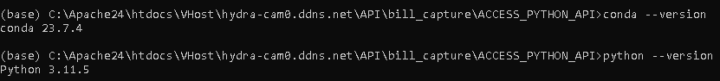  
Access anaconda enviroment and install by pip these packages bellow

pip install easyocr

pip install torch torchvision torchaudio --index-url <https://download.pytorch.org/whl/cu118>

pip install numpy

pip install cv2

pip install imutils

pip install screeninfo

These packages (base64, sys, codecs, fileinput, json, pathlib, math, difflib are build-in/standard of Python

==================================

If use NVIDIA RTX3060 12GB need install pytorch

pip install torch torchvision torchaudio --index-url <https://download.pytorch.org/whl/cu118>

If use other GPU, please check by:  
Open cmd, type

1 – To check information of VGA card

nvidia-smi  
2 – To check version of Cuda ToolKit

nvcc --version

If don’t have NVIDIA driver, please go to this website and install suitable version

1 – NVIDIA Driver

<https://www.nvidia.com/en-us/drivers/>

2 – CUDA Toolkit

<https://developer.nvidia.com/cuda-toolkit>

3 – cuDNN (use for Tensorflow/Pytorch)

<https://developer.nvidia.com/cudnn>

To modify key value, please go to

Go to this folder

~\htdocs\VHost\hydra-cam0.ddns.net\API\bill_capture\ACCESS_PYTHON_API\

Code will auto detect all string, but if you want to use any key, please list them to this array, or you can change in this file - key.txt

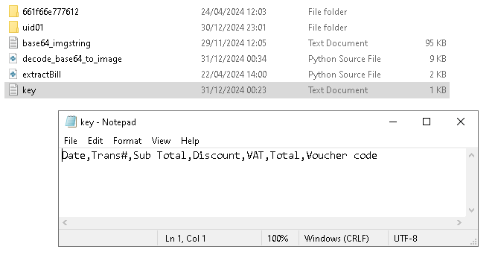

==================================

# 2 – Server AI server

## 2.1 - Install Apache 2.4 / PHP , MySQL

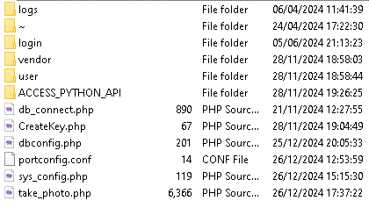

Database:

**dbconfig.php**

User database of bill tracking app. It’s used to login the bill tracking app.

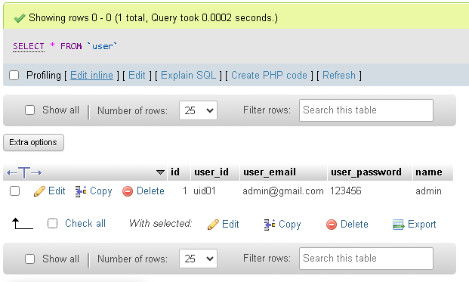

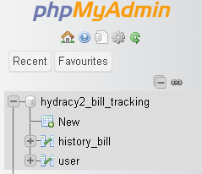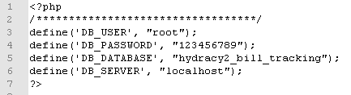

***Figure 1.*** *user database table*

## 2.2 – API



**Register.php:** to create new user

**login/login.php:** login to the app and return access token

**login/check_login.php**: Check the access token is valid or not.

**take_photo.php**: upload the image image and call the python api to analyze and return the informations of bill.

At last, the take_photo.php write an event to logs/log.txt

==================================

# 3 – Oauth 2.0 server

Install Apache 2.4 / PHP , MySQL

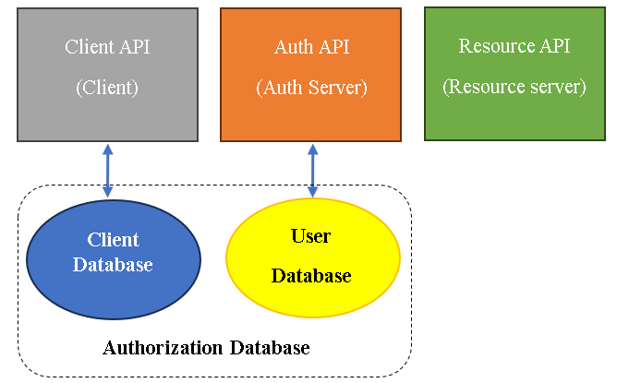

## 3.1 - Install Apache 2.4 / PHP , MySQL

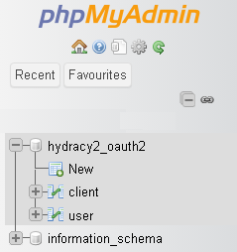

***Figure 2.*** *Database construction of oauth2 server*

Oauth2.0 database include 2 table: user and client.

### **3.1.1 - Client database (client table):** contain the information of the client app that registered the Oauth service with Oauth server.

**Setup ‘client’ table:**

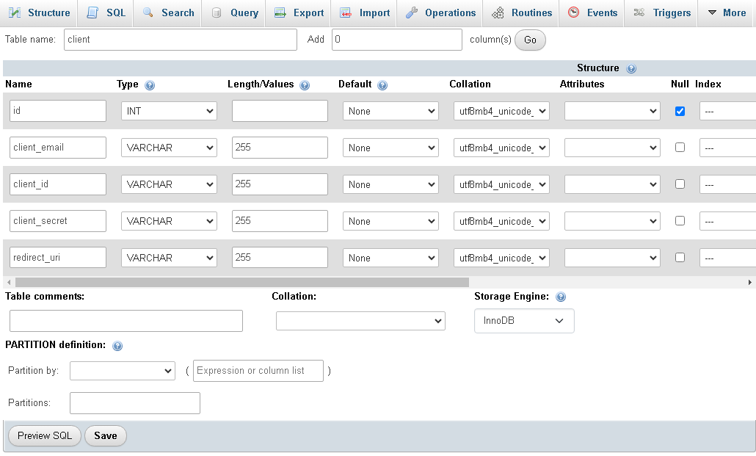

***Figue 3.*** *Setup ‘client’ table*

The most important information are client_id, client_secret and redirect_url. They will be sent with O-authentication request.

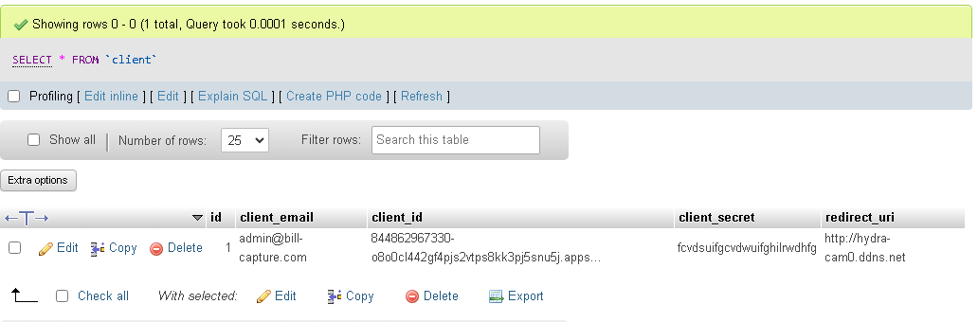

***Figure 4.*** *Client informations.*

### **3.1.2 - User database (user table):** contain the resources of the user that the App want to access. The user will be authenticated with email and password in Authentication page.

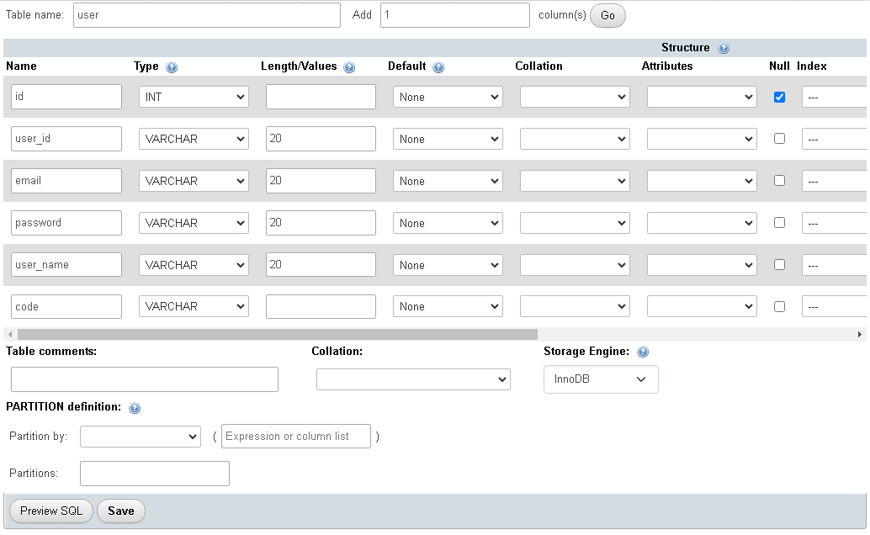

***Figue 5.*** *Setup ‘user’ table*

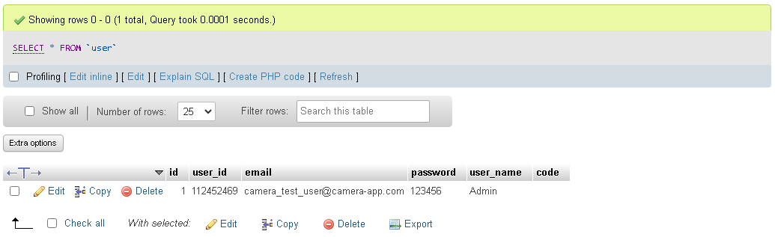

***Figure 6.*** *User informations.*

## 3.2 - O-auth 2.0 API

**The O-auth2 server**

**Client API:** Include the api that redirect the user to authentication server and handle the authentication result (authentication sode, access token ).

**Auth API:** Include the api and UI for user login. It will return a return url with authorization code .

**Resource API:** Contain the api that’s parse the access token.

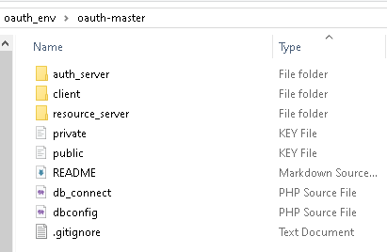

***Figure 7.*** *oauth server api repository*

### 3.2.1 – Public and private keys

Public and private keys will be used to parse the access token. The authentication server use the public key to generate the access token. And prive key will be used to parse the access token in Resource server.

### 3.2.2 - Encryption keys

Encryption keys is used to generate the authentication code. Public key, private key and Encryption key were generated following the link: **h***ttps://oauth2.thephpleague.com/installation/*

### 3.2.3 - Client API (client repository)

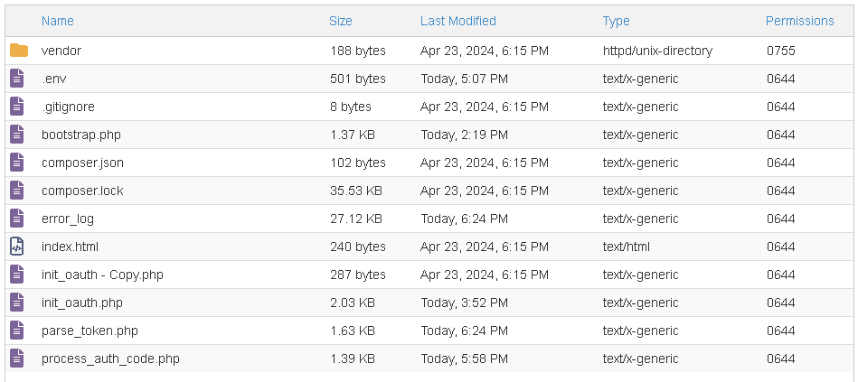

**Figure: client api repository**

**Init environment file (.env):**

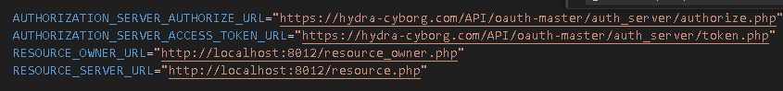

**AUTHORIZATION_SERVER_AUTHORIZE_URL**: **authorize.php**

**AUTHORIZATION_SERVER_ACCESS_TOKEN_URL:** **token.php**.

**RESOURCE_OWNER_URL**: resource_owner.php

**RESOURCE_SERVER_URL**: resource.php

Nhiệm vụ của các api này sẽ được mô tả chi tiết trong phần III.

### 3.2.4 – Authentication sever API

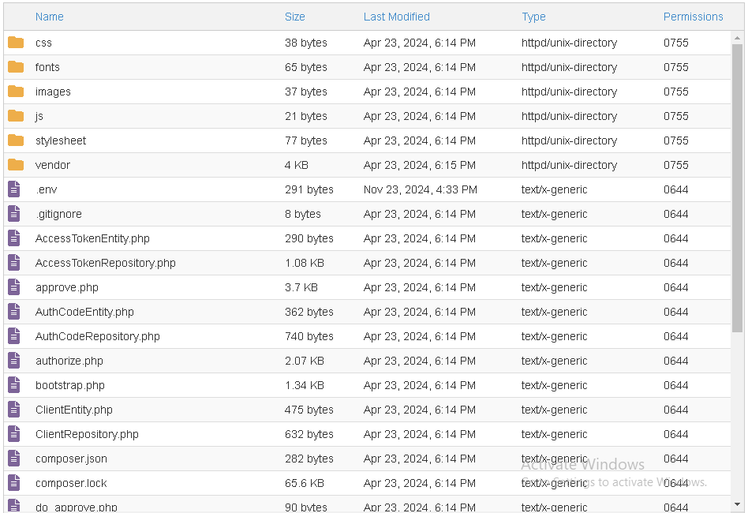

**Init environment file (.env):**



***Figure:*** *auth_server/.env*

**Using encryption key:**

Use the encryption key that’s genetared in 3.3.2 and assign to $encryptionKey in auth_server/bootstrap.php.

The auth_server/authorize.php enpoint will redirect the user to login and approve to use the resource.

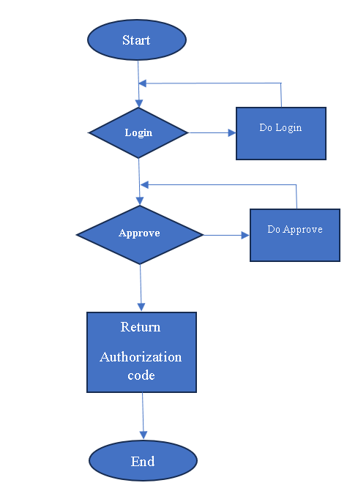

***Figure 8.*** *Authorization proccess in authentication server*

### 3.2.5 – Resource sever API

After install client api and auth api, go to oauth-master folder, open command promp and run ‘php -S localhost:8012 -t resource_server’ command

# 4 – Demo with Phone App

Phone Application Made by Unity version 2022.3.20f1

Can run both on Android and iOs (Current version designed for Android)

Application don’t aprrove sign-up for new user

The registered account will be created from Oauth2.0 server

Username: [admin@gmail.com](mailto:admin@gmail.com)  
Pass: 123456

