**Conclusions and Observations**

Throughout the whole problem resolution, I was able to observe a couple of important trends. The first one and the most obvious is that the rate of male players is much higher compared to the female and other genders in the database. This is easily explained by the common belief that videogames are meant for boys.

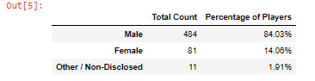

Interesting enough, the average purchase per person is the lowest for the males and higher for the rest of the genders. The rate difference might have something to do and a bigger sample could show different results, but this shows that female players are good consumers in the videogame market and that their participation should be taken more into account.

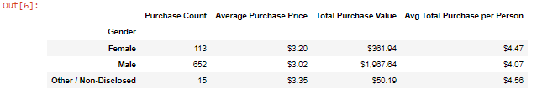

Another interesting trend can be observed when we get to analyze the demographics by age. There is an obvious greater player count in the 20 to 24 age range where young adults might still have spare time and money to spend on videogames. The player rate goes down as the age increases. An interesting observation is that kids less than 10 have the highest average total purchase amount per person that might indicate some parents are willing to spend to spoil their children.

