# README for Guessing Game - PRG155 Assignment

## Overview

This program is a simple guess-a-number game, where a user tries to find a random number between 1 and 100. This game gives personalized feedback based on the player's name, and it allows replay with a new random number.

## Features

1. The application uses the random number generation feature uses the GenerateRandomNumber function from the file named randomNumber.h to generate a random number between 1 and 100.  
2. The input validation feature ensures that the user input is numeric and is also within the specified range (1-100).  
3. There is personalized feedback feature which will ensure we have custom messages using the player's name.  
4. The guessing logic feature will provide feedback on whether the guess is too high or too low.  
5. There is also the replay option feature which enables the user to play again with a new random number.

## Special Instructions

1. Place the randomNumber.h header file in the same directory as the .c file.

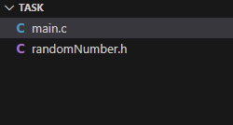

2. Compile the program using a C compiler (e.g., GCC). Use the following command:  
 gcc main.c -o guessing_game  
3. Run the program using the command:  
 ./guessing_game

C:\Users\levis\AppData\Local\Microsoft\Windows\INetCache\Content.Word\this.png

## Testing Scenarios

1. Test with valid input (for example, numbers between 1 and 100).

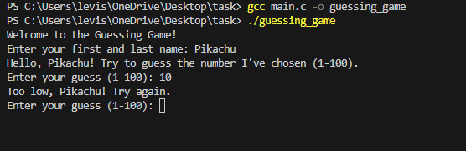

1. Test with invalid input (for example, letters, special characters, or numbers out of range).

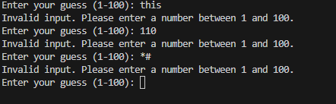  
3. Test the replay functionality to ensure the game restarts with a new random number.

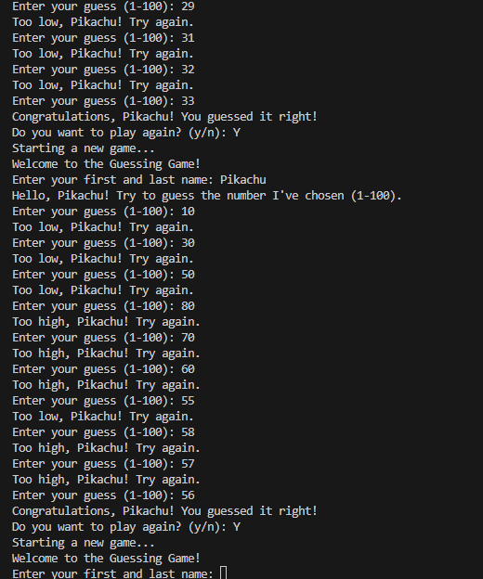  
4. Verify the personalized feedback by entering different names.

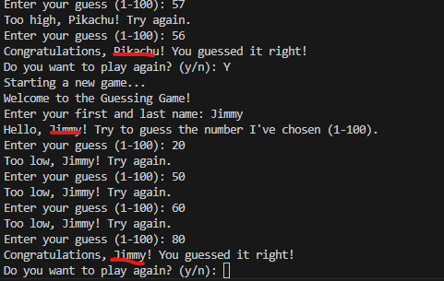

## Unique Features

1. Personalized messages using the player's name enhance user engagement.  
2. Replay functionality allows for seamless restarts, ensuring a smooth user experience.

## Acknowledgment

This program was created as part of the PRG155 assignment for Professor Sugivan Ratneswarran's class. Special thanks to ChatGPT for assistance in generating and refining the code.