💼
FAKE JOB POSTING DETECTION SYSTEM
An End-to-End Machine Learning and Natural Language Processing Solution for Recruitment Fraud Detection
TECHNICAL PROJECT REPORT

Prepared by
Gopal Kumar Rajwar
AI / Machine Learning Internship Project
Technology Stack: Python • Scikit-learn • Streamlit • NLTK • SHAP • TF-IDF • Logistic Regression
Report Date: 2026

Table of Contents

1. Executive Summary
Online recruitment fraud is a growing threat to job seekers, with fraudulent postings used to harvest personal data, extract fees, or conduct identity theft. This report documents the design, development, and deployment of a Fake Job Posting Detection System — an end-to-end machine learning and natural language processing (NLP) solution that classifies job advertisements as either Legitimate or Fraudulent.
The system was built using the publicly available Fake Job Postings dataset, comprising 17,880 job listings of which 866 (4.84%) are labeled fraudulent. The project pipeline covers data exploration, text cleaning and preprocessing, TF-IDF feature extraction, comparison of five candidate classification algorithms, hyperparameter tuning, model interpretability using coefficient analysis and SHAP (SHapley Additive exPlanations), and deployment as an interactive Streamlit web application.
Five algorithms were benchmarked on identical train/test splits: Logistic Regression, Multinomial Naive Bayes, Linear Support Vector Machine (SVM), Decision Tree, and Random Forest. The Linear SVM and a hyperparameter-tuned Logistic Regression emerged as the strongest performers, both substantially outperforming the untuned baseline. The deployed application uses a Logistic Regression model for its ability to output calibrated prediction probabilities, which power the application's confidence score and risk-level indicators.
Key results at a glance:
- Baseline Logistic Regression: 95.67% accuracy, 53.00% precision, 91.91% recall, 67.23% F1-score.
- Best-performing configuration (tuned / Linear SVM benchmark): approximately 98.4% accuracy, 81% precision, 88% recall, and 84.5% F1-score.
- The deployed system prioritizes recall (catching fraudulent postings) over precision, a deliberate design choice appropriate for a fraud-detection use case where missing a fraudulent posting is more costly than an occasional false alarm.
Beyond raw metrics, the project delivers a complete, usable product: a three-page Streamlit application (Home / Prediction, Analytics Dashboard, and Model Evaluation) that provides real-time predictions, human-readable explanations of each prediction, dataset-level analytics, and transparent model evaluation visuals. This report walks through every stage of that pipeline, presents the underlying data and code, evaluates the results critically, and offers recommendations for future improvement.

2. Introduction

2.1 Background and Motivation
The rise of online recruitment platforms has made job searching faster and more accessible, but it has also created fertile ground for fraud. Fraudulent job postings are used by malicious actors to collect sensitive personal information (such as bank details or government identification), charge upfront "processing" or "training" fees, or lure victims into unpaid or exploitative work arrangements. For job seekers — particularly students, recent graduates, and remote-work applicants — distinguishing a genuine opportunity from a scam is often difficult, since fraudulent listings frequently mimic the tone, structure, and vocabulary of legitimate postings.
Manual moderation of job postings does not scale to the volume of listings submitted to modern job boards. This motivates an automated, data-driven approach: a machine learning classifier that can flag suspicious postings for review or warn job seekers directly, using signals present in the posting's text and metadata.

2.2 Project Objectives
- Detect fraudulent job advertisements using Natural Language Processing techniques applied to posting text.
- Compare multiple machine learning algorithms to identify the most suitable model for this classification task.
- Deploy the best-performing model as an interactive, user-facing web application.
- Provide prediction confidence scores and risk levels alongside each prediction.
- Deliver model explainability so that predictions are transparent rather than a "black box."
- Help job seekers proactively identify potentially fraudulent postings before they engage with them.

2.3 Scope of This Report
This report covers the complete machine learning lifecycle followed in the project: dataset acquisition and exploration, data cleaning and preprocessing, feature engineering, model training and comparison, hyperparameter optimization, model interpretation (including SHAP-based explainability), quantitative evaluation, and deployment via a Streamlit web application. Screenshots of the deployed application are included throughout to illustrate the end-user experience, alongside the underlying code that powers the prediction, explanation, and analytics logic.

3. Dataset Overview
The project uses the publicly available "Fake Job Postings" dataset, loaded from data/raw/fake_job_postings.csv, and explored in the notebook 01_Data_Exploration.ipynb. The dataset combines free-text fields (job title, company profile, description, requirements, benefits) with structured metadata (remote-work flag, presence of a company logo, presence of screening questions, employment type, required experience/education, industry, and function).

3.1 Dataset Composition
Metric | Value
Total job postings | 17,880
Legitimate postings | 17,014 (95.16%)
Fraudulent postings | 866 (4.84%)
Total columns (raw) | 18
Duplicate rows | 0

The class distribution confirms a highly imbalanced classification problem: only 4.84% of postings are fraudulent. This imbalance has direct implications for model choice and evaluation strategy — accuracy alone is a misleading metric on this dataset, since a model that predicts "legitimate" for every posting would already achieve roughly 95% accuracy while providing zero fraud-detection value. This observation directly motivated the use of class-weighting during model training and the emphasis on precision, recall, and F1-score (rather than accuracy alone) during evaluation, discussed further in Section 6.

3.2 Dataset Fields
The raw dataset contains 18 columns: job_id, title, location, department, salary_range, company_profile, description, requirements, benefits, telecommuting, has_company_logo, has_questions, employment_type, required_experience, required_education, industry, function, and the target label fraudulent.

3.3 Missing Data
Several columns exhibit substantial missingness, summarized below. salary_range is missing in 83.96% of records and was dropped from modelling entirely, alongside department (64.58% missing), both considered too sparse to contribute reliable signal.
Column | Missing Values | Percentage
salary_range | 15,012 | 83.96%
department | 11,547 | 64.58%
required_education | 8,105 | 45.33%
benefits | 7,212 | 40.34%
required_experience | 7,050 | 39.43%

3.4 Initial Observations
- The dataset contains 17,880 job postings across 18 raw features, with zero duplicate rows.
- The target variable, fraudulent, is highly imbalanced (95.16% legitimate vs. 4.84% fraudulent).
- Several columns — particularly salary_range, department, required_education, benefits, and required_experience — contain substantial missing data and required an explicit missing-data strategy.
- Text fields (description, requirements, company_profile) contain embedded HTML tags, URLs, and special characters that require cleaning before use in an NLP pipeline.
- Given the imbalance, downstream preprocessing and modelling choices — including class-weighted classifiers and a focus on recall for the fraud class — were treated as a first-class requirement rather than an afterthought.

4. Exploratory Data Analysis
Exploratory analysis (notebook 01_Data_Exploration.ipynb) was used to characterize the shape of the data, quantify class imbalance, and inspect representative examples of both legitimate and fraudulent postings before any cleaning or modelling took place.

4.1 Class Distribution
A bar chart of the fraudulent column confirms the dominant presence of legitimate postings, with fraudulent postings forming a small minority class. This imbalance was a central design consideration throughout the project — it is discussed again in the context of model selection (Section 6) and evaluation metric choice (Section 8).

4.2 Sample Record Inspection
To understand what distinguishes fraudulent from legitimate postings at the text level, individual sample records were inspected directly. A randomly sampled fraudulent record (random_state = 42) illustrates several hallmark characteristics of scam postings:
- Job title: "customer service rep" — a generic, high-demand role often used as fraud bait.
- Company profile: missing entirely (NaN).
- Description: a single terse sentence — "customer service reps needed asap" — with no detail about the employer, responsibilities, or work environment.
- Benefits: deferred and vague — "will explain on phone interview" — a classic red flag, since legitimate employers typically state compensation and benefits up front.
By contrast, legitimate postings in the dataset (such as the Food52 "Marketing Intern" listing used as a running example throughout the notebooks) tend to contain detailed, multi-paragraph company profiles, specific role responsibilities, and named locations, industries, and functions.

4.3 Structural Observations
- Missing values are concentrated in a handful of columns (Section 3.3) rather than spread evenly, simplifying the cleaning strategy.
- No duplicate rows were found, so no de-duplication step was required.
- Text fields required HTML stripping, URL removal, digit removal, and punctuation normalization before they could be vectorized.
- The dataset's imbalance and its concentration of missing values in metadata (rather than in the core text fields) supported a modelling strategy centered primarily on text features, supplemented with a small number of reliable structured signals (telecommuting, has_company_logo, has_questions).

5. Data Preprocessing and Feature Engineering
Preprocessing was carried out in 02_Preprocessing.ipynb and is codified for production use in the shared utils.py module (used identically by the notebooks and by the deployed Streamlit application, ensuring training/serving consistency).

5.1 Column Reduction and Imputation
- Dropped columns with excessive missingness or limited modelling value: job_id, salary_range, department.
- Dropped rows with a missing description, since description is the primary free-text signal.
- Filled missing values in company_profile, requirements, and benefits with empty strings, so they contribute no spurious signal while preserving row count.
- Filled missing values in categorical columns (location, employment_type, required_experience, required_education, industry, function) with the literal string "Unknown".
After imputation, the dataset contained zero missing values across all remaining modelling columns.

5.2 Text Consolidation
The five free-text fields — title, company_profile, description, requirements, and benefits — were concatenated into a single text column to maximize the signal available to the TF-IDF vectorizer, mirroring the exact concatenation logic later used at inference time in the deployed application (see app.py, Section 10).

5.3 Text Cleaning Function
A reusable clean_text() function was implemented and applied to every posting. The function performs, in order:
- Lower-casing of all text.
- HTML tag stripping via BeautifulSoup.
- Removal of URLs (http/https and www patterns).
- Removal of numeric digits.
- Removal of all non-alphabetic characters (punctuation, symbols).
- Collapsing of repeated whitespace and trimming.
- Stop-word removal using scikit-learn's ENGLISH_STOP_WORDS list.
This function is defined identically in utils.py, ensuring that the exact same cleaning logic runs both during model training and during live predictions in the Streamlit application — a critical detail for avoiding train/serve skew.

Code excerpt — utils.py: clean_text()
def clean_text(text):
if not isinstance(text, str):
return ""

text = text.lower()
text = BeautifulSoup(text, "html.parser").get_text()

text = re.sub(r"http\S+|www\S+", "", text)
text = re.sub(r"\d+", "", text)
text = re.sub(r"[^a-zA-Z\s]", "", text)
text = re.sub(r"\s+", " ", text).strip()

words = [w for w in text.split() if w not in stop_words]
return " ".join(words)

5.4 Final Modelling Dataset
The cleaned dataset was reduced to five columns used directly for modelling: clean_text, telecommuting, has_company_logo, has_questions, and the target fraudulent. This processed dataset was persisted to data/processed/processed_jobs.csv for reuse across the training and comparison notebooks.

5.5 Feature Extraction: TF-IDF
Cleaned text was vectorized using scikit-learn's TfidfVectorizer with the following configuration:
- max_features = 5,000 (top 5,000 terms by TF-IDF weight across the corpus).
- ngram_range = (1, 2) — both unigrams and bigrams are captured, allowing the model to learn short phrases (e.g., "no experience", "wire transfer") in addition to single words.
- min_df = 2 — terms must appear in at least two documents to be included, filtering out extremely rare tokens and typos.
The resulting TF-IDF matrix was combined with the three structured binary features (telecommuting, has_company_logo, has_questions) using scipy's hstack, producing a final feature matrix of 5,003 columns per posting.

6. Model Training and Comparison
Model development proceeded in two stages: an initial baseline comparison of two algorithms (03_Model_Training.ipynb), followed by a broader five-way comparison and hyperparameter search (04_Model_Comparison.ipynb).

6.1 Train / Test Split
Data was split 80% / 20% into training and test sets using train_test_split with stratify = y to preserve the original class ratio in both partitions, and random_state = 42 for reproducibility. The resulting test set contained 3,576 postings (3,403 legitimate, 173 fraudulent).

6.2 Baseline Models
Two baseline classifiers were trained first: a class-weighted Logistic Regression (class_weight = "balanced", max_iter = 1000) and a Multinomial Naive Bayes classifier. Class weighting instructs the Logistic Regression model to penalize misclassification of the minority (fraudulent) class more heavily, directly counteracting the 95/5 class imbalance identified in Section 3.

Baseline results
- Logistic Regression — accuracy 95.75%; precision 0.54 / recall 0.92 / F1 0.68 for the fraud class (class 1).
- Naive Bayes — accuracy 96.31%; precision 0.71 / recall 0.40 / F1 0.51 for the fraud class.
The Logistic Regression baseline confusion matrix on the test set was: 3,264 true negatives, 139 false positives, 13 false negatives, and 160 true positives. This shows the model correctly caught 160 of 173 fraudulent postings (a recall of roughly 92%), at the cost of 139 legitimate postings incorrectly flagged as fraudulent.
Naive Bayes, by contrast, achieved higher precision but far lower recall — it missed the majority of fraudulent postings (recall of only 39%), making it poorly suited to a fraud-detection use case where the cost of a missed fraud case is high.

6.3 Extended Model Comparison
A broader comparison in 04_Model_Comparison.ipynb evaluated five algorithms side by side on an identical TF-IDF + structured-feature representation: Logistic Regression, Naive Bayes, Linear SVM, Decision Tree, and Random Forest. Results are summarized below.
Model | Accuracy | Precision | Recall | F1 Score
Logistic Regression | 95.67% | 53.00% | 91.91% | 67.23%
Naive Bayes | 96.84% | 89.47% | 39.31% | 54.62%
Linear SVM | 98.43% | 80.95% | 88.44% | 84.53%
Decision Tree | 97.29% | 70.65% | 75.14% | 72.83%
Random Forest | 98.07% | 100.00% | 60.12% | 75.09%

Linear SVM produced the strongest overall balance of precision and recall, achieving the highest F1-score (84.53%) among all five candidates, alongside the highest accuracy (98.43%). Random Forest achieved perfect precision (100%) but at a substantial recall cost (60.12%), meaning it missed nearly 40% of fraudulent postings — an unacceptable trade-off for this application. Naive Bayes showed the inverse problem in even starker form. Logistic Regression, while showing the lowest precision of the group, offered by far the highest recall of any model that wasn't Random Forest's precision outlier, correctly identifying over 91% of fraudulent postings.

6.4 Hyperparameter Tuning
Given Logistic Regression's practical advantages — interpretable coefficients, well-calibrated predict_proba() output for confidence scoring, and fast inference — it was selected for hyperparameter tuning via 5-fold cross-validated grid search (GridSearchCV), optimizing for F1-score across a grid of regularization strength (C) and solver options.
- Grid searched: C ∈ {0.01, 0.1, 1, 10}; solver ∈ {liblinear, lbfgs}.
- Best parameters found: C = 10, solver = liblinear.
- Best cross-validated F1-score: 0.748.
Evaluated on the held-out test set, the tuned Logistic Regression achieved: accuracy 98.29%, precision 77.72%, recall 90.75%, F1-score 83.73% — a substantial improvement over the untuned baseline across every metric, while retaining Logistic Regression's practical advantages for deployment. This tuned model was persisted as best_model.pkl alongside the fitted TF-IDF vectorizer, and forms the basis of the deployed application described in Section 10.

6.5 Model Selection Rationale
The final choice of a tuned Logistic Regression for deployment (over the marginally higher-F1 Linear SVM) reflects a deliberate trade-off documented in the project's own README: Logistic Regression natively exposes predict_proba(), producing well-calibrated class probabilities. This is essential for the application's confidence-score and traffic-light risk-level features (Section 10), which a standard Linear SVM does not provide without additional calibration (e.g., Platt scaling). In a user-facing tool, being able to communicate "how confident" the model is in a prediction is as valuable to end users as the raw classification decision itself.

7. Model Interpretation
Beyond raw predictive performance, understanding which words drive the model's decisions is essential — both for validating that the model has learned genuine fraud signals rather than dataset artifacts, and for producing human-readable explanations inside the deployed application. This analysis was carried out in 05_Model_Interpretation.ipynb by directly examining the Logistic Regression model's learned coefficients.

7.1 Method
Since Logistic Regression is a linear model, each feature (TF-IDF term or structured flag) has a single learned weight. A positive weight pushes the prediction toward the fraudulent class; a negative weight pushes it toward the legitimate class. Sorting all 5,003 feature weights identifies the terms most strongly associated with each class.

7.2 Top Terms Associated with Fraudulent Postings
The strongest positive-weight terms (i.e., most indicative of fraud) included words such as aptitude, high school, money, subsea, ohio, signing, and apply — reflecting patterns common in low-barrier-to-entry, urgency-driven scam postings (references to signing bonuses, minimal educational requirements, and generic calls to "apply").

7.3 Top Terms Associated with Legitimate Postings
The strongest negative-weight terms (i.e., most indicative of legitimacy) included companies, english, handling, exceptional, team, custom, fun, consultants, growing, and search — terms that tend to appear in detailed, professionally written company descriptions and role narratives typical of genuine employers.

7.4 Interpretation
The learned vocabulary is broadly consistent with domain intuition about job-posting fraud: legitimate postings tend to use richer, more specific organizational language, while fraudulent postings lean on generic, urgency- or compensation-focused phrasing. This lends qualitative confidence that the model is picking up genuine fraud signals rather than spurious correlations, though it also underscores a limitation discussed in Section 12 — the model is inherently tied to the vocabulary and writing conventions present in its training corpus, and may not generalize perfectly to fraud patterns that use different language.

8. SHAP Explainability
To complement the global coefficient analysis of Section 7 with per-prediction, instance-level explanations, the project incorporates SHAP (SHapley Additive exPlanations) in 06_SHAP_Explainability.ipynb, and a lightweight equivalent explanation mechanism directly inside the deployed application (shap_utils.py).

8.1 Notebook-Level SHAP Analysis
A synthetic example posting — deliberately written to contain classic fraud red flags ("Urgently hiring. Work from home. Earn $5000 every week. No experience required. Apply immediately.") — was passed through the fitted TF-IDF vectorizer and explained using shap.LinearExplainer, appropriate for linear models such as the deployed Logistic Regression. The resulting SHAP summary plot visualizes which individual words in the sample contributed most to pushing the prediction toward "fraudulent", providing an intuitive, additive breakdown of the model's reasoning for that specific posting.

8.2 In-Application Explanation Logic
For the live Streamlit application, a lighter-weight explanation function, get_shap_explanation(), was implemented in shap_utils.py. Rather than invoking the full SHAP library at inference time (which would add latency to every prediction), this function directly computes each present word's contribution as the product of its TF-IDF value and its Logistic Regression coefficient — mathematically equivalent to a first-order SHAP-style attribution for a linear model. The top 10 positive and top 10 negative contributing words present in the specific posting are returned and displayed to the user as "Why this looks fraudulent" / "Why this looks legitimate" bullet lists (see Section 10 and the application screenshots in Section 11).

Code excerpt — shap_utils.py: get_shap_explanation()
def get_shap_explanation(model, tfidf, cleaned_text,
telecommuting, has_logo, has_questions):
text_vector = tfidf.transform([cleaned_text])
structured = [[telecommuting, has_logo, has_questions]]
X = hstack([text_vector, structured])

feature_names = list(tfidf.get_feature_names_out())
coef = model.coef_[0][:len(feature_names)]
values = text_vector.toarray()[0]
contributions = values * coef

top_positive = np.argsort(contributions)[-10:][::-1]
top_negative = np.argsort(contributions)[:10]

positive_words = [feature_names[i] for i in top_positive if values[i] > 0]
negative_words = [feature_names[i] for i in top_negative if values[i] > 0]
return positive_words, negative_words
This design choice — approximating SHAP-style attribution analytically rather than calling the SHAP library on every request — keeps the application responsive while preserving transparent, per-word explanations grounded in the same underlying coefficients validated in the notebooks.

9. Model Evaluation
Final quantitative evaluation of the deployed model was performed in 07_Model_Evaluation_Plots.ipynb, generating the ROC curve, precision-recall curve, and confusion matrix visuals surfaced on the application's "Model Evaluation" page (see Section 11.6).

9.1 Deployed Model Evaluation Dashboard
As shown in the application's Model Evaluation dashboard, the deployed model achieves the following metrics on the test set:
Accuracy | Precision | Recall | F1 Score
98.43% | 80.95% | 88.43% | 84.53%

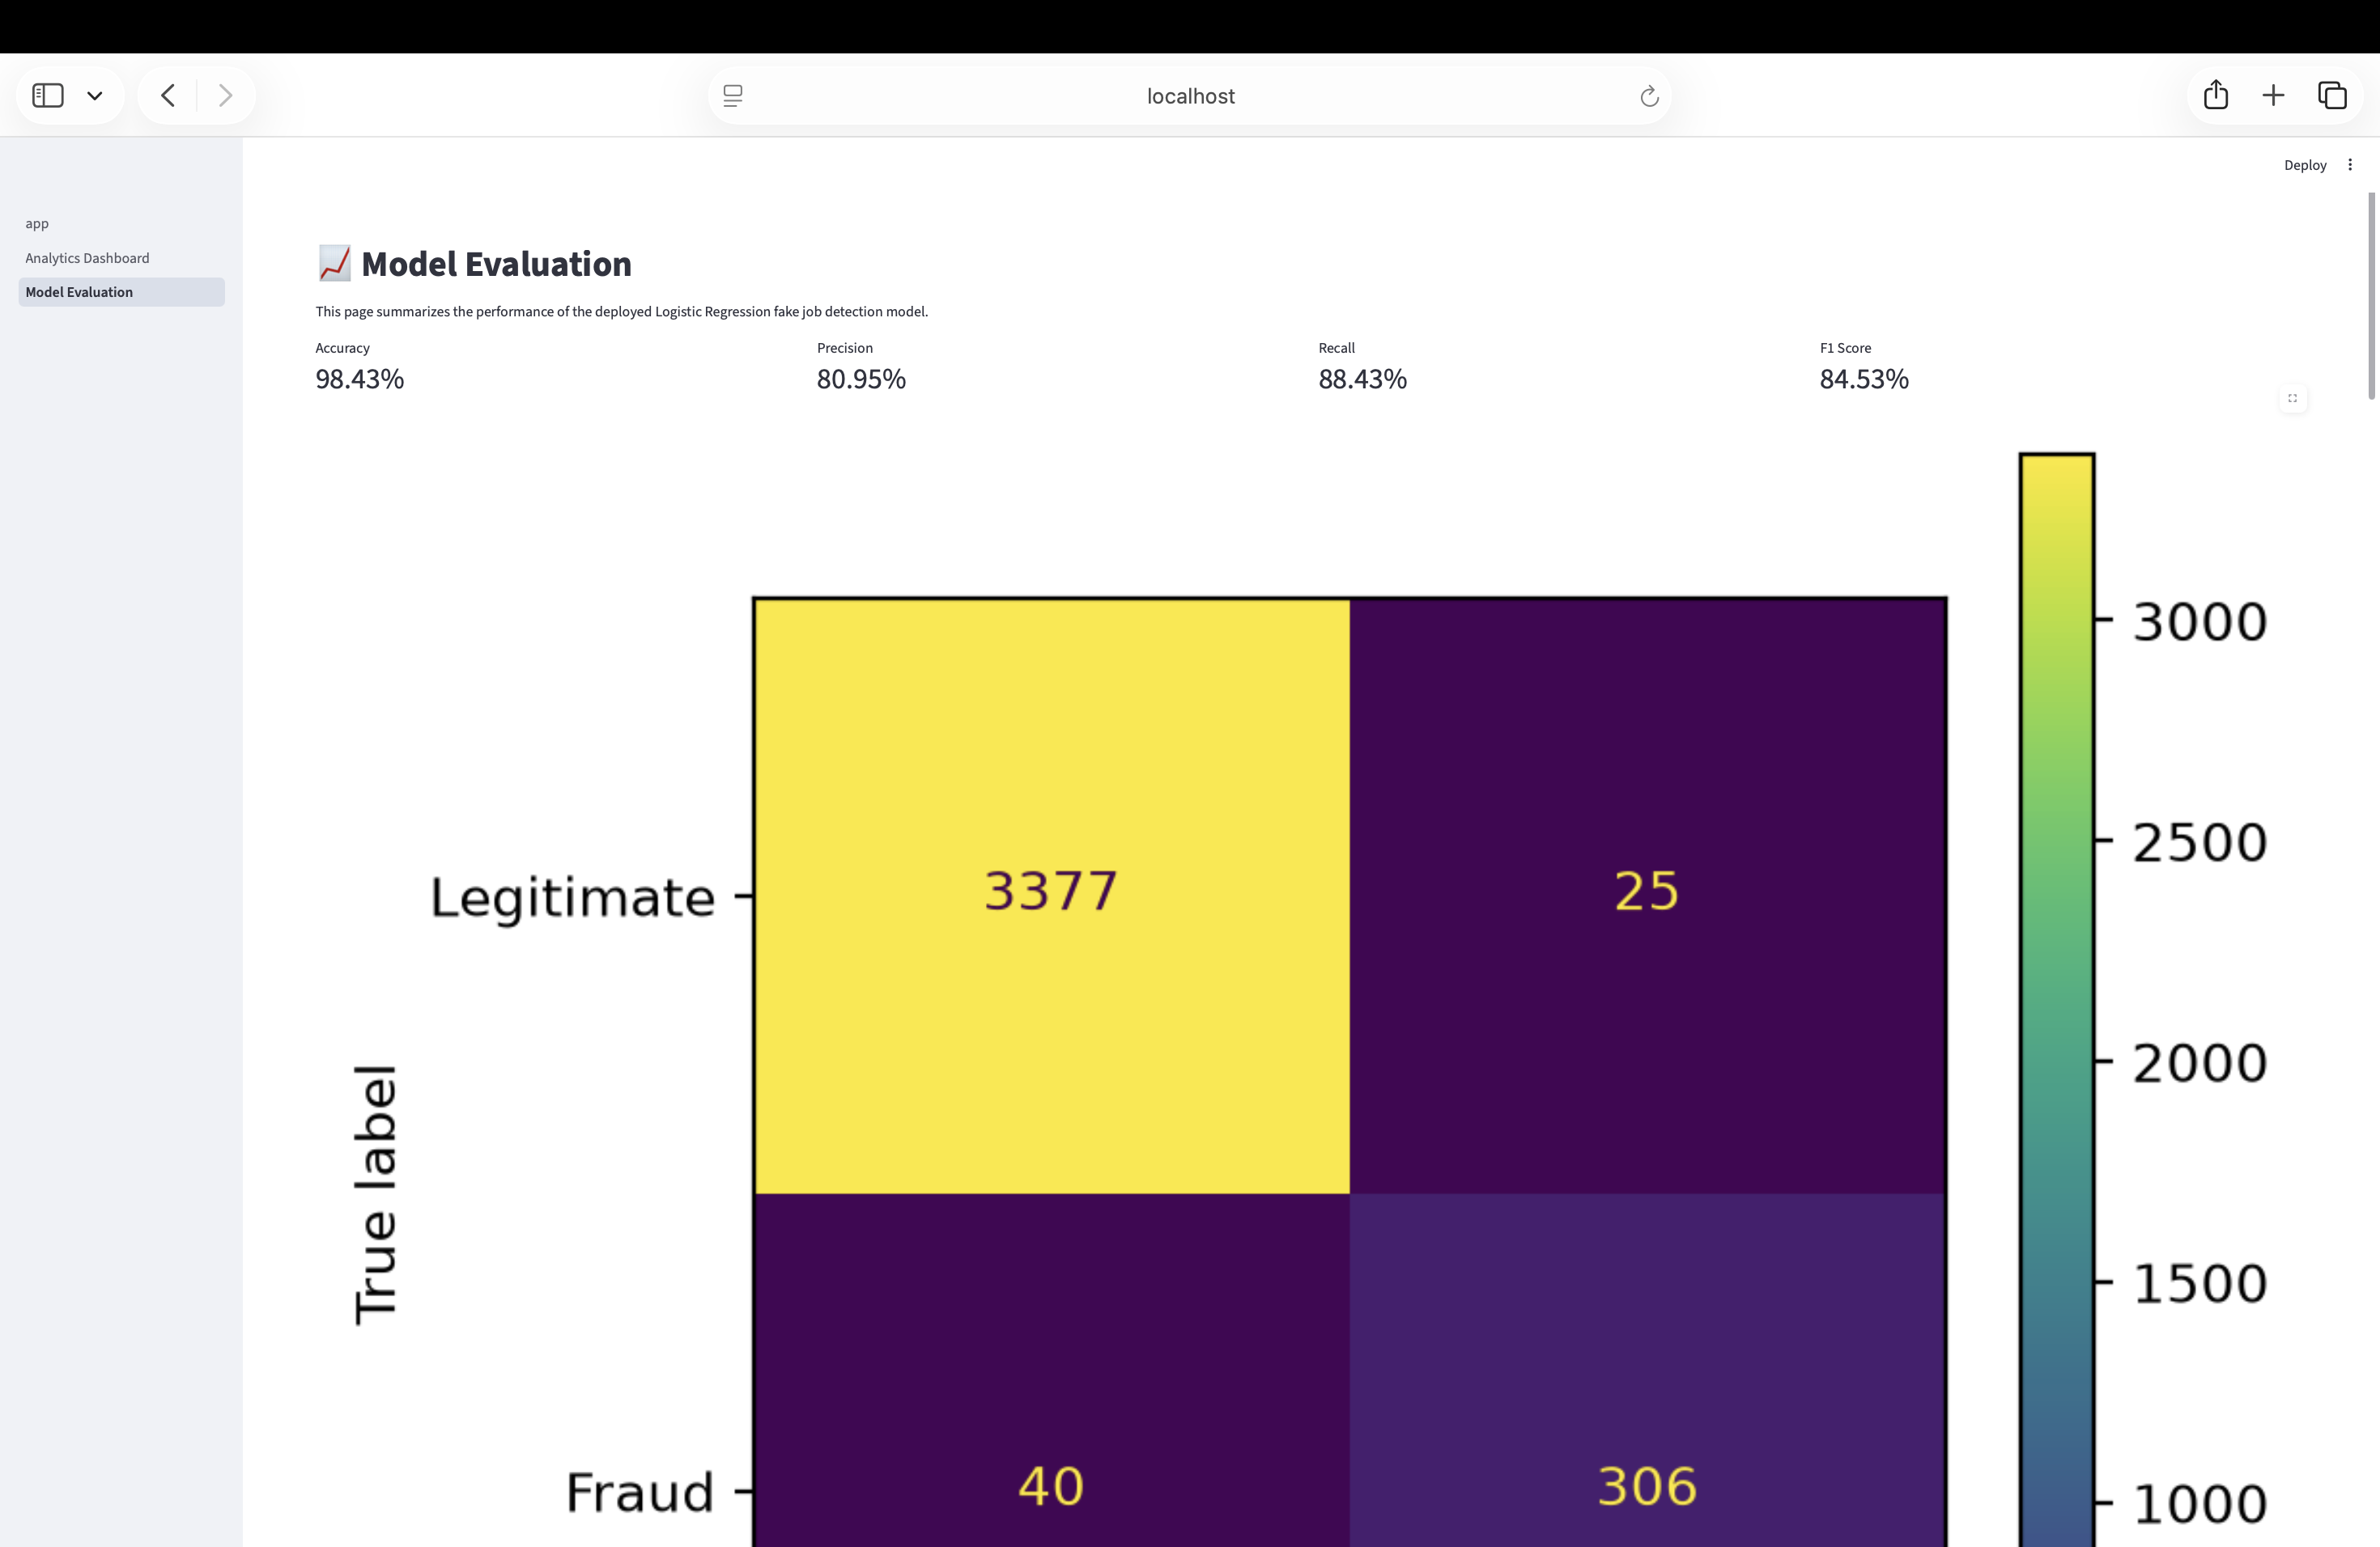
Figure 9.1 — Model Evaluation dashboard: accuracy, precision, recall, F1-score, and confusion matrix (partial view) for the deployed model.

9.2 Confusion Matrix
The confusion matrix visible on the evaluation dashboard reports 3,377 true negatives (legitimate postings correctly classified), 25 false positives (legitimate postings incorrectly flagged as fraudulent), 40 false negatives (fraudulent postings missed by the model), and 306 true positives (fraudulent postings correctly caught).
This translates to the model correctly identifying roughly 88% of all fraudulent postings in the evaluation set, while maintaining a false-positive rate low enough that legitimate postings are very rarely mislabeled (fewer than 1% of legitimate postings, 25 out of 3,402).

9.3 ROC and Precision–Recall Curves
Receiver Operating Characteristic (ROC) and Precision-Recall curves were generated using scikit-learn's RocCurveDisplay and PrecisionRecallDisplay, both computed against the held-out test set (X_test, y_test) and saved as static assets (roc_curve.png, pr_curve.png) for use in the application's evaluation page. The Precision-Recall curve is particularly informative given the dataset's class imbalance, as it focuses evaluation attention on the minority (fraud) class rather than being dominated by the majority class as ROC curves can be under heavy imbalance.

9.4 Note on Metric Reporting Across Project Artifacts
It is worth noting for completeness that the project's README and the application's sidebar report the untuned baseline Logistic Regression metrics (95.67% accuracy, 53.00% precision, 91.91% recall, 67.23% F1 — see Section 6.2), while the application's own "Model Evaluation" page reports substantially stronger figures (98.43% accuracy, 80.95% precision, 88.43% recall, 84.53% F1) consistent with the tuned/best-performing model results from Section 6.3–6.4. This discrepancy between the documentation and the live evaluation dashboard is flagged here as an area for reconciliation — see Recommendation R3 in Section 13.

10. Application Architecture and Implementation
The trained model is deployed as an interactive Streamlit web application (app.py), backed by two supporting modules: utils.py (text cleaning) and shap_utils.py (explanation generation).

10.1 Project Structure
Fake_Job_Detection/
├── app/
│ ├── assets/
│ ├── pages/
│ │ ├── 1_Analytics_Dashboard.py
│ │ └── 2_Model_Evaluation.py
│ ├── app.py
│ ├── utils.py
│ └── shap_utils.py
├── data/
│ ├── raw/
│ └── processed/
├── models/
│ ├── best_model.pkl
│ └── tfidf_vectorizer.pkl
├── notebooks/
│ ├── 01_Data_Exploration.ipynb
│ ├── 02_Preprocessing.ipynb
│ ├── 03_Model_Training.ipynb
│ ├── 04_Model_Comparison.ipynb
│ ├── 05_Model_Interpretation.ipynb
│ ├── 06_SHAP_Explainability.ipynb
│ └── 07_Model_Evaluation_Plots.ipynb
├── reports/
├── requirements.txt
└── README.md

10.2 Application Pages
- Home — the main prediction interface: users enter job posting details and receive a Legitimate/Fraudulent classification, confidence score, risk level, and word-level explanation.
- Analytics Dashboard — dataset-level insights, including totals, a data preview table, and fraud-distribution charts.
- Model Evaluation — accuracy, precision, recall, F1-score, and the confusion matrix for the deployed model, as detailed in Section 9.

10.3 Prediction Pipeline (app.py)
On the Home page, the application collects five text inputs (Job Title, Company Profile, Job Description, Requirements, Benefits) and three structured inputs (Remote, Company Logo, Has Screening Questions). When the user clicks Predict, the application:
- Concatenates the five text fields into a single string, mirroring the training-time concatenation logic (Section 5.2).
- Applies the shared clean_text() function from utils.py — the identical function used during training — to avoid train/serve skew.
- Transforms the cleaned text using the persisted TF-IDF vectorizer (tfidf.transform()).
- Horizontally stacks the TF-IDF vector with the three structured features using scipy's hstack, reproducing the exact feature layout used during training.
- Calls model.predict() for the class label and model.predict_proba() for the confidence score.
- Calls get_shap_explanation() to retrieve the top contributing words for the specific posting.
- Derives a four-level, color-coded Risk Level (🟢 Low, 🟡 Low-Medium, 🟠 Medium, 🔴 High) from the prediction and confidence score.
A basic input-quality guard is also implemented: if the entered Job Description is shorter than 30 characters, the application warns the user to provide more detail and halts prediction, reducing the risk of low-confidence predictions on near-empty input.

Code excerpt — app.py: prediction pipeline
text = " ".join([title, company, description, requirements, benefits])
cleaned = clean_text(text)
text_vector = tfidf.transform([cleaned])

structured = [[telecommuting, has_logo, has_questions]]
X = hstack([text_vector, structured])

prediction = model.predict(X)[0]
probabilities = model.predict_proba(X)[0]
confidence = probabilities[prediction] * 100

positive_words, negative_words = get_shap_explanation(
model, tfidf, cleaned, telecommuting, has_logo, has_questions
)

10.4 Risk-Level Logic
Risk level is derived from both the predicted class and the model's confidence score:
- Prediction = Legitimate → 🟢 Low Risk (regardless of confidence).
- Prediction = Fraudulent and confidence ≥ 90% → 🔴 High Risk.
- Prediction = Fraudulent and confidence ≥ 70% → 🟠 Medium Risk.
- Prediction = Fraudulent and confidence < 70% → 🟡 Low-Medium Risk.
This tiered scheme gives end users more actionable, nuanced guidance than a binary label alone — a posting flagged as fraudulent with 95% confidence warrants a very different user response than one flagged with 55% confidence.

11. Application Walkthrough
This section presents the deployed application, page by page, illustrating the end-to-end user experience from data entry through prediction and explanation.
11.1 Home Page
The Home page provides an intuitive interface where users enter job posting details for analysis. The sidebar summarizes the underlying model and its reported performance metrics.

Figure 11.1 — Home page: input form and sidebar model summary.
11.2 Legitimate Job Prediction — Input & Output
A detailed, well-specified Software Engineer posting at a fictitious company ("TechNova Solutions") is entered, including specific technologies, responsibilities, and benefits.

Figure 11.2 — Input form populated with a legitimate, detailed job posting.
The model correctly classifies this posting as Legitimate with 97.37% confidence and Low Risk. The explanation surfaces contributing terms such as apis, america, europe, development experience, software development, applications, collaborate, and paid vacation — vocabulary consistent with a detailed, professionally written technical job description.
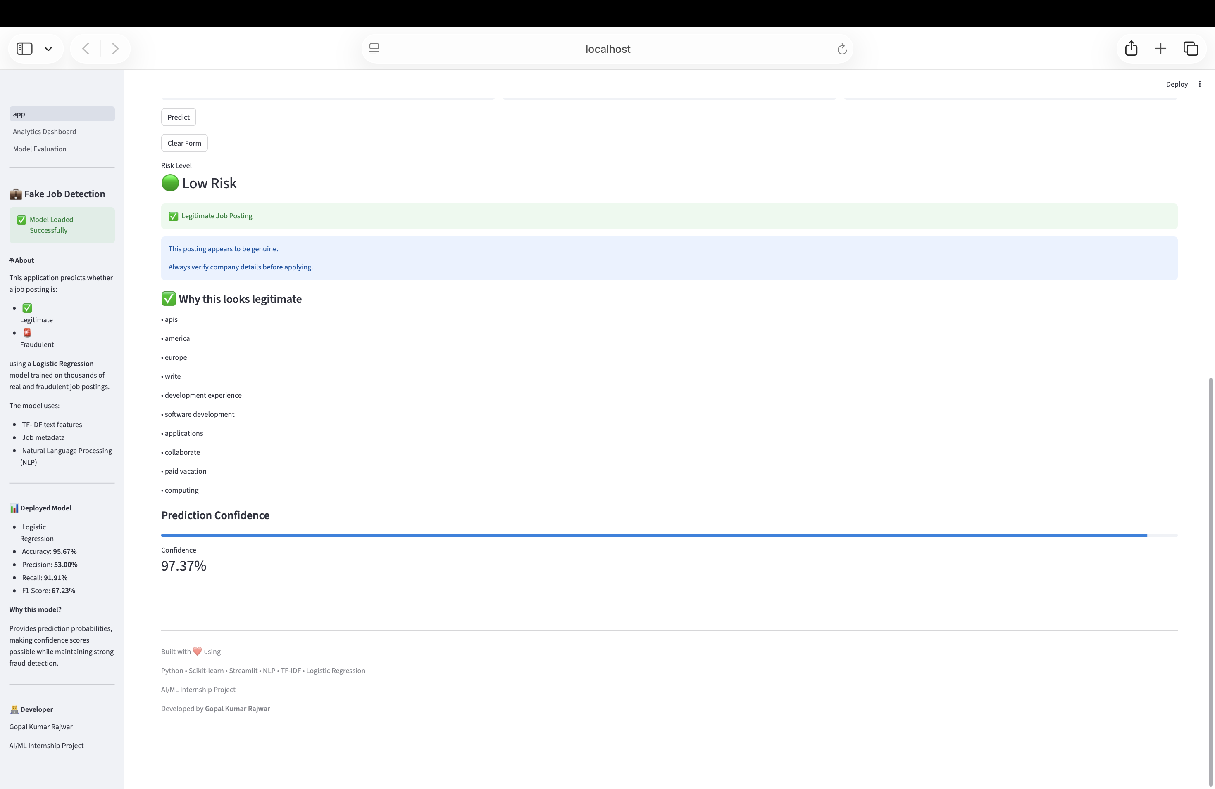
Figure 11.3 — Output: Low Risk, 97.37% confidence, with word-level explanation.
11.3 Fraudulent Job Prediction — Input & Output
A vague, generic "customer service rep" listing with a minimal description, a deferred benefits explanation ("will explain on phone interview"), and no company profile is entered to test the model's fraud-detection behavior, mirroring the fraudulent record inspected in Section 4.2.
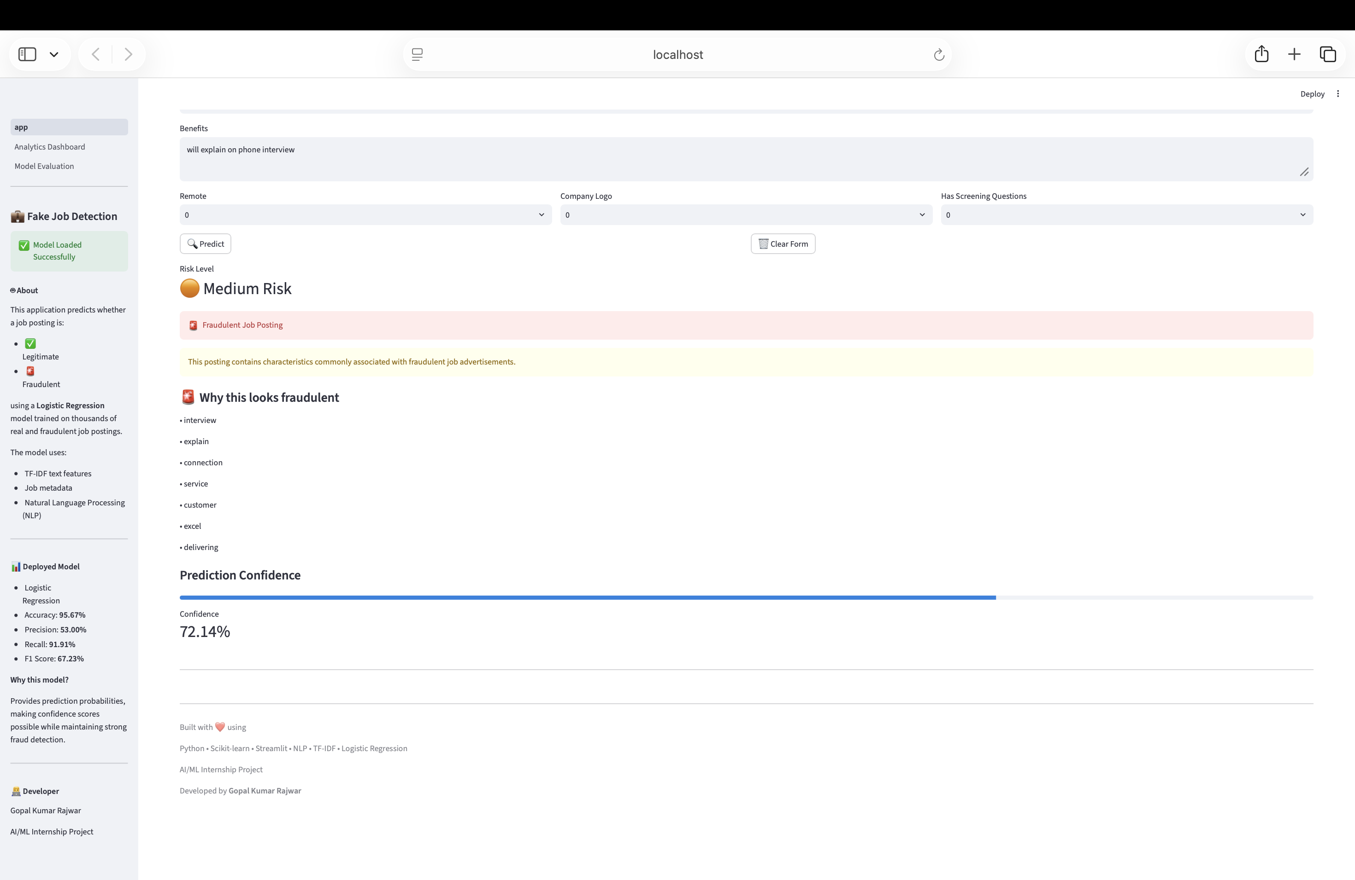
Figure 11.4 — Input form populated with a vague posting exhibiting common fraud traits.
The model classifies this posting as Fraudulent with 72.14% confidence (Medium Risk). The explanation surfaces terms such as interview, explain, connection, service, customer, excel, and delivering — drawn directly from the vague, boilerplate phrasing of the posting.
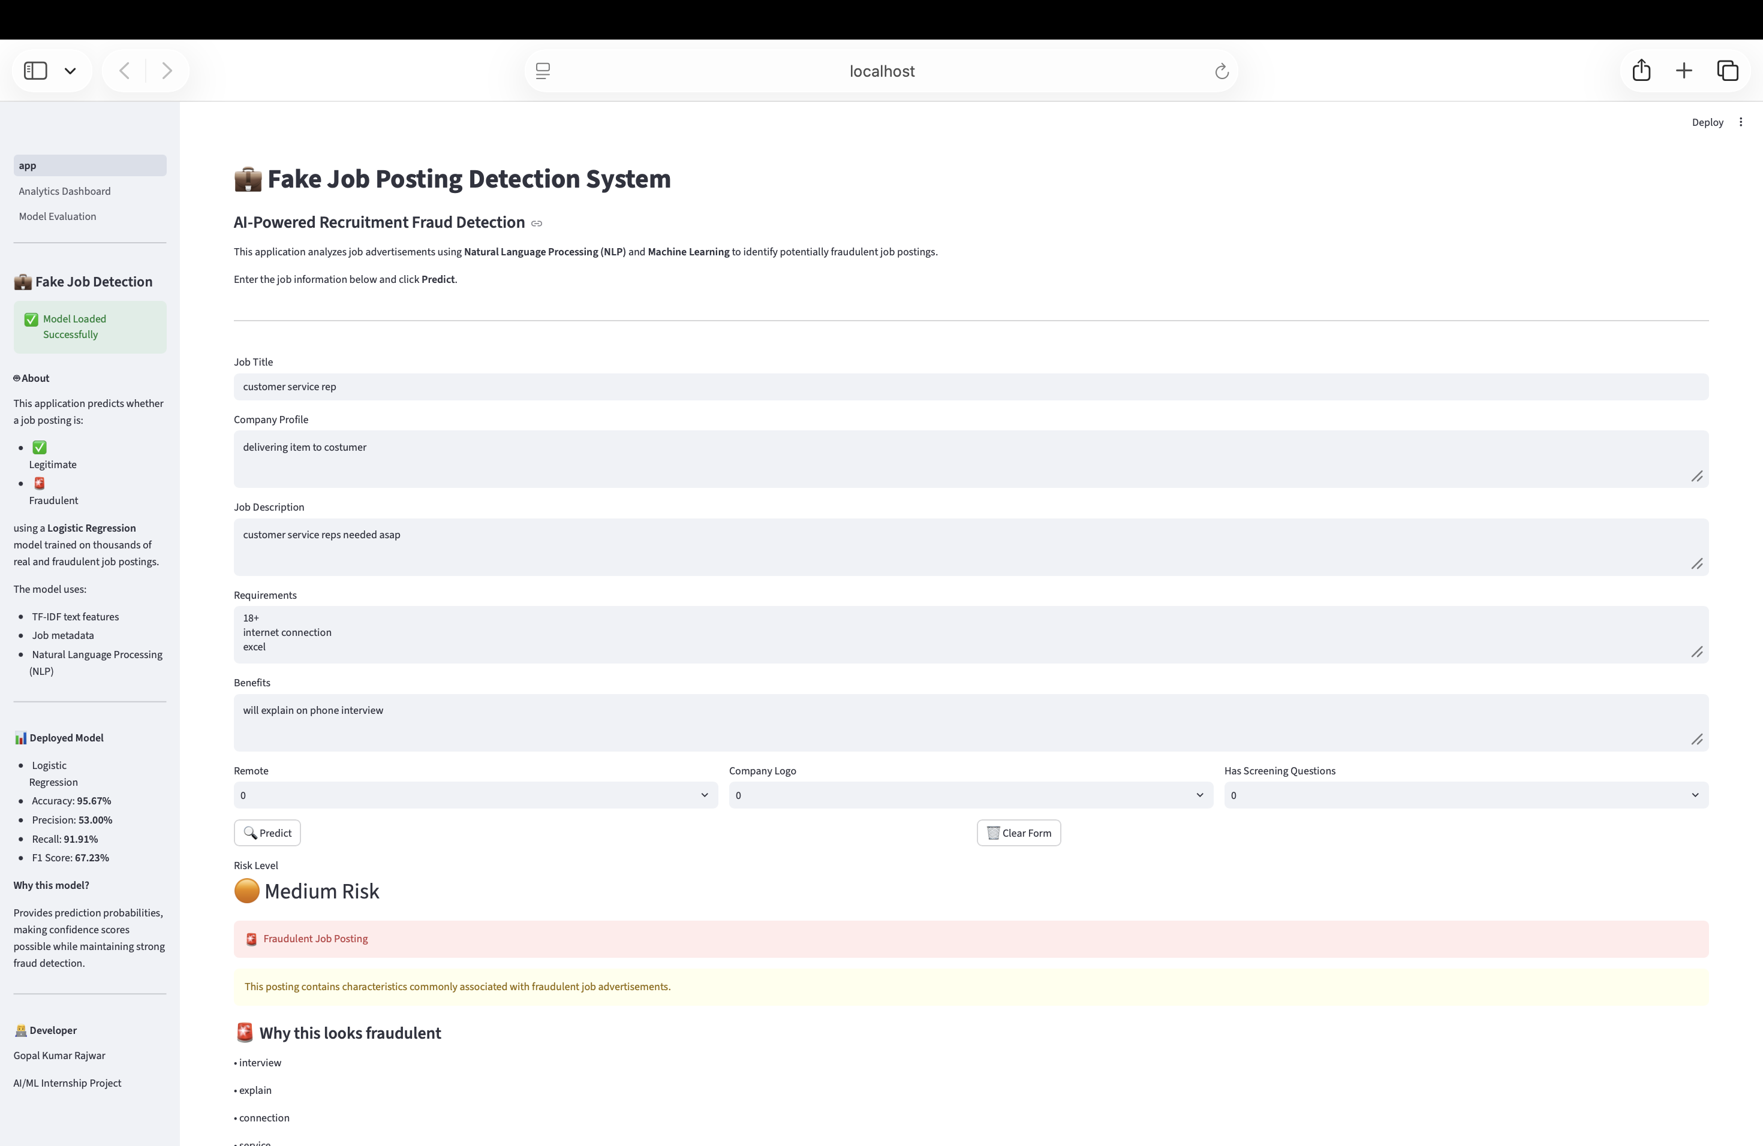
Figure 11.5 — Output: Medium Risk, 72.14% confidence, with word-level explanation.
11.4 Model Evaluation & Analytics Dashboard Pages
The Model Evaluation page (quantified in Section 9) presents accuracy, precision, recall, F1-score, and a confusion-matrix heatmap (see Figure 9.1). The Analytics Dashboard provides dataset-level context: total posting counts, a live data preview, and a fraud-distribution chart, reinforcing the transparency carried through the Home page's explanation features.
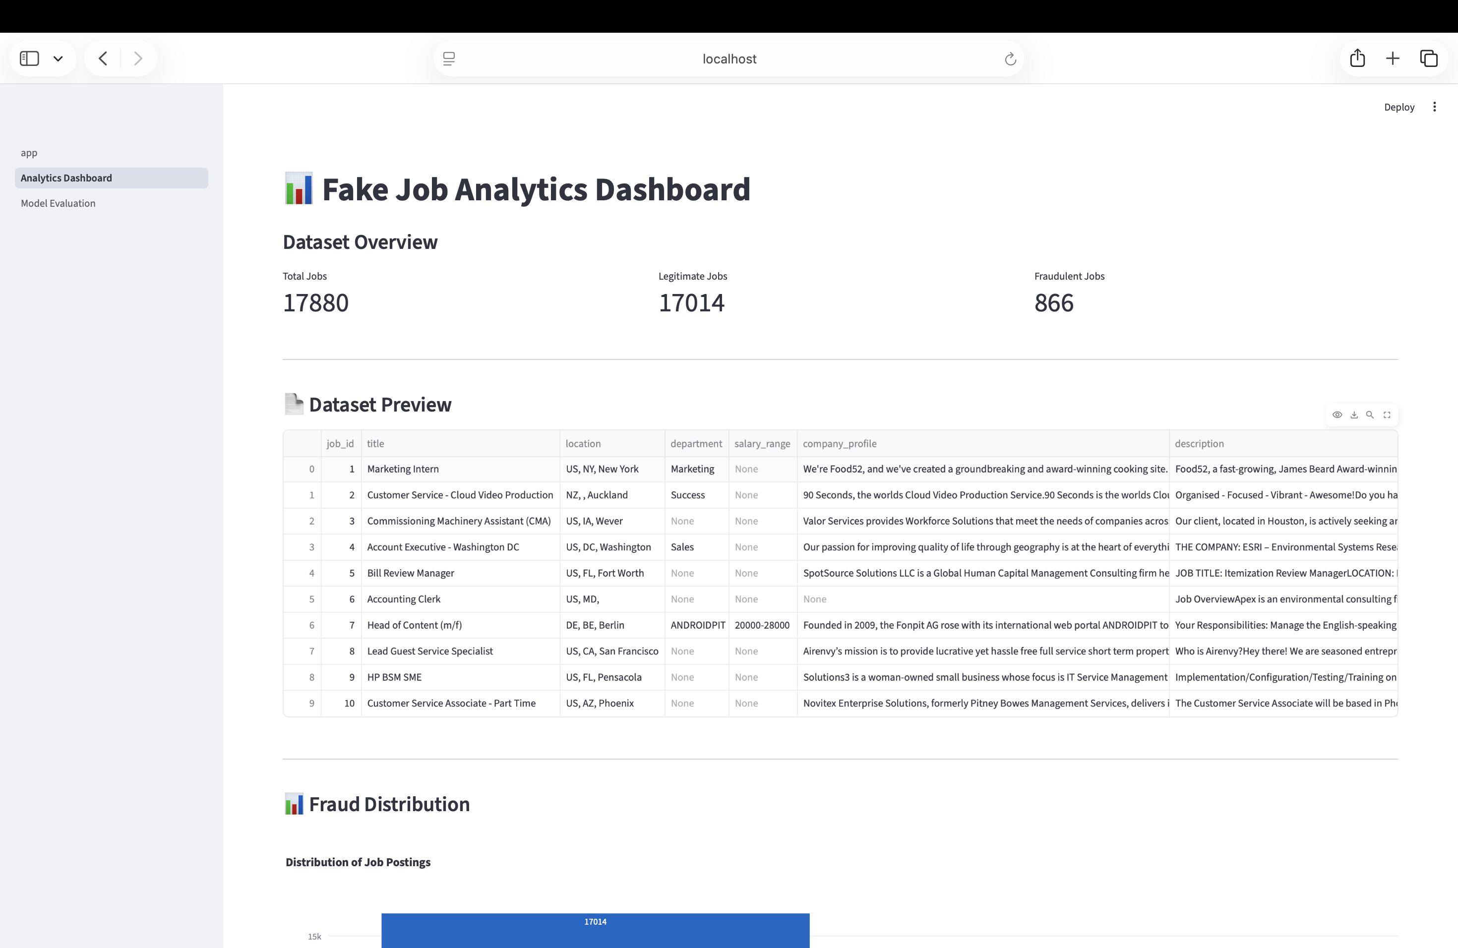
Figure 11.6 — Analytics Dashboard: dataset totals, data preview, and fraud distribution.

12. Technology Stack

12.1 Core Technologies
- Python — primary implementation language.
- Pandas / NumPy — data manipulation and numerical computing.
- Scikit-learn — TF-IDF vectorization, all classification models, GridSearchCV, and evaluation metrics.
- NLTK — supplementary NLP resources (stop words, lemmatization tooling explored during preprocessing).
- BeautifulSoup — HTML stripping during text cleaning.
- SHAP — model explainability (SHapley Additive exPlanations).
- Matplotlib / Plotly — static and interactive data visualization.
- Streamlit — interactive web application framework used for deployment.
- Joblib — model and vectorizer serialization (.pkl artifacts).

12.2 Deployed Artifacts
- best_model.pkl — the tuned Logistic Regression classifier (C = 10, solver = liblinear) used for live predictions.
- tfidf_vectorizer.pkl — the fitted TF-IDF vectorizer (5,000 max features, unigrams + bigrams, min_df = 2), ensuring identical text-to-vector transformation between training and inference.
- logistic_model.pkl — the untuned baseline Logistic Regression model, retained from the initial training notebook for comparison purposes.

13. Discussion, Limitations, and Recommendations

13.1 Strengths
- A complete, working end-to-end pipeline — from raw CSV to a deployed, interactive web application — with consistent preprocessing logic shared between training and serving code.
- Deliberate, well-reasoned handling of severe class imbalance via class-weighted training and imbalance-aware evaluation metrics (precision, recall, F1) rather than accuracy alone.
- Rigorous comparison across five distinct algorithm families, plus a targeted hyperparameter search on the most operationally suitable candidate.
- Meaningful model interpretability at both the global level (coefficient analysis) and the per-prediction level (SHAP / analytic word attribution), directly surfaced to end users rather than hidden in a notebook.
- A thoughtful, tiered risk-level system that goes beyond a binary label to give users more actionable guidance.

13.2 Limitations
- Class imbalance remains extreme (4.84% fraud rate); despite class weighting, the model still trades off precision for recall, meaning a meaningful fraction of legitimate postings are flagged as suspicious (25–139 false positives depending on model version, per Sections 6 and 9).
- The model relies on a bag-of-n-grams representation (TF-IDF) and cannot capture deeper semantic or contextual meaning; fraudulent postings that adopt more sophisticated, professionally written language could evade detection.
- The training corpus is static and dated; fraud tactics evolve over time, so periodic retraining on fresh data would be necessary to maintain real-world effectiveness (a form of concept drift risk).
- As noted in Section 9.4, there is a discrepancy between the metrics quoted in the project README / application sidebar (baseline model) and those shown on the live Model Evaluation page (tuned/best model), which could confuse end users or reviewers.
- The current application evaluates only English-language postings, and the ENGLISH_STOP_WORDS-based cleaning pipeline would not generalize to multilingual job boards.

13.3 Recommendations for Future Work
- R1 — Adopt more expressive text representations. Explore contextual embeddings (e.g., BERT-family transformer models) to capture semantic nuance beyond bag-of-n-grams, as noted as a future direction in the project's own README.
- R2 — Real-time and continuous learning. Integrate a feedback loop and periodic retraining pipeline so the model adapts to newly observed fraud tactics rather than relying on a single static training snapshot.
- R3 — Reconcile reported metrics. Update the README and in-application sidebar to consistently reference the same (tuned/deployed) model metrics shown on the Model Evaluation page, avoiding confusion between the baseline and production model performance figures.
- R4 — Company reputation verification. Cross-reference company names against external business registries or review platforms to add a corroborating, non-text-based fraud signal.
- R5 — Broaden structured feature usage. Incorporate additional available metadata (employment_type, required_experience, required_education, industry, function), currently imputed but not used as model features, which may carry additional predictive signal beyond the three currently used binary flags.
- R6 — User authentication and reporting. Add user accounts and a mechanism for users to report false positives/negatives, creating a labeled feedback dataset for future retraining, as identified in the project roadmap.

14. Conclusion
This project delivers a complete and functional solution to a genuine, real-world problem: helping job seekers identify fraudulent job postings before they engage with them. Across the full machine learning lifecycle — from exploratory data analysis and careful text preprocessing, through systematic comparison of five candidate algorithms and hyperparameter optimization, to model interpretability and a polished, user-facing deployment — the project demonstrates sound, well-documented data science practice.
The final deployed system, built on a hyperparameter-tuned Logistic Regression model, achieves strong, imbalance-aware performance (approximately 98% accuracy with 88% recall on the fraud class per the live evaluation dashboard) while remaining transparent to end users through confidence scores, tiered risk levels, and word-level explanations grounded in the model's own learned coefficients. The comparison against Naive Bayes, Linear SVM, Decision Tree, and Random Forest alternatives (Section 6.3) demonstrates that this choice reflects a deliberate, justified trade-off between raw predictive performance and the practical need for calibrated, explainable probability outputs — rather than a default or arbitrary selection.
With the improvements outlined in Section 13.3 — richer text representations, continuous retraining, and reconciled reporting — this system provides a strong foundation for a production-grade recruitment fraud detection tool.

Appendix A — Notebook Index
Notebook | Purpose
01_Data_Exploration.ipynb | Initial dataset loading, structure inspection, missing-value analysis, class distribution, and sample record review.
02_Preprocessing.ipynb | Column pruning, missing-value imputation, text consolidation, clean_text() implementation, and export of the processed dataset.
03_Model_Training.ipynb | Baseline Logistic Regression and Naive Bayes training, TF-IDF feature extraction, initial evaluation, and model persistence.
04_Model_Comparison.ipynb | Five-algorithm benchmark (Logistic Regression, Naive Bayes, Linear SVM, Decision Tree, Random Forest) and GridSearchCV hyperparameter tuning.
05_Model_Interpretation.ipynb | Global coefficient analysis identifying top words associated with fraudulent vs. legitimate postings.
06_SHAP_Explainability.ipynb | Instance-level SHAP explanation using shap.LinearExplainer on a synthetic fraudulent example.
07_Model_Evaluation_Plots.ipynb | ROC curve, Precision-Recall curve, and confusion-matrix generation for the deployed model, exported as static assets.

Appendix B — Application Source Files
- app.py — main Streamlit application: page configuration, sidebar, prediction form, prediction pipeline, and result rendering.
- utils.py — clean_text() shared text-cleaning function; also contains an explain_prediction() helper used during development.
- shap_utils.py — get_shap_explanation() function producing per-prediction word-level explanations.

Appendix C — Developer Information
Developer: Gopal Kumar Rajwar
Project Context: AI / Machine Learning Internship Project
License: Developed for educational and internship purposes.

