ME 460

HW #7

Leviticus Rhoden

8.17)

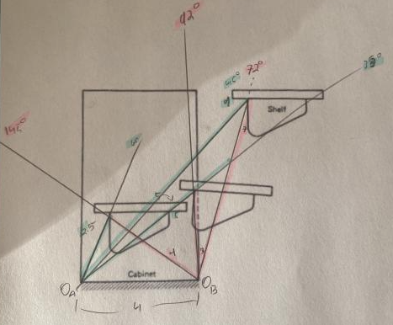

R1 = ( -3.36 - 3.54\*I ) ( 4.88 @ -133.44018503191052 degs)

R2 = ( 4.41 + 5.81\*I ) ( 7.29 @ 52.7845761700723 degs)

R2 = ( -0.17 - 11.2\*I ) ( 11.2 @ -90.8670148785741 degs)

R4 = ( -2.77 + 12.5\*I ) ( 12.8 @ 102.51920831958913 degs)

R5 = ( 7.19 - 6.68\*I ) ( 9.81 @ -42.929869952551186 degs)

R6 = ( 4.0 + 1.0\*I ) ( 4.12 @ 14.035437687729242 degs)

Oa = ( -1.06 - 2.27\*I + 2.5\*exp(1.13446401379631\*I) )

A = ( -4.41 - 5.81\*I + 2.5\*exp(1.13446401379631\*I) )

C = ( 2.5\*exp(1.13446401379631\*I) )

B = ( 2.77 - 12.5\*I + 2.5\*exp(1.13446401379631\*I) )

Ob = ( 2.94 - 1.27\*I + 2.5\*exp(1.13446401379631\*I) )

8.23)

R1 = ( 4.91 + 1.97\*I ) ( 5.29 @ 21.87059357146099 degs)

R2 = ( -2.91 + 9.43\*I ) ( 9.87 @ 107.16329982309091 degs)

R2 = ( -4.17 + 6.95\*I ) ( 8.10 @ 120.9696802868146 degs)

R4 = ( -1.91 + 2.9\*I ) ( 3.48 @ 123.35467306195633 degs)

R5 = ( -1.0 + 6.52\*I ) ( 6.60 @ 98.7144104612985 degs)

R6 = ( 8.08 + 1.55\*I ) ( 8.23 @ 10.85836153491947 degs)

Oa = ( 0 )

A = ( 4.91 + 1.97\*I )

C = ( 2 + 11.4\*I )

B = ( 3.91 + 8.49619140625\*I )

Ob = ( 8.08 + 1.55\*I )

8.25)

R1 = ( 1.98 - 0.504\*I ) ( 2.04 @ -14.281980196010023 degs)

R2 = ( 10.2 - 2.56\*I ) ( 10.5 @ -14.121115580677882 degs)

R2 = ( 2.4 + 3.12\*I ) ( 3.94 @ 52.46984105311812 degs)

R4 = ( 4.7 - 2.6\*I ) ( 5.37 @ -28.955630759785254 degs)

R5 = ( 5.46 + 0.0449\*I ) ( 5.46 @ 0.47155626029768033 degs)

R6 = ( 5.04 - 3.58\*I ) ( 6.18 @ -35.390215373070866 degs)

Oa = ( -12.14 + 3.06\*I )

A = ( -10.160751953125 + 2.55609375\*I )

C = ( 0 )

B = ( -4.7 + 2.6\*I )

Ob = ( -7.1 - 0.52\*I )

9.12)

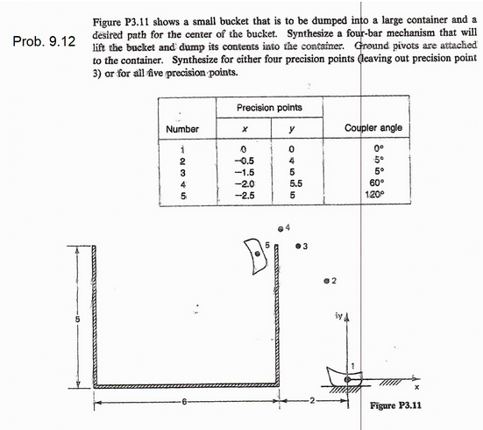

R1 = ( 1.65 + 2.12\*I ) ( 2.69 @ 52.21805295955476 degs)

R2 = ( 2.35 - 2.12\*I ) ( 3.17 @ -42.05560573878955 degs)

R2 = ( 3.47 + 0.305\*I ) ( 3.48 @ 5.036636135480762 degs)

R4 = ( 1.53 - 1.31\*I ) ( 2.02 @ -40.37701844836722 degs)

R5 = ( 0.819 - 0.818\*I ) ( 1.16 @ -44.96515704218827 degs)

R6 = ( -1.0 + 1.0\*I ) ( 1.41 @ 135.01386061668146 degs)

Oa = ( 0 )

A = ( 1.65 + 2.12\*I )

C = ( 4 )

B = ( 2.46 + 1.31\*I )

Ob = ( -1.0 + 1.0\*I )

HW3-Prob.3)

R1 = ( -3.19 + 0.854\*I ) ( 3.30 @ 165.00112314870543 degs)

R2 = ( 5.12e-11 + 1.58e-9\*I ) ( 1.58e-9 @ 88.1538092020129 degs)

R2 = ( -2.81 + 1.34\*I ) ( 3.11 @ 154.49596435614566 degs)

R4 = ( -2.97 - 0.0316\*I ) ( 2.97 @ -179.3887800315539 degs)

R5 = ( 2.97 + 0.0316\*I ) ( 2.97 @ 0.611219968446101 degs)

R6 = ( 2.59 - 0.455\*I ) ( 2.63 @ -9.964863508455084 degs)

Oa = ( 3.19 - 0.854\*I + 3.3\*exp(2.87979326579064\*I) )

A = ( -5.12e-11 - 1.58e-9\*I + 3.3\*exp(2.87979326579064\*I) )

C = ( 3.3\*exp(2.87979326579064\*I) )

B = ( 2.97 + 0.0316\*I + 3.3\*exp(2.87979326579064\*I) )

Ob = ( 5.78 - 1.31\*I + 3.3\*exp(2.87979326579064\*I) )

