------------------ REPORT ------------------

Report generated on 14-Jul-2016 18:56:12

------------------ ELECTRODES ------------------

Total number of channels used: 128

+ Electrode 1 (64 channels) is configured with config neuroNexusA8x8.txt

+ Electrode 2 (64 channels) is configured with config neuroNexusA8x8.txt

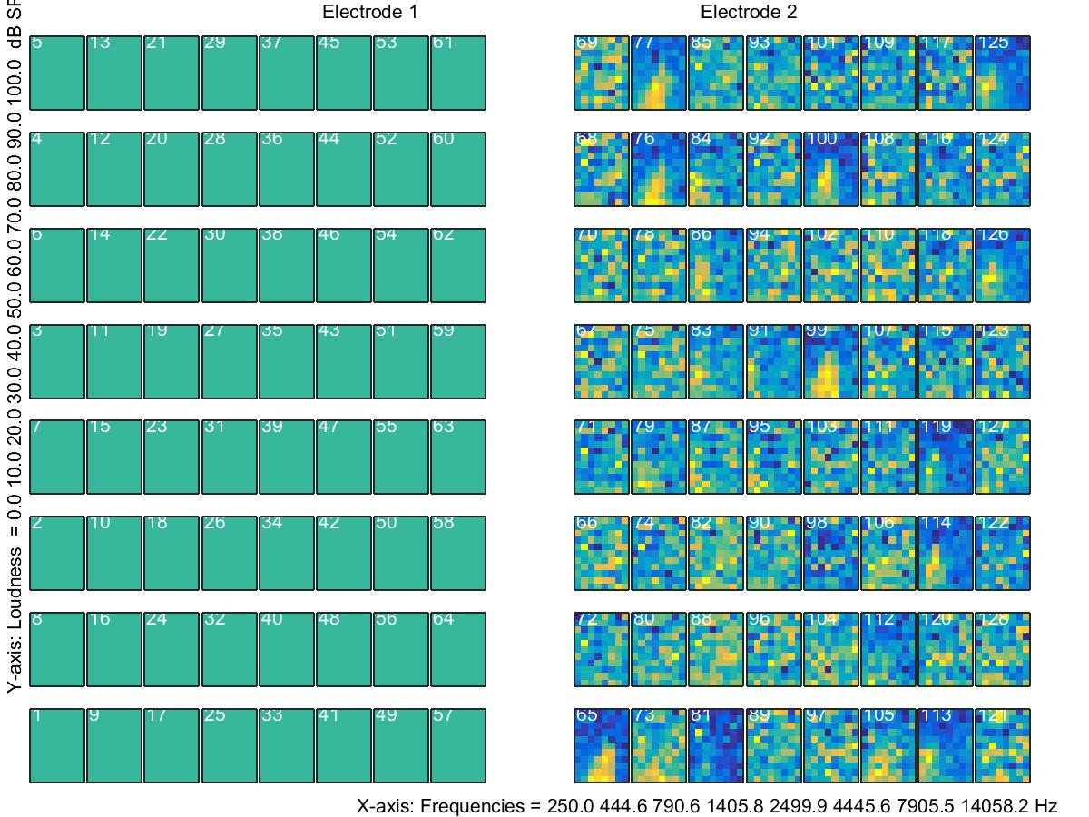

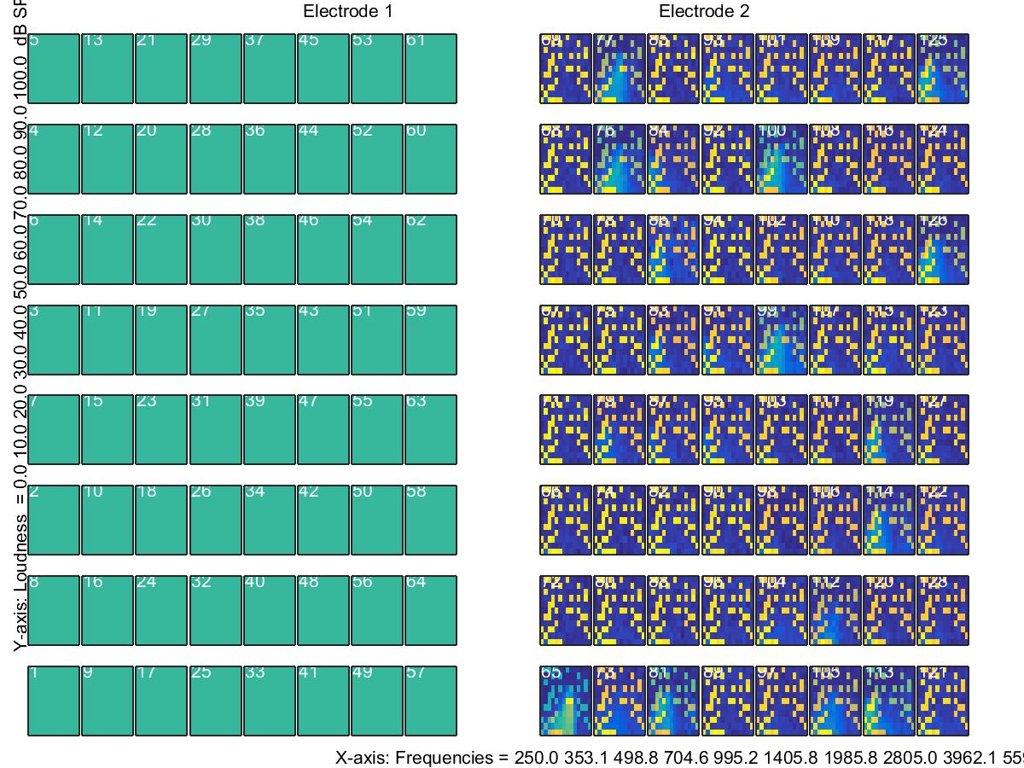

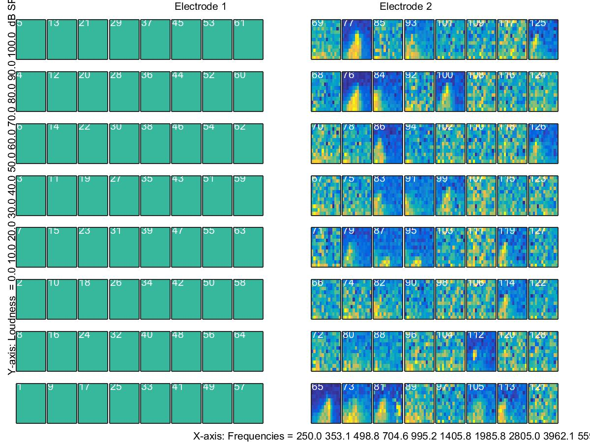

------------------ RECEPTIVE FIELDS ------------------

Path/to/14_Jul_2016_17_35_06/receptiveFields_1.jpg

Path/to/14_Jul_2016_17_35_06/receptiveFields_2.jpg

Path/to/14_Jul_2016_17_35_06/receptiveFields_3.jpg

------------------ CALIBRATION ------------------

Plot of calibration of left ear wasn't found.

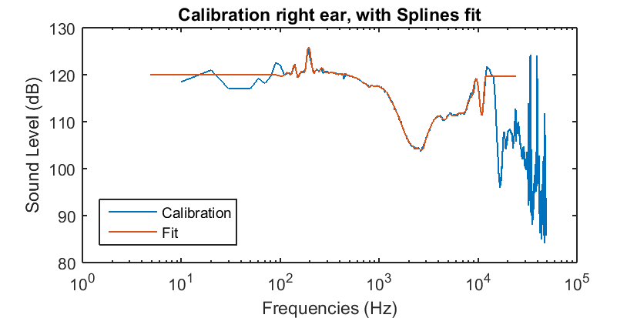

------------------ COMMENTS ------------------

Comments made during the experiment

* Restarted loop at number 75 (14-Jul-2016 18:50:22)

------------------ TDT OBJECT ------------------

Not implementerd yet