**CAED_LAB#09**

**Hamza Ahmed Siddiqui**

**FA17-BECE-0026**

Task_01;

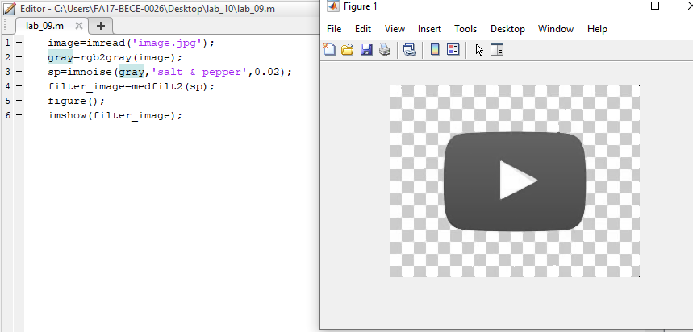

Task_02;

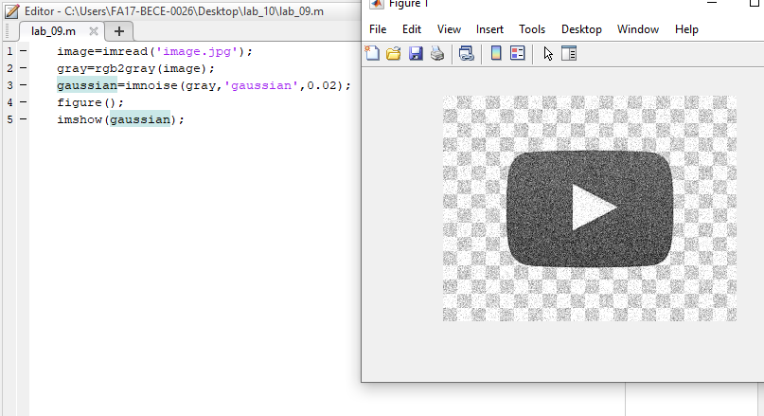

Task_03;

