OS Lab 05
Exercises

Task 01: Write a script to print the sum of digits of number. i.e. 546=5+4+6=15. Print number in reverse
order using for loop. i.e. 10-1.

Code:
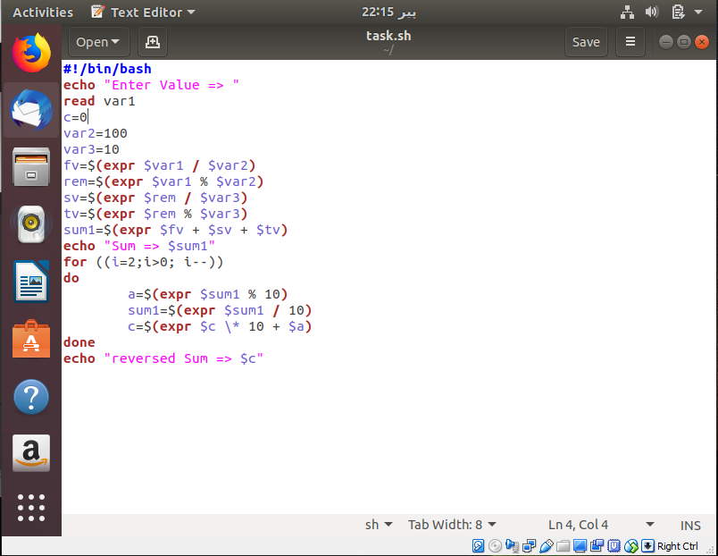

Result of Task 01:
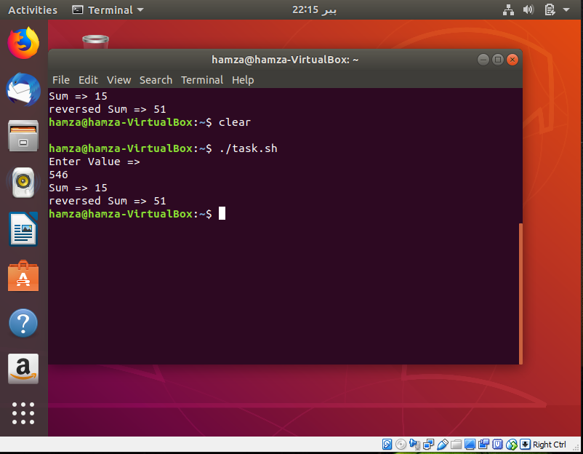

Task 02: Write a shell script to take a number input from user and then print the table for the given
number. i.e. if n=5 then 5*1=5.
Code:
#!/bin/bash
echo "Enter the Number to print its table => "
read var1
for ((i=1; i<=10 ; i++ ))
do
mul=$(expr $var1 \* $i)
echo "$var1 x $i = $mul "
done
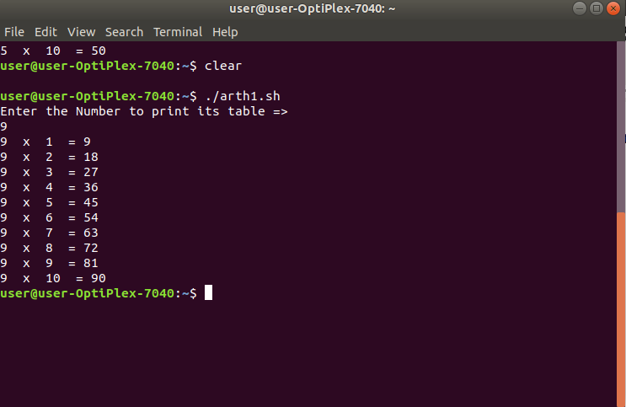

Task 03: Write scripts /commands / syntax that take input and check the number is positive or negative.

Code:
#!/bin/bash
echo "Enter the number: "
read var1

if (( "$var1" < 0 ))
then
echo "The number is negative!"
else
echo "The number is positive!"
fi

Result of Task03:
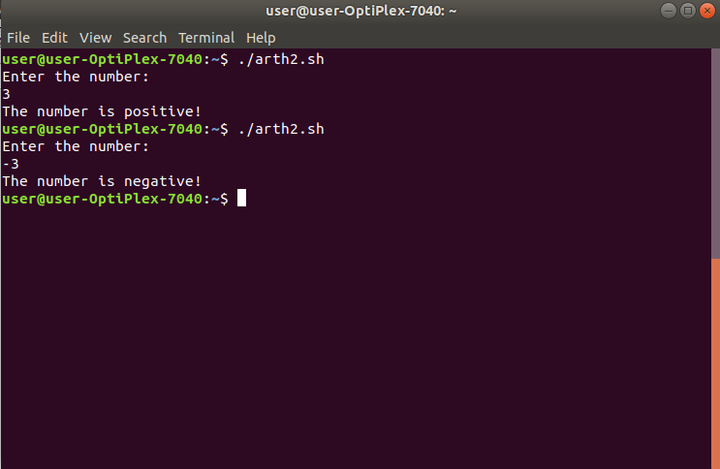

Task 04: Write scripts /commands / syntax that print a message 10 times.

Code:
#!/bin/bash

for (( i=1; i<=10;i++ ))
do
echo "My name is LEVORD :p"
done

Result of Task04:



