**Problem Statement:  
Create two independent Spring Boot RESTful microservices: one for handling account details and one for handling loan details. Each microservice should expose a GET API returning a dummy JSON response based on the provided account or loan number. Each microservice should be in its own Maven project with separate ports.**

**Steps:**

1. Create a folder to store all microservices.
2. Visit <https://start.spring.io> and create a Spring Boot project with:
   * Group: com.cognizant
   * Artifact: account
   * Dependencies: Spring Web, Spring Boot DevTools
3. Download and extract the account project.
4. Build the project using:

mvn clean package

1. Import the project into Eclipse.
2. Create AccountController.java inside:

src/main/java/com/cognizant/account/controller/

1. Paste the following code in AccountController.java:

package com.cognizant.account.controller;

import java.util.HashMap;

import java.util.Map;

import org.springframework.web.bind.annotation.GetMapping;

import org.springframework.web.bind.annotation.PathVariable;

import org.springframework.web.bind.annotation.RestController;

@RestController

public class AccountController {

@GetMapping("/accounts/{number}")

public Map<String, Object> getAccountDetails(@PathVariable String number) {

Map<String, Object> response = new HashMap<>();

response.put("number", number);

response.put("type", "savings");

response.put("balance", 234343);

return response;

}

}

1. Ensure AccountApplication.java looks like this:

package com.cognizant.account;

import org.springframework.boot.SpringApplication;

import org.springframework.boot.autoconfigure.SpringBootApplication;

@SpringBootApplication

public class AccountApplication {

public static void main(String[] args) {

SpringApplication.run(AccountApplication.class, args);

}

}

1. Run the application and test the endpoint:

bash

http://localhost:8080/accounts/00987987973432

1. Repeat steps 2–9 for the loan microservice:
   * Use artifact: loan
   * Endpoint: /loans/{number}
   * Response:

{

"number": "H00987987972342",

"type": "car",

"loan": 400000,

"emi": 3258,

"tenure": 18

}

1. Change the port for the loan microservice by adding the following to src/main/resources/application.properties:

server.port=8081

1. Run both microservices simultaneously.

Output (Account Microservice):

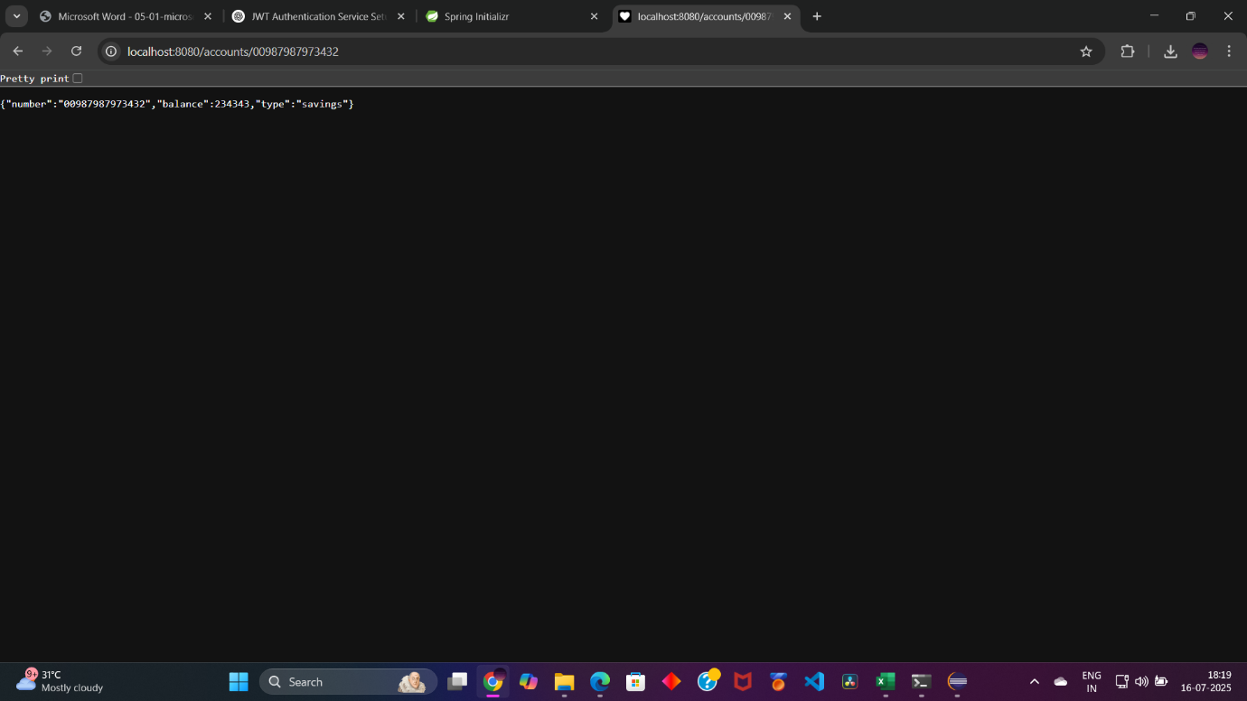

Output (Loan Microservice):

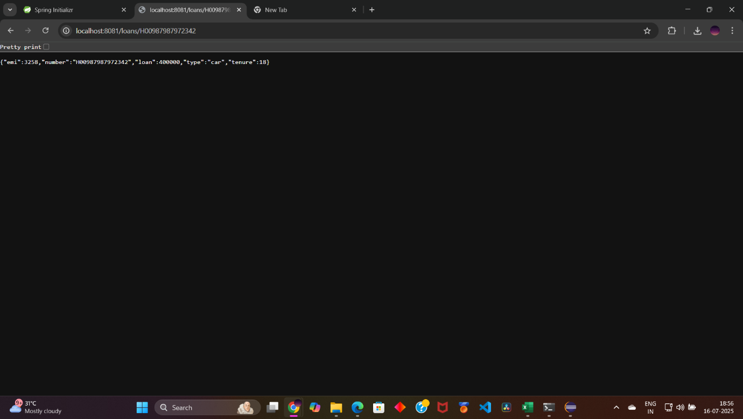

Both (Side-by-side):

