**📘 1. ReactJS-HOL.docx**

**Problem Statement / Objective**

Create a new React Application named **“myfirstreact”** and display the heading:  
**“Welcome to the first session of React”**

**Code**

npx create-react-app myfirstreact

cd myfirstreact

npm start

Edit src/App.js:

import React from 'react';

function App() {

return (

<div>

<h1>Welcome to the first session of React</h1>

</div>

);

}

export default App;

output:

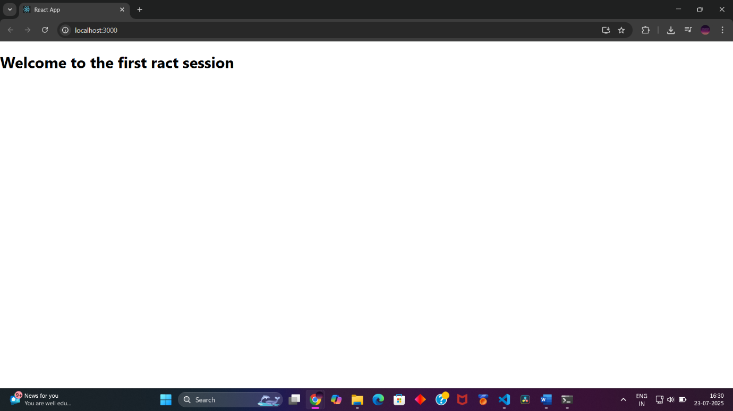

**📘 2. ReactJS-HOL.docx**

**Problem Statement / Objective**

Create a React project named **“StudentApp”** with three components:

* Home: displays "Welcome to the Home page of Student Management Portal"
* About: displays "Welcome to the About page of the Student Management Portal"
* Contact: displays "Welcome to the Contact page of the Student Management Portal"  
  Use all three in the main App component.

**Code**

npx create-react-app StudentApp

cd StudentApp

Create folder src/Components/ and add the following files:

**Home.js**

import React from 'react';

function Home() {

return <h3>Welcome to the Home page of Student Management Portal</h3>;

}

export default Home;

**About.js**

import React from 'react';

function About() {

return <h3>Welcome to the About page of the Student Management Portal</h3>;

}

export default About;

**Contact.js**

import React from 'react';

function Contact() {

return <h3>Welcome to the Contact page of the Student Management Portal</h3>;

}

export default Contact;

**App.js**

import React from 'react';

import Home from './Components/Home';

import About from './Components/About';

import Contact from './Components/Contact';

function App() {

return (

<div>

<Home />

<About />

<Contact />

</div>

);

}

export default App;

output:

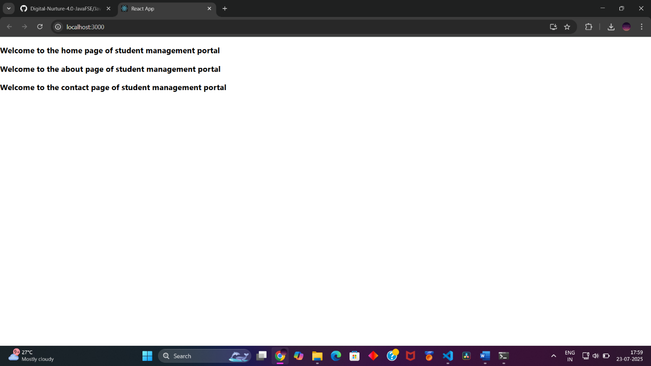

**📘 3. ReactJS-HOL.docx**

**Problem Statement / Objective**

Create a React project named **“scorecalculatorapp”**. Inside it, create a function component CalculateScore that accepts Name, School, Total, and Goal and calculates the average. Also apply styles using a CSS file.

**Code**

npx create-react-app scorecalculatorapp

cd scorecalculatorapp

Create src/Components/CalculateScore.js:

import React from 'react';

import '../Stylesheets/mystyle.css';

function CalculateScore() {

const name = 'Arshita';

const school = 'XYZ School';

const total = 480;

const goal = 500;

const average = (total / goal) * 100;

return (

<div className="score-box">

<h3>{name}</h3>

<p>School: {school}</p>

<p>Total Marks: {total}</p>

<p>Goal: {goal}</p>

<p>Average Score: {average.toFixed(2)}%</p>

</div>

);

}

export default CalculateScore;

Create src/Stylesheets/mystyle.css:

.score-box {

border: 1px solid black;

padding: 15px;

margin: 10px;

background-color: #f2f2f2;

}

Edit src/App.js:

import React from 'react';

import CalculateScore from './Components/CalculateScore';

function App() {

return (

<div>

<CalculateScore />

</div>

);

}

export default App;

output:

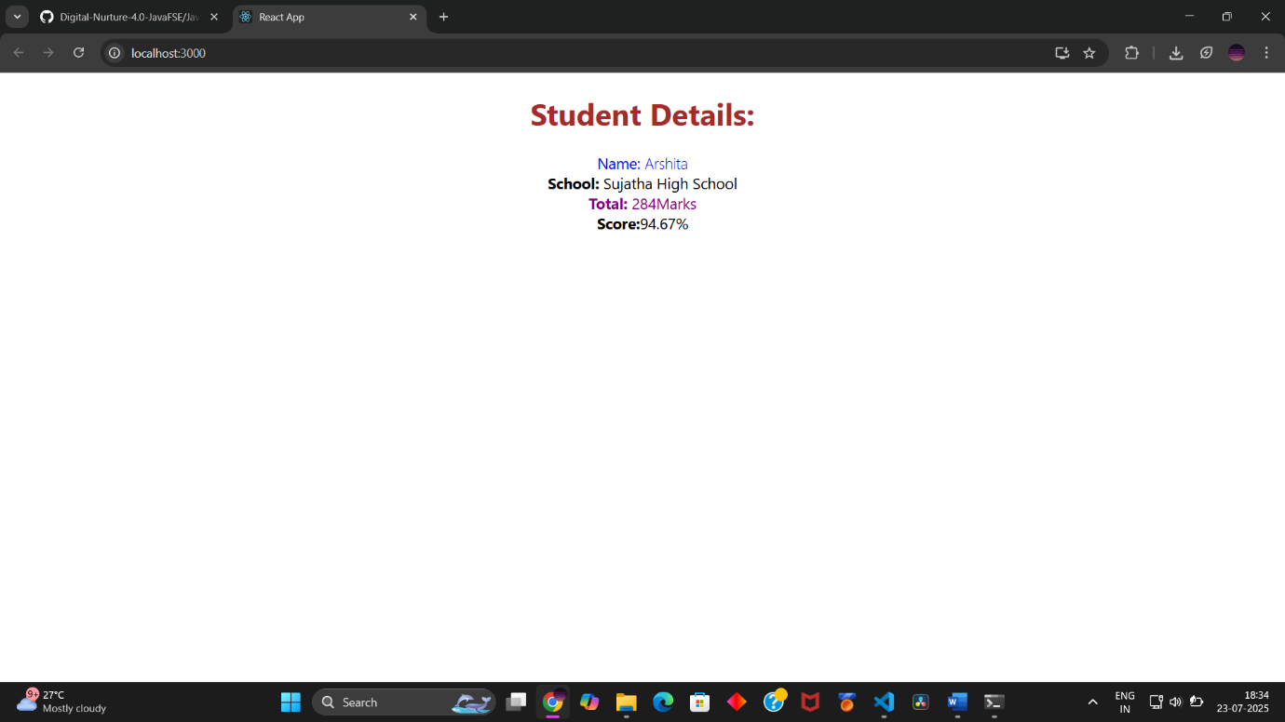

**📘 4. ReactJS-HOL.docx**

**Problem Statement / Objective**

Create a React app named **“blogapp”**.

* Create a Post class (model)
* Create a Posts component
* Use componentDidMount() to fetch data from https://jsonplaceholder.typicode.com/posts
* Render post titles and bodies
* Use componentDidCatch() to alert on errors

**Code**

**src/Post.js**

class Post {

constructor(userId, id, title, body) {

this.userId = userId;

this.id = id;

this.title = title;

this.body = body;

}

}

export default Post;

**src/Posts.js**

import React, { Component } from 'react';

import Post from './Post';

class Posts extends Component {

constructor(props) {

super(props);

this.state = { posts: [] };

}

loadPosts = async () => {

const response = await fetch('https://jsonplaceholder.typicode.com/posts');

const data = await response.json();

const postObjects = data.map(p => new Post(p.userId, p.id, p.title, p.body));

this.setState({ posts: postObjects });

};

componentDidMount() {

this.loadPosts();

}

componentDidCatch(error, info) {

alert('An error occurred: ' + error.toString());

}

render() {

return (

<div>

{this.state.posts.map(post => (

<div key={post.id}>

<h4>{post.title}</h4>

<p>{post.body}</p>

</div>

))}

</div>

);

}

}

export default Posts;

**App.js**

import React from 'react';

import Posts from './Posts';

function App() {

return (

<div>

<h2>Blog Posts</h2>

<Posts />

</div>

);

}

export default App;

output:

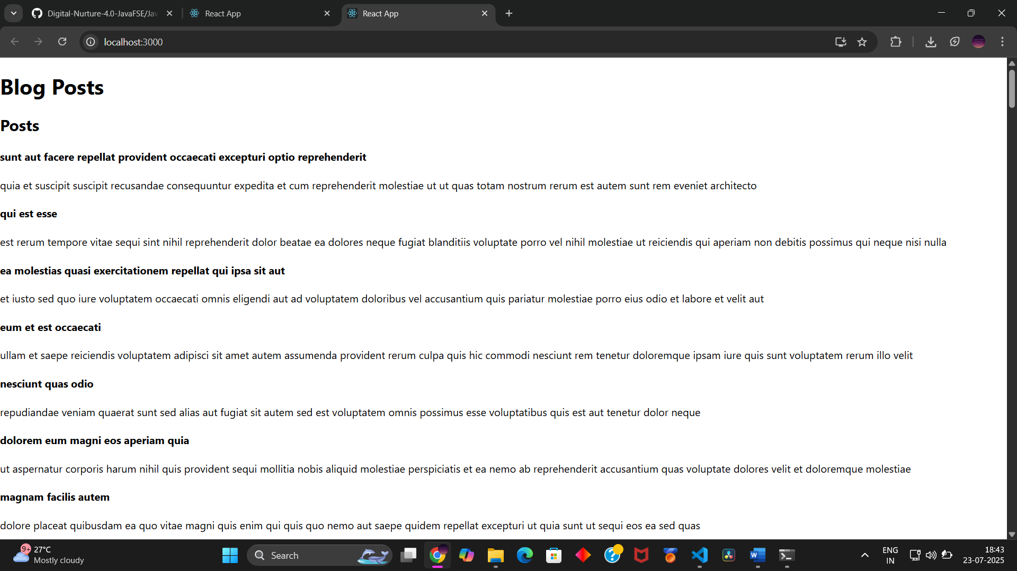

**📘 5. ReactJS-HOL.docx**

**Problem Statement / Objective**

Style an existing React component CohortDetails using:

* CSS Module with a .box class
* <dt> element styled via tag selector
* Conditional styling for <h3> based on cohortStatus (green if ongoing, else blue)

**Code**

**CohortDetails.module.css**

.box {

width: 300px;

display: inline-block;

margin: 10px;

padding: 10px 20px;

border: 1px solid black;

border-radius: 10px;

}

dt {

font-weight: 500;

}

.greenStatus {

color: green;

}

.blueStatus {

color: blue;

}

**CohortDetails.js**

import React from 'react';

import styles from './CohortDetails.module.css';

function CohortDetails(props) {

const status = props.cohort.currentStatus.toLowerCase();

const statusClass = status === 'ongoing' ? styles.greenStatus : styles.blueStatus;

return (

<div className={styles.box}>

<h3 className={statusClass}>

{props.cohort.cohortCode} - {props.cohort.technology}

</h3>

<dl>

<dt>Started On</dt>

<dd>{props.cohort.startDate}</dd>

<dt>Current Status</dt>

<dd>{props.cohort.currentStatus}</dd>

<dt>Coach</dt>

<dd>{props.cohort.coachName}</dd>

<dt>Trainer</dt>

<dd>{props.cohort.trainerName}</dd>

</dl>

</div>

);

}

export default CohortDetails;

**App.js (Usage)**

import React from 'react';

import CohortDetails from './CohortDetails';

const cohort = {

cohortCode: 'C101',

technology: 'React',

startDate: '2025-06-01',

currentStatus: 'ongoing',

coachName: 'John Doe',

trainerName: 'Jane Smith',

};

function App() {

return (

<div>

<CohortDetails cohort={cohort} />

</div>

);

}

export default App;

output:

