## **Week 7**

## **9. ReactJS-HOL**

**Create a React Application named “cricketapp” with the following components:**

***ListOfPlayers.js***

const ListOfPlayers = () => {

const players = [

{ name: "Virat", score: 95 },

{ name: "Rohit", score: 85 },

...

{ name: "Shami", score: 65 }

];

// Use map to display all players

const allPlayers = players.map((player, index) => (

<li key={index}>{player.name} - {player.score}</li>

));

// Filter players with score < 70 using arrow function

const filteredPlayers = players

.filter(player => player.score < 70)

.map((player, index) => (

<li key={index}>{player.name} - {player.score}</li>

));

return (

<div>

<h2>All Players</h2>

<ul>{allPlayers}</ul>

<h2>Filtered Players (score &lt; 70)</h2>

<ul>{filteredPlayers}</ul>

</div>

);

};

***IndianPlayers.js:***

const IndianPlayers = () => {

const OddTeam = ["Kohli", "Dhoni", "Raina"];

const EvenTeam = ["Rohit", "Ashwin", "Shami"];

// Destructuring

const [odd1, odd2, odd3] = OddTeam;

const [even1, even2, even3] = EvenTeam;

// Merging arrays

const T20Players = ["Bumrah", "Gill"];

const RanjiPlayers = ["Sarfaraz", "Pujara"];

const AllPlayers = [...T20Players, ...RanjiPlayers];

return (

<div>

<h2>Odd Team Players</h2>

<ul>

<li>{odd1}</li>

<li>{odd2}</li>

<li>{odd3}</li>

</ul>

<h2>Even Team Players</h2>

<ul>

<li>{even1}</li>

<li>{even2}</li>

<li>{even3}</li>

</ul>

<h2>All Players (Merged)</h2>

<ul>

{AllPlayers.map((player, index) => (

<li key={index}>{player}</li>

))}

</ul>

</div>

);

};

***App.js***

import ListOfPlayers from './components/ListOfPlayers';

import IndianPlayers from './components/IndianPlayers';

function App() {

let flag = true; // Change to false to see IndianPlayers

return (

<div className="App">

<h1>Cricket App</h1>

{flag ? <ListOfPlayers /> : <IndianPlayers />}

</div>

);

}

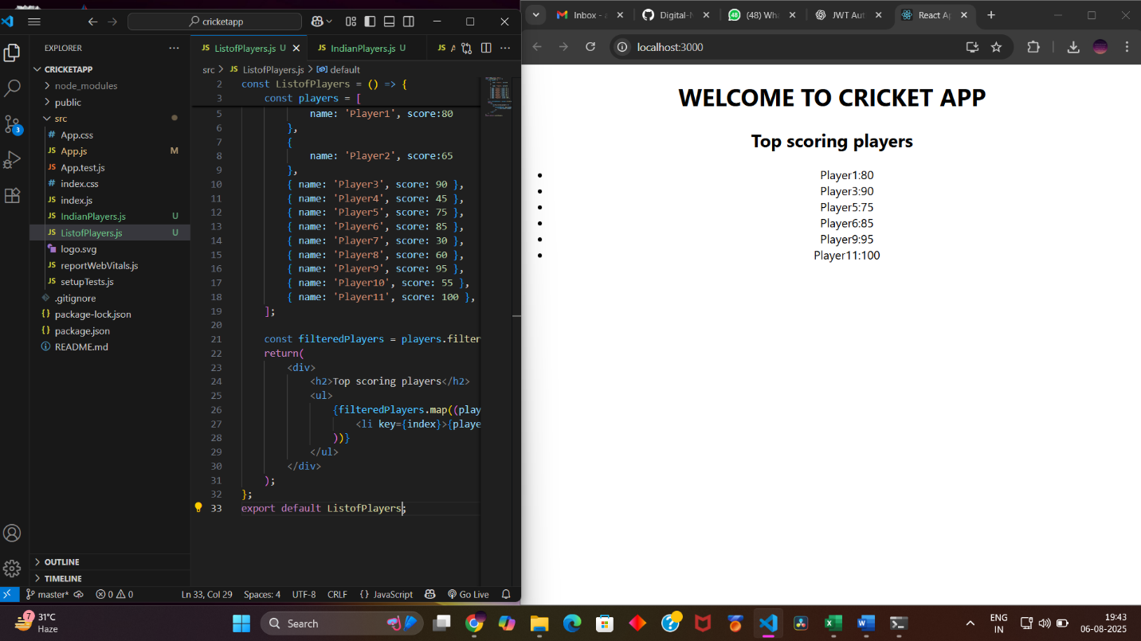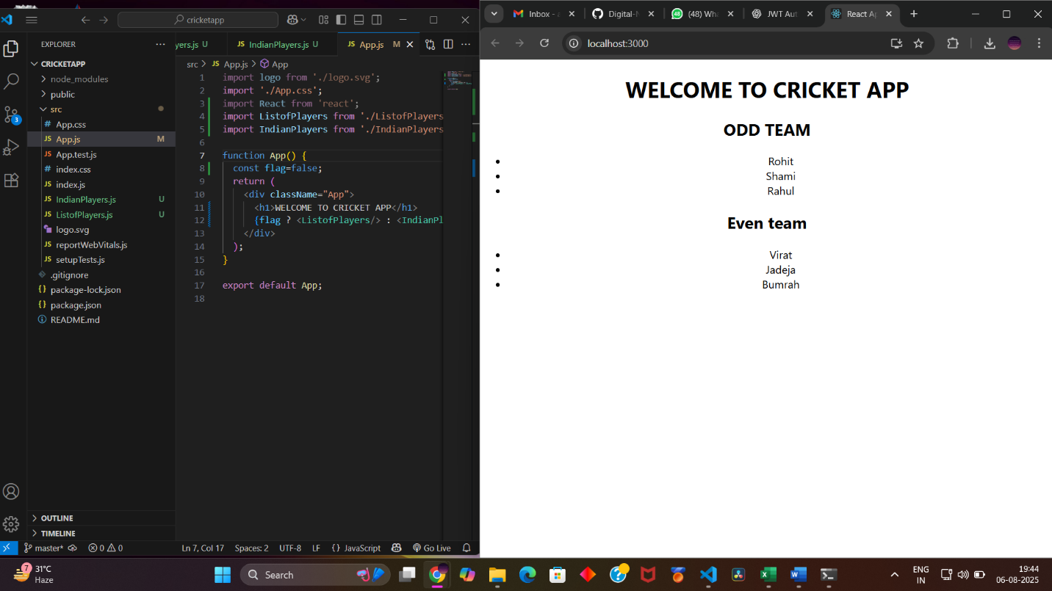

## **10. ReactJS-HOL**

**Create a React Application named “officespacerentalapp” which uses React JSX to create elements, attributes and renders DOM to display the page.**

**App.js:**

import React from 'react';

import './App.css';

function App() {

// Sample list of office spaces

const officeList = [

{

name: "Downtown Workspace",

rent: 55000,

address: "12 Main Street, Mumbai",

image: "https://via.placeholder.com/300x150?text=Downtown+Office"

},

{

name: "Tech Park View",

rent: 72000,

address: "88 IT Hub, Bengaluru",

image: "https://via.placeholder.com/300x150?text=Tech+Park+Office"

},

{

name: "Startup Corner",

rent: 48000,

address: "23 Ring Road, Hyderabad",

image: "https://via.placeholder.com/300x150?text=Startup+Corner"

}

];

return (

<div className="App">

<h1>🏢 Office Space Rental App</h1>

{/* Loop through the office list and display each office */}

{officeList.map((office, index) => (

<div className="office-card" key={index}>

<img src={office.image} alt={office.name} />

<h2>{office.name}</h2>

<p><strong>Address:</strong> {office.address}</p>

<p className={office.rent < 60000 ? 'rent-low' : 'rent-high'}>

<strong>Rent:</strong> ₹{office.rent}

</p>

</div>

))}

</div>

);

}

export default App;

**App.css:**

.App {

text-align: center;

padding: 20px;

font-family: sans-serif;

background-color: #f5f5f5;

}

.office-card {

background-color: white;

padding: 15px;

margin: 15px auto;

width: 60%;

border-radius: 10px;

box-shadow: 0px 0px 8px rgba(0, 0, 0, 0.1);

}

.office-card img {

width: 100%;

height: auto;

border-radius: 5px;

}

.rent-low {

color: red;

}

.rent-high {

color: green;

}

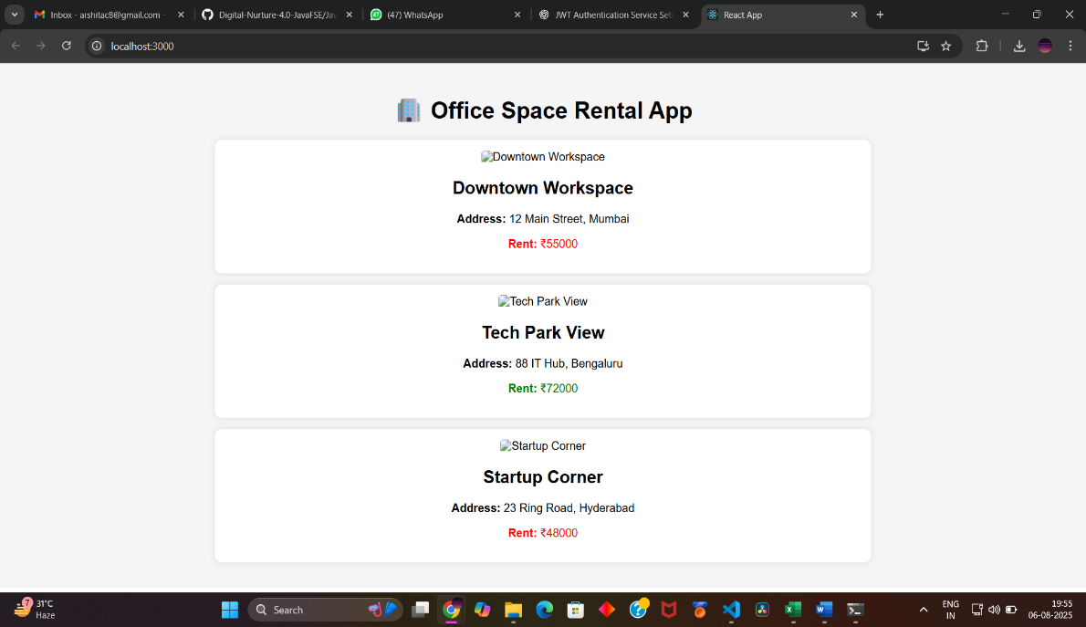

## **11. ReactJS-HOL**

**Create a React Application “eventexamplesapp” to handle various events of the form elements in HTML.**

**App.js**

import React, { useState } from 'react';

import './App.css';

import CurrencyConverter from './CurrencyConverter';

function App() {

const [count, setCount] = useState(0);

const increment = () => {

setCount(prev => prev + 1);

sayHello();

};

const decrement = () => {

setCount(prev => prev - 1);

};

const sayHello = () => {

alert("Hello! This is the static message.");

};

const sayMessage = (message) => {

alert(`You said: ${message}`);

};

const handleSyntheticEvent = (e) => {

alert("I was clicked!");

};

return (

<div className="App">

<h1>🎯 Event Examples App</h1>

<h2>Counter: {count}</h2>

<button onClick={increment}>Increment</button>

<button onClick={decrement}>Decrement</button>

<br /><br />

<button onClick={() => sayMessage("Welcome")}>Say Welcome</button>

<br /><br />

<button onClick={handleSyntheticEvent}>OnPress</button>

<br /><br />

<CurrencyConverter />

</div>

);

}

export default App;

**CurrencyConverter.js**

import React, { useState } from 'react';

const CurrencyConverter = () => {

const [rupees, setRupees] = useState('');

const [euro, setEuro] = useState('');

const convertToEuro = (e) => {

e.preventDefault(); // prevent default form behavior

const euroRate = 0.011; // 1 INR ≈ 0.011 EUR

const converted = (parseFloat(rupees) * euroRate).toFixed(2);

setEuro(converted);

};

return (

<div className="converter">

<h2>Currency Converter 💱</h2>

<form onSubmit={convertToEuro}>

<input

type="number"

placeholder="Enter amount in INR"

value={rupees}

onChange={(e) => setRupees(e.target.value)}

required

/>

<button type="submit">Convert</button>

</form>

{euro && <p>Converted Amount in Euro: €{euro}</p>}

</div>

);

};

export default CurrencyConverter;

**App.css**

.App {

text-align: center;

padding: 30px;

font-family: Arial, sans-serif;

}

button {

margin: 5px;

padding: 10px 15px;

font-size: 16px;

}

.converter {

margin-top: 30px;

}

input {

padding: 8px;

font-size: 16px;

}

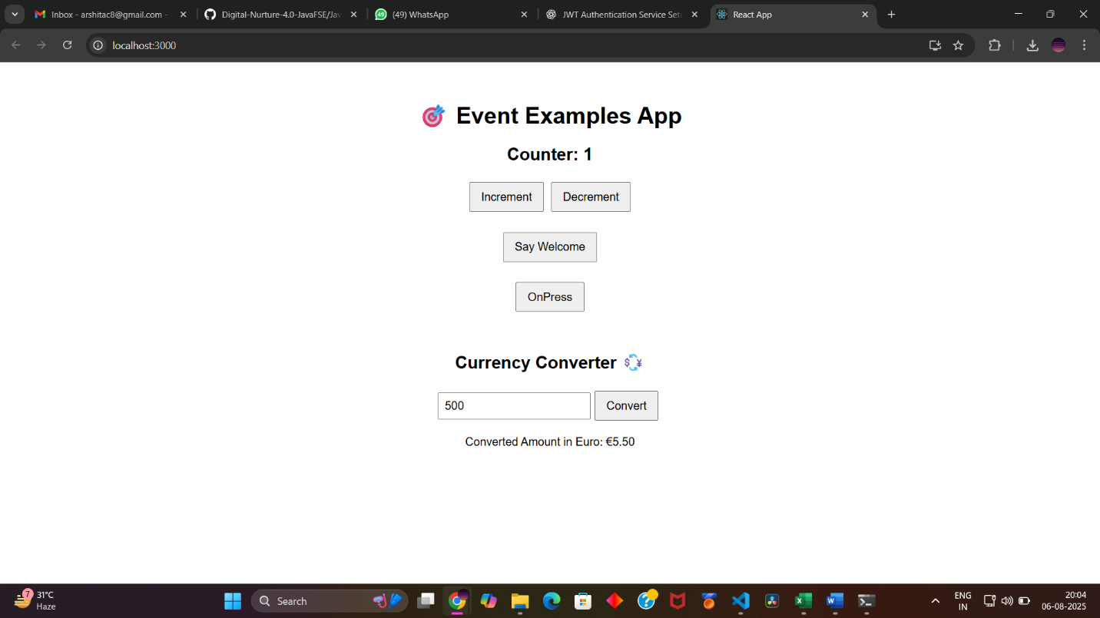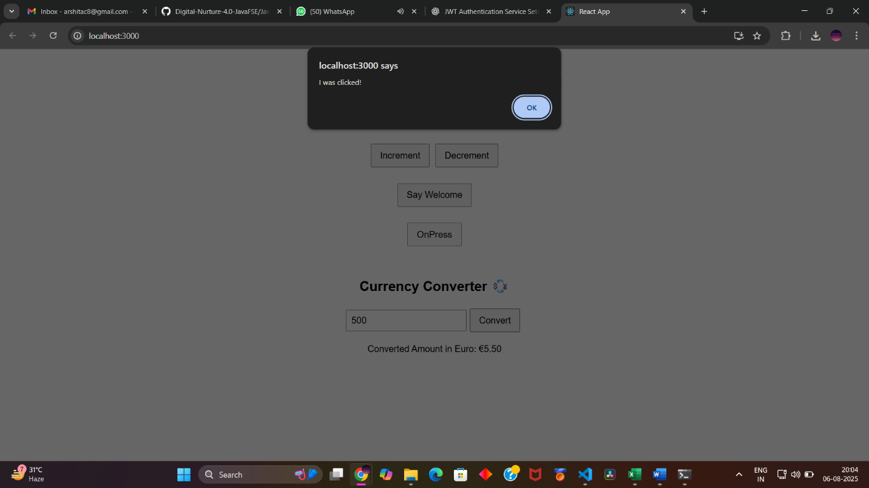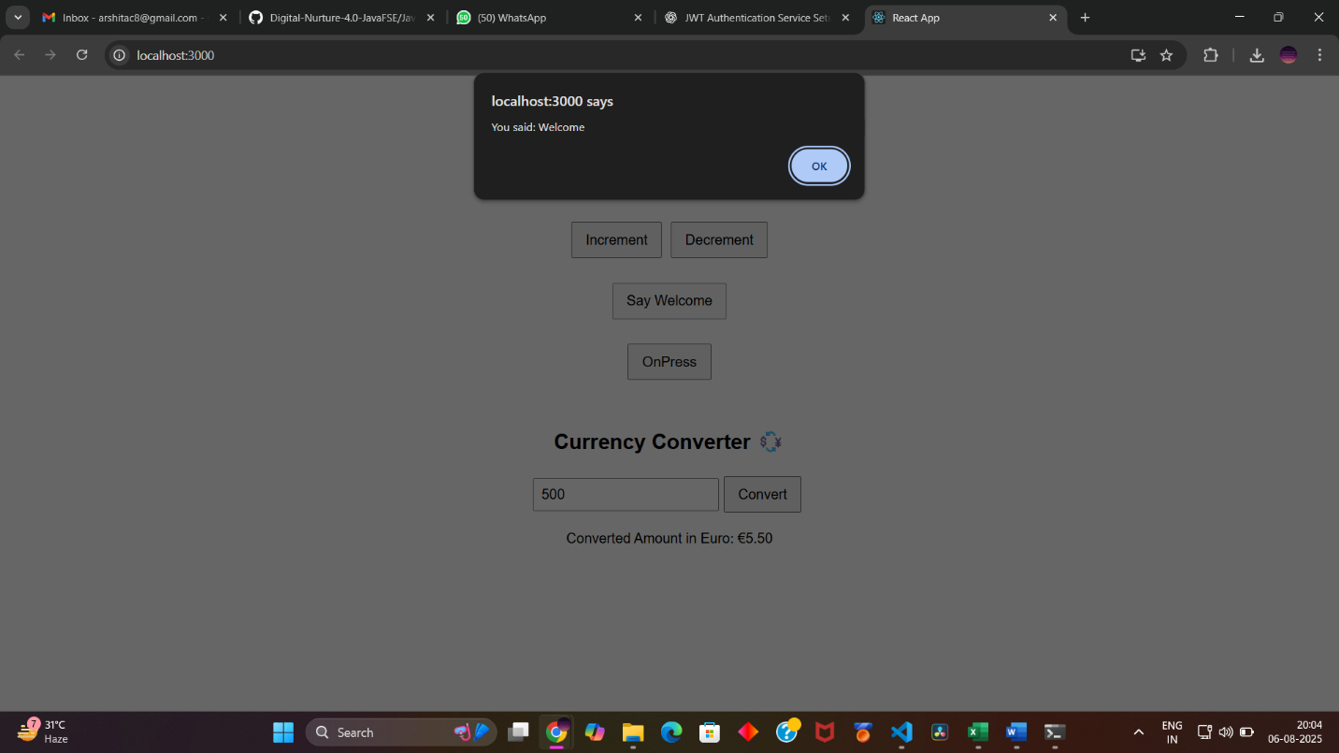

## **12. ReactJS-HOL**

**Create a React Application named “ticketbookingapp” where the guest user can browse the page where the flight details are displayed whereas the logged in user only can book tickets.**

**The Login and Logout buttons should accordingly display different pages. Once the user is logged in the User page should be displayed. When the user clicks on Logout, the Guest page should be displayed.**

**App.js**

import React, { useState } from 'react';

function GuestPage({ onLogin }) {

return (

<div>

<h2>Welcome Guest</h2>

<h3>Available Flights:</h3>

<ul>

<li>Flight: AI-101 | From: Delhi | To: Mumbai</li>

<li>Flight: AI-202 | From: Bangalore | To: Chennai</li>

<li>Flight: AI-303 | From: Hyderabad | To: Kolkata</li>

</ul>

<button onClick={onLogin}>Login</button>

</div>

);

}

function UserPage({ onLogout }) {

return (

<div>

<h2>Welcome User</h2>

<h3>Book Your Ticket:</h3>

<p>Flight: AI-101 | From: Delhi | To: Mumbai</p>

<button>Book Now</button>

<br /><br />

<button onClick={onLogout}>Logout</button>

</div>

);

}

function App() {

const [isLoggedIn, setIsLoggedIn] = useState(false);

const handleLogin = () => {

setIsLoggedIn(true);

}

const handleLogout = () => {

setIsLoggedIn(false);

}

return (

<div style={{ textAlign: 'center' }}>

<h1>Ticket Booking App</h1>

{isLoggedIn

? <UserPage onLogout={handleLogout} />

: <GuestPage onLogin={handleLogin} />

}

</div>

);

}

export default App;

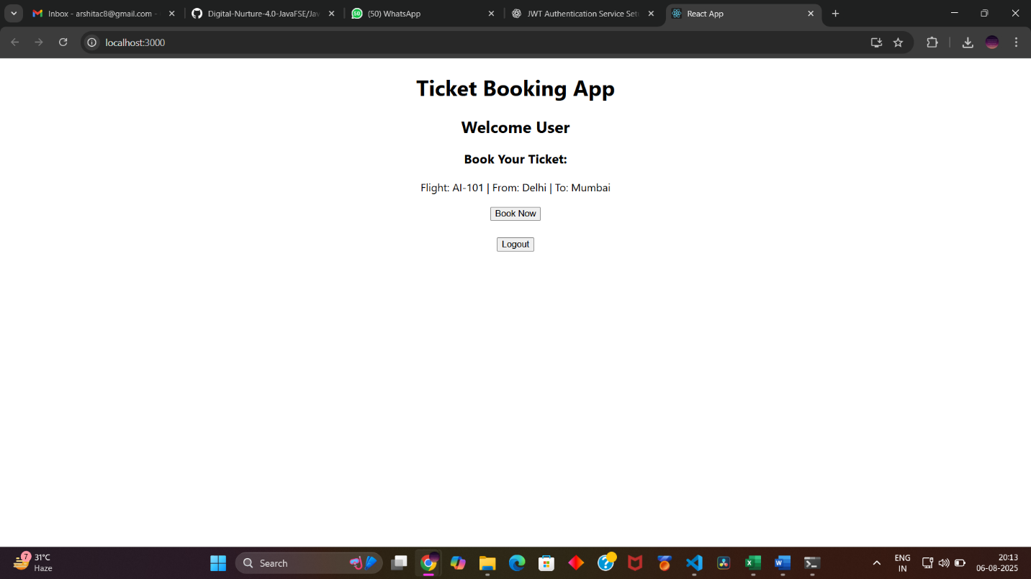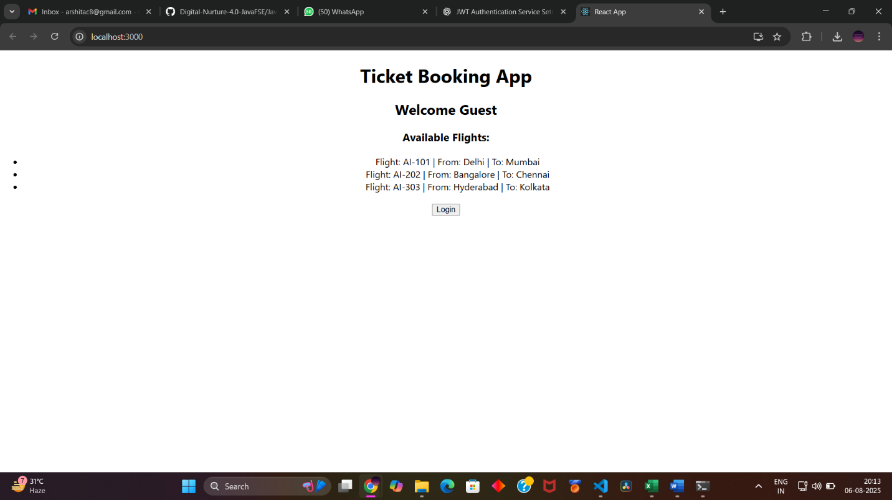

## **13. ReactJS-HOL**

**Create a React App named “bloggerapp” in with 3 components.**

1. **Book Details**
2. **Blog Details**
3. **Course Details**

**Implement this with as many ways possible of Conditional Rendering.**

***BookDetails.js:***

import React from 'react';

const BookDetails = () => {

return (

<div>

<h2>Book Details</h2>

<p>Title: The Art of Learning</p>

<p>Author: Josh Waitzkin</p>

</div>

);

};

export default BookDetails;

***BlogDetails.js***

import React from 'react';

const BlogDetails = () => {

return (

<div>

<h2>Blog Details</h2>

<p>Title: Understanding React Hooks</p>

<p>Author: Jane Doe</p>

</div>

);

};

export default BlogDetails;

***CourseDetails.js***

import React from 'react';

const CourseDetails = () => {

return (

<div>

<h2>Course Details</h2>

<p>Course: Full Stack Web Development</p>

<p>Instructor: John Smith</p>

</div>

);

};

export default CourseDetails;

