**CS370 - GoHousin**

TeamMember: Albert Li, Bill Qi, Cynthia Dong, Nevaeh Tang, David Luo, Alan Huang

Housing struggles are no more -- our website provides Emory students with convenience to review possible housing information, join a forum with the neighbors, find future roommates, etc.

Note: Our website is online now. Go to http://www.gohousin.com/ to use and experience our final project.

**Usage guide:**

Our website has three major building blocks: information review, information sharing, and roommate searching. Go to http://www.gohousin.com/ to use and experience our final project.

Note: you need to sign up and log in to fully experience our website. Please use an Emory email to sign up.

Information Review:

This page includes all basic information of popular housing options around Emory. You can also see how others think about the neighborhood here.

Note: to write a review, you need to log in first.

Information Sharing:

This page includes 5 forums. Inside them, there are many different topics. You can see others’ discussion here. You can also post discussion yourself.

Note: you will need to log into WordPress database to post a question/answer/discussion.

Roommate Searching:

In this page, you can finish the survey. We will then select users who have similar habits with you.

Note: you will need to log in first to finish the survey.

Contact Us:

Write your opinions about our website here.

About Us:

Meet the team!

Below is the guide about how to rebuild our website.

**Installation guide:**

**First Step:**

We used LAMP (Linux/Apache/Mysql/Php) for our project. Please install MAMP if you are running on MACOS or WAMP if you are running on Windows.

**Next Step:**

Unzip the file called "final artifact.zip" in the folder.

Deploy Information Sharing:

We developed the website frontend and connecting the frontend to the backend using php, html, css and javascript. The frameworks we used are Bootstrap and Wordpress. All files are in the "final artifact" folder now.

**Third Step:**

Build database.

Deploy Information Sharing:

We bought a domain name, and connect it to the Google Cloud VM IP address. All database is in the Google cloud VM.

To rebuild the database, you can use a localhost server and connect it to the project folder.

Since we weren't able to download the database from Google Cloud VM, we saved the database structure as the screenshots. You can simply rebuild the database according to the given structure:

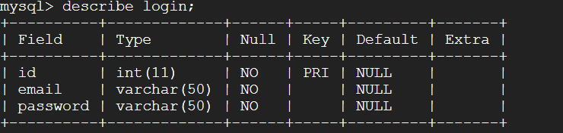

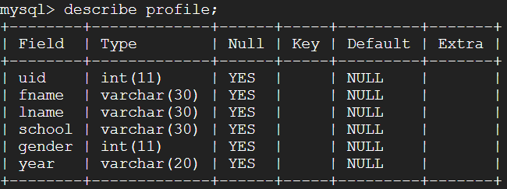

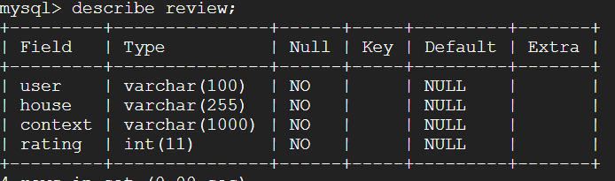

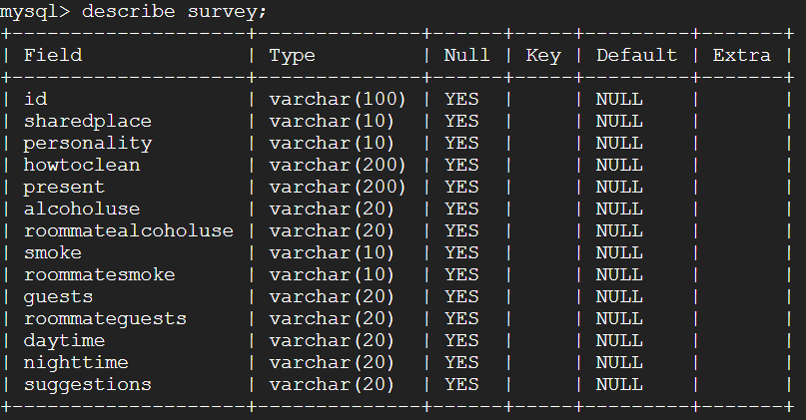

We also implemented the email system on Google Cloud VM. To do this, we followed the instruction here: https://askubuntu.com/questions/47609/how-to-have-my-php-send-mail

To make it concise:

*Run: sudo apt-get install ssmtp*

Edit /etc/ssmtp/ssmtp.conf file, comment out existing mailhub line and add the following lines (this example is for gmail smtp server):

*Run: mailhub=smtp.gmail.com:587*

*Run: UseSTARTTLS=YES*

*Run: AuthUser=gohousinoffcial@gmail.com*

*Run: AuthPass=practicum370*

Now make sure that your php.ini has correct sendmail_path. It should read as: sendmail_path = /usr/sbin/sendmail -t

Reload apache and your php should be able to send outgoing emails now.

**Fourth step**: Setup local Wordpress.

Deploy Information Sharing:

We use Wordpress for our information sharing platform. Before performing this step, please make sure that you have installed mysql and apache

Although all the local files have been provided to you (WordPress, image, plugins), you need to import WordPress’s database to your server in order to run the website.

I would recommend you using phpMyAdmin to manage your database (I am going to use phpMyAdmin in this instruction).

After you go to phpMyAdmin (or other database management platforms):

First, create a new user "wpuser" with password "wordpress" for your database, and grant the user all privileges.

Second, create a new database "wp_myblog" and set its localhost to be "localhost"

Third, import the wordpress database to "wp_myblog". (database's file name is "wordpress_database", and you can find the file in "html" folder)

Fourth(important), edit the database's site's domain to your localhost's domain:

1. use "wp_myblog" database

2. select table "wp_options"

3. change "siteurl" and "home"'s option_value to your own database(see the screenshots below)

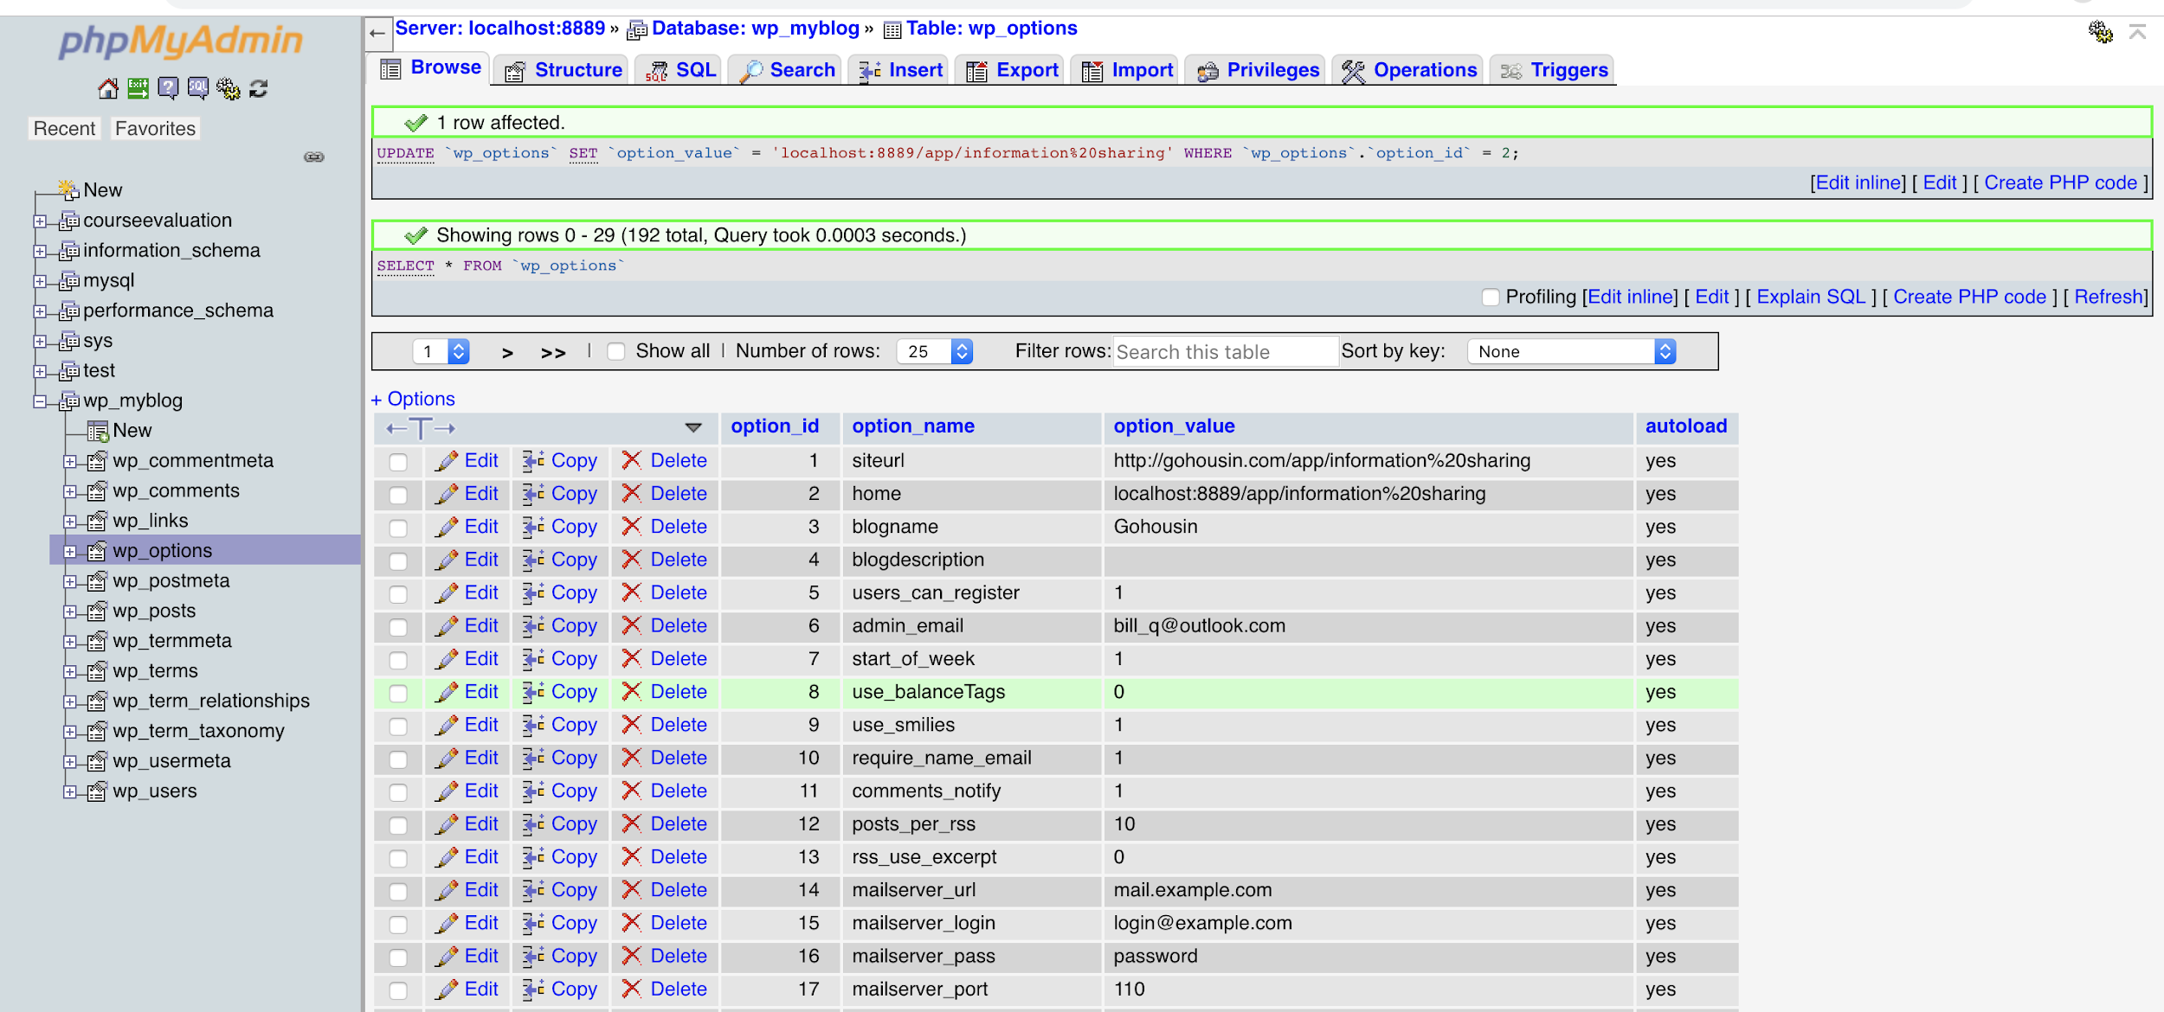

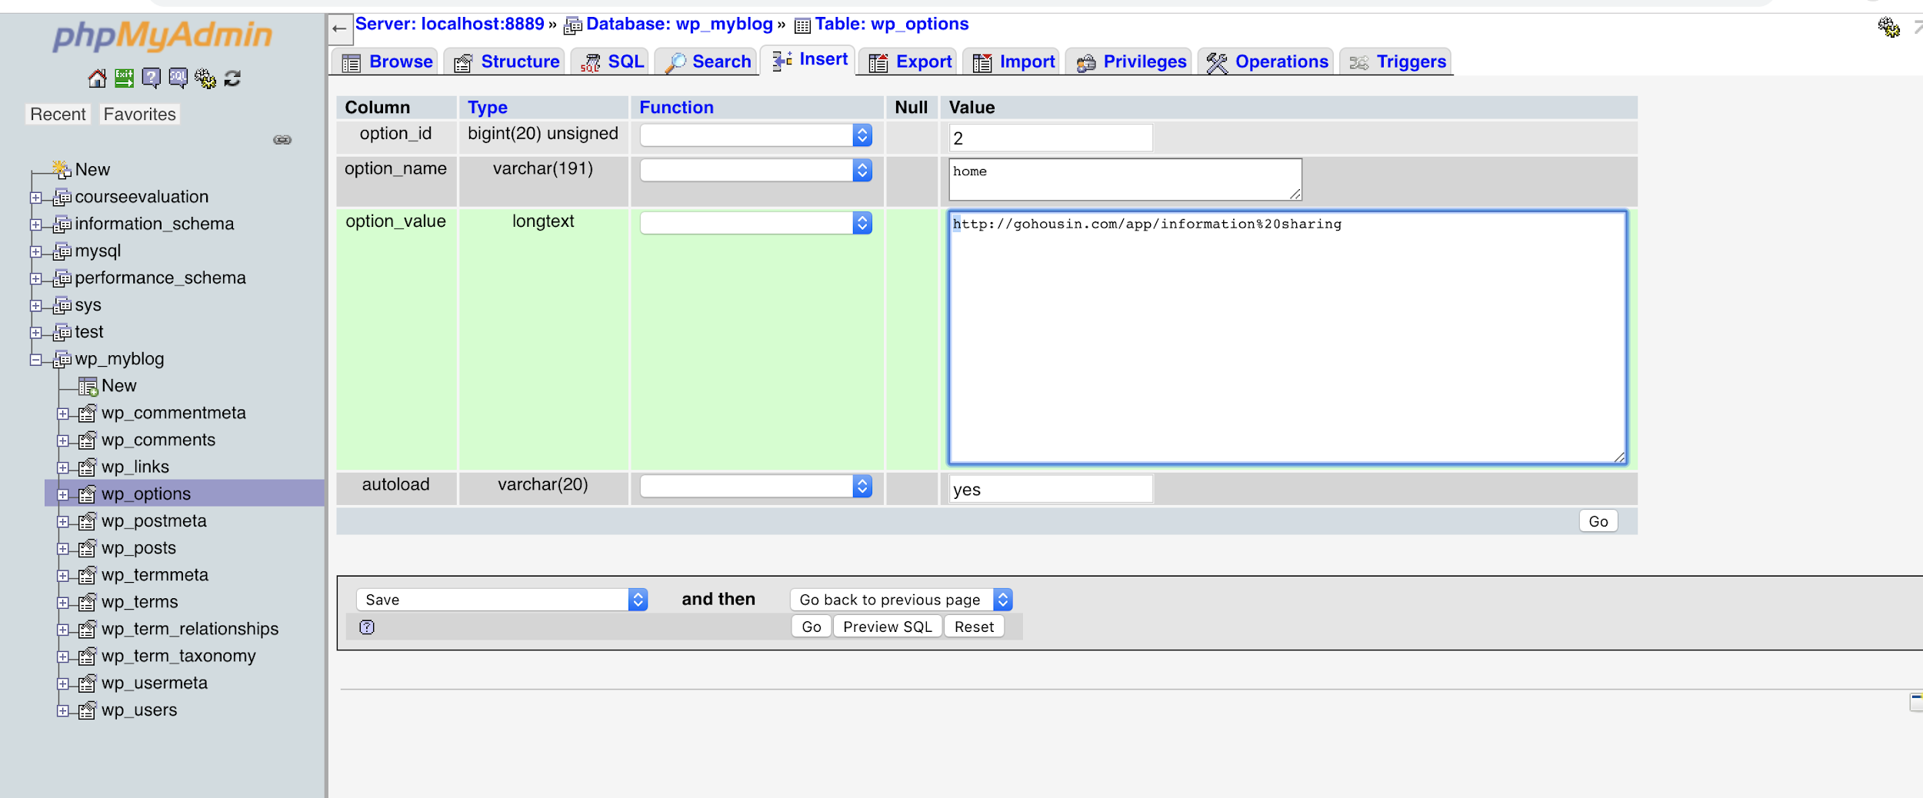

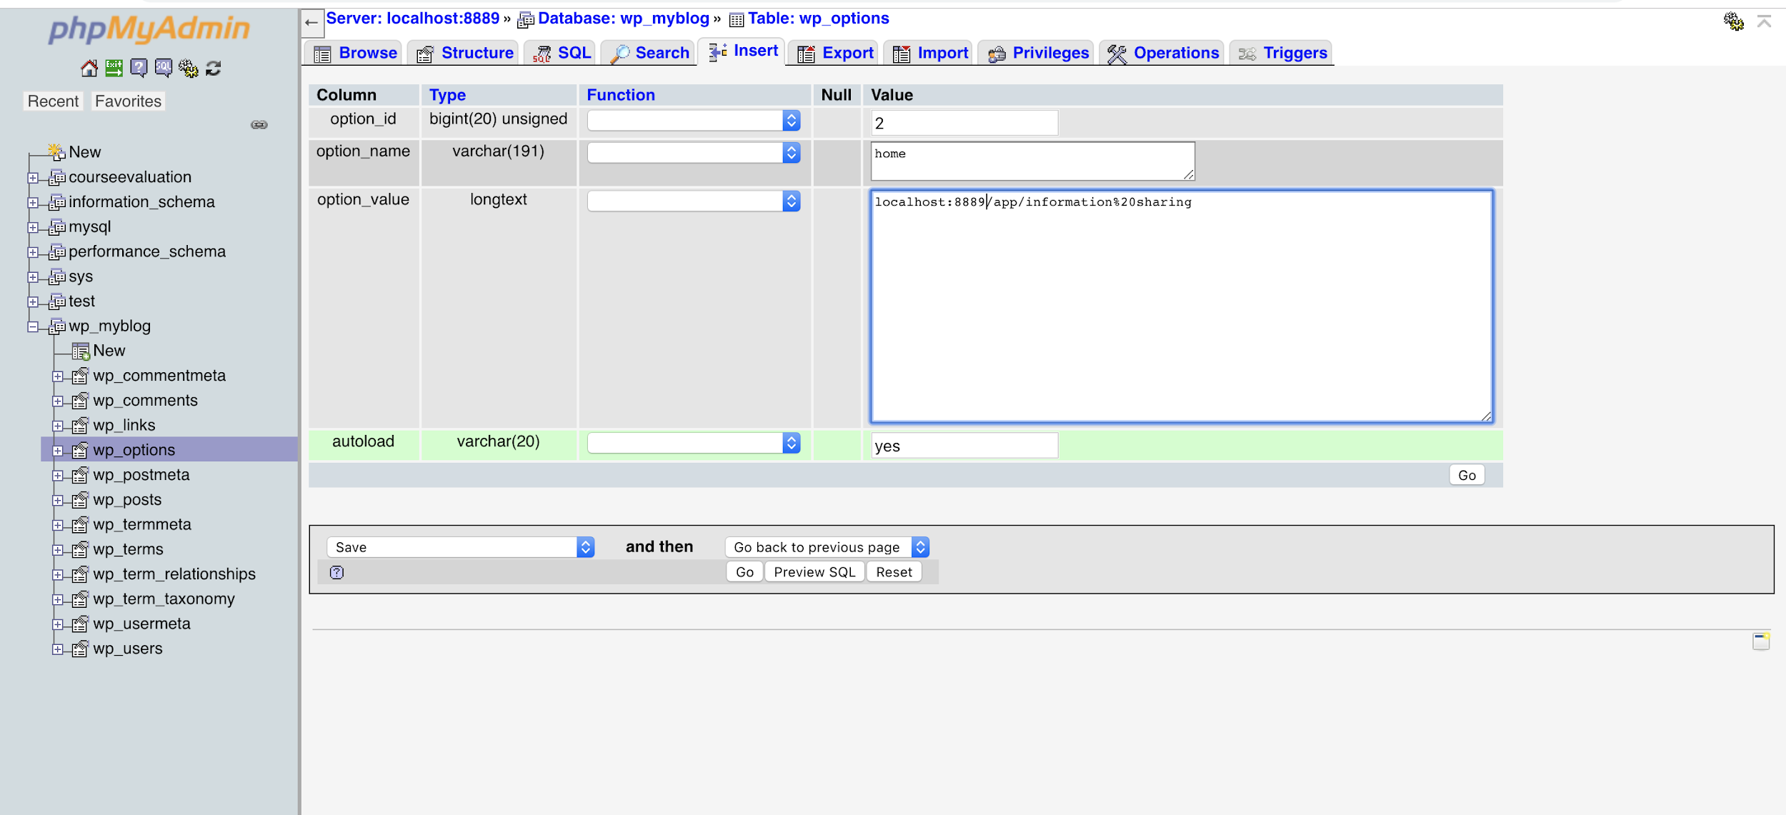

Please check if information sharing could work. Normally, it should work. But if you are running on localhost, the website could still not respond. If this is the case, please go to the fifth step, otherwise, skip step 5.

Fifth(skip this if information sharing already connected to the database)

-Change the localhost port to 80.

- restart your server

Information Sharing page should work properly by now. If you encounter other problems, you could ask me or refer to this website (<https://codex.wordpress.org/Moving_WordPress>) which gives a descriptive instruction on moving a WordPress website.

Congratulations! You have fully rebuilt our project now! Click index.html to go to our landing page and experience the website.