How-to-export-certificate-in-PEM-format-for-import-from-Windows
DESCRIPTION
This document provides the necessary information to export a certificate from Windows Server 2008/2012 R2 in PEM format
STEPS
In Windows the PEM format certificate is known Base-64 X.509 (.CER) The steps outlined below will guide you through the process of exporting the certificate to use with our products.
Finding and exporting your Certificate
- On the Windows system, go to "Run" and enter "mmc.exe" for root console access.
2. Click "File -> Add/Remove Snap-in"
3. In the "Available Snap-in" window look for "certificates" and click "Add >" to add snap in.
4. Select "My User Account" and click "Finish"
5. In the Add or Remove Snap-ins windows, click "OK"
6. At the top level of the certificates snap-in perform a right click on "Certificates - Current User" and go to "All Tasks"
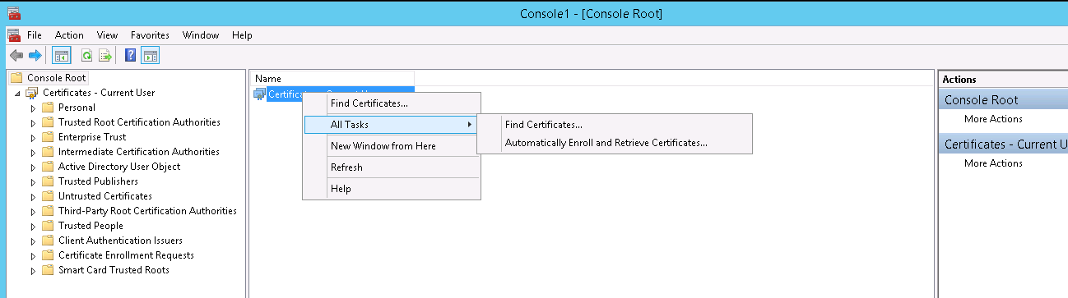
7. Click on "Find Certificates" to launch the Search window
8. Enter a string in the "Contains" text box
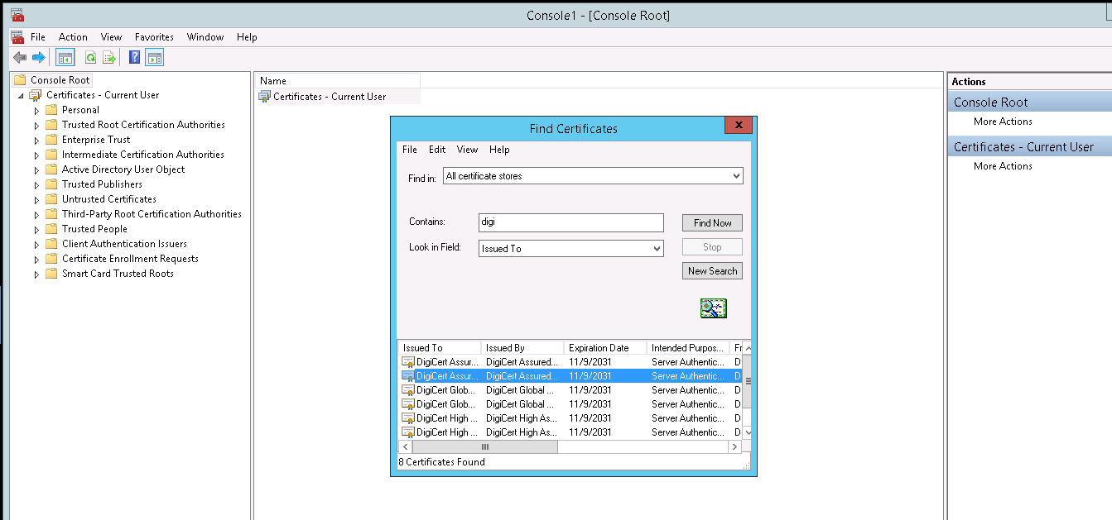
9. Once you have located the certificate that you would like to be exported you can Right-click on the certificate and click and select "Export".
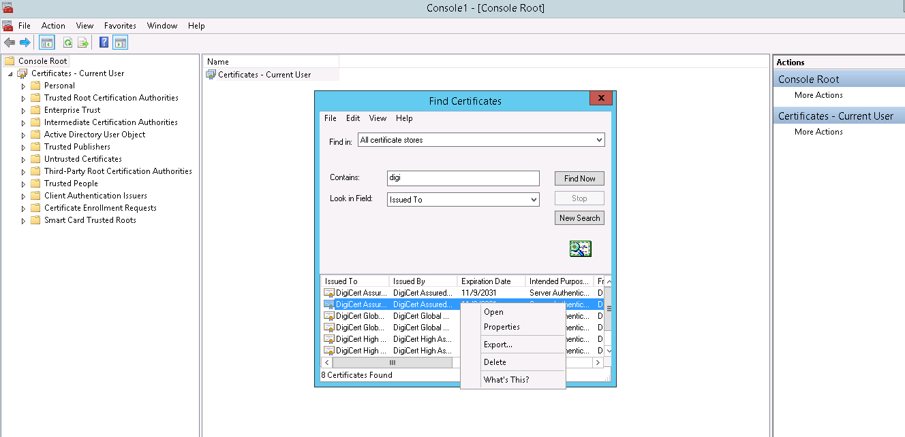
10. Certificate Export Wizard dialog will pop-up. Click "Next" to continue.
a. Select Base-64 encoded X.509 (.CER) for the file export format.
b. Provide a location to save the certificate and a file name.
c. Review the settings you selected and click "Finish".
d. You can rename the certificate file, changing the extension from .CER, to .PEM, if needed.

