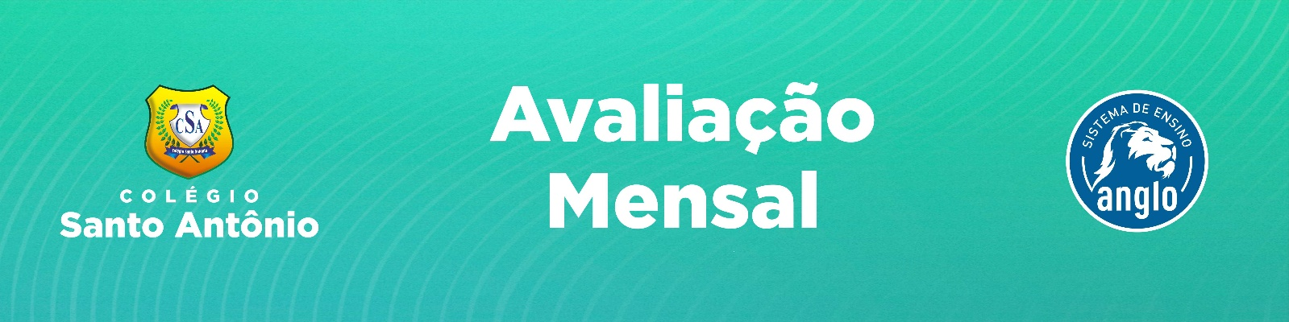

Aluno (a): _________________________________________________________________ Nº _____
Xº Ano “X” – Nível Xº Bimestre Xª Chamada Prof. Nome DATA: ____/____/2026

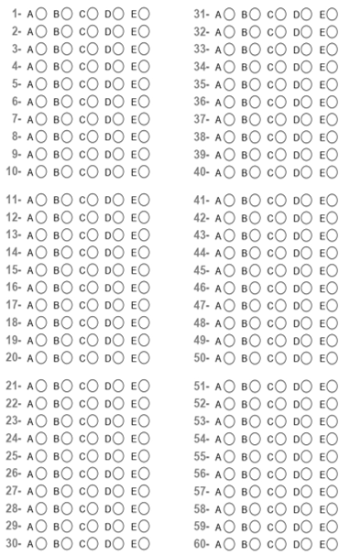
Questão 1
O que é expresso na frase “Tina can speak English and Portuguese”?
a) Permissão.
b) Habilidade.
c) Obrigação.
d) Proibição..

Questão 2
Para a formação da Negativa dos verbos modais, nós usamos os seguintes elementos, nessa ordem:
Modal verb + subject + not + main verb.
Subject + not + modal verb + main verb.
Subject + modal verb + not + main verb.
Modal verb + subject + main verb + not.

Questão 3
Identifique o sentido do modal verb MUST no aviso:
Pedido
Conselho
Obrigação
Habilidade
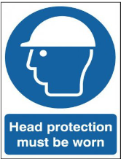

Questão 4
O modal verb SHOULD na forma NEGATIVA indica uma:
Pergunta
Duvida
Proibição
Conselho

Questão 5
Relacione as colunas com os seus sentidos na frases abaixo

Questão 6
Impossibility

Questão 7
Possibility

Questão 8
Prohibition

Questão 9
Advice
( ) Mark studied hard for his exams, but he got poor marks; he can’t be very clever.
( ) You should work less! You look too tired!
( ) She may be in the garden.
( ) You mustn’t enter here.

Questão 10
4 - 2 - 3

Questão 11
4 - 3 - 2

Questão 12
2 - 3 - 1

Questão 13
3 - 2 - 1

Questão 14
Na frase “Jane is a very good pianist. She can play the piano very well.” O modal verb CAN é usado para indicar uma:
Proibição
Habilidade
Ordem
Permissão

Questão 15
Marque a alternativa que indica uma OBRIGAÇÂO
Children can practice math during common activities such as baking or dining.
They do not need to sit at the table and work with a book.
Parents must be a substitute teacher.
It is not an easy task.
TEXTO PARA AS QUESTÕES 8, 9 e 10
Last weekend, Emma and her friends decided they might go camping in the nearby forest. Emma thought it could be a nice change of pace from their usual city outings. However, she knew they would need to prepare carefully since the weather could be unpredictable. Emma suggested they should bring extra blankets and waterproof tents to stay warm and dry.
Her friend Jack insisted that they must also bring a first-aid kit, just in case. He said they might encounter rough terrain, so everyone ought to wear sturdy shoes. Another friend, Sarah, mentioned that they might want to pack some insect repellent, as there could be a lot of mosquitoes. Emma agreed, saying they should plan their meals well because there might not be any shops nearby.
As they packed, Jack reminded them they must leave no trash behind, respecting nature. Emma also said they could have a small campfire but would need to be cautious to avoid any risks. When they finally set off, they realized they might have forgotten a few items, but they were excited and ready for their adventure.

Questão 16
O que Jack disse que eles deveriam usar por causa do terreno?
________________________________________________________________________________________________________

Questão 17
Por que Emma sugeriu que deveriam levar cobertores extras e barracas à prova d’água?
________________________________________________________________________________________________________

Questão 18
Por que Emma disse que deveriam ser cautelosos com a fogueira?
_______________________________________________________________________________________________

