# **Instruction to Deep-SMOLM**

Contents

**Instruction to Deep-SMOLM** 1

**Preparing the environment and software** 3

**Matlab** 3

Install matlab here 3

**Visual studio code (VS code)** 3

Download visual studio code here: 3

Learning debugging in visual studio code here: 3

**Anaconda** 3

Download the Anaconda here: 3

Build environments for Deep-SMOLM: 3

**Install packages** 4

Launch visual studio from anaconda 4

Change the environment to the new created environment through terminal in VS code 4

Install packages through conda using terminal 4

**Generating the training data** 5

**Option 1**: generating training data from matlab scripts 5

**Option 2**: use training data in OSF 5

**Training Deep-SMOLM** 6

**Set comet ml account to monitor the training process** 6

**Modify the config_orientations.json** 6

Parameters you might need to change 6

Parameters you can keep it be the same 8

**Running the training code** 8

**Estimation using Deep-SMOLM** 8

**For simulated data with ground truth** 8

Check if the data loader method match to your data 8

Modify the config_orientations.json file 8

Run the estimation code 9

**For Experimental data** 9

Check if the data loader method match to your data 9

Modify the config_orientations.json file 9

Run the estimation code 10

# **1 Preparing the environment and software**

## **(a) Matlab**

Matlab is used to generate the simulate data

### Install matlab here

[Installation and Licensing Documentation (mathworks.com)](https://www.mathworks.com/help/install/)

## **(b) Visual studio code (VS code)**

I recommend use visual studio code for running Deep-SMOLM due to its user-friendly debugging interface. But any other platforms will also work.

### Download visual studio code here:

[Download Visual Studio Code - Mac, Linux, Windows](https://code.visualstudio.com/Download)

### Learning debugging in visual studio code here:

<https://code.visualstudio.com/Docs/editor/debugging>

## **(c) Anaconda**

Using anaconda for installing packages

### Download the Anaconda here:

[Anaconda | The World's Most Popular Data Science Platform](https://www.anaconda.com/)

### Build environments for Deep-SMOLM:

To separate the running environment of Deep-SMOLM from system’s basic environment or environments for other algorithms, I recommend building a specific environment for Deep-SMOLM and install required packages inside this environment.

In here, I created a new environment named Deep-SMOLM_env

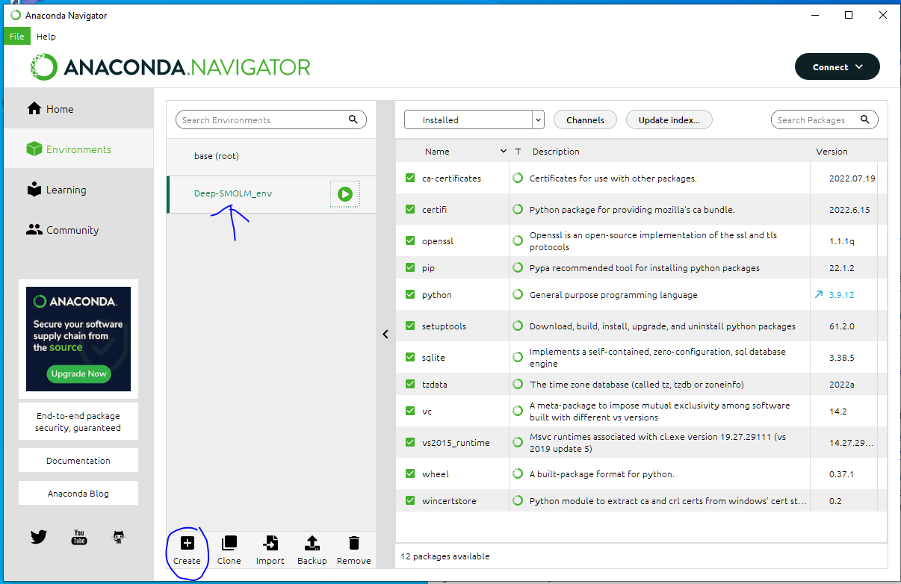

## **(d) Install packages**

### Launch visual studio from anaconda

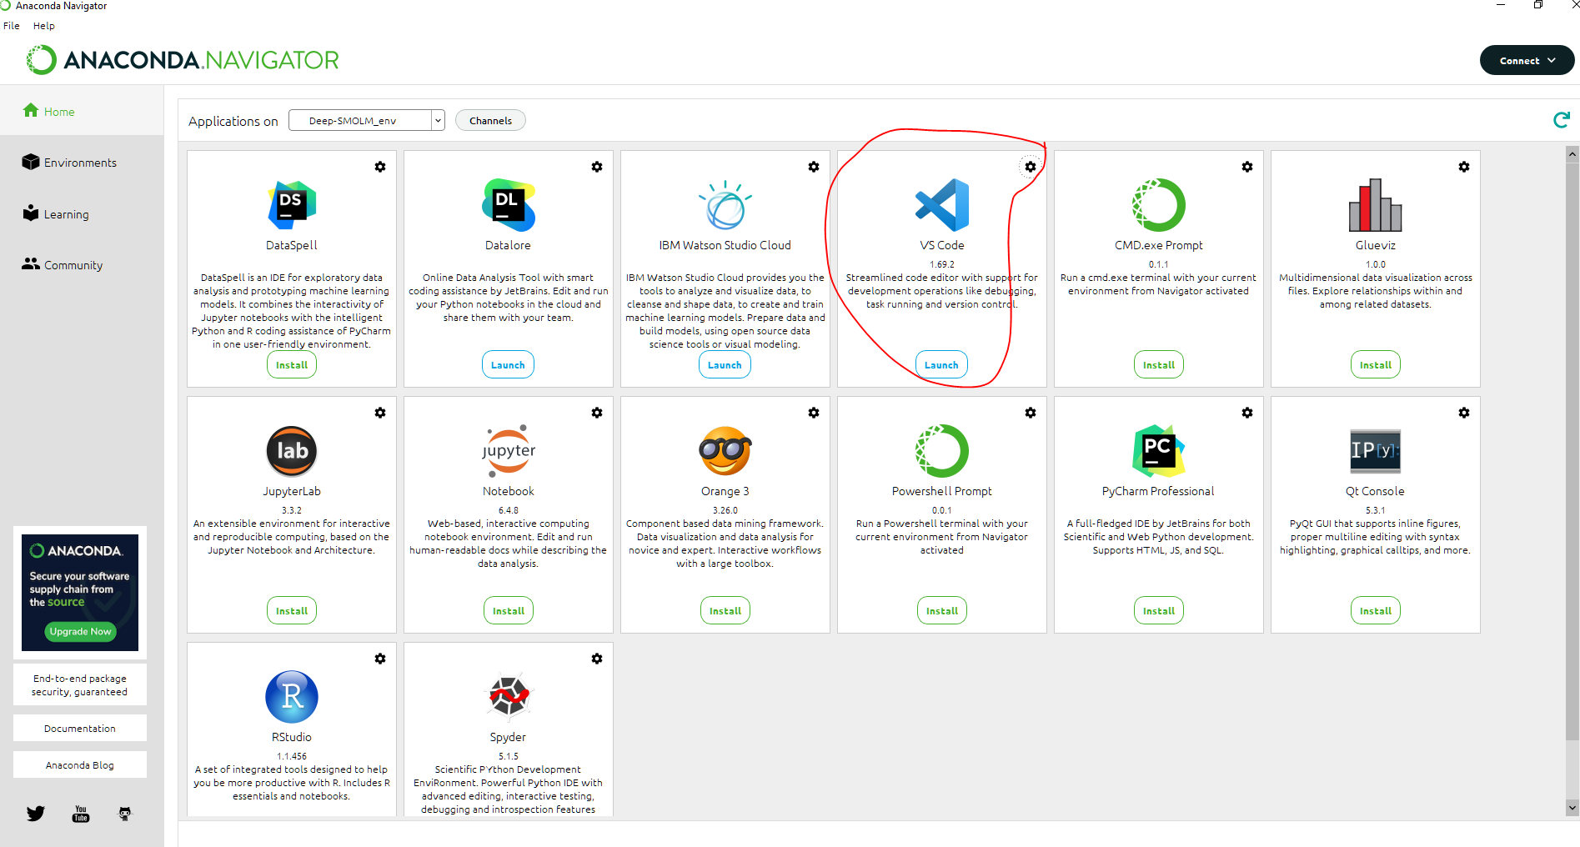

### Change the current environment to Deep-SMOLM’s environment through terminal

* Open terminal on visual studio



* Type in: conda activate [new environment name]



* If succeed, you will see that the visual studio is running under the designed environment

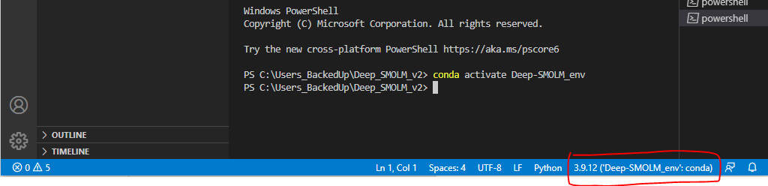

### Install packages using conda

* Make sure the previous changing environment is successful. Otherwise, the packages won’t install in the desired environment.
* Type in the following command in the terminal of visual studio one by one. This will take some time.

conda install -c pytorch pytorch

conda install -c anaconda numpy

conda install -c comet_ml comet_ml

conda install -c anaconda scipy

conda install -c conda-forge tifffile

conda install -c conda-forge matplotlib

conda install -c anaconda pillow

conda install -c conda-forge opencv

conda install -c anaconda scikit-image

conda install -c pytorch torchvision

conda install -c conda-forge tqdm

conda install -c conda-forge iprogress

conda install -c anaconda jupyter

* Once you successfully installed all the packages; the wave underlines in the code will disappear

Examine all the .py files in Deep-SMOLM, make sure there is no wave underlines. If there is, install the related package

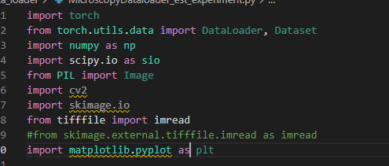

# **2 Generating the training data**

There are two options for getting the training data

## **Option 1**: generating training data from MATLAB scripts (recommended)

As the data generating code is relatively fast (~2h for 30K data), I recommend generating the training data from the MATLAB scripts. Also, in the Deep-SMOLM algorithm package, there are small amount of training data (100 images) for you to test the algorithm and run the algorithm.

* All the simulated data is generated using Matlab scripts under Deep_SMOLM_v2\forward_model; Add this folder to your MATLAB path.
* Generate training data using generate_training_images_pmask_perfect.m for pixOL microscope without aberration ((algorithm used for Fig.1-3 in Deep-SMOLM paper).).
* Generate training data using generate_training_images_retrieved_pmask_w_focal_drift.m. for calibrated pixOL microscope (algorithm used for Fig.4 in Deep-SMOLM paper).; This code generates training images containing emitters that is imaged with focal plane randomly sampled from [-150,150] nm.

## **Option 2**: use training data in OSF

Instead of generating your own training data, you can also directly use the training data stored in the OSF

https://osf.io/x6p8r/?view_onlyb263a8693c5e4418a0b962df31ca0101

# **3 Training Deep-SMOLM**

All the user defined parameters are in the config_orientations.json file.

## **Set comet ml account to monitor the training process**

I use comet.ml to monitor the training process in live.

* Create your comet.ml account here: [www.comet.com](http://www.comet.com)
* Create new project

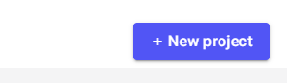 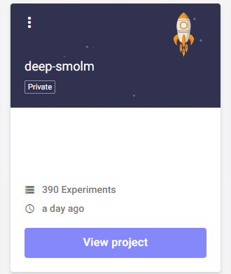

* Find the API of the new account and enter your API to configuration file

Read your API key number under the account profile. (<https://www.comet.com/docs/rest-api/getting-started/>)

At the Deep-SMOLM file: config_orientations.json, enter your API key and change the “savedata” option to be true if you want to turn on the monitoring

## **(b) Modify the config_orientations.json**

config_orientations.json is a file that contains all the information about your training, testing, validation parameters. Idealy, you only need to modiy this configuration file to run the Deep-SMOLM algorithm.

### Parameters you might need to change

* Name of the task; Other names (name1, name2) won’t be read by the code. You can switch between different tasks by assigning the [name] to the desied task.

"name": "training_perfect_pixOL",

* Information of your comet.ml account; the training/testing loss can be monitored on the comet website.

    "comet": {

        "api": "your API key",

        "offline": false,

        "savedata": false

    },

* Change the “save_dir”: directions where your trained results/estimation results will be saved

  "trainer": {

        "epochs": 100,

        "warmup": 0,

        "save_dir": "Examples/trained_Deep-SMOLM_model",

        "save_period": 1,

        "verbosity": 2,

        "asym": false,

        "sym": false,

        "percent": 0.9,

        "subset_percent": 1.0,

        "monitor": "min test_loss",

        "early_stop": 10

    },

* change the [batch_size] and [num_workers] based on your GPU memory and CPU cores

    "****[data_loader]*******":" ",

    "data_loader": {

        "type": "MicroscopyDataLoader",

        "args":{

            "batch_size": 6,

            "shuffle": false,

            "validation_split": 0,

            "num_workers": 8

        }

    },

* Change your training data’s name, location, and size

“noiseless_image_name”: the passion shot noise is added during the training, so please use noiseless image

“GT_image_name”: name of the ground truth image

“file_folder”: location where you save your training data

“number_images”: number of the training data

“dataloader_method”: this refers to rewritten function in data_loader folder for loading the data

    "training_dataset": {

        "noiseless_image_name":"image_noiseless",

        "background_name":"",

        "GT_image_name": "image_GT_up",

        "GT_list_name": "",

        "file_folder": "Examples/training_data/example1_100images",

        "number_images":100,

        "dataloader_method":"MicroscopyDataLoader"

    },

### Parameters you can keep it be the same

Please understand other parameters by reading through the code

## **(c) Running the training code**

* Once you modify the config_orientations.json, you can directly run the code: Deep_SMOLM_main.py either through running or debug running.

I highly recommend running through the debug mode, so that if something is run, you can easily debug the code

* You can monitoring your training curves at [www.comet.ml](http://www.comet.ml)
* Once the running is finished, you will find your results at the folder your assigned for saving the data



# **4 Estimation using Deep-SMOLM**

## **(a) For simulated data with ground truth**

Use Deep_SMOLM_est.py

### Modify the config_orientations.json file

Give the “noise_image_name”, “file_folder”, and “save_name”. You can also give ground truth of your name in “GT_list_name” if applicable, otherwise using “”

    "est_dataset": {

        "noise_image_name":"image_with_poission",

        "GT_image_name": "image_GT_up",

        "background_data":"img_bkg_",

        "GT_list_name": "GT_list",

        "file_folder": "Examples/simulated_biological_fiber/fiber_omega0_100images",

        "number_images":100,

        "batch_size": 16,

        "dataloader_method":"MicroscopyDataLoader_est",

        "save_name":"phantom_orientation_estimation_dense_SMs.mat"

    },

### Check if the data loader method matches to your data

* Modify the “dataloader_method” in the above config file; this refers to function names in data_loader folder for loading the data
* MicroscopyDataloader_est: each estimation paired image is saved into one .mat file; the code read the data batch by batch
* Write new data reading function to fit into your data if needed.

### Run the estimation code

* Use Deep_SMOLM_est.py
* Give the direction of Deep-SMLM model in config_orientations.json; this is the direction that you save your trained Deep-SMOLM model.

## **(b) For Experimental data**

Use Deep_SMOLM_est_experiment.py

### Check if the data loader method matches to your data

* Modify the MicroscopyDataloader_est_experiment.py data reading code to fit into your data if needed.

Current reading method: a stack of images is saved in the .tiff format; the code read the offset image, and read the single molecule image batch by batch

### Modify the config_orientations.json file

    "est_dataset_experiment": {

        "noise_image_name": "_centerY_y410_x_200_FoV420_220_",

        "GT_image_name": "",

        "file_folder": "Examples/experimental_amyloid_fibril/data1_one_FOV/",

        "batch_size":16,

        "number_images_per_dataset":1000,

        "number_FoV": 1,

        "starting_FoV": 6,

        "number_dataSet": 1,

        "starting_dataSet":13,

        "upsampling":6,

        "offset_name":"offset_centerY_y410_x_200_FoV420_220_",

        "background_name":"_bkg_centerY_y410_x_200_FoV420_220_",

        "tophoton": 0.29,

        "y2x_channel_ratio":1.145,

        "dataloader_method":"MicroscopyDataLoader_est_experiment",

        "save_name":"A_beta_data"

    }

### Check if the data loader method matches to your data

* Modify the “dataloader_method” in the above config file; this refers to function names in data_loader folder for loading the data
* MicroscopyDataloader_est: each estimation paired image is saved into one .mat file; the code read the data batch by batch
* Write new data reading function to fit into your data if needed.

### Run the estimation code

* Use Deep_SMOLM_est_experiment.py
* Give the direction of Deep-SMLM model in config_orientations.json; this is the direction that you save your trained Deep-SMOLM model.

